**Acoustic Guitar-Pitch Detection using**

**Cepstral Analysis Excel-GUI Analyzer**

Lester Y. Besabe1, Christian Erick L. Cimbracruz1, Vanessa E. Espino1, John Denver P. Felarca1,

Prince Julius T. Hari1, Engr. Ranil M. Montaril, MSECE2, Hannah Lalaine M. Morasa1, John Daryll M. Moya1

*1 Undergraduate Student, Bachelor of Science in Computer Science, Polytechnic University of the Philippines, Manila*

*2 Master of Science in Electronics Engineering, Bulacan State University*

**Abstract**

Pitch detection of sound is one of the important technologies in audio signal processing. It can be used for interactive computer-music performance. Cepstral Analysis is one of the various Pitch Detection Algorithm. The main focus of this paper is to implement Cepstrum Analysis in detecting the fundamental frequency of an acoustic guitar. The platform used for the project is VBA with an Excel-GUI.

***Key Terms*** *Cepstral Analysis, Cepstrum. Fourier Transform, High-Time Liftering, Pitch Detection*

1. **Background of the Study**

The process of transforming melody into a musical score is difficult, although it is fundamental for the musical activities [1]. So the development of a system that can take musical note automatically is practically very important and desired. Such a system is composed of various fundamental techniques, such as pitch recognition of musical sound, rhythm recognition, tempo recognition and musical instrument recognition [2]. After getting this information, we can develop many applications, such as auto-accompaniment system based on it.

Pitch tracking is a popular topic in the computer music world and there are a number of pre-existing methods that are currently used in various algorithms [3]. Some of the well-known pitch tracking methods include the Average Magnitude Difference Function, Harmonic Product Spectrum, Super Resolution Pitch Detection, McLeod Pitch Method and Cepstral Pitch Determination [4]. In our experiments, the instrumental recording wave file was carefully analyzed and extracted several appropriate parameters. Among those parameters, detecting the fundamental frequency (pitch) is one of the most difficult problems.

This paper aims at extracting the information of the chord being played on an acoustic guitar. It involves having an effective yet computationally efficient onset detection algorithm to determine the pitch frequemcy of the chord. Cepstral Analysis with High- Time Liftering as the algorithm used in this case for the determination of the pitch frequency of the chord.

The implementation of the method described above was done in Visual Basic for Applications (VBA) and MatLab.

* 1. **Problem Statement**

The project seeks to answer the capability of the system in detecting the pitch of a chord by generating Cepstrum for Cepstral Analysis with the help of Matlab and Visual Basic for Applications (VBA) with an Excel-GUI as the platform.

* 1. **Applicable Related Studies**

**Pitch.** McLeod described pitch in his study as quality of perspective that describes the highest and lowness of a sound. It also states that it is related to frequencies contained in the signal, increasing the frequency causing an increase in perceived pitch. The features that a pitch has is important and is studied by most researchers [5]. The study of Sathe-Pathak B in 2012 states pitch as the fundamental frequency of speech signal [6]. The characteristics of pitch are considered by most wide areas of stress evaluation [7]. These known studies considered the subjective assessment of pitch frequency, the statistical analysis of pitch mean, varies and distribution. When speech is generated, the pitch signal depends on the vocal folds tension and the air pressures sub glottal. Due to the vibration of the vocal folds, pitch signal is produced [8].

**Pitch Detection.** Precise pitch is important to musicians, and as the digital technology are making way to use interactive technology for efficient teaching instrument to people, detecting the fundamental frequency known as pitch in a signal becomes an opened field to some researchers as the process of transforming melody into a musical score is difficult especially to the beginners considering the lack of skills on playing instruments, showing more clarity and correctness of the notes playing [9].

The first attempt of actively detecting pitch was done by Helmholts using his resonators, which was discovered in the 1860. Thus a study made by Wu states that pitch detection of music sound is one of the most important findings in technology within the subject of audio processing [10]. Mostly, it is used for interactive computer- music performance. In their paper, they considered some characteristics of a guitar, proposing a specific and accurate method of recognizing pitch. The detected signal transients are employed by using an efficient onset detection algorithm signifying that a note has been played. Once a transient has been detected, it sets off a pitch detection routine which identifies the frequency of the note [11].

**Cepstrum Based Pitch Detection.** The paper written by Sassan Ahmadi in 1999 presents an improved ceptrum-based voicing detection and pitch determination algorithm [12]. Voicing decisions are made using a multifeature voiced/unvoiced classification algorithm based on statistical analysis of cepstral peak, zero-crossing rate, and energy of short-time segments of the speech signal. The extraction of pitch frequency information is modified from a ceptrum-based method and it is carefully refined using pitch tracking, correction, and smoothing algorithms. Performance analysis on a large database indicates considerable improvement relative to the conventional cepstrum method. Cepstral signal analysis is one out of several methods that enable them to find out whether a signal contains periodic elements. The method can also be used to determine the pitch of a signal [13].

1. **Software Design Architecture**

The following shows the models and architecture of Acoustic Guitar-Pitch Detection using Cepstral Analysis Excel-GUI Analyzer

* 1. **Applicable Equations**

The following equations was used for the generation of the Cepstrum.

Discrete Fourier Transform (DFT) is defined as:

$$F \left(k\right)=\sum_{n=0}^{N-1}{f \left(n\right) e^{- \frac{j2Πkn}{N}}}$$

Whereas Inverse Discrete Fourier Transform (IDFT) is defined as:

$$f \left(n\right)= \frac{1}{\sqrt{N}} \sum_{k=0}^{N-1}{F \left(k\right) e^{+ \frac{j2Πkn}{N}}}$$

*Where,*

*F (k) = “Fourier Coefficients” or “Harmonics”*

*N = samples f (n) (number of non-missing values in the input time series)*

*n = values of the input time series, ranges from 0 … N-1*

*k = frequency component, ranges from 0 … N-1*

Conventionally, the sequences f (n) and F (k) is referred to as 'time domain' data and 'frequency domain' data respectively. Of course there is no reason why the samples in f (n) need be samples of a time dependent signal [14].

* 1. **Functional Block Diagram**

The block diagram of Acoustic Guitar-Pitch Detection using Cepstral Analysis Excel-GUI Analyzer (shown in Fig. 1) initially starts with reading the raw data of a chord to generate the Cepstrum that is controlled by a step button, then undergo Cepstral Analysis to calculate the estimated pitch frequency of the chord.

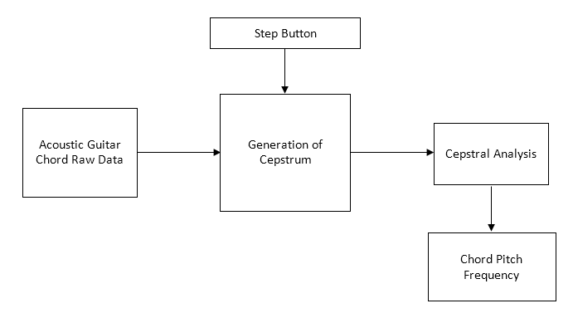

Fig. 1. **Block Diagram**. The image above shows the block diagram model of the Acoustic Guitar-Pitch Detection using Cepstral Analysis Excel-GUI Analyzer with five (5) blocks representing the Raw Data of Guitar Chord, Step Button, Generation of Cepstrum, Cepstral Analysis and the estimated pitch

* 1. **State Diagram**

The state diagram of Acoustic Guitar-Pitch Detection using Cepstral Analysis Excel-GUI Analyzer (shown in Fig. 2) contains eight (8) states and ten (10) input signals (shown in Table 1), from which the program’s main operation is based for Cepstrum Generation for pitch detection.

**Table 1.** States and Input Signals for the State Diagram of Acoustic Guitar-Pitch Detection using Cepstral Analysis Excel-GUI Analyzer

|  |  |  |  |
| --- | --- | --- | --- |
| State | Meaning | Signal | Meaning |
| *q0* | INIT_STATE | *0* | NO_SIGNAL |
| *q1* | STAND_BY | *1* | GET_DATA |
| *q2* | WINDOW_STATE | *2* | DO_WINDOWING |
| *q3* | DFT_STATE | *3* | DONE_WINDOWING |
| *q4* | LOG_DFT_STATE | *4* | D0_DFT |
| *q5* | IDFT_STATE | *5* | D0NE_DFT |
| *q6* | CEPS_ANALYSIS | *6* | DO_LOG_DFT |
| *q7* | FINAL_STATE | *7* | DONE_LOG_DFT |
|  |  | *8* | DO_IDFT |
|  |  | *9* | DONE_IDFT |
|  |  | *10* | GOT_PITCH_FREQ |

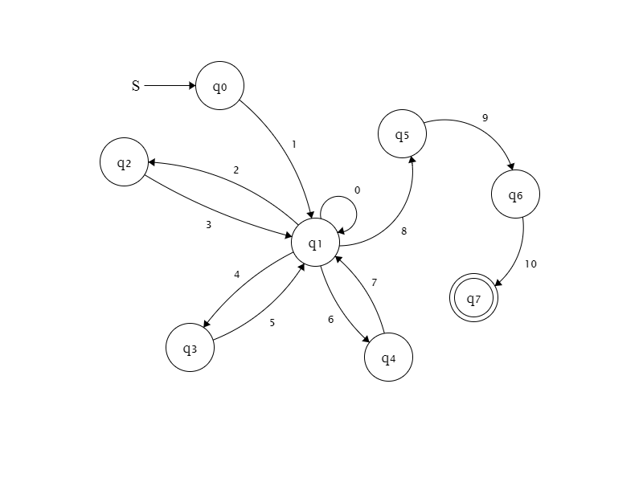

Fig. 2. **State Diagram**. The image above shows the state diagram of the Acoustic Guitar-Pitch Detection using Cepstral Analysis Excel-GUI Analyzer with five (8) states.

* 1. **Architecture**

The system architecture of Acoustic Guitar-Pitch Detection using Cepstral Analysis Excel-GUI Analyzer (shown in Fig. 3) starts with the raw data of a chord as the input to the generation of the Cepstrum.

Cepstrum Generation has four (4) process. The first is the windowing where the raw data is divided into frames/window. Next is performing the Fast Fourier Transform and getting the log of magnitude of each window. Performing the Inverse Fast Fourier Transform of each window is the last step for Cepstrum Generation to produce Cepstral Coefficients. The cepstral coefficients will undergo Cepstral Analysis with High-Time Liftering Algorithm to estimate the pitch frequency of the input chord/data.

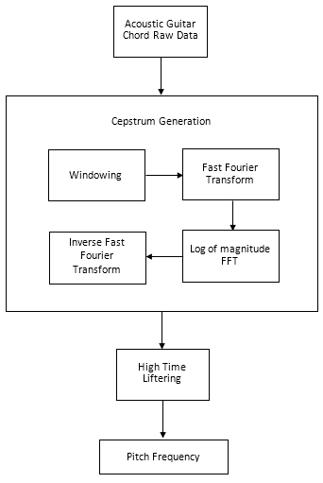

Fig. 3. **System Architecture**. The image above shows the system architecture of the Acoustic Guitar-Pitch Detection using Cepstral Analysis Excel-GUI Analyzer

1. **Simulation Results**
2. **Conclusion**

The project was aimed at extracting useful data from an incoming guitar signal and using that information, the main portion of the implementation was done in VBA and MatLab. For now, the section of implementation that involves Cepstral Analysis was used to detect the acoustic guitar chord strum record pitch.

However, the system still needs an improvement for detecting the pitch frequency of the chords.

1. **Recommendation**

Despite Cepstral Analysis utilization for pitch detection and good performance, there are room for improvements and opportunities. Recommendations include:

1. Detection of pitch for stereophonic sounds
2. Training for detection of pitch frequency of a chord is also a good improvement of the system

***References***

*[1] L. Wu, “Guitar Sound Analysis and Pitch Detection,” n.d.*

*[2] D. Broenink,, “Real Time Pitch Detection,” 2012.*

*[3] E. Gomez, A. Klapuri and B. Meudic, "Melody Description and Extraction in the Context of Music Content Processing," 2002.*

*[4] Z. Duan, “Computational Music Audio Scene Analysis,” 2013.*

*[5] P. McLeod, Fast, Accurate Pitch Detection Tools for Music Analysis. New Zealand, 2008.*

*[6] Bageshree V. Sathe-Pathak, A. R. (2012). Extraction of Pitch and Formants and its Analysis to identify 3 different emotional states of a person. IJCSI International Journal of Computer Science Issues, Vol. 9, Issue 4, No 1, 296-299.*

*[7] T. M. K. T. M. Tamura, "Adaptation of pitch and spectrum for HMM-based speech," IEEE International Conference on, p. 805–808, 2010.*

*[8] E. Mower, "A Framework for Automatic Human Emotion Classification using Emotion Profiles," IEEE Transactions on Audio, Speech and Languare Processing, Vol 19, 2011.*

*[9] G. Beauregard, "Pitch Detection in Flash", Gerry Beauregard, 2017. [Online]. Available: https://gerrybeauregard.wordpress.com/2013/04/30/pitch-detection-in-flash/. [Accessed: 13- Oct- 2017].*

*[10] F. Keiler and S. Marchand, "Survey on extraction of sinusoids in stationary sounds", in Proc. Of the 5th International Conference on Digital Audio Effects (DAFx – 02)., Hamburg, Germany, 2002, pp. 51-58.*

*[11] Pitch detection. 2017. [Online]. Available:* [*https://en.wikipedia.org/wiki/Pitch*](https://en.wikipedia.org/wiki/Pitch)*. [Accessed 18 October 2017].*

*[12] A. S. S. Sassan Ahmadi, "Cepstrum-Based Pitch Detection Using a New Statistical V/UV Classification Algorithm," IEEE TRANSACTIONS ON SPEECH AND AUDIO PROCESSING, pp. 333-338, 1999.*

*[13] "Cepstral Analysis of Speech," Sakshat Virtrual Labs, 2011. [Online]. Available: http://iitg.vlab.co.in/?sub=59&brch=164&sim=615&cnt=1. [Accessed 18 October 2017].*

*[14] “Engineering Productivity Tools”, 2017. [Online]. Available:* [*http://www.engineeringproductivitytools.com/stuff/T0001/PT01.HTM*](http://www.engineeringproductivitytools.com/stuff/T0001/PT01.HTM) *[Accessed 18 October 2017].*

**Curriculum Vitae**

**Lester Y. Besabe c**urrently taking his undergraduate degree in Bachelor in Science in Computer Science since 2014, hopeful to finish the course by 2018. His research interest contains image processing and computer vision, machine learning, and artificial intelligence. Currently working as service crew in Golden Arches Development Corporation known as McDonald’s He attended seminars about Internet of Things, Software Securities, and Robotics. Making softwares in Java, PHP, JavaScript, C#, MatLab, and Databases.

**Christian Erick Cimbracruz**, a student currently taking up Computer Science in Polytechnic University of the Philippines. Has skills in Web Design, Programming, Photography and Digital Music



**Vanessa E. Espino** is a Bachelor of Science Student at Polytechnic University of the Philippines, Manila campus. Having certain knowledge for Web developing, MATLAB, C and C# programming. Proficient in Microsoft Office and Adobe Photoshop. Hobbies are reading, watching YouTube tutorials, mostly coding tutorials and playing RPG games. Interested in art and music.



**John Denver P. Felarca** is currently taking up Bachelor of Science in Computer Science at the Polytechnic University of the Philippines. He is currently focused on learning thoroughly about Web Development. His current research focuses on the prevention and analysis of violent crimes. In his free time, Denver enjoys playing volleyball, badminton, working-out, and traveling.

**Prince Julius T. Hari** currently pursuing the BSc in Computer Science at Polytechnic University of the Philippines, Manila. Vice President of the Association for Computer Intelligence Integration (Year 2015-16), the official organization of Department of Computer Science. His research interest includes the development of image processing, databases and data mining, expert systems and natural language processing.



**Hannah Lalaine M. Morasa** is currently taking Bachelor of Science in Computer Science at the Polytechnic University of the Philippines. She has a good knowledge and interest in Web development, Digital Signal Processing, and researching. Also she obtain experienced in multi-tasking, critical analysis and committed to work with her full potential as part of the team.

**John Daryll M. Moya** is a student of Bachelor of Science in Computer Science under the Computer Science Research (CSR) track at the Polytechnic University of the Philippines. He is a learner with dedication and passion who is also equipped with necessary knowledge and skills. He has experienced skills in web development, database management and various programming languages.