**The Ultimate Guide to Excelling in Competitive Programming**

1. **Understanding the Basics of Competitive Programming**



**A What is Competitive Programming?**

Competitive programming is mind sport where participants compete to solve algorithmic mathematical problems within a specified time frame. The goal is to write code that not only provides the correct solution but does so efficiently and elegantly.

**B. Key Components and Skills Needed**



* Proficiency in programming languages like C++, Java, Python
* Strong problem-solving skills
* Knowledge of various data structures and algorithms
* Ability to think critically and analytically

**C. Importance in the Tech Industry**

Competitive programming plays a significant role in the tech industry as it helps developers enhance their problem-solving abilities, coding speed, and efficiency. Companies often look for candidates with a background in competitive programming as it demonstrates their capability to tackle complex coding challenges.

**II. Essential Strategies for Success in Competitive Programming**

**A. Problem-Solving Techniques**

* Utilize different approaches such as divide and conquer, dynamic programming, and greedy algorithms
* Focus on developing efficient algorithms to solve problems effectively
* Consistent practice and persistence are key to improving problem-solving skills

**III. Mastering Data Structures and Algorithms**

**A. Fundamentals of Data Structures**

* Understand common data structures like arrays, linked lists, stacks, queues, trees, and graphs
* Learn how to implement these data structures and their applications in solving real-world problems
* Practice algorithms related to data structure manipulation to enhance problem-solving abilities

**IV. Practical Tips for Improving Competitive Programming Skills**

**A. Continuous Learning and Practice**

* Utilize online platforms and resources like Codeforces, LeetCode, and HackerRank for learning and practicing
* Build confidence by solving problems regularly and challenging yourself with difficult tasks
* Collaborate with fellow programmers to exchange ideas, strategies, and solutions

**V. Advancing to Higher Levels in Competitive Programming**

**A. Participating in Coding Competitions**

* Explore different types of coding competitions such as hackathons, CodeJam, TopCoder, and Google Code Jam
* Navigate competitive platforms like Codeforces and AtCoder to compete against skilled programmers
* Develop strategies for competition success, including time management, problem selection, and debugging techniques

**Summary**

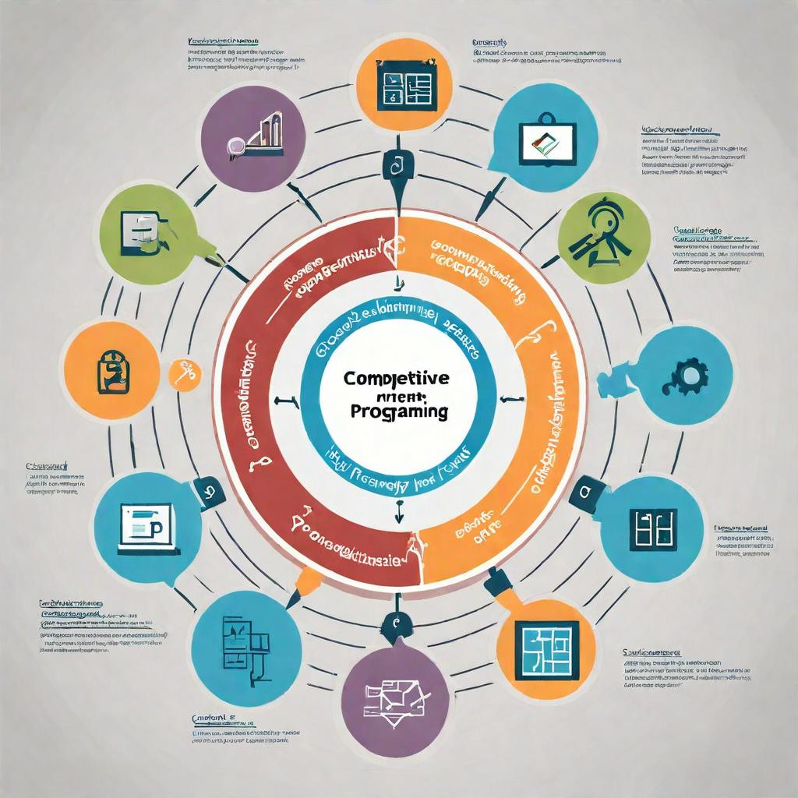

Competitive programming requires a combination of problem-solving skills, knowledge of data structures and algorithms, continuous learning, and practice. By understanding the basics, adopting essential strategies, mastering key concepts, and applying practical tips, anyone can excel in competitive programming.

**FAQs**

1. How can I improve my problem-solving skills for competitive programming?
2. What are the best resources for learning data structures and algorithms?
3. How can I participate in coding competitions to enhance my skills and experience?

Remember, success in competitive programming is a journey that requires dedication, passion, and continuous learning. Start small, persist through challenges, and you'll soon find yourself excelling in this exciting field. Happy coding!