Linux Operating System

* Introduction to Linux Operating System



Linux Operating System, often referred to as Linux, is a popular open-source operating system widely used for various purposes. In this comprehensive guide, we will dive into the basics of Linux, including its definition, history, and key features.

*What is Linux Operating System?*

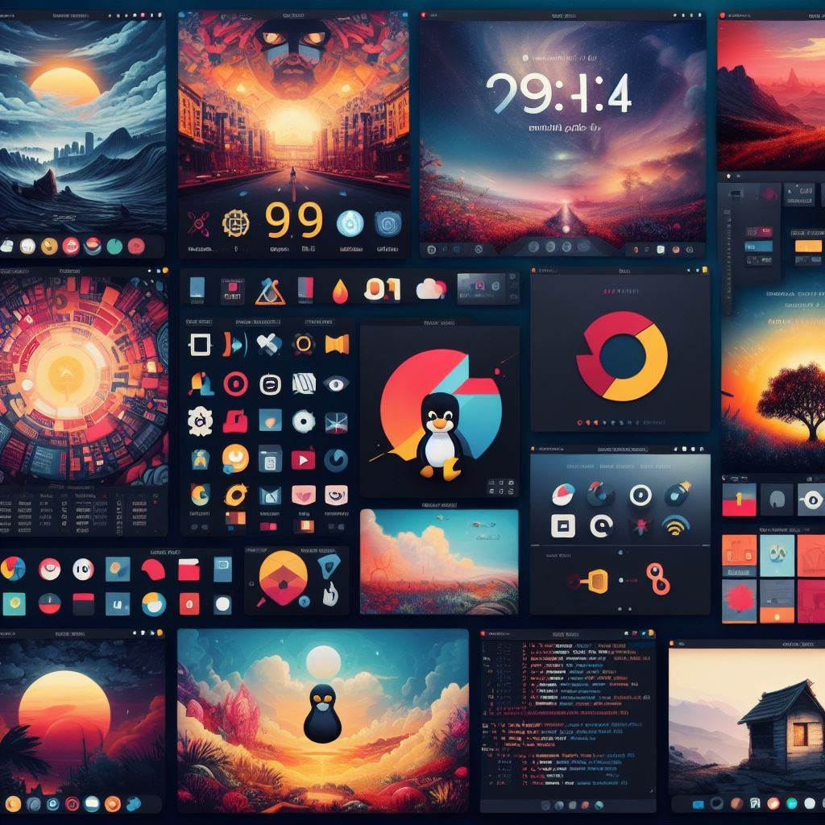

Linux is an open-source operating system kernel initially created by Linus Torvalds in 1991. It is the backbone of many Linux distributions, such as Ubuntu, Fedora, and CentOS, powering computers, servers, mobile devices, and more.

History of Linux

The history of Linux dates back to the early 1990s when Linus Torvalds, a Finnish student, created the initial version of the Linux kernel. Over the years, it has grown into a global community-driven project with contributions from developers worldwide.

Key Features of Linux

Linux is known for its stability, security, flexibility, and customizability. It provides a robust platform for users to tailor to their specific needs, whether for personal use, development, or server hosting.

* Installing Linux Operating System

Before diving into the Linux environment, you need to install the operating system on your computer. Let's explore the steps involved in installing Linux.

Choosing the Right Linux Distribution

There are several Linux distributions available, each with its unique characteristics and target users. Popular distributions include Ubuntu for beginners, CentOS for servers, and Arch Linux for advanced users.

Preparing Your Computer for Installation

Before installing Linux, make sure to back up your data and choose a suitable installation method, such as dual-booting with an existing operating system or installing Linux as the sole OS on your computer.

Step-by-step Installation Process

The installation process varies depending on the distribution you choose. Generally, you will need to create a bootable USB drive or DVD, boot from the media, and follow on-screen instructions to install Linux.

* Navigating the Linux Environment

Once you have Linux up and running on your system, it's essential to familiarize yourself with its environment and navigation options.

Desktop Environment Options

Linux offers various desktop environments, such as GNOME, KDE, and XFCE, each providing a different look and feel. Choose the one that suits your preferences and workflow.

Command Line Interface Basics

The command line interface (CLI) is a powerful tool in Linux for executing commands and managing the system. Learning basic commands like ls, cd, and mkdir can help you navigate the file system efficiently.

File System Navigation Commands

Understanding file system navigation commands like pwd, cp, and rm is crucial for managing files and directories in Linux. Practice using these commands to become more proficient in navigating the system.

Customizing Your Linux Experience

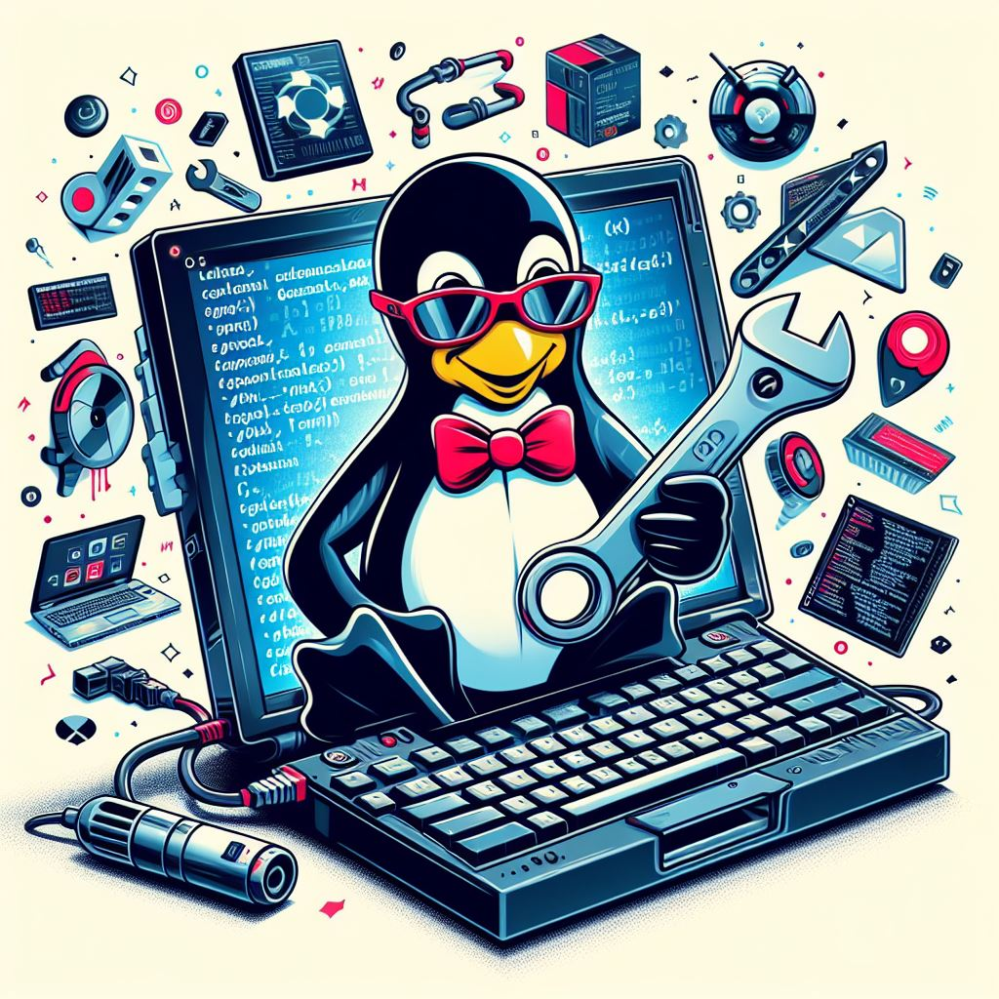

One of the standout features of Linux is its customizability. Let's explore how you can personalize your Linux experience.

Installing and Removing Software

Linux package managers like apt and yum make it easy to install, update, and remove software from your system. Explore the vast software repositories available for your distribution.

Personalizing Desktop Themes

Change the look and feel of your desktop environment by installing custom themes, icons, and wallpapers. Experiment with different themes to create a personalized workspace.

Creating Custom Shortcuts and Scripts

Boost your productivity by creating custom shortcuts and scripts in Linux. Automate repetitive tasks and streamline your workflow using shell scripting and keyboard shortcuts.

* Managing Security in Linux

Security is paramount in any operating system, and Linux provides robust tools for securing your system and data.

Understanding User Permissions

Linux uses a robust permission system to control access to files and directories. Learn how to manage user permissions to safeguard sensitive information.

Configuring Firewall Settings

Protect your system from external threats by configuring firewall settings in Linux. Use tools like iptables or firewalld to control incoming and outgoing network traffic.

Updating and Patching Software

Regularly updating your software is vital for maintaining system security. Use package managers to update your system and apply security patches to stay protected from vulnerabilities.

* Summary

In this article, we explored the basics of the Linux Operating System, including its history, installation process, navigation, customization options, and security management. Linux offers a robust and flexible platform for users to tailor to their needs.

FAQs:

\* \*\*Is Linux free to use?\*\*

Yes, Linux is an open-source operating system and is free to download and use.

\* \*\*Can I run Windows applications on Linux?\*\*

While some Windows applications may be compatible with Linux using compatibility tools, native Linux applications are recommended for optimal performance.

\* \*\*How do I update software in Linux?\*\*

You can update software in Linux using package managers like apt or yum, which automatically fetch and install the latest updates for your system.

Remember, Linux is a powerful operating system with a supportive community ready to help you on your journey. Enjoy exploring the world of Linux and discovering all it has to offer!