# EXPERIMENT: 1

# UiPath - Installation

## Steps to install UiPath Studio

You will have to follow the steps given below to install UiPath Studio on your local system.

**Step 1** − First to install UiPath, follow the link [https://www.uipath.com/developers/community-edition-download](https://www.uipath.com/developers/community-edition-download" \t "https://www.tutorialspoint.com/uipath/_blank).



**Step 2** − Next, we need to fill the credentials in the form.

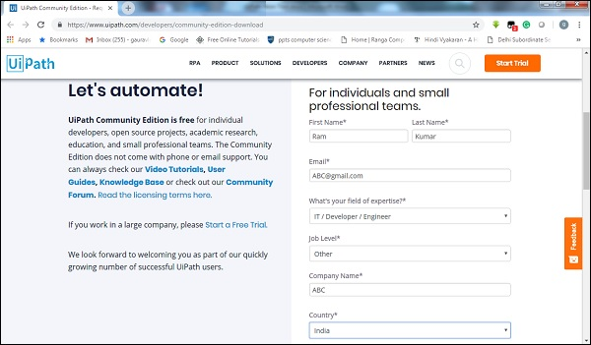

**Step 3** − Now, click the button for requesting community edition.

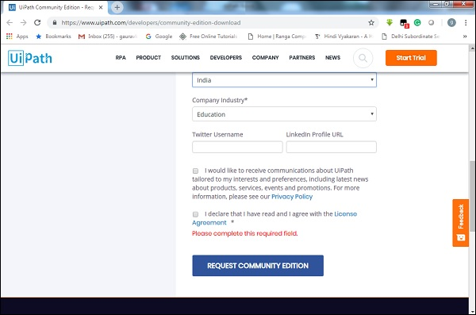

**Step 4** − Next, you will get a link in your email id. Click that for downloading UiPath. It will download an exe file on your computer.

**Step 5** − Now in order to install run the exe file named **UiPathStudio.exe**, you got in step 4.

**Step 6** − UiPath will start its installation on your computer.

## Starting UiPath Studio

Once the installation steps, discussed in previous section, are completed, we can see the following screen −

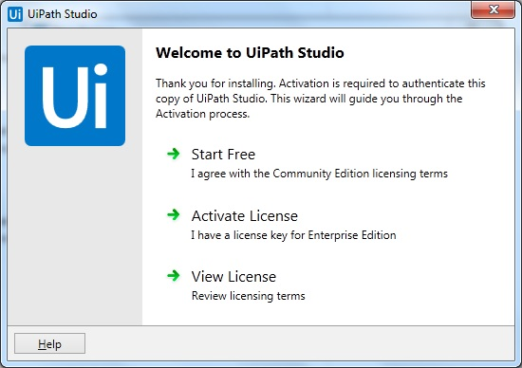

Now to start, we need to click an option. Here we are using free community edition so click on *Start Free* option and Your software installation will be done successfully

Experiment 2

Assign a value to a variable and print it as a message

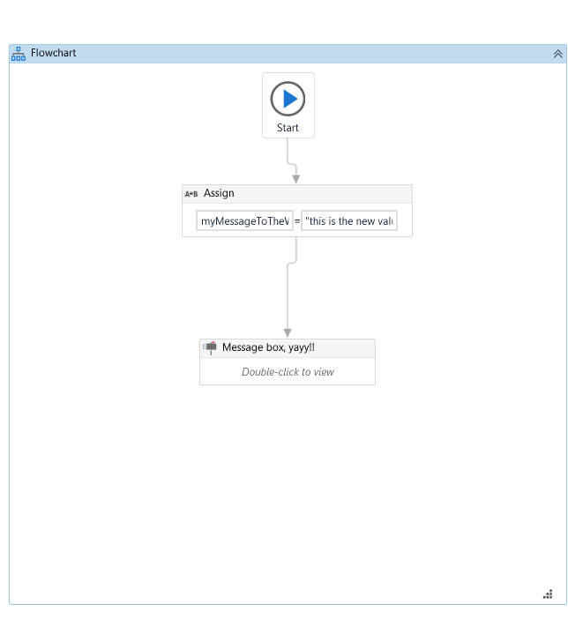

Experiment 3

Use if loop to find if given year is Leap year or not

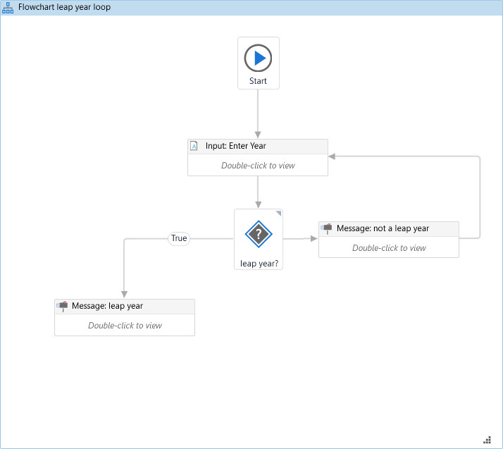

Experiment 4

Using if-while loop to find if given year is leap year or not

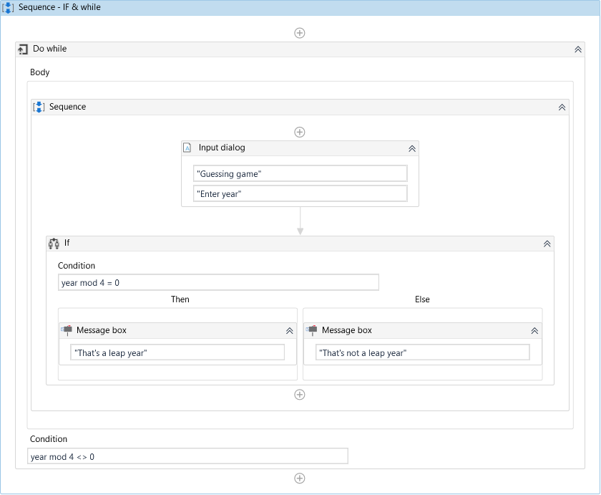

Experiment 5

Generate a random number and use nested if loop to make a guess the name game

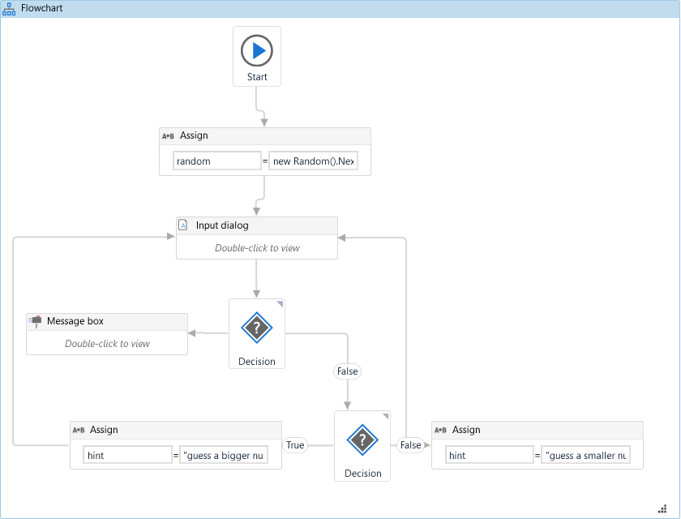

Experiment 6

Input and string concatenation

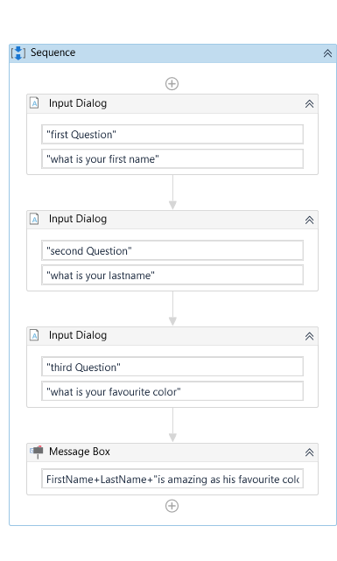

Experiment 7

Build a data table using UiPath and write it in Excel File

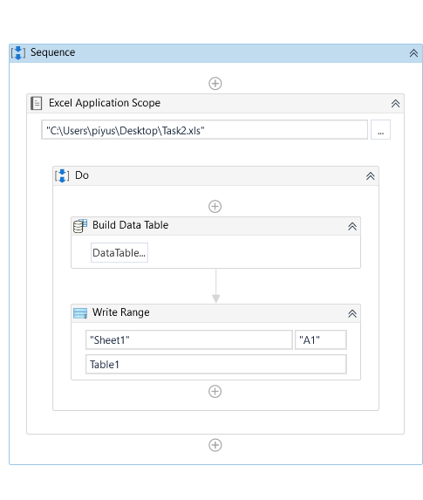

Experiment 8

Use UiPath to extract data about products from amazon.in

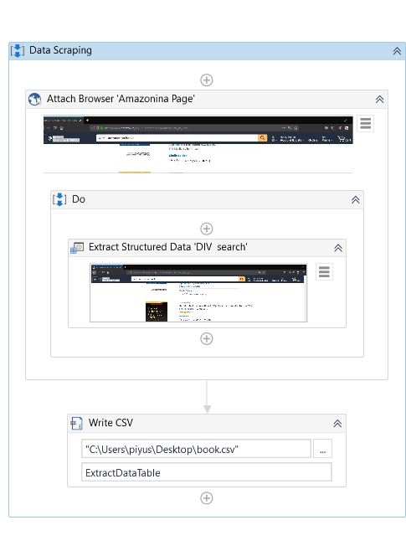

Experiment 9

NotePad Automation using UiPath, write something in notepad and automate it to change its font using desktop recorder

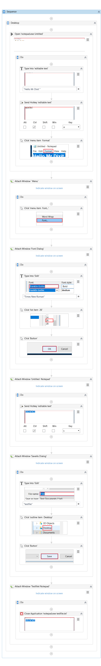

Experiment 10

Filter Data Table and output in a message

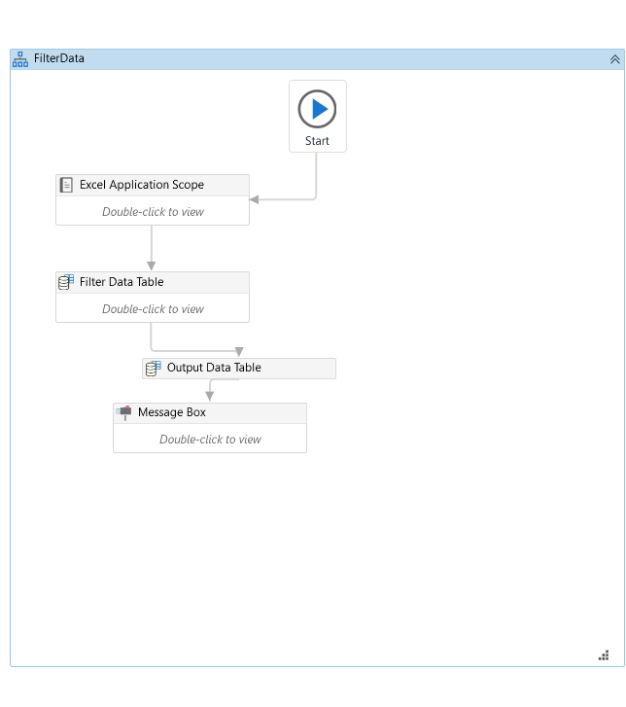

Experiment 11

Sort a data table and print out as message

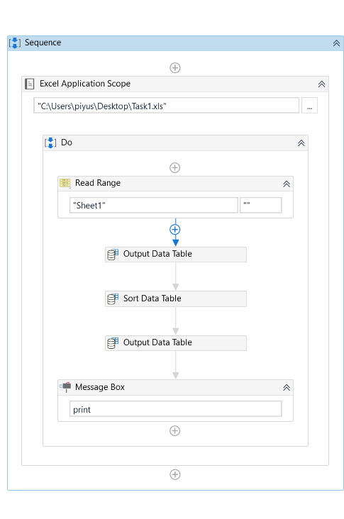

Experiment 12

Use Web Recorder to fetch the latest changes in Stock Prices and notify the change

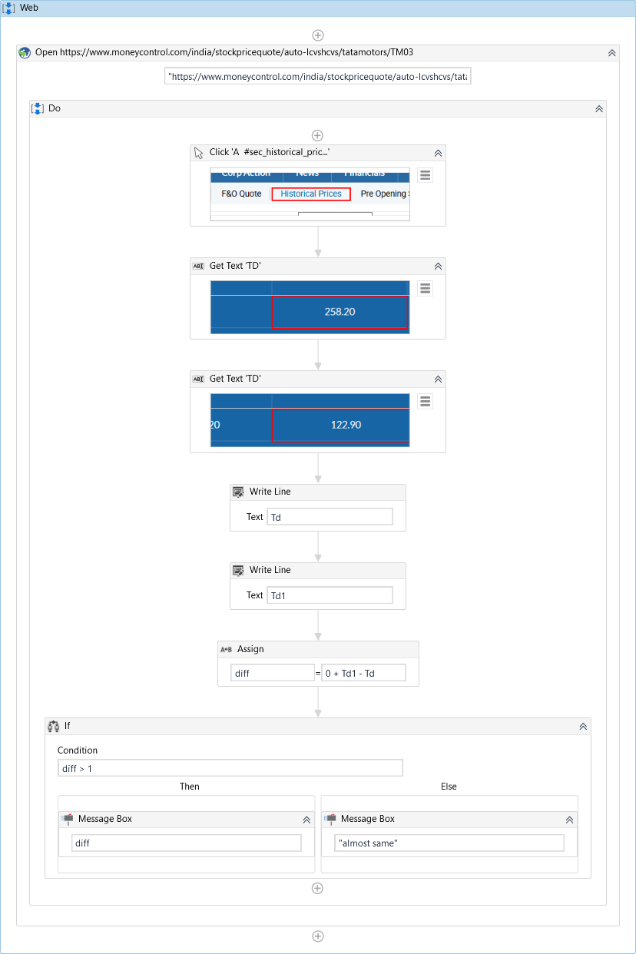

Experiment 13

Create a workflow to find the temperature of any city using UiPath

