Results of RabbitMQ vs Apollo

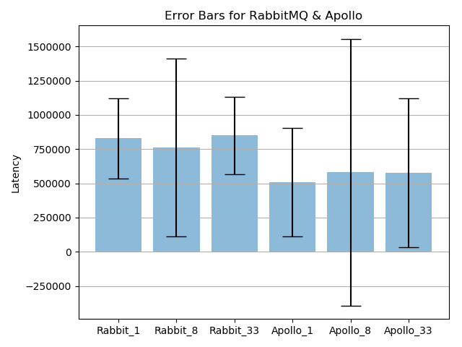

Fig 1-Displaying Error Bars in RabbitMQ and Apollo MQTT

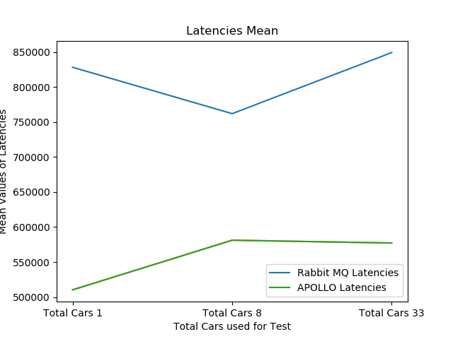

Fig 2- Mean of Latencies calculated during the experiments

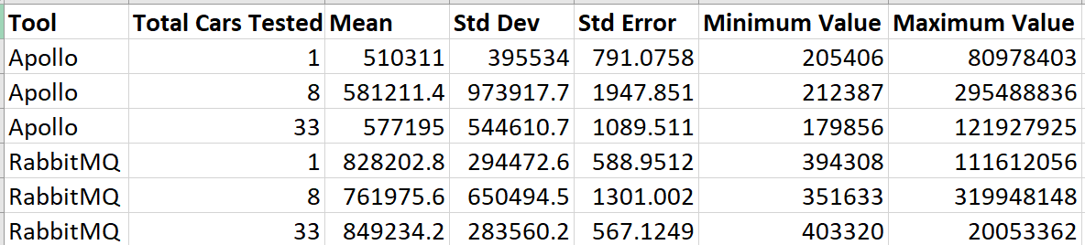

Fig 3 shows the Mean, Standard Deviation, Standard Error , Minimum Value, Maximum Value of the Latencies in Nano Seconds.

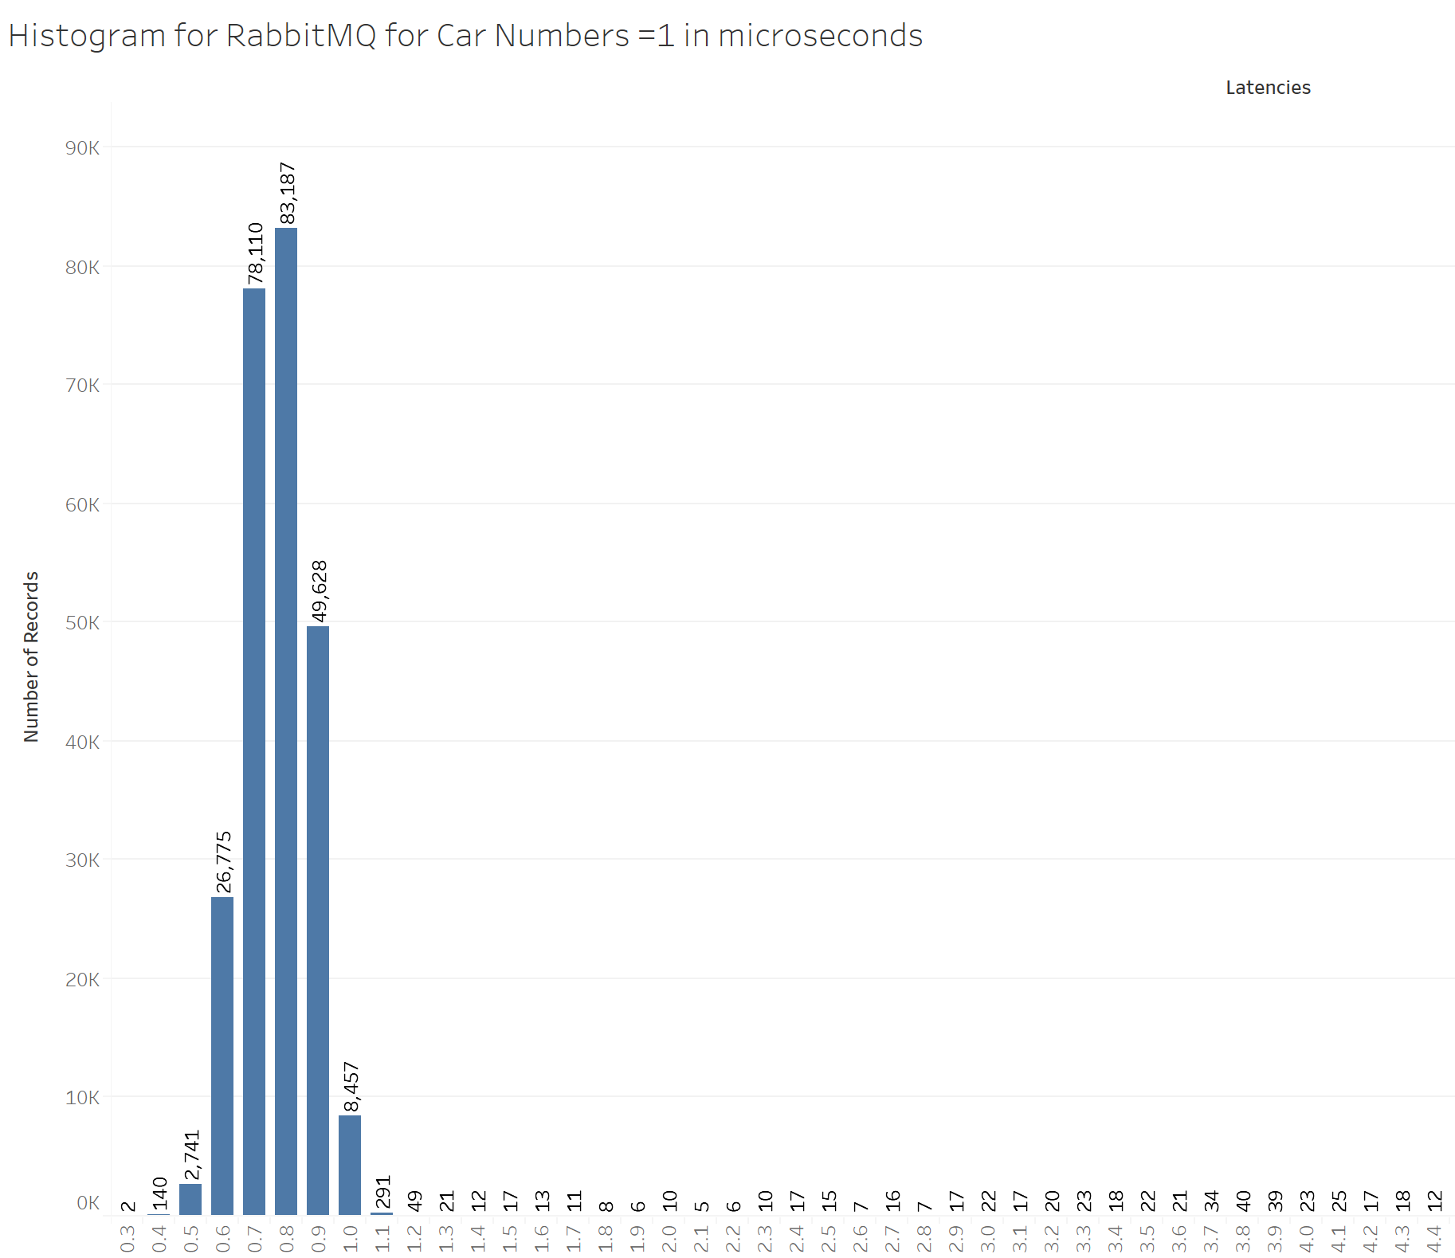

Fig 4 -Histogram of Latencies for RabbitMQ for Car Number =1

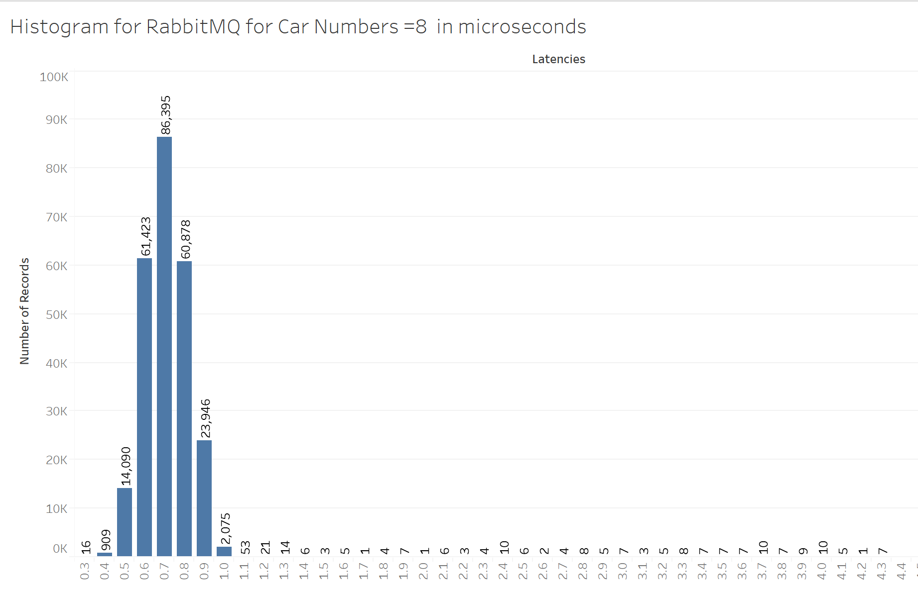

Fig 5-Histogram of Latencies for RabbitMQ for Car Number =8

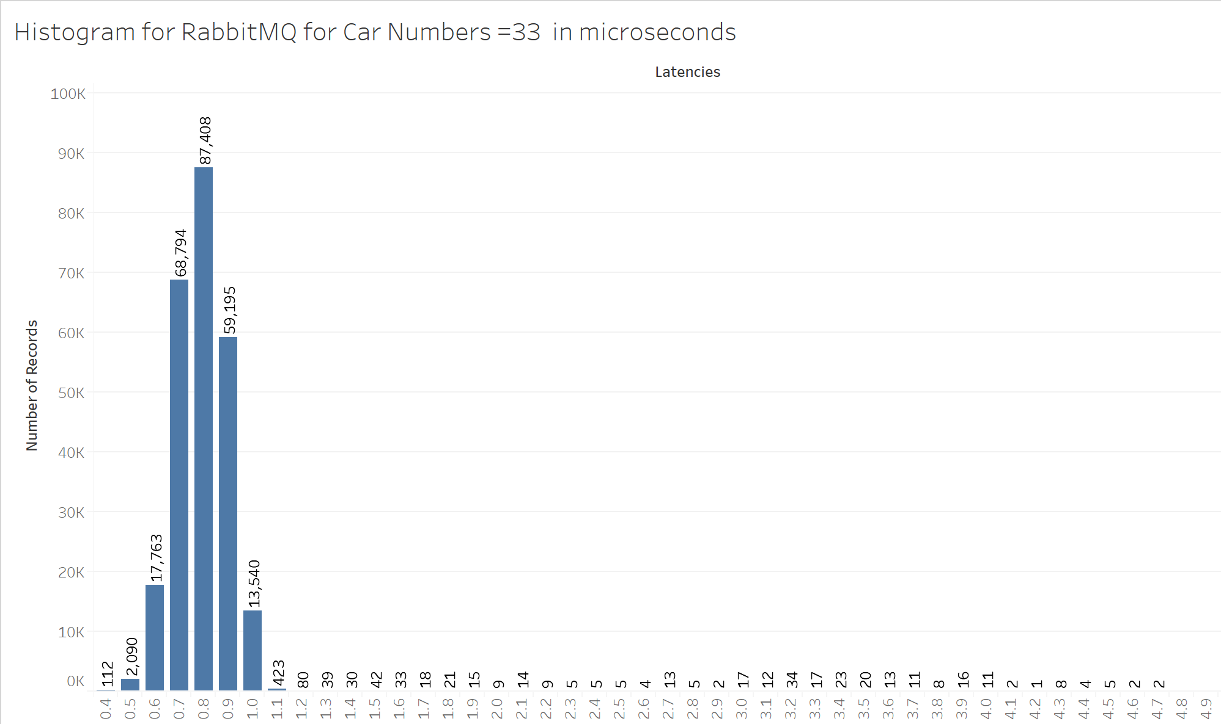

Fig 6-Histogram of Latencies for RabbitMQ for Car Number =33

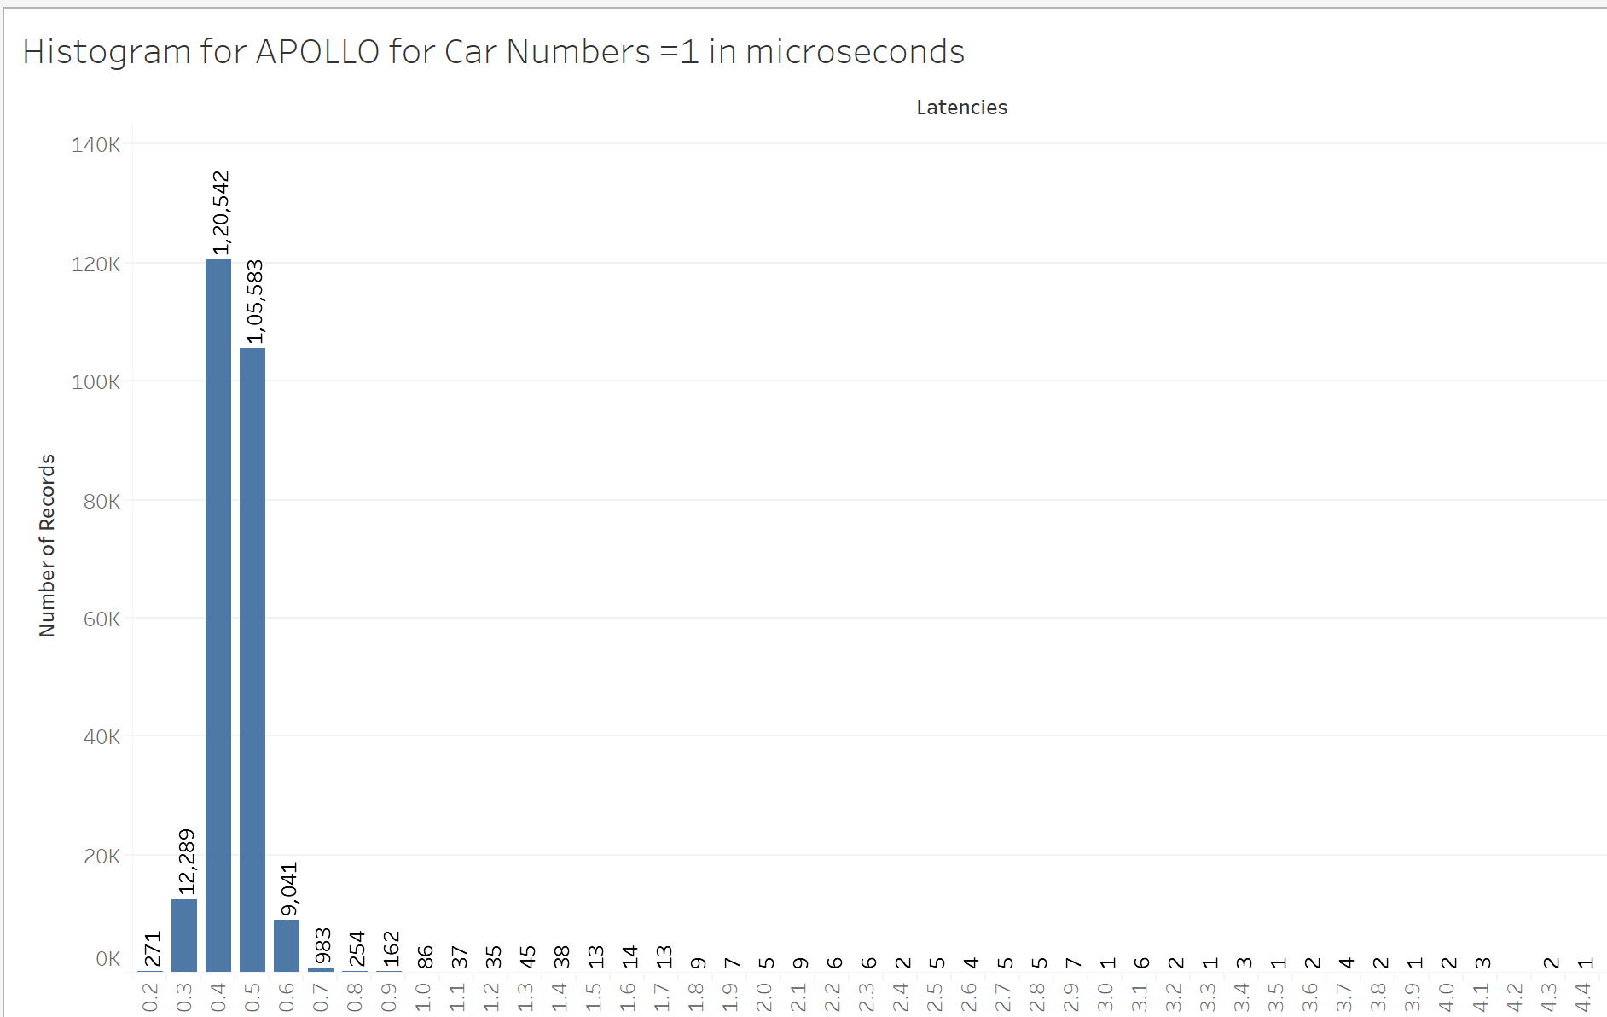

Fig 7-Histogram of Latencies for APOLLO for Car Number =1

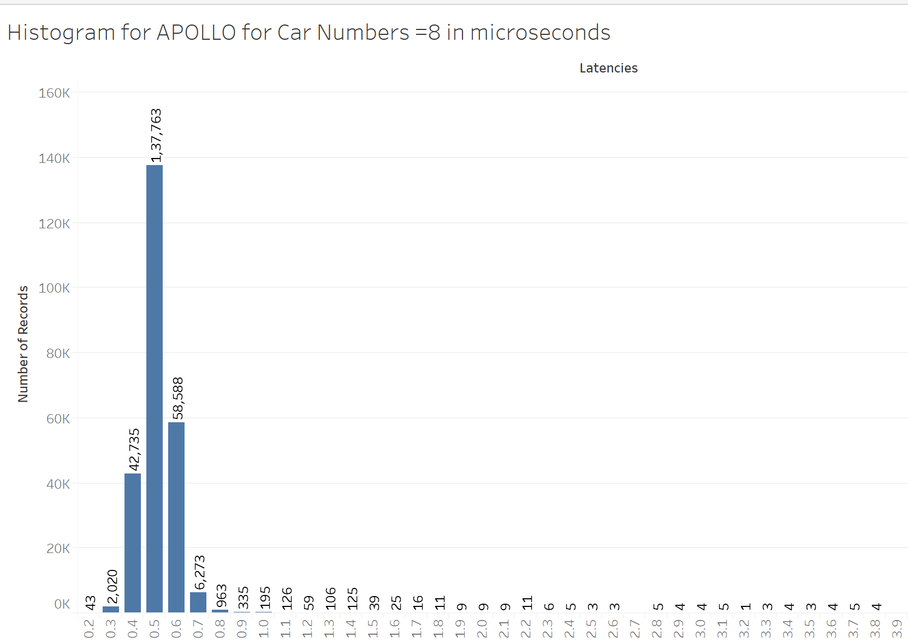

Fig 8- Histogram of Latencies for APOLLO for Car Number =8

Fig 9a showing the DB size while data is being loaded on Node 1-

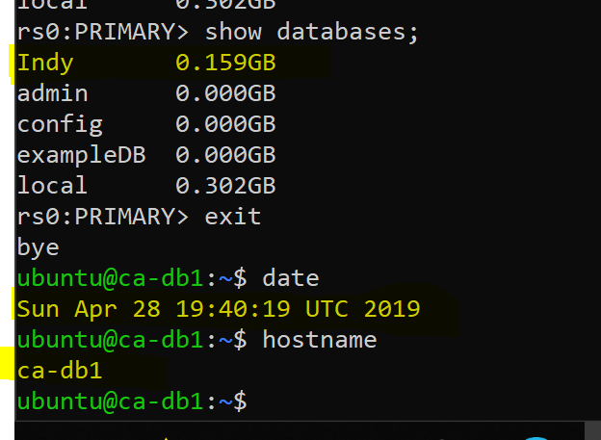

Fig 9b showing the DB size while data is being loaded on Node 2-

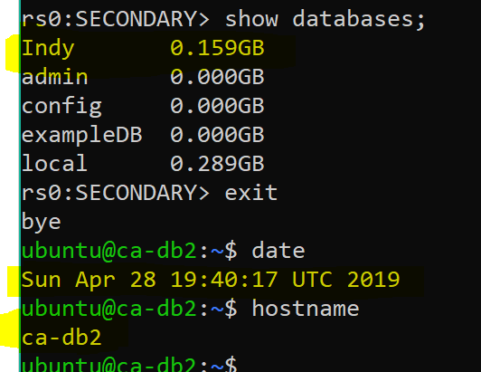

Fig 9c showing the DB size while data is being loaded on Node 3

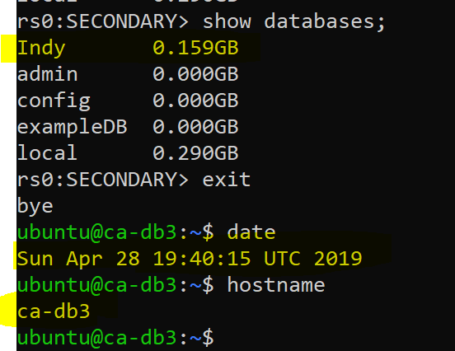

Fig 10a, 10b, 10c below show the same database size of Indy database on all 3 nodes after the Loading into DB is completed.

Fig 10a showing the DB size on Node 1

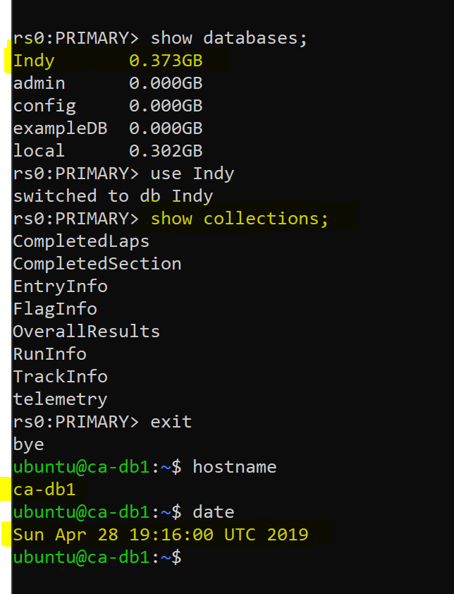

Fig 10b showing the DB size on node 2

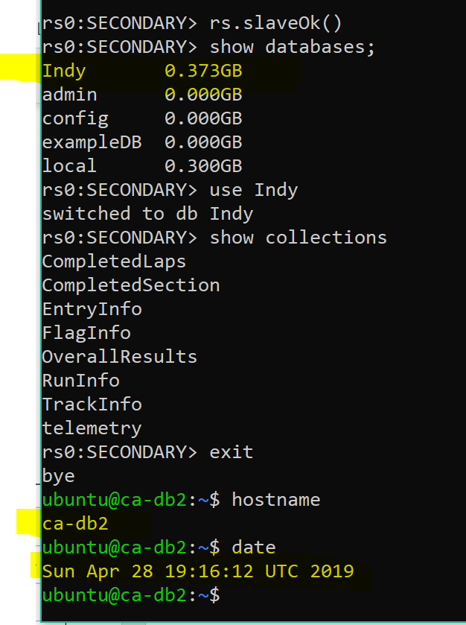

Fig 10c showing the DB size on node 3

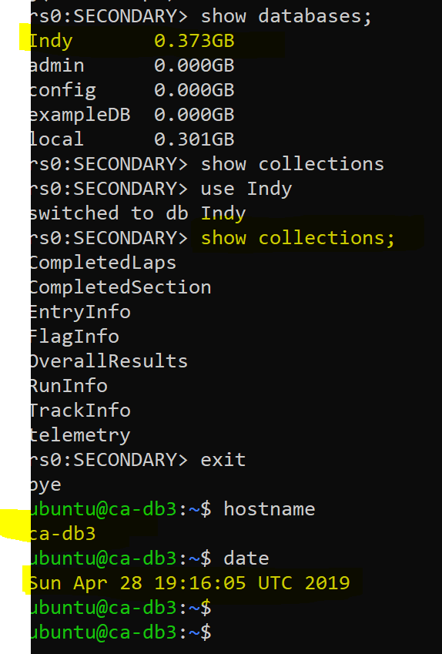

Demo implementation of MongoDB queries and their results.

* Suppose there are two drivers in the series, the getAll function from the DriverService module-

indycarDBClient.drivers().getAll()

Output-

[["driver_name" : "Conor Daly",  "driver_id" : "580"],["driver_name":"Alexander Rossi",  "driver_id" : "522" ]]

* Suppose there are two drivers in a race, the getDriversByRace function from the DriverService module-

parameters- int race_id

indycarDBClient.drivers().getDriversByRace(1)

Output-

[["driver_name" : "Conor Daly",  "driver_id" : "580"],["driver_name":"Alexander Rossi",  "driver_id" : "522" ]]

* getdriver function from the DriverService module-

parameters- String driver_id

indycarDBClient.drivers().getdriver("747")

Output-

[["driver_name" : "Gabby Chaves",  "driver_id" : "747", "car_number" : "88",  "engine" : "Chevy", "team" : "Harding Racing",  "team_id" : "145", "hometown" : "Bogota Colombia",  "unique_identifier" : "15" ]]

* search function from the DriverService module-

parameters- String partial_string

indycarDBClient.drivers().search("sa"))

Output-

[Takuma Sato, Sage Karam]

* getLapRecords function in DriverService module-

parameters- int race_id, String car_num

indycarDBClient.drivers().getLapRecords(1,"23");

Output-

[[["car_num" : "23",  "completed_laps" : 0, "elapsed_time" : "5EC0",  "last_laptime" : "C5839", "lap_status" : "T", "best_lap_time" : "0",  "best_lap" : "0", "current_status" : "Active", "pit_stop_counts" : "0",  "last_pitted_lap" : 0, "start_position" : 15, "laps_led" : "0", "run_command" : "R",  "race_id" : "1" ], . . .(more lap records)]

[["car_num" : "23",  "section_identifier" : "T1",  "elapsed_time" : "1A535769", "last_section_time" : "3615",  "last_lap" : 0, "run_command" : "R", "race_id" : "1", "unrelated_counter" : 62 ],...(more section records)]]

* getAll function in RaceService module-

indycarDBClient.getRaceService().getAll()

Output-

[["event_name" : "102nd Indianapolis 500",  "race_id" : "1" ]]

* getRace function in RaceService module-

parameters- int race_id

indycarDBClient.getRaceService().getRace(1)

Output-

[["event_name" : "102nd Indianapolis 500",  "event_round" : "IMS", "start_time_date" : "5B0AA2AC",  "race_id" : "1" ]]

* getFlags function from RaceService module-

parameters- int race_id

indycarDBClient.getRaceService().getFlags(1)

Output-

[["track_status" : "G",  "lap_number" : "0", "timeOfDay" : "16:04:19.",  "counter_$F" : 101 ], ... (more FlagInfo records) ]

* getRanks function from RaceService module-

parameters- int race_id

indycarDBClient.getRaceService().getRanks(1)

Output-

[["overall_rank" : 1,  "no" : "12", "first_name" : "Will",  "last_name" : "Power" ], ["overall_rank" : 2,  "no" : "20", "first_name" : "Ed", "last_name" : "Carpenter" ], .... (more records)]

* getsnapshot_final function in RaceService module-

parameters- int hours, int minutes, double seconds, int race_id,int threshold_in_seconds

indycarDBClient.getRaceService().getsnapshot_final(16,24,0.5,1,1)

Output-

[["$oid" : "5cc207e3f1da2e31c4bc7bc3" },  "command" : "$P", "car_num" : "9", "lap_distance" : "986.14",  "time_of_day" : "16:24:00.526", "hours" : 16, "minutes" : 24, "seconds" : 0.526,  "time_in_seconds" : 59040.526, "ratio" : [118.081052, 0.0], "time_for_comparison" : 1,  "vehicle_speed" : "215.970", "engine_rpm" : "11267", "throttle" : "5", "date" : "2018-05-27",  "race_id" : "1", "flag_from_$h" : "G", "run_command" : "R], ...(more records)]

* getAll function in TrackService module-

indycarDBClient.getTrackService().getAll()

Output-

[Indianapolis Motor Speedway]

* getTrack function in TrackService module-

parameters- String TrackName

indycarDBClient.getTrackService().getTrack("Indianapolis Motor Speedway")

Output-

[["track_name" : "Indianapolis Motor Speedway",  "venue" : "I", "number_of_sections" : "20", "race_id" : "1",  "section_information" : [{ "section_name" : "S1", "section_length" : "11856", "section_start" : "SF", "section_end" : "T1" }, { "section_name" : "S2A", "section_length" : "19800", "section_start" : "T1", "section_end" : "SS1" }, { "section_name" : "S2B", "section_length" : "19800", "section_start" : "SS1", "section_end" : "T2" }, { "section_name" : "S3A", "section_length" : "19800", "section_start" : "T2", "section_end" : "BS" }, { "section_name" : "S3B", "section_length" : "19800", "section_start" : "BS", "section_end" : "T3" }, { "section_name" : "S4A", "section_length" : "19800", "section_start" : "T3", "section_end" : "SS2" }, { "section_name" : "S4B", "section_length" : "19800", "section_start" : "SS2", "section_end" : "T4" }, { "section_name" : "S5A", "section_length" : "12672", "section_start" : "T4", "section_end" : "FS" }, { "section_name" : "S5B", "section_length" : "15072", "section_start" : "FS", "section_end" : "SF" }, { "section_name" : "S2", "section_length" : "39600", "section_start" : "T1", "section_end" : "T2" }, { "section_name" : "S3", "section_length" : "39600", "section_start" : "T2", "section_end" : "T3" }, { "section_name" : "S4", "section_length" : "39600", "section_start" : "T3", "section_end" : "T4" }, { "section_name" : "S5", "section_length" : "27744", "section_start" : "T4", "section_end" : "SF" }, { "section_name" : "T1", "section_length" : "1440", "section_start" : "T1T", "section_end" : "T1" }, { "section_name" : "T2", "section_length" : "1440", "section_start" : "T2T", "section_end" : "T2" }, { "section_name" : "T3", "section_length" : "1440", "section_start" : "T3T", "section_end" : "T3" }, { "section_name" : "T4", "section_length" : "1440", "section_start" : "T4T", "section_end" : "T4" }, { "section_name" : "TSF", "section_length" : "1974", "section_start" : "SF", "section_end" : "SFT" }, { "section_name" : "WI1", "section_length" : "16800", "section_start" : "PT3", "section_end" : "PSS2" }, { "section_name" : "WI2", "section_length" : "16800", "section_start" : "PSS2", "section_end" : "PT4" }, { "section_name" : "WI3", "section_length" : "15078", "section_start" : "PT4", "section_end" : "PI" }, { "section_name" : "WO1", "section_length" : "16800", "section_start" : "PO", "section_end" : "PSS1" }, { "section_name" : "WO2", "section_length" : "16800", "section_start" : "PSS1", "section_end" : "PT2" }, { "section_name" : "P1", "section_length" : "12690", "section_start" : "PI", "section_end" : "SFP" }, { "section_name" : "P2", "section_length" : "11874", "section_start" : "SFP", "section_end" : "PO" }, { "section_name" : "PIC", "section_length" : "5712", "section_start" : "PIC", "section_end" : "PI" }, { "section_name" : "L2", "section_length" : "24564", "section_start" : "PI", "section_end" : "PO" }, { "section_name" : "L3", "section_length" : "146544", "section_start" : "PO", "section_end" : "SF" }, { "section_name" : "L4", "section_length" : "145734", "section_start" : "SF", "section_end" : "PI" }, { "section_name" : "L5", "section_length" : "59400", "section_start" : "PO", "section_end" : "BS" }, { "section_name" : "L6", "section_length" : "74478", "section_start" : "BS", "section_end" : "PI" }, { "section_name" : "L7", "section_length" : "133878", "section_start" : "PO", "section_end" : "PI" }] ]]