**Simulation on Reliability problem:**

**Introduction :**

Simulation is used to model efficiently a wide variety of systems that are important to managers. A simulation is basically an imitation, a model that imitates a real-world process or system . However, most simulations are sufficiently complex from a practical standpoint to require the use of computers in running them.

**Objective 1 :**

**First : Problem formulation**

The problem is : A large milling machine has three different bearings that fall in service. The cumulative distribution function of the life of each bearing is identical as shown in the table. When a bearing fails, the mills stop, a repairperson is called, and a new bearing is installed. The delay time of the repair person arriving at the milling machine is also a random variable, with the distribution given in table 2. Downtime for the mill is estimated at $5 per minute. The direct on site cost of the repairperson is $15 per hour. It takes 20 minutes to change one bearing, 30 minutes to change two bearings, and 40 minutes to change three bearings. The bearings cost $16 each. A proposal has been made to replace all three bearings whenever a bearing fails. Management needs an evaluation of this proposal.

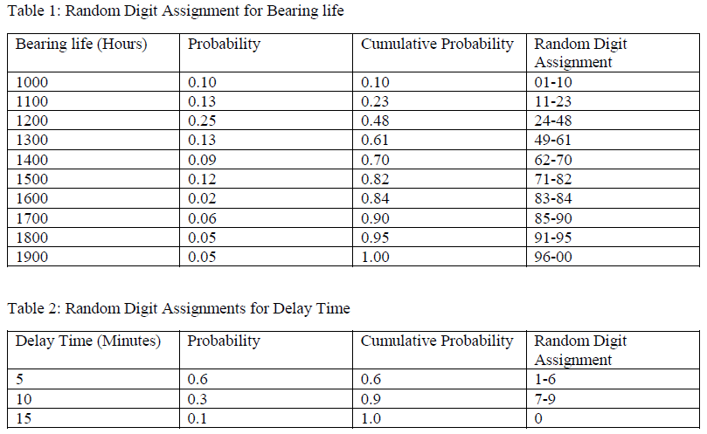

Objective 2 :

**Second : Setting objectives and overall project plan**

Due to using a coarse grid of 100 hours.

It will be assumed in these examples that the times are never the same, therefore no more than one bearing is changed at any breakdown.

16 bearing changes were made for bearings 1 & 2 .

but 14 bearing changes only were required for bearing 3.

**Third : Model conceptualization & Data collection**

**The Current method costs :**

The cost of the current system is estimated as follows:

**Cost of bearings** = 46 bearings × $16/bearing = $736

**Cost of delay time** = (110 + 125 + 95) minutes × $5/minute = $1650

**Cost of downtime during repair** = 46 bearings × 20 minutes/bearing × $5/minute = 4600$

**Cost of repair persons** = 46 bearings × 20 minutes/bearing × $15/60 minutes= 230$

**Total cost** = $736 + $1650 + $4600 + $230 = 7216$

Objective 3 )

Table D is a simulation using the proposed method. Notice that bearing life is taken from Tables A , B & C.

So that for as many bearings as were used in the current method, the bearing life is identical for both methods.

**Bearing Replacement Using Current Method :**

**Table A)**

Bearing 1 :

|  |  |  |  |  |  |
| --- | --- | --- | --- | --- | --- |
| Random digits | Life (in hours) | Life ( in hours ) | Random digits | Delay (in minutes) |  |
| 43 | 1200 | 2700 | 7 | 10 |  |
| 86 | 1700 | 4400 | 3 | 5 |  |
| 93 | 1800 | 6200 | 1 | 5 |  |
| 81 | 1600 | 7800 | 2 | 5 |  |
| 70 | 1500 | 1500 | 0 | 15 |  |
| 19 | 1100 | 10100 | 1 | 5 |  |
| 44 | 1200 | 9000 | 8 | 10 |  |
| 52 | 1300 | 21000 | 5 | 5 |  |
| 45 | 1300 | 12700 | 7 | 10 |  |
| 51 | 1300 | 11300 | 1 | 5 |  |
| 12 | 1100 | 13800 | 8 | 5 |  |
| 48 | 1300 | 15100 | 0 | 15 |  |
| 9 | 1000 | 16100 | 8 | 10 |  |
| 44 | 1200 | 17300 | 1 | 5 |  |
| 46 | 1200 | 18500 | 2 | 5 |  |
| 40 | 1200 | 19700 | 8 | 10 |  |
|  |  |  |  | 125 |  |
|  |  |  |  |  |  |

Table B)

Bearing 2 :

|  |  |  |  |  |  |
| --- | --- | --- | --- | --- | --- |
| Random digits | Life (in hours) | Life ( in hours ) | Random digits | Delay (in minutes) |  |
| 43 | 1200 | 2700 | 7 | 10 |  |
| 86 | 1700 | 4400 | 3 | 5 |  |
| 93 | 1800 | 6200 | 1 | 5 |  |
| 81 | 1600 | 7800 | 2 | 5 |  |
| 70 | 1500 | 1500 | 0 | 15 |  |
| 19 | 1100 | 10100 | 1 | 5 |  |
| 44 | 1200 | 9000 | 8 | 10 |  |
| 52 | 1300 | 21000 | 5 | 5 |  |
| 45 | 1300 | 12700 | 7 | 10 |  |
| 51 | 1300 | 11300 | 1 | 5 |  |
| 12 | 1100 | 13800 | 8 | 5 |  |
| 48 | 1300 | 15100 | 0 | 15 |  |
| 9 | 1000 | 16100 | 8 | 10 |  |
| 44 | 1200 | 17300 | 1 | 5 |  |
| 46 | 1200 | 18500 | 2 | 5 |  |
| 40 | 1200 | 19700 | 8 | 10 |  |
|  |  |  |  | 125 |  |

Table (C)

Bearing number 3 :

|  |  |  |  |  |
| --- | --- | --- | --- | --- |
| Random digits | Life (in hours) | Life ( in hours ) | Random digits | Delay (in minutes) |
| 65 | 1400 | 2900 | 2 | 5 |
| 61 | 1400 | 4300 | 7 | 10 |
| 96 | 1900 | 6200 | 1 | 5 |
| 76 | 1500 | 1500 | 0 | 15 |
| 65 | 1400 | 7600 | 3 | 5 |
| 56 | 1300 | 8900 | 3 | 5 |
| 57 | 1300 | 13000 | 1 | 5 |
| 11 | 1100 | 10000 | 6 | 5 |
| 86 | 1700 | 11700 | 3 | 5 |
| 49 | 1300 | 14300 | 4 | 5 |
| 36 | 1200 | 15500 | 8 | 10 |
| 78 | 1500 | 20000 | 7 | 10 |
| 44 | 1200 | 16700 | 2 | 5 |
| 94 | 1800 | 18500 | 1 | 5 |
|  |  |  |  | 95 |

Table D )

Bearing Replacement using Proposed Method :

|  |  |  |  |  |  |  |
| --- | --- | --- | --- | --- | --- | --- |
| Bearing 1 Life (hrs) | Bearing 2 Life (hrs) | Bearing 3 Life (hrs) | First failure (hrs) | Accumulated life | Random digits | delay |
| 1400 | 1500 | 1500 | 1400 | 1400 | 3 | 5 |
| 1000 | 1200 | 1400 | 1000 | 2400 | 7 | 10 |
| 1300 | 1700 | 1400 | 1300 | 3700 | 5 | 5 |
| 1600 | 1800 | 1900 | 1600 | 5300 | 1 | 5 |
| 1200 | 1600 | 1400 | 1200 | 6500 | 4 | 5 |
| 1200 | 1200 | 1300 | 1200 | 7700 | 3 | 10 |
| 1000 | 1100 | 1100 | 1000 | 8700 | 7 | 10 |
| 1400 | 1300 | 1700 | 1300 | 10000 | 8 | 10 |
| 1000 | 1300 | 1300 | 1000 | 11000 | 8 | 5 |
| 1000 | 1100 | 1300 | 1000 | 12000 | 3 | 5 |
| 1500 | 1300 | 1200 | 1200 | 13200 | 2 | 5 |
| 1300 | 1000 | 1200 | 1000 | 14200 | 4 | 5 |
| 1100 | 1200 | 1800 | 1100 | 15300 | 1 | 5 |
| 1300 | 1200 | 1500 | 1200 | 16500 | 6 | 5 |
| 1700 | 1200 | 63/1400 | 1200 | 17700 | 2 | 5 |
| 1500 | 1300 | 21/1100 | 1100 | 18800 | 7 | 10 |
| 85/1700 | 53/1300 | 23/1100 | 1100 | 19900 | 0 | 15 |
| 5/1000 | 29/1200 | 51/1300 | 1000 | 20900 | 5 | 5 |
|  |  |  |  |  |  | 125 |

It is assumed that the bearings are in order on a shelf and they are taken sequentially and placed on the mill. Since the proposed method uses more bearings than the current method, the second simulation uses new random digits for generating the additional lifetimes.

The random digits that lead to the lives of the additional bearings are shown above the slashed line beginning with the 15th replacement of bearing 3.

When the new policy is used, some 18 sets of bearings were required. In the two simulations, repairperson delays were not duplicated but were generated independently using different random digits.

**The total cost of the new policy is computed as follows:**

**Cost of bearings** = 54 bearings × $16/bearing = $864

**Cost of delay time** = 125 minutes × $5/minute = $625

**Cost of downtime during repairs** = 18 sets× 40 minutes/set× $5/minute = $3600

**Cost of repair persons** = 18 sets × 40 minutes/set × $15/60 minutes = $180

**Total cost** = $864 + $625 + $3600 + $180 = $5269

So , The new policy generates a savings of $1947 over a 20,000-hour simulation.

If the machine runs continuously, the simulated time is about (2 and fourth years). Therefore, the savings are about $865 per year.

**Conclusion :**

By this way , we reached the main **purpose of simulation** which is to shed light on the underlying mechanisms that control the behavior of a system.

And used it to predict the future behavior of a system, and determine what you can do to influence that future behavior.

**Resources**

Mahmud, Khizir; Town, Graham E. (2016). "A review of computer tools for modeling electric vehicle energy requirements and their impact on power distribution networks".