CECS 478 – Final Project Proposal
Project Title: Tamper‑Evident Logging and Verification System
Student: Dean Chou
Course: CECS 478 Sec 01 (4512)
Working Style: Solo
Date: 11/13/2025

1. Problem Statement
System logs are one of the most important parts for audits, diagnostics, compliance checks, and forensic investigations. However, most logging systems rely on plain text files that can be modified if an attacker gains write access. This makes logs unreliable during security incidents. Entries can be removed, rewritten, or reordered without any clear evidence of tampering.
The goal of this project is to design a lightweight, Python‑based tamper‑evident logging program using chained HMAC hashes. Each log entry will cryptographically depend on the previous one, forming a verifiable chain. Any modification, no matter how small, breaks the chain and becomes detectable during verification.
• Logs can be silently altered without cryptographic protections.
• Attackers often delete or reorder entries to hide malicious activity.
• Traditional systems lack built‑in, verifiable integrity mechanisms.

2. Threat Model
The threat model assumes that an attacker may be able to modify the log file directly but cannot access the HMAC secret key. Under this model, the attacker may try to remove evidence of malicious activity, falsify events, or alter past entries. The project assumes that full system compromise is out of scope; instead, it focuses on scenarios where logs can be altered but the overall system is not completely lost.
• Malicious actors: insiders, compromised processes, and attackers with log‑write capability.
• Assets: integrity of log contents and event order.
• Assumptions: attacker cannot read the secret key; OS permissions remain intact.

3. Success Metrics
Success is evaluated by effectiveness, clarity, and performance. The verification tool must reliably detect tampering in all tested scenarios. Performance will also be monitored to ensure hashing operations remain efficient within normal application use.
• Detection for log modifications, deletions, and insertions.
• Clear reporting of the first corrupted entry index during verification.
• Low runtime overhead during log writes compared to standard JSON logging.

4. Dataset and Testing Plan
All logs for this project will be synthetically generated to cover all basis without compromising real data. Automated scripts will produce large sets of structured log entries and then apply controlled corruptions. The verification tool will be tested against each corrupted file to measure detection accuracy and robustness.
• Synthetic logs only, no sensitive or real data.
• Automated corruption tests: edit, delete, reorder, and insertion.
• Evaluation involves both accuracy and overhead measurements.

5. Risks, Ethics, and Scope Limits
Ethical risks are minimal because no real user data or real system logs are collected. The main risk lies in mishandling the cryptographic secret, which could allow attackers to generate fraudulent log entries that appear valid. The project focuses solely on tamper detection, not prevention or encryption.
• The system guarantees integrity only, not confidentiality or availability.
• Total system compromise invalidates integrity guarantees.

6. Architecture Overview
The tamper‑evident logging system is structured in this manner:
1. Logging Interface – Accepts and formats messages into canonical JSON entries.
2. Hash Chain Engine – Computes an HMAC for each new entry and embeds the previous entry’s hash.
3. Append‑Only Log File – Stores each entry in sequence, forming a cryptographic chain.
4. Verification Module – Reads the log from start to finish, recomputing hashes to detect any inconsistencies.
This design ensures that even a single altered character in any entry causes a chain break that is immediately detectable.
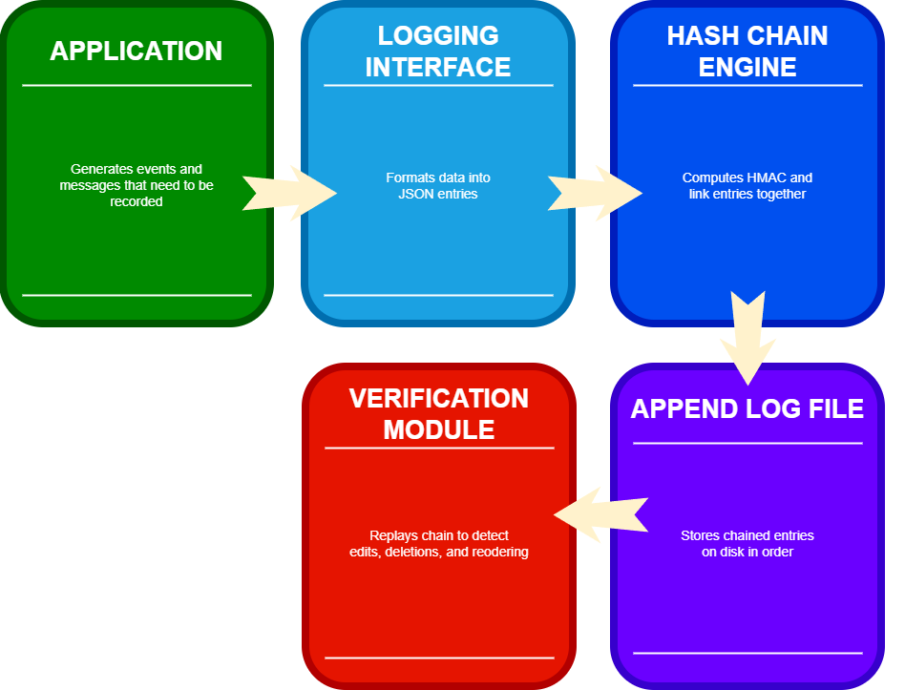

7. Project Plan
The project will begin with implementing log‑entry structure and HMAC chaining logic. Once the core system is working, automated corruption scripts will be created to test detection capabilities under different attack scenarios. The verification tool will then be enhanced to provide clear diagnostic output, including the index of the first corrupted entry.
Finally, the project will produce evaluation artifacts such as logs, summary tables, and documentation for the final report. This ensures that the system is fully functional, reproducible, and supported by nonbiased data.

