🛠️ Laborator: "Hostname-ul Stricat"
Depanare rețea – Activitate individuală acasă
🇷🇴 Versiunea în Română

Context
Wiki-ul intern al companiei tale ar trebui să fie accesibil la adresa wiki.local. Un coleg spune că nu funcționează. Sarcina ta este să investighezi și să rezolvi problema.

Pregătire (durează 2 minute)
Adaugă această intrare GREȘITĂ în fișierul hosts:

• Windows:
C:\Windows\System32\drivers\etc\hosts
• Mac/Linux:
/etc/hosts

Adaugă această linie la sfârșitul fișierului:
1.2.3.4 wiki.local

Sarcinile Tale

Sarcina 1 — Confirmă problema
Rulează comanda:
ping wiki.local
❓ La ce adresă IP se rezolvă? Este accesibil? Care este eroarea?

Sarcina 2 — Verifică rezoluția DNS
Rulează comanda:
nslookup wiki.local
❓ De unde vine răspunsul — de la serverul tău DNS sau dintr-o suprascriere locală?

Sarcina 3 — Urmărește traseul
Rulează comanda:
tracert wiki.local (Windows)
traceroute wiki.local (Mac/Linux)
❓ Câte hopuri până se întrerupe? Unde se oprește?

Sarcina 4 — Rezolvă problema
Editează din nou fișierul hosts și redirecționează wiki.local către propriul calculator:
127.0.0.1 wiki.local
Rulează din nou ping wiki.local și nslookup wiki.local.
❓ Ce s-a schimbat? Este accesibil acum? De ce?

Sarcina 5 — Reflecție
Răspunde în 2–3 propoziții:
- Care a fost cauza principală a problemei?
- Într-o companie reală, ce instrument sau sistem ar fi putut cauza această greșeală de configurare în mod automat?
- Cum ai preveni-o?

Ce Trebuie Predat
- Capturi de ecran pentru fiecare comandă rulată
- Răspunsuri scrise la întrebările marcate cu ❓

🛠️ Lab: "The Broken Hostname"
Network Debugging – Individual Home Activity
🇬🇧 English Version

Background
Your company's internal wiki is supposed to be accessible at wiki.local. A colleague says it's down. Your job is to investigate and fix it.

Setup (takes 2 minutes)
Add this WRONG entry to your hosts file:

• Windows:
C:\Windows\System32\drivers\etc\hosts
• Mac/Linux:
/etc/hosts

Add this line at the bottom:
1.2.3.4 wiki.local

Your Tasks

Task 1 — Confirm the problem
Run:
ping wiki.local
❓ What IP does it resolve to? Is it reachable? What is the error?
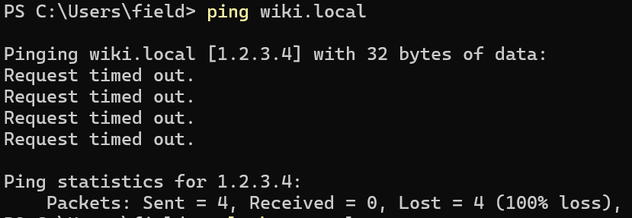
wiki.local resolves to the IP address 1.2.3.4 because of the manual entry added in the hosts file. The address is not reachable, and the ping request returns “Request timed out” as the error because no valid server is responding at that IP address.

Task 2 — Check DNS resolution
Run:
nslookup wiki.local
❓ Where is the answer coming from — your DNS server or a local override?
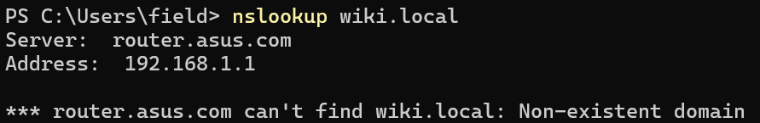
The nslookup output shows that the configured DNS server is router.asus.com with the address 192.168.1.1. However, the incorrect resolution to 1.2.3.4 is not actually coming from that DNS server. It comes from the local hosts file override that was manually added earlier.
The operating system checks the hosts file before contacting a DNS server. Because the file contains the line:
1.2.3.4 wiki.local
the system immediately resolves wiki.local to 1.2.3.4 locally. The DNS server shown in nslookup is simply the server configured for normal DNS queries, but in this case the manual hosts entry takes priority and overrides normal DNS resolution.
Nslookup does not use the hosts file for name resolution.
It sends the query directly to the configured DNS server, which in this case is:
router.asus.com (192.168.1.1)
On the other hand, commands like ping, browsers, and most applications first check the local hosts file before using DNS.

Task 3 — Trace the path
Run:
tracert wiki.local (Windows)
traceroute wiki.local (Mac/Linux)
❓ How many hops before it times out? Where does it die?
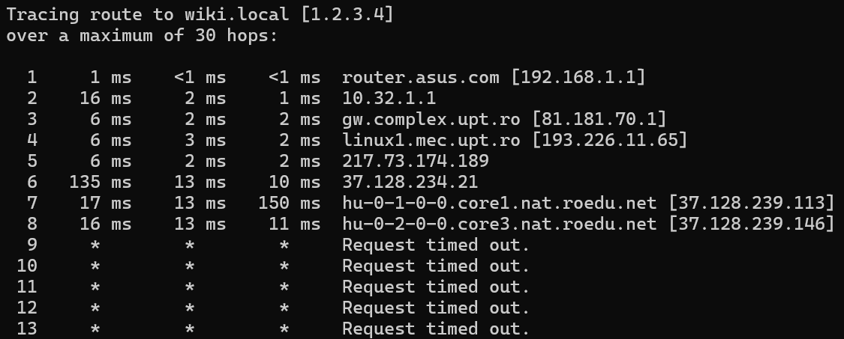
The trace successfully reaches 8 hops before timing out. The last responding router is:
hu-0-2-0-0.core3.nat.roedu.net [37.128.239.146]
Starting from hop 9, all requests return “Request timed out.” This means the packets stop receiving responses after leaving that router. The route therefore “dies” after hop 8, because the destination 1.2.3.4 is unreachable, or does not exist as a valid responding host.

Task 4 — Fix the problem
Edit the hosts file again and point wiki.local to your own machine:
127.0.0.1 wiki.local
Re-run ping wiki.local and nslookup wiki.local.
❓ What changed? Is it reachable now? Why?
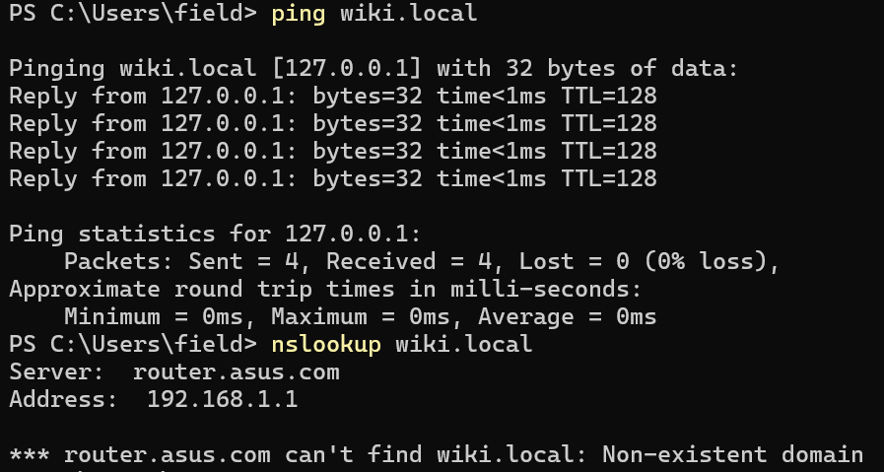
After updating the hosts file, wiki.local now resolves to 127.0.0.1 instead of 1.2.3.4. The ping command is now successful because 127.0.0.1 is the loopback address, which always points to the local machine itself. The packets never leave the computer, so the replies are immediate and there is no packet loss.
However, nslookup wiki.local still returns “Non-existent domain.” This happens because nslookup bypasses the hosts file and queries the DNS server directly. Since the DNS server (192.168.1.1) has no DNS record for wiki.local, it reports that the domain does not exist.

Task 5 — Reflect
Answer in 2–3 sentences:
- What was the root cause of the outage?
- In a real company, what tool or system could have caused this misconfiguration automatically?
- How would you prevent it?

The root cause of the outage was an incorrect entry in the local hosts file, which forced wiki.local to resolve to the wrong IP address (1.2.3.4) instead of the correct server. In a real company, this type of misconfiguration could be caused automatically by configuration management software, VPN clients, security tools, malware, or scripts that modify the hosts file. This can be prevented by restricting write access to the hosts file, monitoring it for unauthorized changes, and relying on centrally managed DNS instead of manual local overrides.

What to Submit
- Screenshots of each command output
- Written answers to the ❓ questions

