Experiments write-up

Experiment 1: Multi-HUC Joint Training
In Experiment 1, a single LSTM model is trained jointly on all HUC-12 basins in the study domain simultaneously, with the static attribute vector s providing the basin-discriminating information at each time step. The joint training dataset pools all available daily records across basins, multiplying the effective training set size by the number of basins B and exposing the model to the full range of snow evolution regimes, elevation gradients, and hydrometeorological extremes present in the Pacific Northwest. For training, we focused on 533 HUC12 sub-basins in the Pacific Northwest, where, according to the snow type classification (Sturm, 1995 and Sturm and Liston, 2021), maritime or montane forest snow predominates (Figure 1). Within these regions, we treated each HUC12 sub-basin unit as a separate time series.

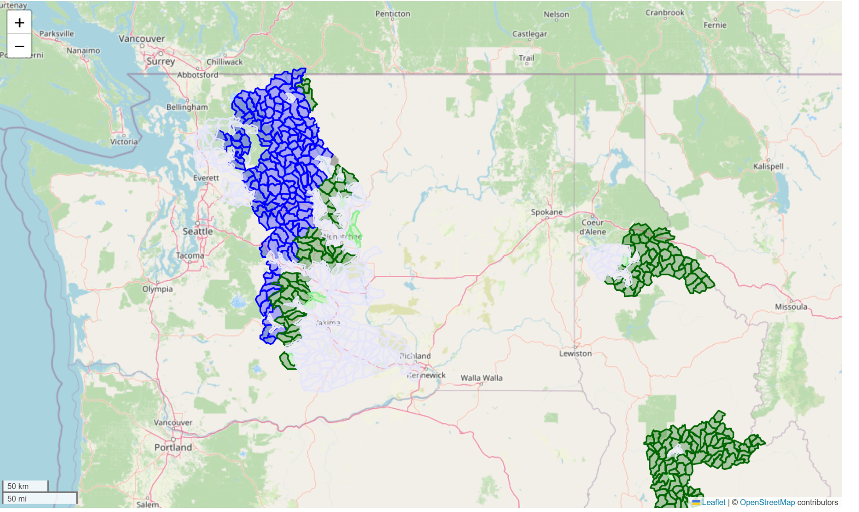
Figure 1. Blue- Maritime Snow Predominates (155), Green - Montane Forest Snow Predominates (187), Lilac - Ephemeral Snow Predominates (180), Light Green - Prairie Snow Predominates (11), White - Boreal Forest (1)
Within Experiment 1, we considered two different sub-experiments as described below:
1A) all 533 basins, including the ephemeral basins, were considered in the training dataset and,
1B) HUC12 sub-basins dominated by ephemeral snow were excluded, as we are primarily interested in modeling persistent snowpack; this selection process resulted in 270 HUC12 units available for training.
In Experiment 1A, we considered a 60/20/20 random split into training, validation, and test groups, resulting in the subwatersheds shown in Figure 2. This split resulted in ZZ sub-watersheds for model training, ZZ for validation, and ZZ for Test Set A1 (Figure 2). In Experiment 1B, in which the HUC12 sub-watershed units that are predominated by ephemeral snow were excluded, we randomly split the 270 HUC12 sub-watersheds into training, validation, and test groups using the same 60/20/20 split, resulting in 162 HUC12 sub-watersheds for model training, 54 for validation, and 54 for test set A2 (Figure ZZ). It's worth noting that train/validation/test splits from random selection resulted in a validation set that was somewhat overweighted in Motane Forest sub-watersheds (65%) compared to the training (52%) and test sets (56%).
[similar as below, but for Experiment 1A]
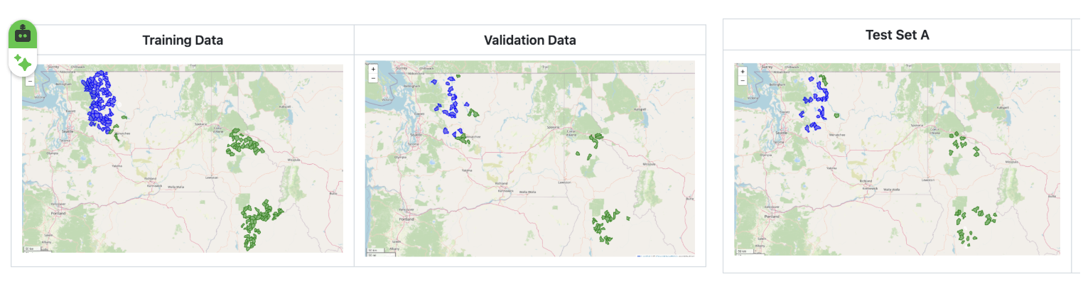
Figure ZZ.
We also defined test set B as the HUC12 units in Upper Yakima (17030001) and Naches (17030002), which contain a mix of ephemeral, maritime, and montane forest snowpack. The distribution of the snow type in each HUC12 subwatershed is shown in Figure ZZ. The Yakima/Naches region is ecologically important in the Pacific Northwest and for farming in the Yakima Valley. These regions play the role of completely unseen regions in our experiment setup. Test set B is the same for both 1A and 1B experiments.
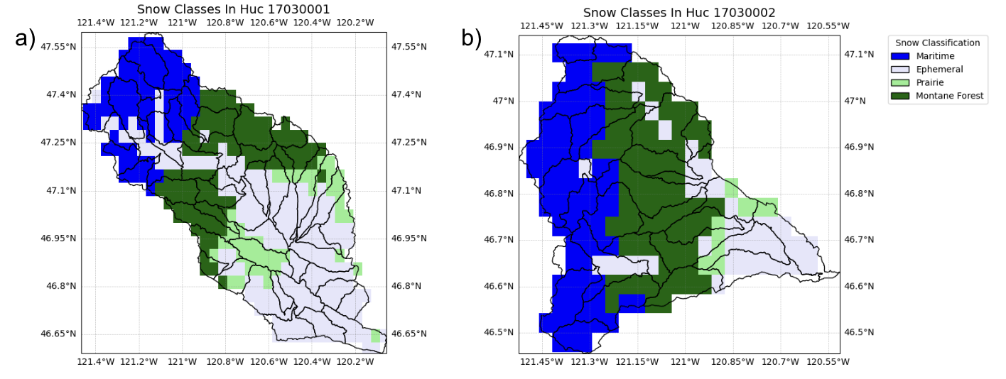
Figure 3. Distribution of HUC12 subwatersheds of different snow types: ephemeral (light blue), prairie (light green), montane forest (dark green), and maritime (dark blue) in a) Upper Yakima HUC8 sub-basin and b) Naches HUC8 sub-basin.
In both 1A and 1B experiments, we explored eight model variations, consisting of four variable combinations, each run with learning rates of .001 and .0003.
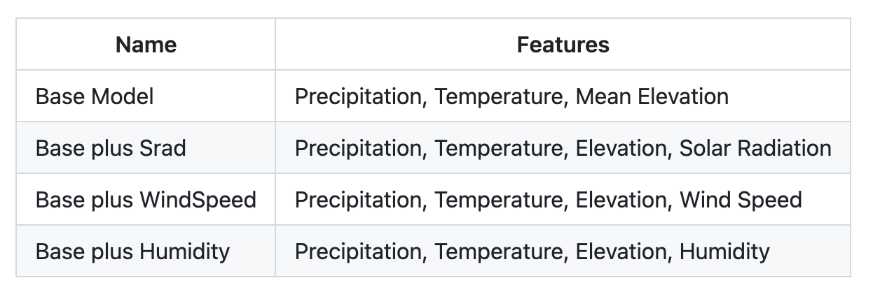
For each of 8 different variable and learning rate combinations, we trained the model using the multiple HUC12 units in the training set for 30 epochs, assessing performance against the validation set at the end of each epoch, and logging a separate model in MLflow, an open-source platform designed to manage the end-to-end machine learning and AI lifecycle, at the end of each epoch. After all runs were complete, we selected the "best" model by examining the median test_kge across all validation set HUCs and choosing the model that yielded the maximum median_test_kge. Finally, we used the selected model to predict results on test sets A1 and A2, as well as test set B.

Experiment 2: Fine-Tuning Multi-HUC Models
In Experiment 2, we combine the advantages of large-sample pre-training (Experiment 1) with basin-specific adaptation through transfer learning. The 1A and 1B multi-HUC models from Experiment 1 are used as the pre-trained base. The pre-trained models are then fine-tuned independently for each target HUC-12 basin in the Yakima and Naches HUC8 basins (Figure 2) using only that basin's training record. Fine-tuning updates both the LSTM layer and the output head for epochs 3–10, ensuring that the pre-trained weight structure is not drastically overwritten while still allowing meaningful basin-specific adaptation. The output dropout rate during fine-tuning is reduced to 0.2 to improve signal propagation through the smaller basin-specific training set. Fine-tuning on basin-specific data then adjusts the model's gate activations and output projection to the local snow climate, terrain, and vegetation characteristics of the target HUC12 without discarding the regional process knowledge that cannot be learned from a single basin's short record.

Experiment 3: Individually Trained HUC-12 Models (Single-Basin Baseline)
In Experiment 3, a separate LSTM model is trained independently for each HUC12 subwatershed in the study domain. We examined the 533 HUC12 sub-basins in the HUC8 basins shown in Figure 1. We used an LSTM model with mean temperature and mean precipitation as input features. The choice of model features was informed by the previous experiments and is detailed in the Results section. Each individual HUC12 unit was trained on data from that unit only and tested on later years of data using a 0.67 train/test split. We ran pairwise t-tests with unequal variances (Welch's test) to test for differences in mean Test KGE and mean Test MSE between snow types. All values were significant at the p = 0.001 level. We examine whether the joint multi-HUC and fine-tuned multi-HUC models achieve better performance than the ensemble of individually trained models. We will evaluate the performance in individual snow classes.

Goal for the SnowML
Goal for the SnowML project: unify the setups and hyperparameters across the LSTM experiments

Experiment 1 Multi-HUC Joint Training
In Experiment 1, a single LSTM model is trained jointly on all HUC-12 basins in the study domain simultaneously. 1 but with the static attribute vector s providing the basin-discriminating information at each time step. The joint training corpus pools all available daily records across basins, multiplying the effective training set size by the number of basins B and exposing the model to the full range of snow accumulation regimes, elevation gradients, and hydrometeorological extremes present in the Pacific Northwest.

This experiment is described at https://github.com/DSHydro/SnowML/blob/main/docs/Ex3_MultiHucTraining.md

Tasks: re-run the experiment to include the ephemeral basins (https://github.com/DSHydro/SnowML/blob/main/docs/Ex2_VariationByHuc.md)

Identify the best models from the experiments

Experiment 2. Fine-tune the pre-trained models

Challenge: a HUC-8 basin (like the Upper Yakima Huc No: 17030001 and Naches 17030002) is composed of many HUC-12 basins

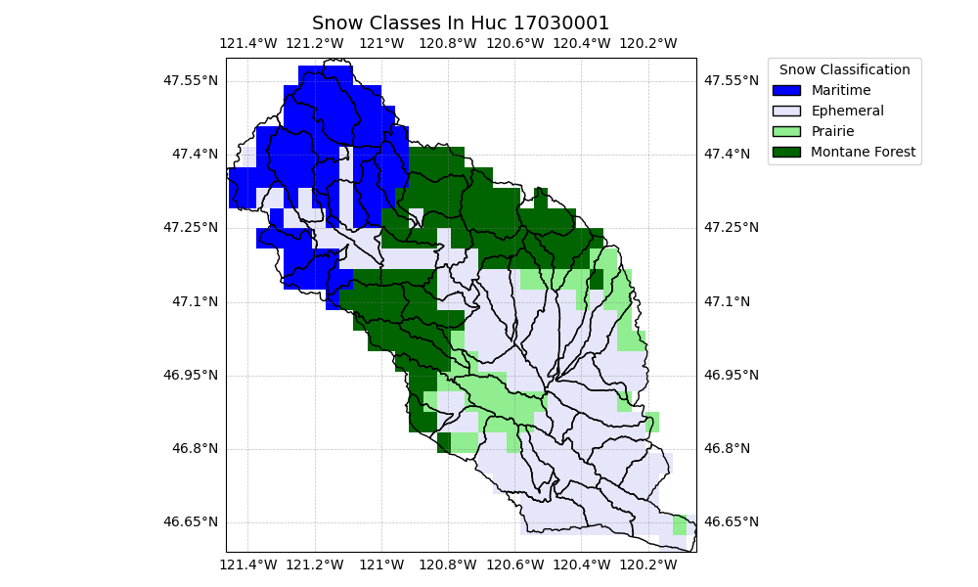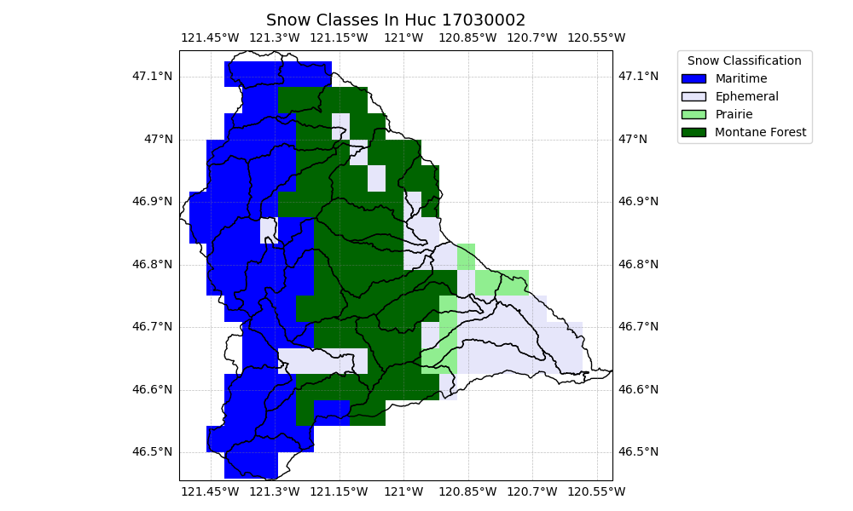

Experiment: fine-tune each of the sub-basins and calculate HUC-8 SWE. Use the best pretrained models with and without the ephemeral basins.

