Email-Based AI-Assisted Grievance Redressal
Made by Interns of AICOE
Background and Context
The West Bengal Govt. offices, receives a significant number of grievances related to pension and administrative matters through official email channels. These grievances often include email text and scanned or handwritten attachments, perhaps in the Bengali language.
At present, grievance handling through email is largely manual, requiring officials to read, interpret, categorize, and respond to emails individually. This results in delays, limited visibility into pending grievances, and inconsistent response quality.
This project was undertaken as an initiative to study the feasibility of introducing AI-assisted automation in the email-based grievance redressal workflow, with a focus on pension-related grievances.
Purpose of the Initiative
At present, these emails are handled manually, which makes it difficult to:
- Track how many grievances are pending
- Identify which emails are follow-ups
- Ensure timely replies
- Get an overall picture of grievance workload
This initiative demonstrates a simple, dashboard-based system that helps officials monitor, organize, and respond to grievance emails more efficiently.
What the System Does
The system acts like an intelligent assistant for the official email inbox. It does not send replies on its own, but helps officials by organizing information clearly. It helps answer questions such as:
- How many new grievance emails have come today?
- Which emails are still unanswered?
- Which emails are follow-ups?
- How many emails regarding grievances and what are those categories?
- What could be an appropriate reply to a particular email?
- How many emails had come from a particular sender id?

How Emails Are Handled
- The system automatically reads emails from the official mailbox.
- For each email, the system notes:
- Who sent the email
- The subject
- The content
- Date and time received
- Whether there is any attachment
This information is stored securely in structured grievance database for monitoring purposes.
Grievance Classification
- Grievances are grouped into predefined categories.
- Emails that do not clearly match any category are placed under “Miscellaneous”.
This helps officials quickly understand:
- What type of grievances are coming
- Which categories receive the most complaints
Fresh and Follow-Up Identification
The system identifies whether an email is a fresh grievance or a follow-up to an earlier email. This removes the need for manual checking and helps prioritize responses.
Monitoring Reply Status and Delay
For each email, the system clearly shows:
- Whether it has been replied to or not
- How many days it has been pending
This allows supervisors to quickly see:
- Delayed cases
- Backlogs requiring attention
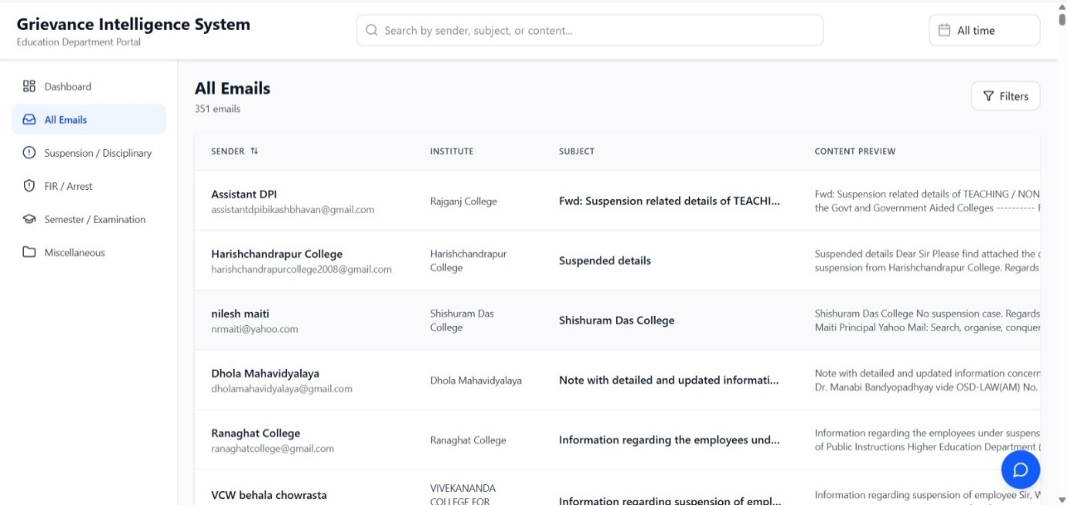
Reply Suggestion Support
- For each email, the system provides a suggested draft reply.
- The suggestion is based on the content of the email.
- Officials can:
  - Use it as reference
  - Modify it
  - Ignore it entirely
Final replies are always sent by officials themselves.
Dashboard View
The dashboard presents information in a clear, summarized manner:
- Total number of emails received
- Number of fresh and follow-up emails
- Number of replied and pending emails
- Category-wise grievance counts
When an official clicks on a category, they can see:
- Sender name
- Subject and content
- Date on which the mail was received
- Fresh / follow-up status
- Reply/un-replied status
- Suggested reply text
- Attachments (if present)

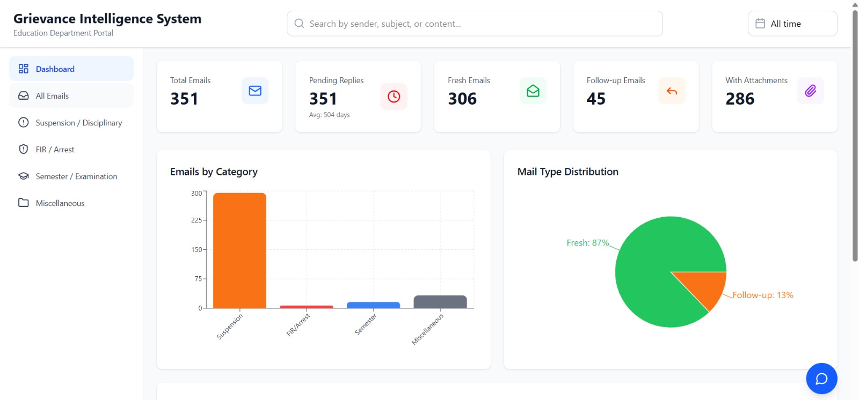
Chatbot for Quick Information
The system also includes a simple chatbot that answers general questions such as:
- How many new emails were received today?
- How many emails are still pending?
- How many emails came from a particular sender?
- How many emails fall under each category?
This helps officers get quick information without manually searching emails.

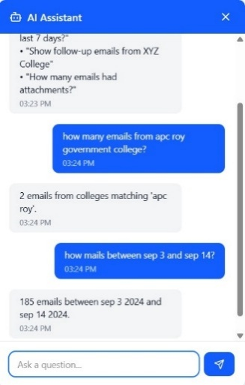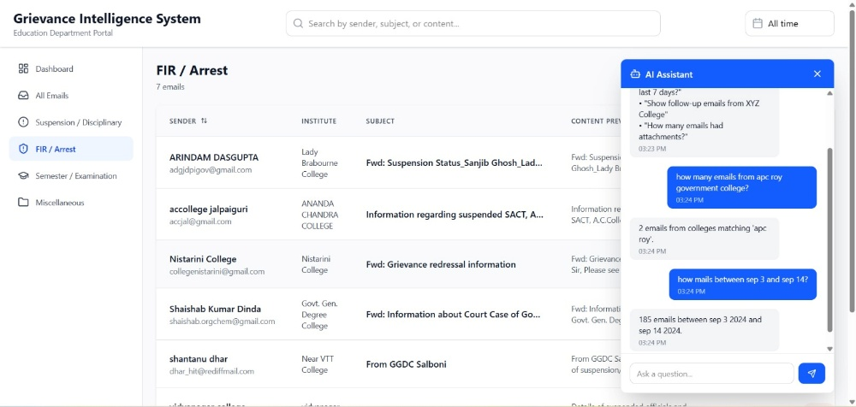
How to use
Open the System Dashboard
- Open a web browser (Chrome / Edge recommended).
- Enter the following URL:
https://webel-final-showdown.vercel.app/
- The main dashboard page will open automatically.
This dashboard shows a summary view of grievance emails received in the official mailbox.
Understand the Dashboard Summary
On the dashboard, the user can immediately see:
- Total number of emails received
- Number of fresh emails
- Number of follow-up emails
- Number of emails with attachments
- Category-wise distribution of grievances
This gives a quick overview of the current grievance load.
View Grievances by Category
- The dashboard displays different grievance categories (like: Suspension, FIR/Arrest, Semester).
- Emails that do not fit any defined category are shown under “Miscellaneous”.
Action:
- Click on any category name.
Result:
- The system displays all emails under that category.
For each email, the following details are shown clearly:
- Sender’s email ID
- Subject of the email
- Email content
- Date and time of receipt
- Whether the email is Fresh or a Follow-up
- Whether the email has been Replied or Not Replied
- Whether the email contains any attachment and also viewing the attachment.
Reply Suggestions
- For each unreplied email, the system displays a suggested draft reply.
- This suggestion is based on the content and tone of the email.
Important to Note:
- The system does not send replies automatically.
- The suggestion is only for reference and assistance.
- Officials can:
  - Copy and edit the suggestion
  - Use it partially
  - Or ignore it completely
The final reply is always sent manually through the official email system.
Identify Pending and Delayed Emails
- Emails that are not replied are clearly marked.
- The system also shows how many days an email has been pending.
This helps officers:
- Quickly identify delayed grievances
- Prioritize replies
- Avoid missing follow-up communications
Use the Chatbot for Quick Information
The system includes a simple chatbot to answer general questions.
The user can ask questions like:
- “How many fresh emails are there?”
- “How many emails are still pending?”
- “How many emails came from a particular sender?”
- “How many emails are in each category?”
The chatbot provides instant answers based on the dashboard data.
This is useful for:
- Quick reviews
- Meetings
- Status updates
Technical Architecture & Implementation Details
The system is a modular, API-driven grievance monitoring platform that ingests emails from an official mailbox using IMAP, persists structured metadata, categorizes pension-related grievances, computes operational metrics (fresh/follow-up, reply status, delay), and provides AI-assisted reply drafting along with a query-driven chatbot interface for mailbox-level analytics.
The application follows a decoupled frontend–backend architecture:
- Frontend: React-based dashboard deployed on Vercel
- Backend: Python (Flask/FastAPI-style) services deployed on Hugging Face Spaces
- LLM Integration: Hugging Face transformer models
- Persistence Layer: Structured database (logical schema-driven)

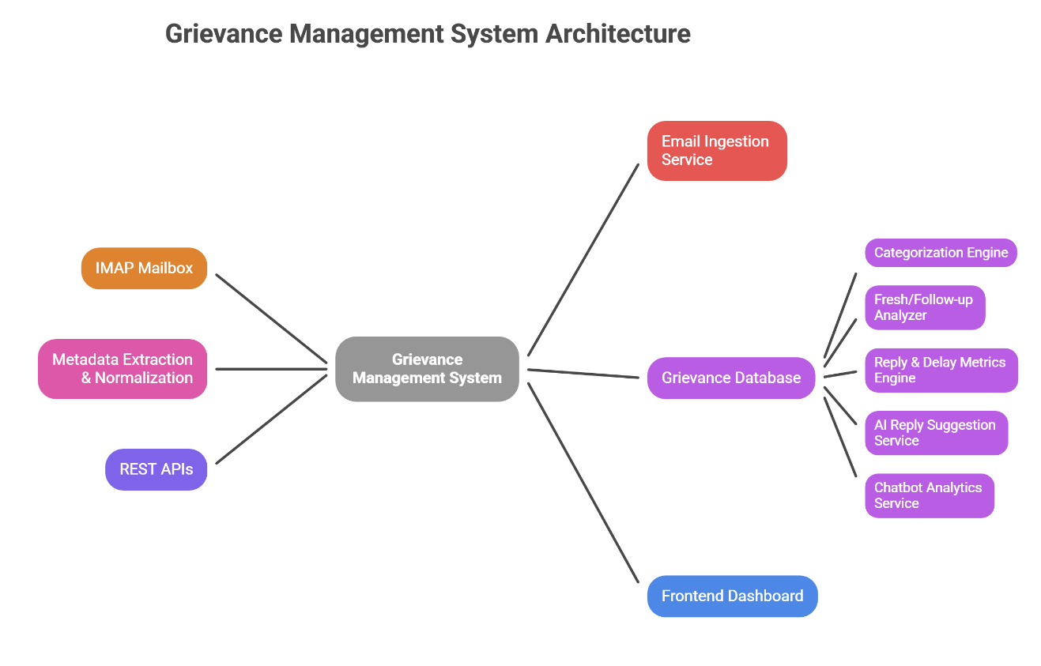
Backend Components
IMAP Email Ingestion Module
- Authenticate using IMAP credentials
- Fetch new and unread emails
- Maintain mailbox sync without duplication
- Key Outputs: raw email payloads passed to metadata parser
Metadata Extraction
Extracted Fields:
- Sender Email ID
- Subject
- Body Content (plain text / HTML normalized)
- Sent Timestamp
- Attachment Flag (boolean)
- Message-ID (used for threading)
- Stored in structured database tables
- Indexed for sender, category, date, and status queries
Grievance Categorization Engine
- Classifies pension-related grievances into predefined categories
- Emails not matching any rule/model fall under Miscellaneous
- Trigger: Executed automatically upon new email ingestion
- Output: category_id assigned per email record
Fresh vs Follow-Up Identification
- Thread-based and sender-based analysis
- Uses Message-ID / Subject similarity / temporal proximity
- Flags: is_fresh and is_follow_up
Reply Status & Delay Computation
Metrics Computed:
- Replied / Not Replied
- Reply Timestamp
- Delay Duration (in days)
- Use Case: Identifying overdue grievances
AI-Assisted Reply Suggestion Service
Model Source: Hugging Face pretrained LLM
Input:
- Email content
- Grievance category
- Historical reply patterns (if available)
Output: Draft reply text for human reference only.
Replies are not auto-sent, human approval is mandatory.
Chatbot Analytics Module
Purpose: Natural-language querying of grievance data.
Supported Queries:
- Count of fresh emails
- Category-wise grievance count
- Sender-wise statistics
- Pending / delayed grievance summaries
Execution Flow:
User Query → NLP Parsing → Database Query → Aggregated Response
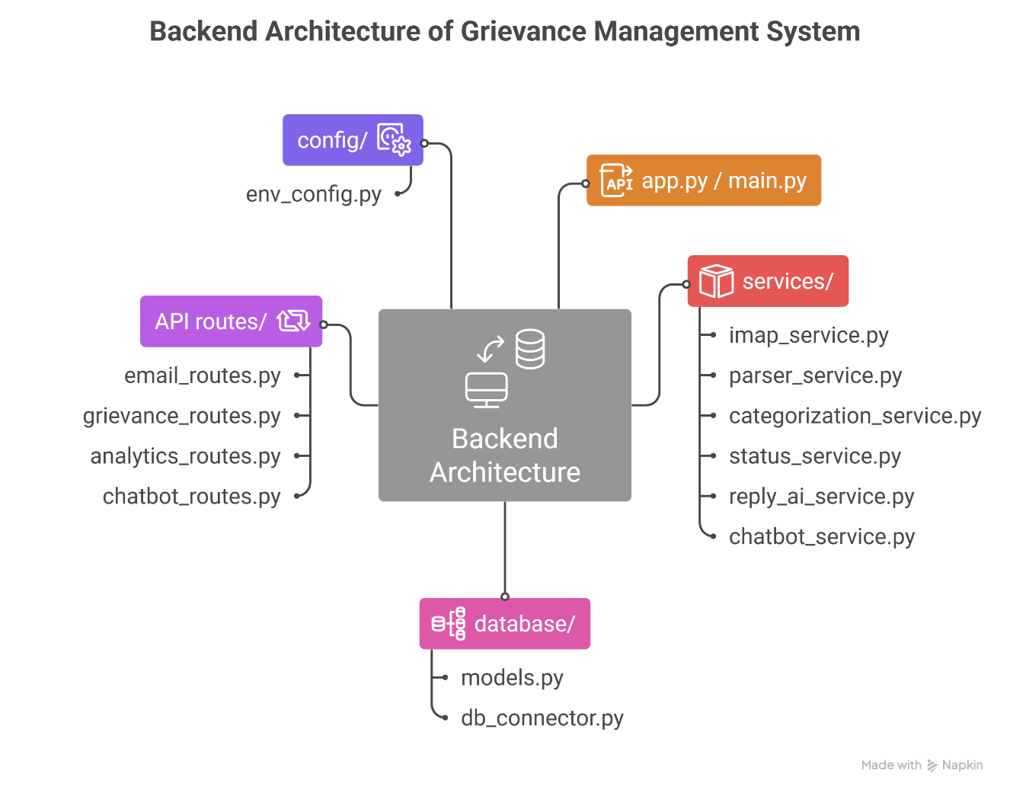
REST API Layer
Key API Endpoints
GET /api/emails
GET /api/emails/category/{category_id}
GET /api/metrics/summary
GET /api/metrics/pending
POST /api/reply/suggest
POST /api/chatbot/query
Each endpoint returns JSON responses, optimized for frontend consumption.
Frontend Functional Flow
- Dashboard loads summary metrics
- Category selection triggers category-specific API calls
- Email table displays Sender, Subject, Content, Timestamp, Fresh/Follow-up, Reply status, Attachment indicator
- Selecting an email triggers AI reply suggestion fetch
- Chatbot component queries analytics APIs

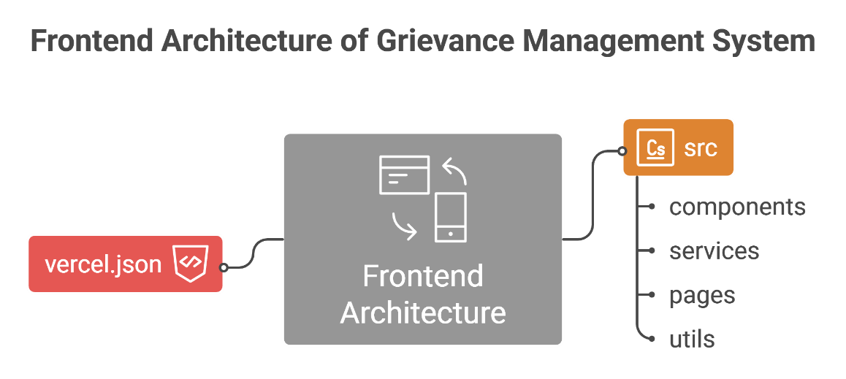
Deployment Details
Backend
- Hosted on Hugging Face Spaces
- Stateless REST services
- Environment variables used for credentials
Frontend
- Hosted on Vercel
- API base URL configured via environment variables
Benefits to the Administrators
- Better visibility of grievance workload
- Reduced chances of missing follow-ups
- Faster response preparation
- Improved monitoring and accountability
- No disruption to existing official processes

