Program 3

You are to write a program builds statistics on a Stock CSV file of your choosing.

**Note: You may find this program sneaky difficult.**

First, we need a CSV file.

Go to finance.yahoo.com and enter a stock ticker for your stock (I chose GME).

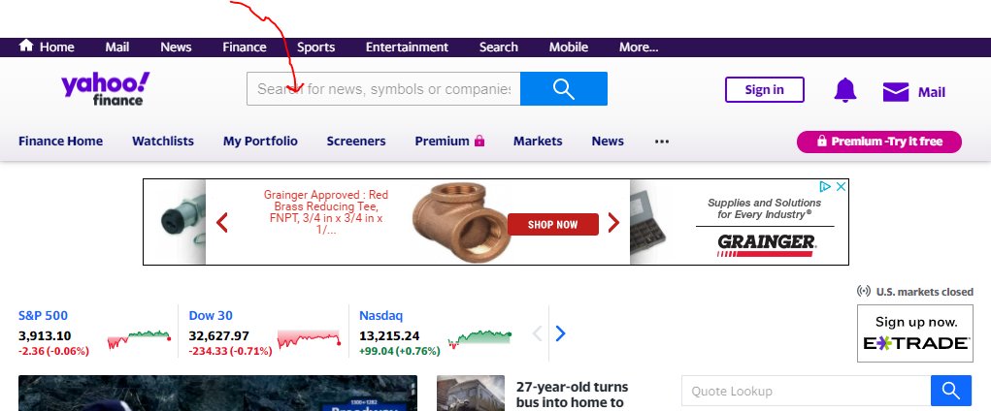

Next, download “Historical Data”

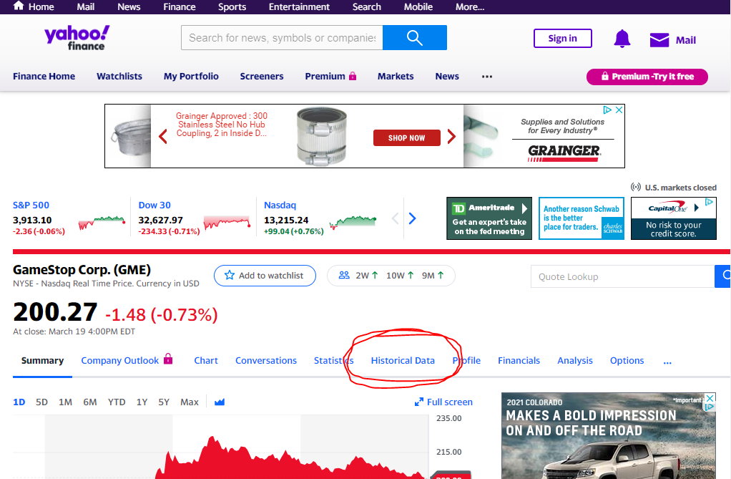

Next, select a date range and then download:

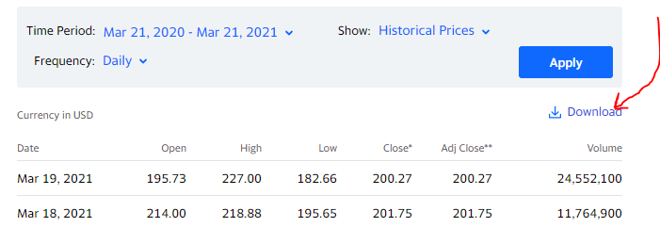

Now we will write a program that does the following:

1. Read in the CSV file
2. Ask the user if they want statistics on the Close Price, the Volume, or the Daily Range (where “Daily Range” is a value you are to calculate, the High Price less the Low Price).
3. Depending on the user choice, calculate, for the entire date range in the CSV file:
   1. The number of observations in the analysis
   2. Max (along with the date the max occurred)
   3. Min (along with the date the min occurred)
   4. Mean
   5. Vol (aka Standard Deviation)

**Requirements:**

* Your program must contain **at least three functions** (you may do more if you desire).
* You MAY NOT USE LIST HELPER FUNCTIONS, such as “max” or “min” or “mean”.
* You may use math.sqrt() and len()
* Your program should use the “main function” convention we discussed in class.

If you need help calculating standard deviation, see “Basic Examples” here:

<https://en.wikipedia.org/wiki/Standard_deviation>

# Sample Output

Welcome to Program 3

Opening File...

What metric do you want to analyze?

C) Close Price

V) Volume

R) Range

Choice: C

Total Observations: 253

Mean: 27.55288549407115

Vol: 55.88398140851177

Max: 347.51001

Max Day: 2021-01-27

Min: 2.8

Min Day: 2020-03-20

Goodbye!