**Greece 2.0**

**Basic Research Financing Action**

**(Horizontal support of all Sciences)**

**Sub-action 1**

**Funding New Researchers**

**PART B2.1**

# Part B2.1 Research Proposal

*(max. 16 pages including cover page and references)*

**Proposal Title**

**Proposal Acronym**

* **Principal Investigator** (Name/Surname):
* Scientific Area:
* Scientific Field:
* Scientific Subfield:
* Project Duration (in months):
* Total Budget (€):
* Host Institution:
* Cooperating Organization(s): (*if applicable*)



## Excellence, State-of-the-art and Objectives

*Indicative fields should include:*

* *Relevance with the selected Scientific Area*
* *Proposal objectives and necessity/challenges*
* *State-of-the-art & Innovation*
* *Scientific and/or social impact*

*Please write your text here*

## Methodology and Implementation

*Indicative fields should include:*

* *Research Methodology*
* *Work Plan*
* *Research Team*

### Research Methodology

*Please write you text here…*

### Work Plan (Work Packages, Gantt Chart, Deliverables and Milestones Table, Table of Risks and Contingency Plan}

*Please include the following:*

*- Brief outline of the overall work plan.*

*- Description of each Work Package (WPs).*

*- Tables of Deliverables and Milestones.*

*- Table of Risks and Contingency Plan.*

*- Timeline/timetable of the different work packages and their components (Gantt Chart).*

#### Brief outline of the overall work plan

*Please write your text here…*

#### Description of each Work Package (WPs)

*Indicative Table for the description of each Work Package.*

*[****Important:*** *Please include a Project Management and a Dissemination and Communication Management Work Package]*

|  |  |  |
| --- | --- | --- |
| **WP Number: 1** | **WP Title: Refactoring** | |
| **Starting Month: 1** | **Ending Month: 3** | **Person Months (PMs):** |
| Objectives  Description of Work  Tasks  Deliverables  Milestones | | |

|  |  |  |
| --- | --- | --- |
| **WP Number: 2** | **WP Title: Software Development** | |
| **Starting Month: 3** | **Ending Month: 12** | **Person Months (PMs):** |
| Objectives  Description of Work  Tasks  Deliverables  Milestones | | |

|  |  |  |
| --- | --- | --- |
| **WP Number: 3** | **WP Title: Jason 3** | |
| **Starting Month: 13** | **Ending Month: 15** | **Person Months (PMs):** |
| Objectives  Description of Work  Tasks  Deliverables  Milestones | | |

|  |  |  |
| --- | --- | --- |
| **WP Number: 4** | **WP Title: Sentinel 3A / 6A** | |
| **Starting Month: 16** | **Ending Month: 18** | **Person Months (PMs):** |
| Objectives  Description of Work  Tasks  Deliverables  Milestones | | |

|  |  |  |
| --- | --- | --- |
| **WP Number: 5** | **WP Title: HY:C** | |
| **Starting Month: 19** | **Ending Month: 21** | **Person Months (PMs):** |
| Objectives  Description of Work  Tasks  Deliverables  Milestones | | |

|  |  |  |
| --- | --- | --- |
| **WP Number: 6** | **WP Title: Testing - Processing** | |
| **Starting Month: 16** | **Ending Month: 24** | **Person Months (PMs):** |
| Objectives  Description of Work  Tasks  Deliverables  Milestones | | |

|  |  |  |
| --- | --- | --- |
| **WP Number: 7** | **WP Title: Time series analysis** | |
| **Starting Month: 21** | **Ending Month: 24** | **Person Months (PMs):** |
| Objectives  Description of Work  Tasks  Deliverables  Milestones | | |

|  |  |  |
| --- | --- | --- |
| **WP Number: 8** | **WP Title: Dissemination and communication management** | |
| **Starting Month: 6** | **Ending Month: 24** | **Person Months (PMs):** |
| Objectives  Description of Work  Tasks  Deliverables  Milestones | | |

|  |  |  |
| --- | --- | --- |
| **WP Number: 9** | **WP Title: Project Management** | |
| **Starting Month: 1** | **Ending Month: 24** | **Person Months (PMs):** |
| Objectives  Description of Work  Tasks  Deliverables  Milestones | | |

#### Deliverables

*Indicative deliverables: technical reports, research results, databases, new studies, interactive tools, e-learning tools, dissemination reports [peer-reviewed journals, publications in conference proceedings, books/chapters in books, lectures/conferences/workshops presentations), posters, patents etc.]*

|  |  |  |  |  |  |
| --- | --- | --- | --- | --- | --- |
| **Deliverable Number** | **Deliverable Name** | **Related WP** | **Type[1]** | **Dissemination Level[2]** | **Due Date**  **(in months)[3]** |
| **D1.1** | Technical Report | 1 | R | CO | 3 |
| **D2.1** | Technical Report | 2 | R | CO | 12 |
| **D3.1** | Technical Report | 3 | R | CO | 15 |
| **D4.1** | Technical Report | 4 | R | CO | 18 |
| **D5.1** | Technical Report | 5 | R | CO | 21 |
| **D6.1** | Technical Report | 6 | R | CO | 24 |
| **D6.2** | Software | 6 | DEM | PU | 21 |
| **D7.1** | Technical Report | 7 | R | CO | 24 |
| **D8.1** | Technical Report | 8 | R | CO | 24 |
| **D8.2** | Conference presentation 1 | 8 | DEC | PU | 14 |
| **D8.3** | Conference Presentation 2 | 8 | DEC | PU | 21 |
| **D8.4** | Peer reviewed paper | 8 | DEC | PU | 21 |
| **D8.5** | Website | 8 | DEM | PU | 24 |
| **D9.1** | Report for technical and financial management | 9 | R | CO | 24 |

#### Milestones

|  |  |  |  |  |
| --- | --- | --- | --- | --- |
| **Milestone Number** | **Milestone Name** | **Related WP** | **Due Date**  **(in months)** | **Means of Verification** |
| **M1.1** | Software specifications | 1 | 3 | Report |
| **M2.1** | Software Release v1.0b1 | 2 | 12 | Beta Release |
| **M3.1** | Software Release v1.0b2 | 3 | 15 | Beta Release |
| **M4.1** | Software Release v1.0b3 | 4 | 18 | Beta Release |
| **M5.1** | Software Release v1.0b4 | 5 | 21 | Beta Release |
| **M6.1** | Software Release v1.0 | 6 | 21 | Release |
| **M6.2** | Data Processing | 6 | 21 | Products |

*Copy table below to add information*

#### Risks and Contingency Plan

|  |  |  |
| --- | --- | --- |
| **Description of risk**  (indicate level of likelihood: Low/Medium/High) | **WPs involved** | **Proposed risk –Mitigation measures** |
|  |  |  |
|  | *Insert row below to add information* |  |

#### Timeline/timetable of the different work packages and their components (Gantt Chart).

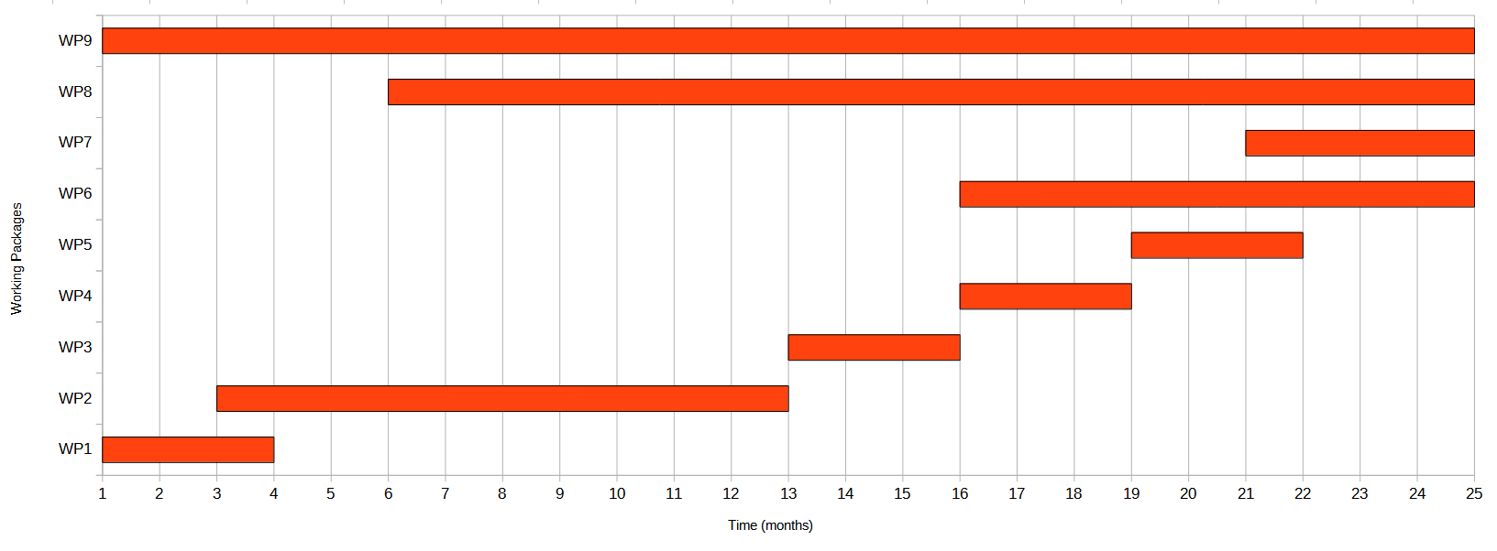

### Research Team

*Describe the specific roles of the Research Team members in the implementation of the project. The involvement of all members of the Research Team, as well as the involvement of the Collaborating Organizations (if applicable) has to be fully justified, with emphasis on the scientific added value they bring to the project.*

## Budget

*Please complete/modify the following table to include all costs of the proposed project.*

**Table 3.1. Project Budget and justification**

|  |  |
| --- | --- |
| **Cost Category** | **Restrictions** |
| **DIRECT COSTS** |  |
| **Personnel costs1 (PI and Research Team members)** | **≥ 50% of the total budget** |
| **Consumables** | - |
| **Dissemination and Travel** | - |
| **Equipment (Depreciation value)** | - |
| **Other costs** | - |
| **Subcontracting costs** | **≤ 10% of the total budget** |
| **INDIRECT COSTS** | **≤15%**  **of personnel costs** |
| **Total HI Budget** | **€** |

*1For personnel costs please refer to the terms described in Table4 of the call.*

**Budget justification**

*Please justify the proposed costs per category here*

1. Please add one of the following types:

   **R** = Report (document, including interim and final report)

   **DEM** = Demonstrator (prototype, plan, etc.)

   **DEC** = Publications, patents, etc.

   **Other**
2. Please add one of the following types:

   **PU** = PUBLIC (public available)

   **CO** = CONFIDENTIAL (available only to the research team and H.F.R.I.)
3. *Please add the respective Project’s delivery month.*