Survey32 Writeup

## Who Are the Soldiers?

Survey 32 was given out to soldiers in 1943, approximately 5 years before the military was integrated. The survey was passed out to 7442 black soldiers and 4793 white soldiers and asked for basic demographic information, career aspirations, and more but of interests to us, Survey 32 asked the soldiers for their opinions on integration of military outfits.

## age edu enlist outfits state community  
## 1 <=19 4TH GRADE VOLUNTEERED Seperated <NA> Small Town  
## 2 20 4TH GRADE VOLUNTEERED Together WASHINGTON City  
## 3 20 4TH GRADE VOLUNTEERED Seperated MISSISSIPPI Small Town  
## 4 20 4TH GRADE VOLUNTEERED Doesn't Matter GEORGIA Town  
## 5 30-34 HIGH SCHOOL NATIONAL GUARD Together ILLINOIS Large City  
## 6 20 4TH GRADE VOLUNTEERED Seperated OHIO Large City  
## 7 20 4TH GRADE VOLUNTEERED Doesn't Matter <NA> Town  
## 8 20 4TH GRADE VOLUNTEERED <NA> <NA> City  
## 9 20 SOME COLLEGE VOLUNTEERED Seperated SOUTH CAROLINA City  
## 10 21-24 HIGH SCHOOL DRAFTED Doesn't Matter INDIANA City  
## race  
## 1 Black  
## 2 Black  
## 3 Black  
## 4 Black  
## 5 White  
## 6 Black  
## 7 Black  
## 8 Black  
## 9 White  
## 10 White

### How Old Are the Soldiers

Age was not collected on a continuous scale and was discretized into a few different age groups. We see that the overwhelming bulk of black soldiers who were survied were 20 years old with a small portion who were 19 or younger. In the meanwhile, the white soldiers had more spread to their ages with most soldiers being between the ages of 21 and 24.

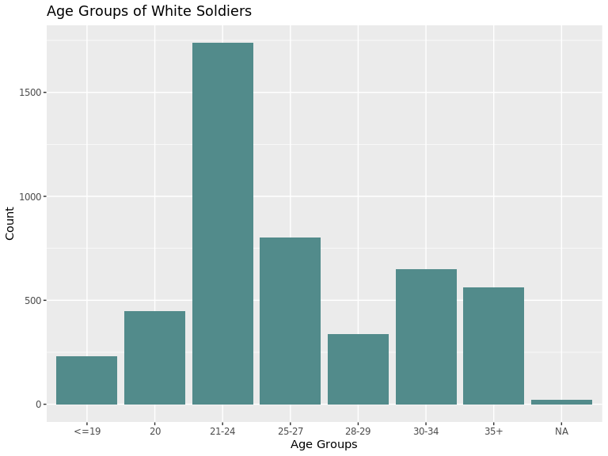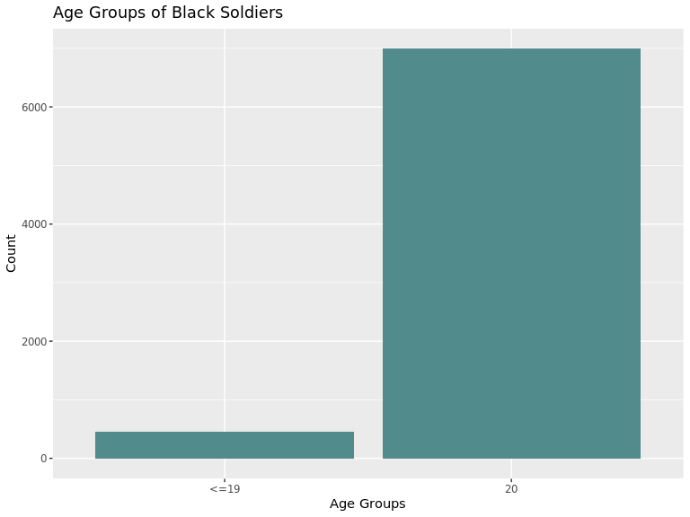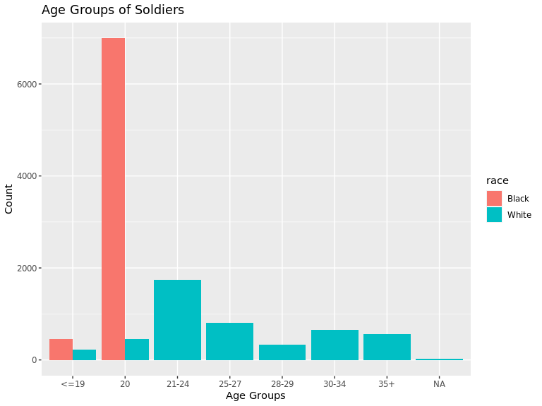

## Warning in melt(., id.vars = "age"): The melt generic in data.table has been  
## passed a data.frame and will attempt to redirect to the relevant reshape2  
## method; please note that reshape2 is deprecated, and this redirection is now  
## deprecated as well. To continue using melt methods from reshape2 while both  
## libraries are attached, e.g. melt.list, you can prepend the namespace like  
## reshape2::melt(.). In the next version, this warning will become an error.

## Warning: Removed 6 rows containing missing values (geom_bar).

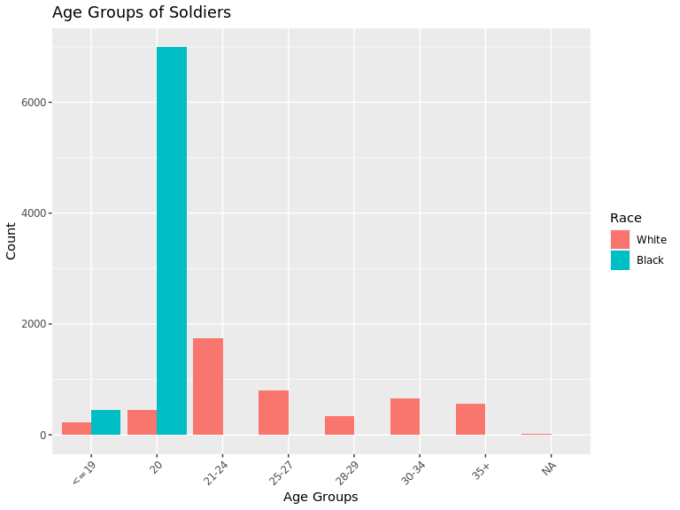

### How Far in School Were They?

If we look at education now we see that again black soldiers have littel spread in their education. Remarkably, all of the black soldiers survied have less than a 5th grade education at the time. Meanwhile, the bulk of the white soldiers have had a high school/some high school.

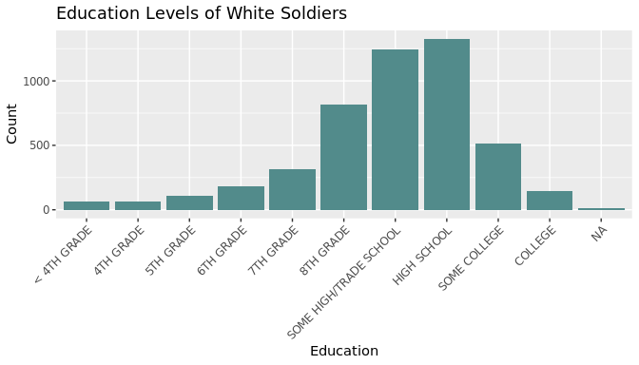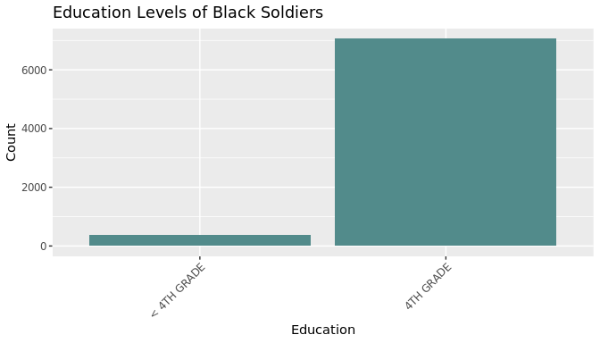

## Warning in melt(., id.vars = "edu"): The melt generic in data.table has been  
## passed a data.frame and will attempt to redirect to the relevant reshape2  
## method; please note that reshape2 is deprecated, and this redirection is now  
## deprecated as well. To continue using melt methods from reshape2 while both  
## libraries are attached, e.g. melt.list, you can prepend the namespace like  
## reshape2::melt(.). In the next version, this warning will become an error.

## Warning: Removed 9 rows containing missing values (geom_bar).

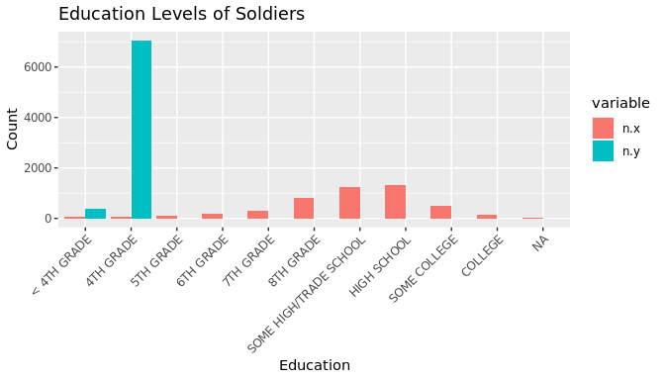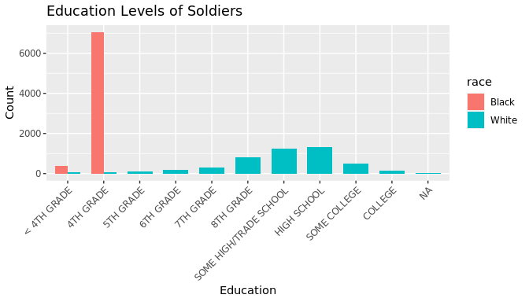

## Warning in melt(., id.vars = "edu"): The melt generic in data.table has been  
## passed a data.frame and will attempt to redirect to the relevant reshape2  
## method; please note that reshape2 is deprecated, and this redirection is now  
## deprecated as well. To continue using melt methods from reshape2 while both  
## libraries are attached, e.g. melt.list, you can prepend the namespace like  
## reshape2::melt(.). In the next version, this warning will become an error.  
  
## Warning in melt(., id.vars = "edu"): Removed 9 rows containing missing values  
## (geom_bar).

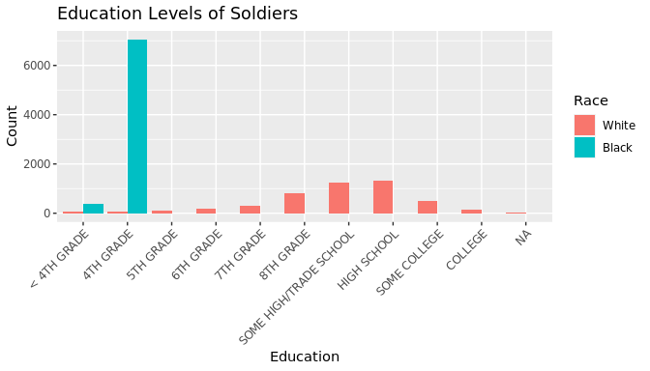

## Warning in melt(., id.vars = "edu"): The melt generic in data.table has been  
## passed a data.frame and will attempt to redirect to the relevant reshape2  
## method; please note that reshape2 is deprecated, and this redirection is now  
## deprecated as well. To continue using melt methods from reshape2 while both  
## libraries are attached, e.g. melt.list, you can prepend the namespace like  
## reshape2::melt(.). In the next version, this warning will become an error.  
  
## Warning in melt(., id.vars = "edu"): Removed 9 rows containing missing values  
## (geom_bar).

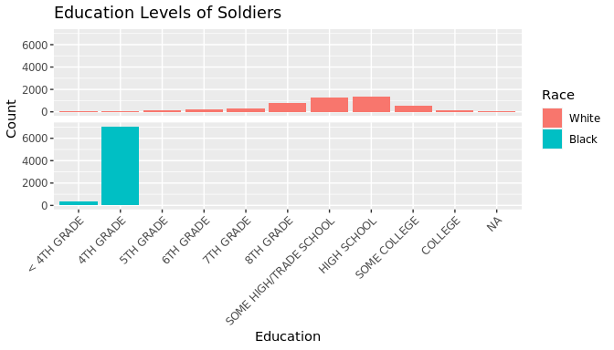

### How Did They End Up in the Military

Something interesting arises here were we find that vast majority of the black soldiers actually volunteered to join the military whereas about 3/4 of the survied white soldiers were drafted and the remaining soldiers were moslty volunteers and a few were from the National Guard. 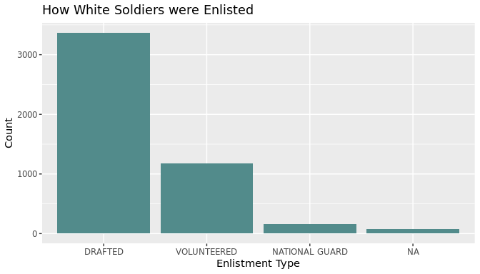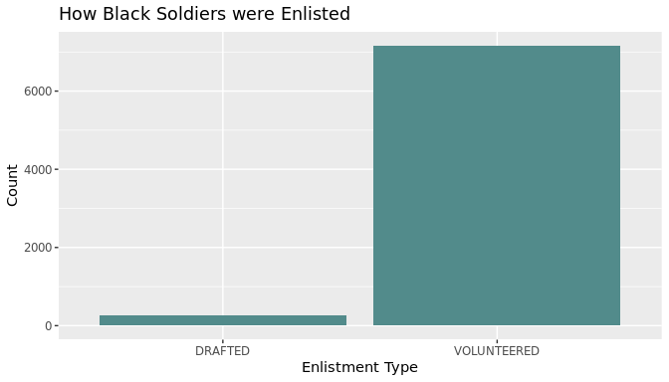

## Warning in melt(., id.vars = "enlist"): The melt generic in data.table has  
## been passed a data.frame and will attempt to redirect to the relevant reshape2  
## method; please note that reshape2 is deprecated, and this redirection is now  
## deprecated as well. To continue using melt methods from reshape2 while both  
## libraries are attached, e.g. melt.list, you can prepend the namespace like  
## reshape2::melt(.). In the next version, this warning will become an error.

## Warning: Removed 2 rows containing missing values (geom_bar).

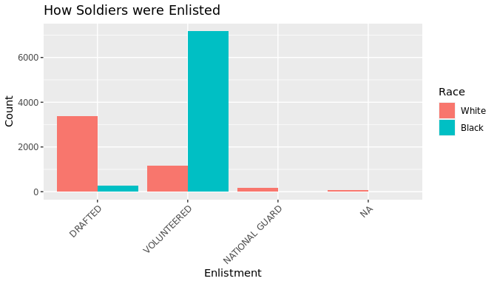

### Where Are the Soldiers From?

Expectedly, most of the soldiers hailed from the most populous states at the time. White soldiers were mostly from Illionois, Pennsylvania, Ney York, Texas, and Michigan while black soldiers were mostly from Texas, New York, Illinois, Pennsylvania, and Ohio. Note that the top 4 states for white soldiers had similar amounts of soldiers but there was a sever drop off in representation of black soldiers from other states after Texas and New York.

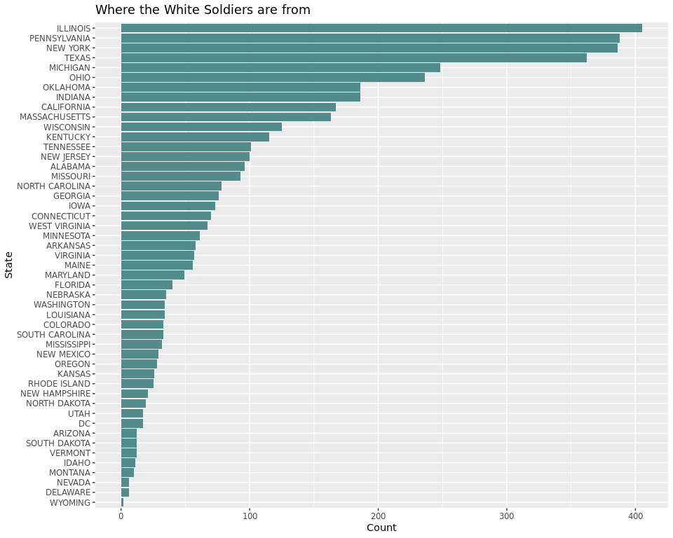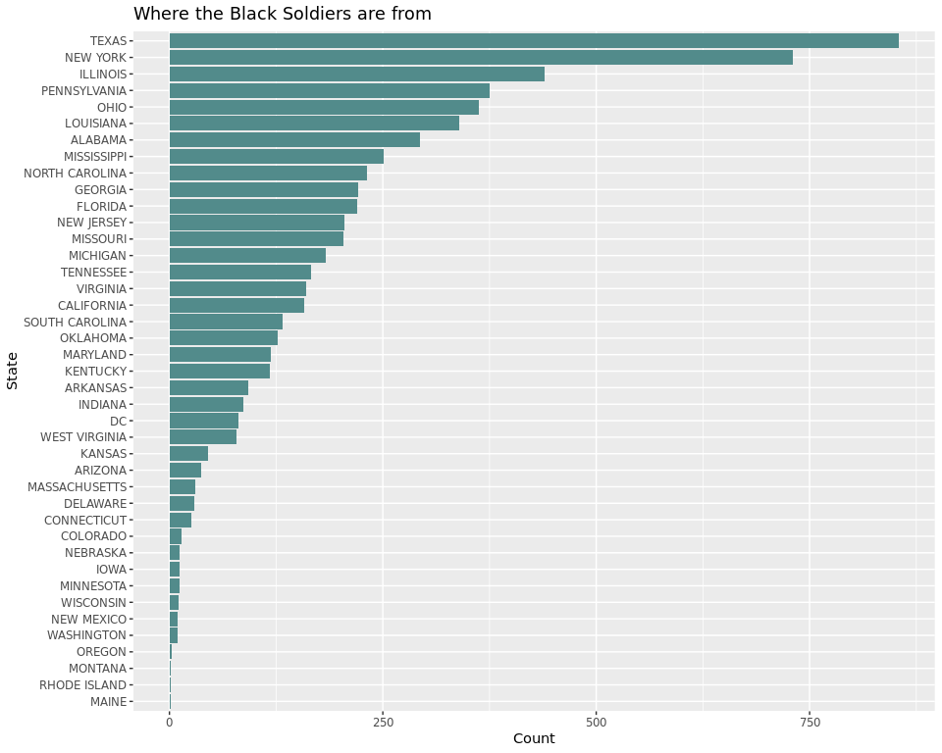

## Warning in melt(., id.vars = "state"): The melt generic in data.table has  
## been passed a data.frame and will attempt to redirect to the relevant reshape2  
## method; please note that reshape2 is deprecated, and this redirection is now  
## deprecated as well. To continue using melt methods from reshape2 while both  
## libraries are attached, e.g. melt.list, you can prepend the namespace like  
## reshape2::melt(.). In the next version, this warning will become an error.

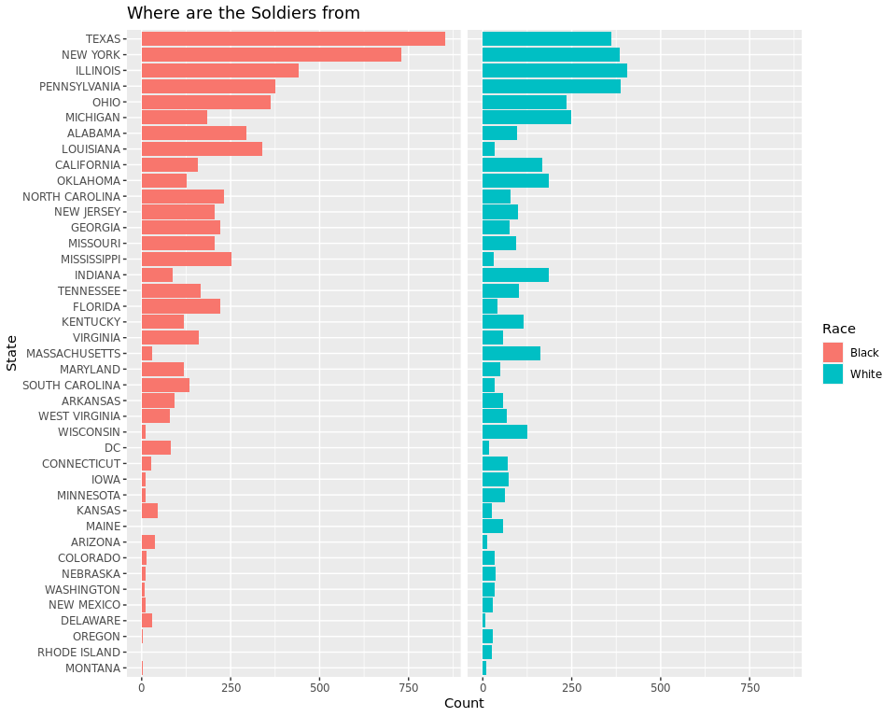

## `summarise()` ungrouping output (override with `.groups` argument)

## Warning: Use of `map_df$x` is discouraged. Use `x` instead.

## Warning: Use of `map_df$y` is discouraged. Use `y` instead.

## Warning: Use of `map_df$group` is discouraged. Use `group` instead.

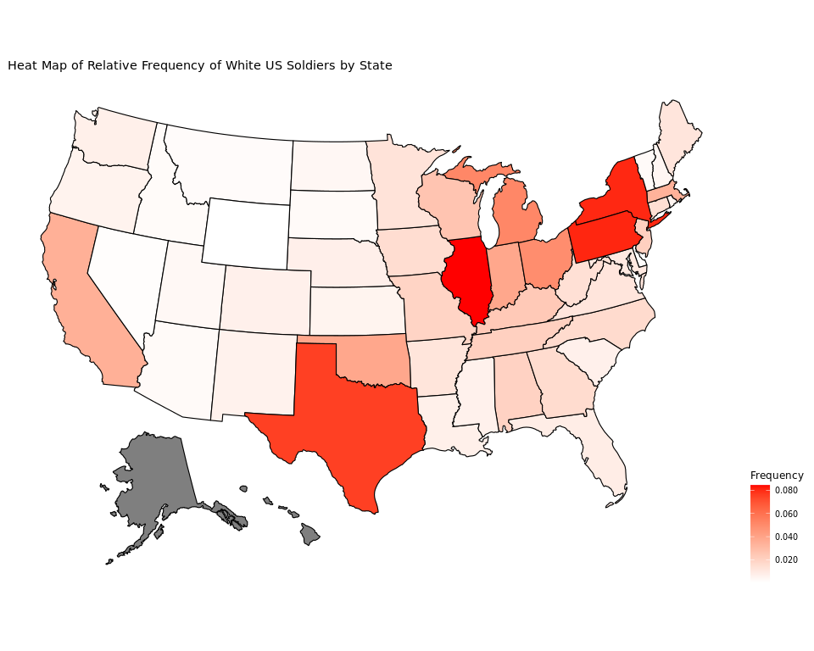

## `summarise()` ungrouping output (override with `.groups` argument)

## Warning: Use of `map_df$x` is discouraged. Use `x` instead.

## Warning: Use of `map_df$y` is discouraged. Use `y` instead.

## Warning: Use of `map_df$group` is discouraged. Use `group` instead.

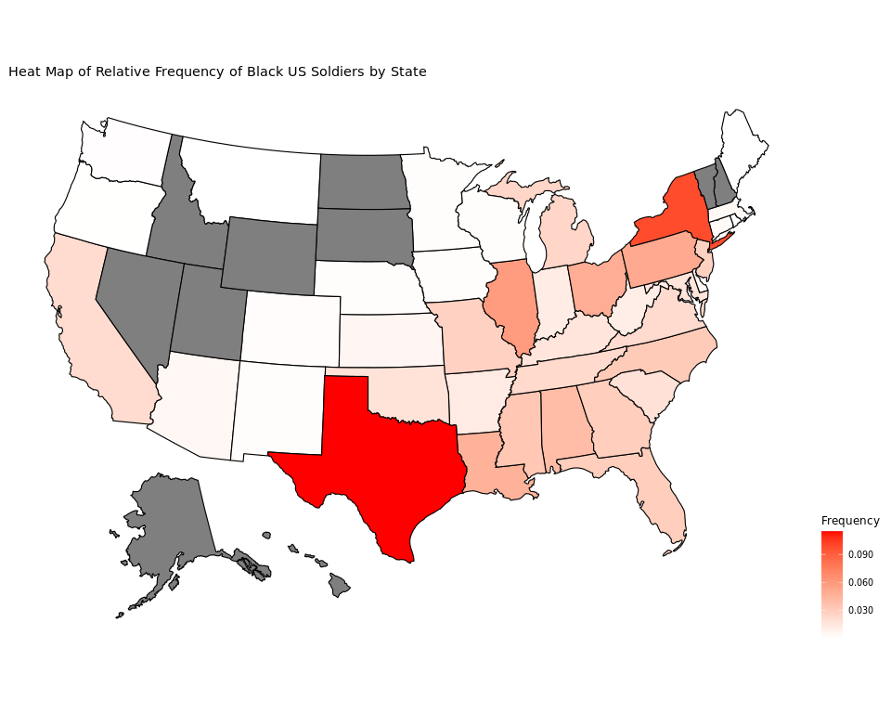

### What sort of places did they live in?

As expected, most soldiers whose home communities are large cities had the most representation across both groups. White soldiers saw roughly equal representation from soldiers who came from a farm, town, or city with actually slightly less people from cities. On the otherhand, the next community with the largest representation for black soldiers was a city followed by farms and towns which had approximately similar contributions.

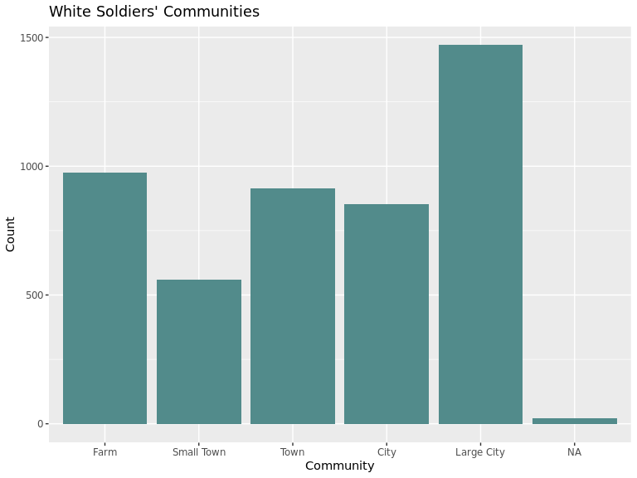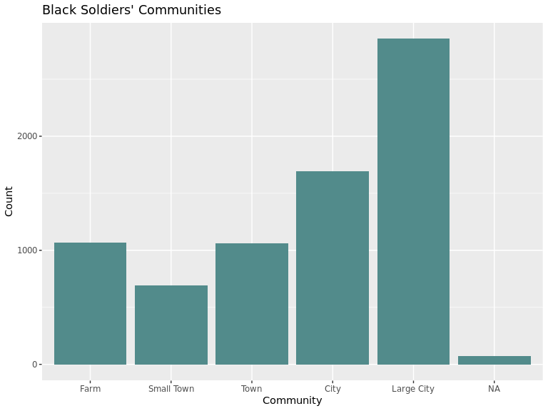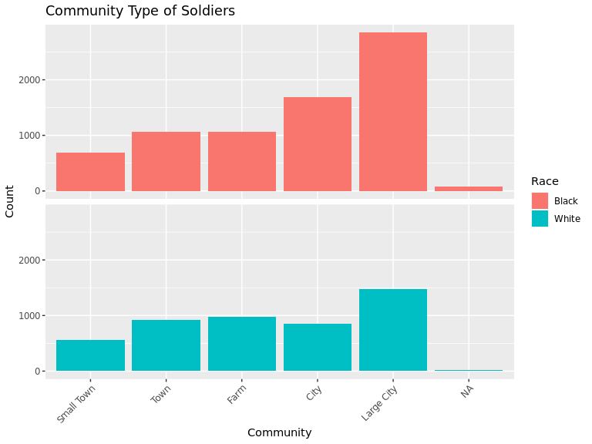

### Integrating Outfits

Our key variable of interest from this survey is the soldiers opinions on integrating their outfits. Expectedly, we see the vast majority of white soldiers are against integrating however the black soldeirs seem to be divided on whether they want integration or not. They are rougly evenly split on keeping outfits seperated and integrating them and a good amount are also undecided or indifferent. 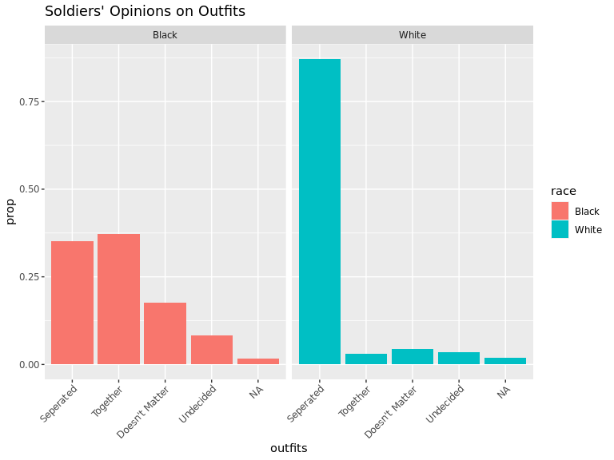

## Deeper relationships

Of course, we are interested in seeing how these variables intearct with one another to underdstand and reveal any deeper inticracies in the data.

### Breaking down Education

When we overlay the distribution of education levels with age ranges, we see that older white soldiers made up a larger porportion of white soldiers with less education compared to soldiers with some high school. As a contingent, it appears that soldiers between 21 and 24 with a high school education make up the largest contingent of white white soldiers when grouped by education and age.

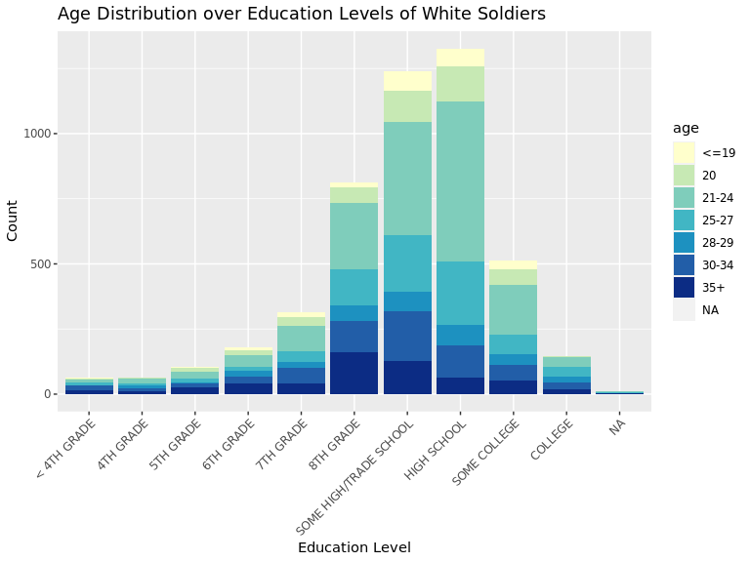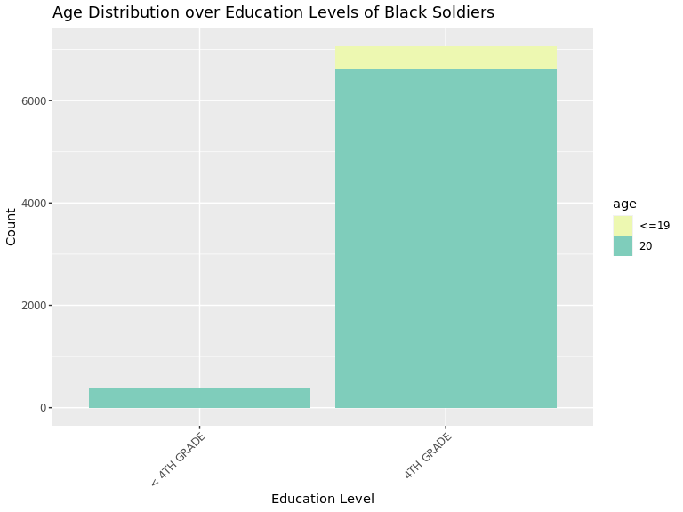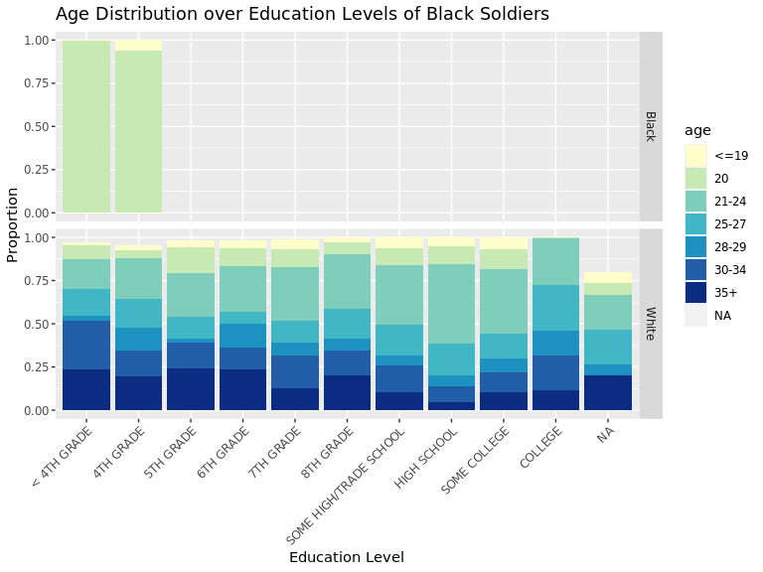

We see that larger portions of soldiers who are more educated come from communities whihc are larger in population.

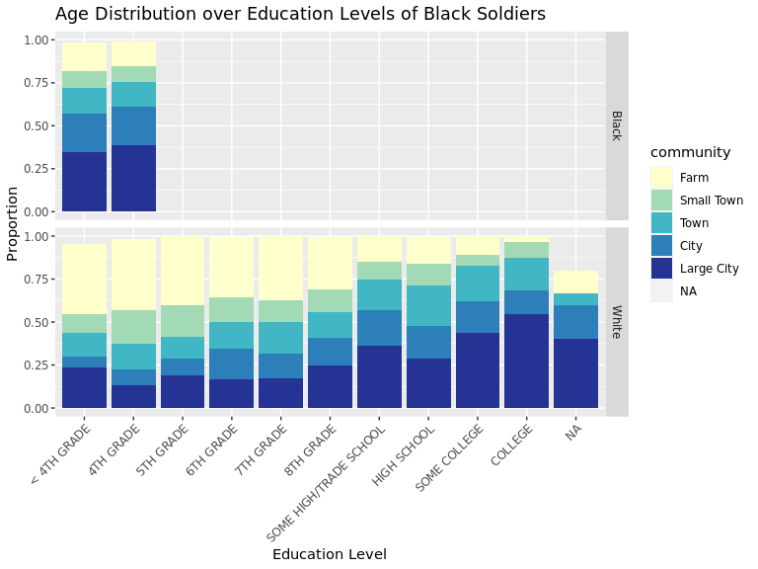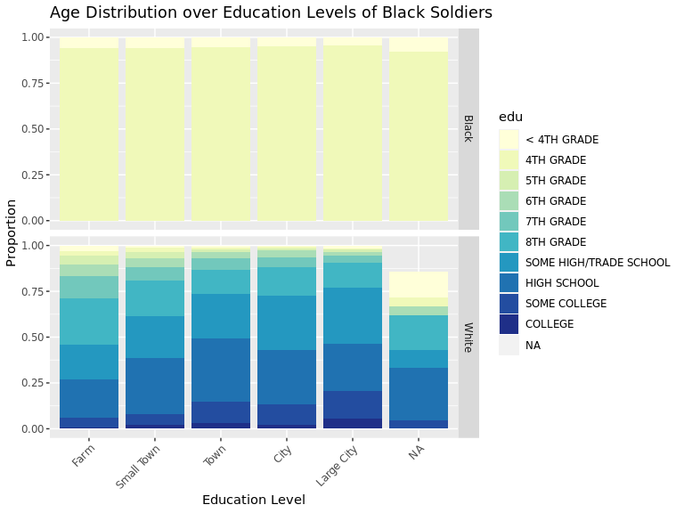

### Breaking Down Enlistment

Due to the sample only having black soldiers no older than 20 we can't discern if race may have an impact on how different age groups enlist. For the most part, age makes no difference among the white soldiers in this regard with the exception that those 19 and younger enlisted through the draft and volunteering at similar rates. Of course, we should keep in mind that there were not that many soldiers within this group to begin with. 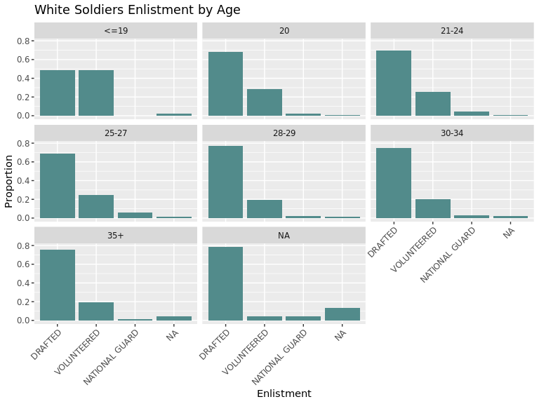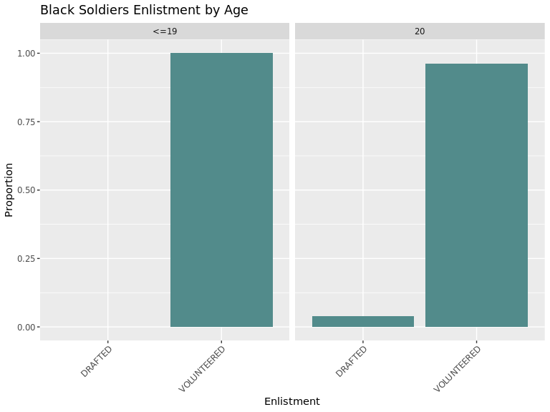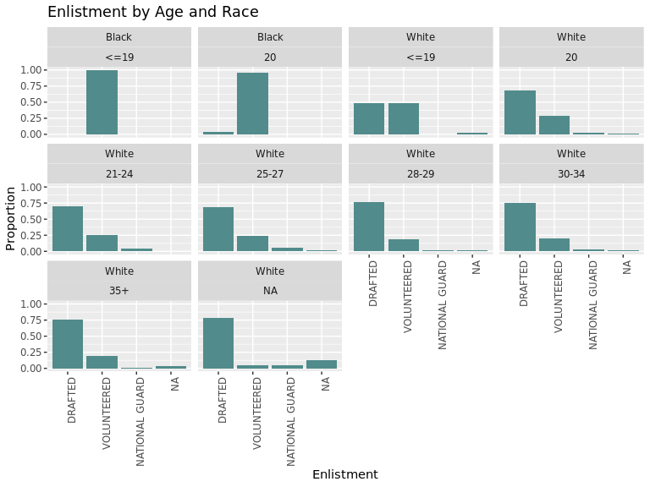

Not to interesting, white volunteered soldiers appear to be slighly younger. 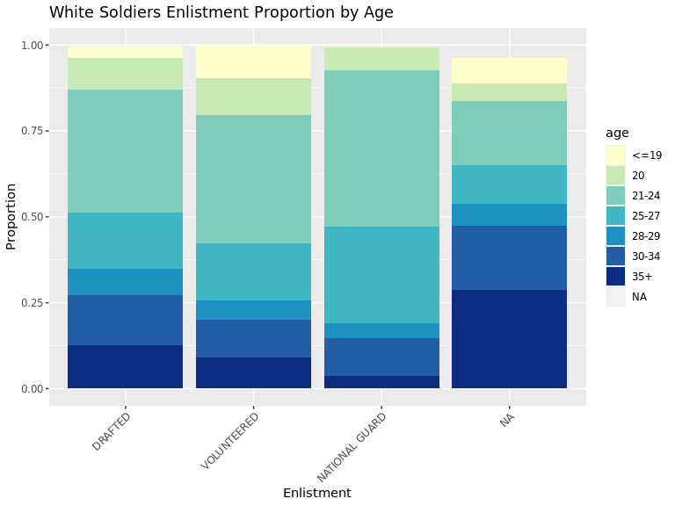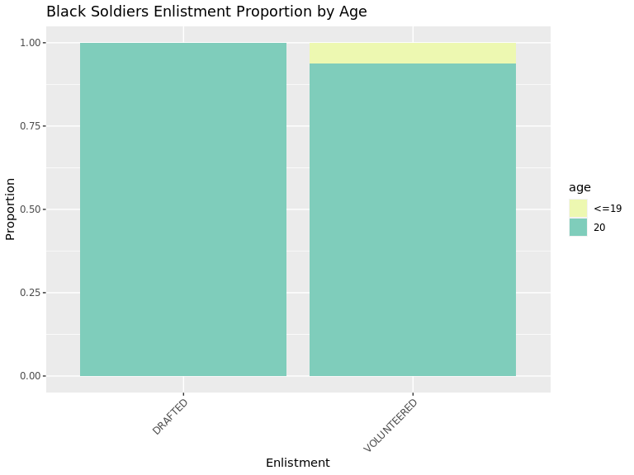

### Breaking Down Outfits Opinion

If we look at the proportion of ages who elected for each category we see that the proportions are relatively stable across all opinions towards integration.

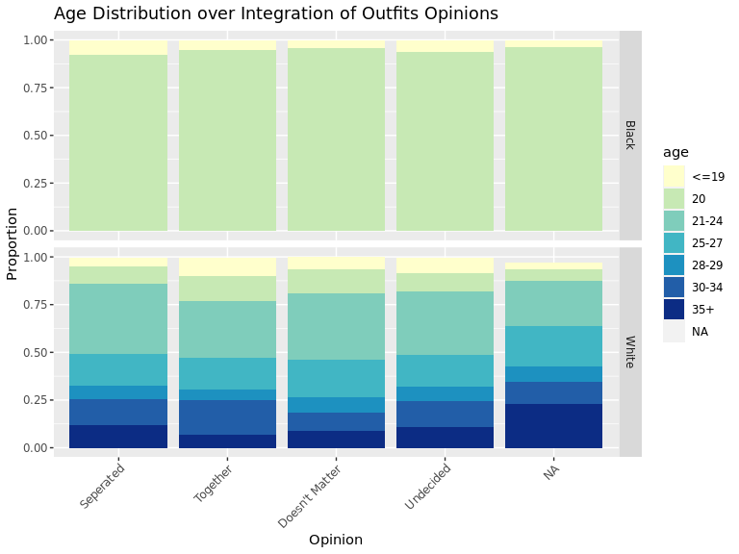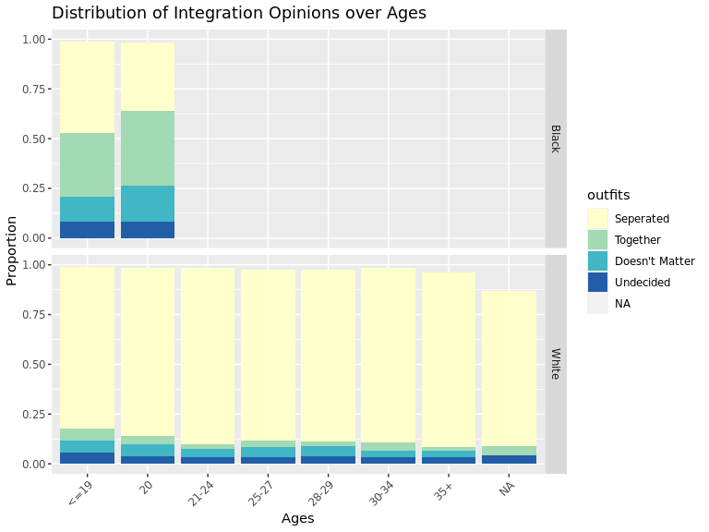

Now if we are to overlay the education distribution over the integration opinions we see something more interesting. It appears that the white soldiers that voted for the outfits to be together skew towards being more educated. In fact, over 50% of the soldiers who did vote for integrated units have atleast finished high school. This is not the case for any of the other responses.

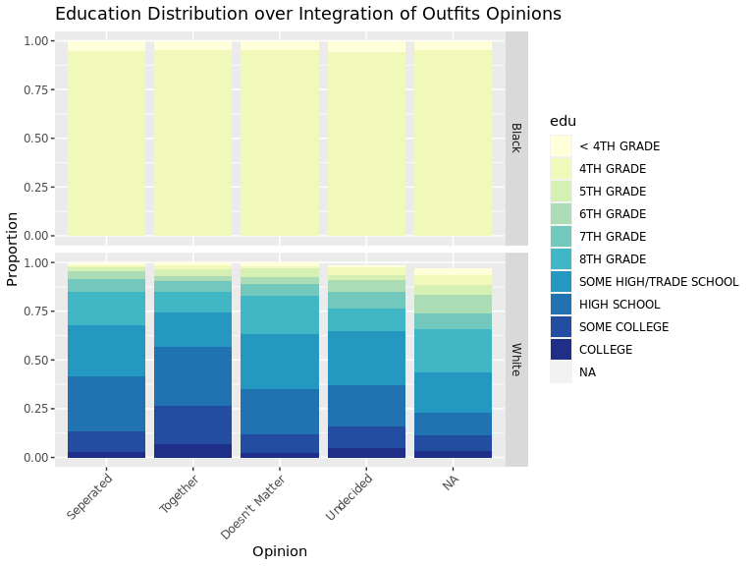

Across both races we also see that of those who choose integration a greater portion were from large cities and soldiers who came from more populated voted for sepration less proportionally.

