Load cell calibration report

Illustrating common tasks in reproducible reporting

Richard Layton

2016-08-24

# Introduction

Calibrating a *load cell* (a sensor for measuring uniaxial force) yields two main results: a calibration equation relating output voltage (mV) to input force (lb); and an estimate of sensor accuracy as a percentage of full span. In this report, I present the test results for an Omega LCL-005 load cell calibrated following the ANSI/ISA procedure [1].

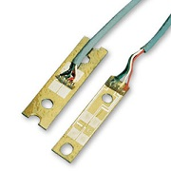

Figure 1. Omega LCL005 load cell (replace stock photo with image of our setup)

The data, shown in Table 1, has 41 observations over 6 up-down cycles. Per the ANSI/ISA standard, the test begins and ends at a midspan test point in the same direction, thus the first and last cycle are incomplete (indicated by NA).

Table 1: Calibration data

|  |  |  |  |  |  |  |  |
| --- | --- | --- | --- | --- | --- | --- | --- |
| Test point | Force (lb) | Cycle 1 (mV) | Cycle 2 (mV) | Cycle 3 (mV) | Cycle 4 (mV) | Cycle 5 (mV) | Cycle 6 (mV) |
| 2 up | 1.5 | NA | 29.9 | 30.2 | 29.5 | 30.7 | 30.7 |
| 3 up | 2.5 | 51.1 | 49.4 | 49.7 | 49.6 | 48.5 | 51.6 |
| 4 up | 3.5 | 70.4 | 70.0 | 70.1 | 70.7 | 71.0 | NA |
| 5 up | 4.5 | 88.8 | 91.6 | 89.5 | 91.4 | 91.2 | NA |
| 4 dn | 3.5 | 69.4 | 69.0 | 68.5 | 68.6 | 70.8 | NA |
| 3 dn | 2.5 | 49.5 | 50.1 | 49.8 | 49.2 | 50.6 | NA |
| 2 dn | 1.5 | 30.7 | 30.8 | 29.2 | 28.5 | 30.0 | NA |
| 1 dn | 0.5 | 8.7 | 10.9 | 10.6 | 10.7 | 9.5 | NA |

# Analysis

*Calibration curve.* The independent variable in this calibration is the sensor input (force) and the dependent variable is the sensor output (voltage readings). Performing a linear regression yields the results summarized in Table 2.

Table 2: Regression results

|  |  |  |
| --- | --- | --- |
| Result | Value | Units |
| slope | 20.04 | mV/lb |
| intercept | -0.09 | mV |
| adjusted $R^{2}$ | 1.00 | mV |
| max residual | 1.58 | mV |
| min residual | -1.56 | mV |

Thus the calibration equation in terms of the force $F$ (lb) and the sensor readout $R$ (mV) is given by

$$R=20.04F-0.09$$

and the calibration curve is shown in Figure 2. The data markers in the graph have been jittered to reduce overprinting, but the regression line is based on non-jittered values.

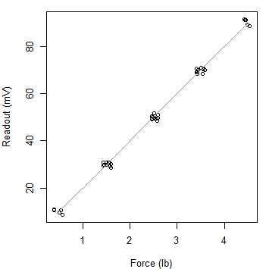

Figure 2: Calibration curve.

*Accuracy.* Accuracy is defined as the largest positive and the largest negative residuals of the regression. Thus, from Table 2, the accuracy bounds are $1.58$ mV and $-1.56$ mV. The residuals are plotted in Figure 3 with the upper and lower bounds indicated with dashed lines.

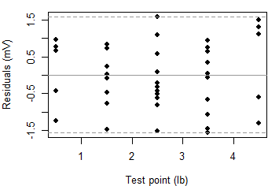

Figure 3: Residuals from the linear regression

As a percentage of span, sensor accuracy is $+1.97$ and $-1.94$%. Many users prefer a single value to estimate systematic uncertainty in a measurement, so we take the more conservative of the two numbers and report

accuracy $=±1.97\%$ of reading

# References

1. (1993) *Process instrumentation terminology*, American National Standards Institute/International Society of Automation, ANSI/ISA-S51.1-1979 (rev. 1993).