## 

## 

## EE 242-02

## Electrical Engineering Department

## Lab #1

## Phasor Diagrams and Power Measurements

## Report Delivered on: 01-17-25

## Lab Partners: Allen Dinh, David Rock, Alan Odnoblyudov

## Group 1

**Introduction**

Experiment #1 constructs phasor diagrams using GeoGebra and measures real, reactive, and apparent power in AC circuits. The lab examines series RL and RLC circuits under AC steady-state conditions. The objectives are to confirm Kirchhoff’s Voltage Law, determine inductor parameters (L, RL, Q), and calculate circuit power factors. The procedures involve measuring voltages, drawing phasor diagrams, and comparing results to calculated values.

**Procedure**

**RL (Resistor and Inductor) Circuit Measurements**

Equipment

* Keysight EDU33121A Function Generator
* Keysight EDU34450A Digital Multimeter
* Keysight EDU33121A Function Generator
* Keysight EDU34450A Digital Multimeter
* Extech 380193 LCR Meter
* Inductor Decade Box (0.1H)
* Resistor Decade Box (1kW)
* Capacitor Decade Box (0.4mF)
* BNC-Banana
* Banana-Banana
* Bag of short leads

**1.** Create LTSpice Schematic with specifications from the pre-lab.

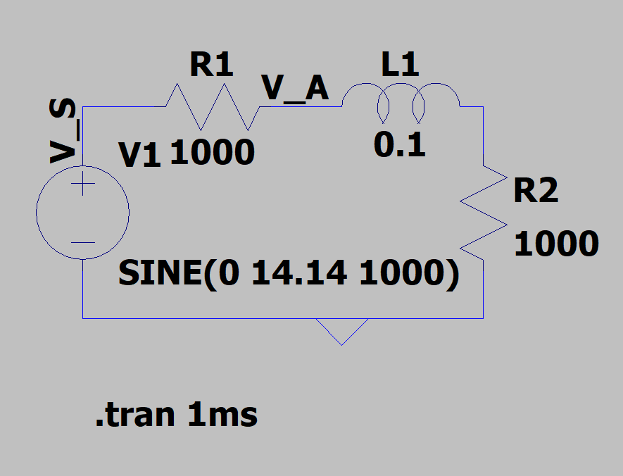

Figure 1.1 (LTSpice Schematic of RL Circuit)

**1.2** Simulate Circuit at VS (Black) and VA (Red) VR(Green)

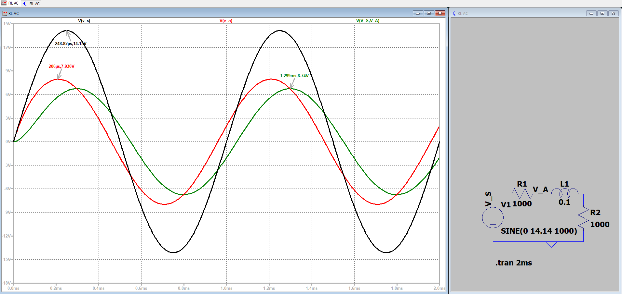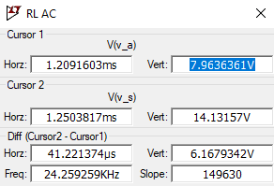

Figure 1.2 (LTSpice Simulation)

**1.3** Record Theoretical Measurements for VA, VR, and VS

VA: VS: VR: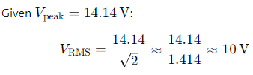

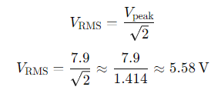

| VA | 5.58 V RMS |
| --- | --- |
| VR | 4.76 V RMS |
| VS | 10 V RMS |

Figure 1.3 (Theoretical Values)

**1.4** Measure Experimental Values for VA, VR, and VS

| VA | 6.8372 V RMS |
| --- | --- |
| VR | 3.1224 V RMS |
| VS | 9.8802 V RMS |

Figure 1.4 (Recorded Values)

**1.5** Geogebra Phasor Diagram for RL Circuit

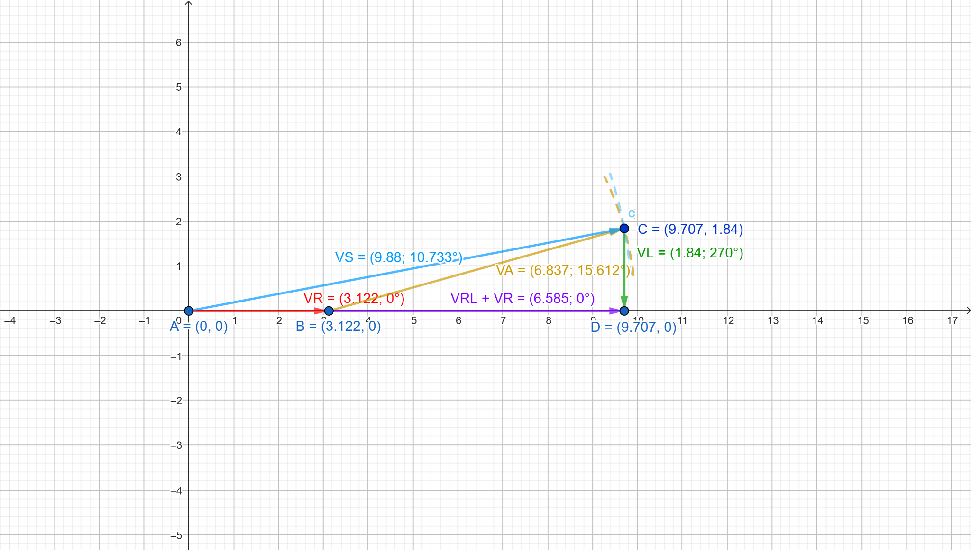

Figure 1.4 (RL Phasor Diagram)

**1.6**  Power Calculations

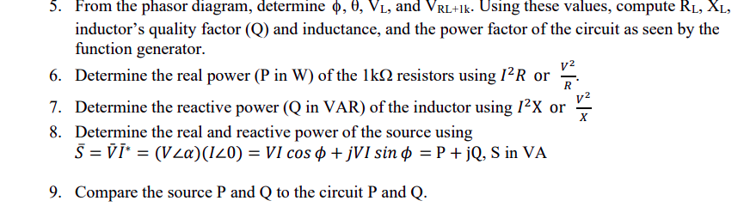

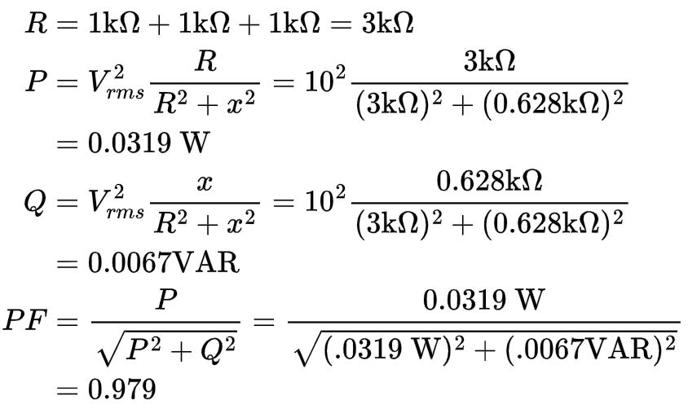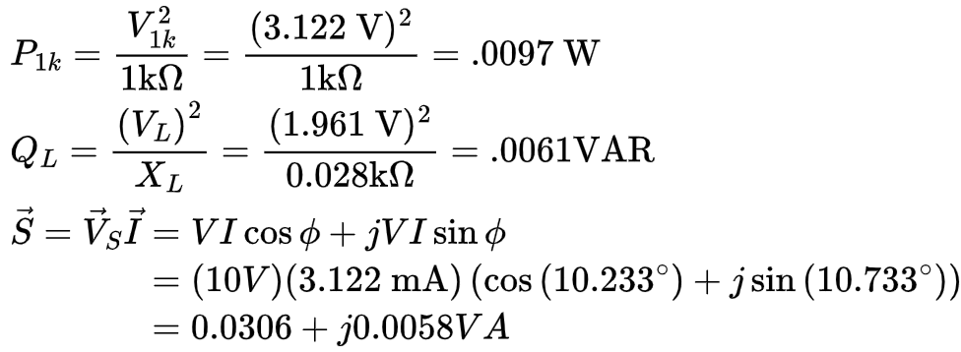

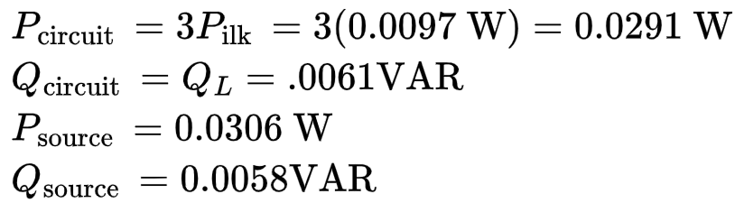

**RL (Resistor and Inductor) Circuit Measurements**

**2.1** Create LTSpice Schematic of RLC (Resistor, Inductor, and Capacitor)

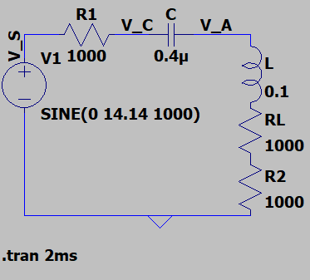

Figure 2.1 (LTSpice RLC Schematic)

**2.2** Measure Theoretical Values for VS (Black),VA (Red), VR(Green), and VC (aqua)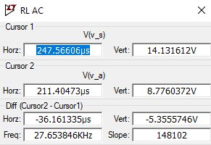

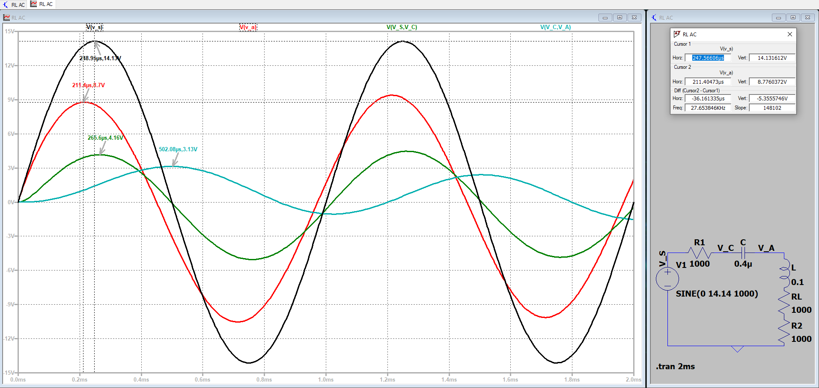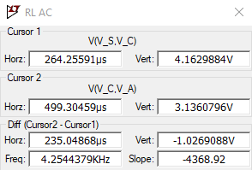

Figure 2.3 (RLC Simulation)

**2.3** Convert Theoretical Values of VA, VC, VR , and VS to RMS

VA: VR:



VC: VS:



| VA | 6.20 V RMS |
| --- | --- |
| VC | 2.21 V RMS |
| VR | 2.94 V RMS |
| VS | 10 V RMS |

Figure 2.3 (Theoretical Values)

**2.4**  Measure Experimental Values

| VA | 6.9449 V RMS |
| --- | --- |
| VC | 1.2274 V RMS |
| VR | 3.174 V RMS |
| VS | 9.8750 V RMS |

Figure 2.4 (Measured Values)

**2.5** Geogebra Phasor Diagram of RLC Circuit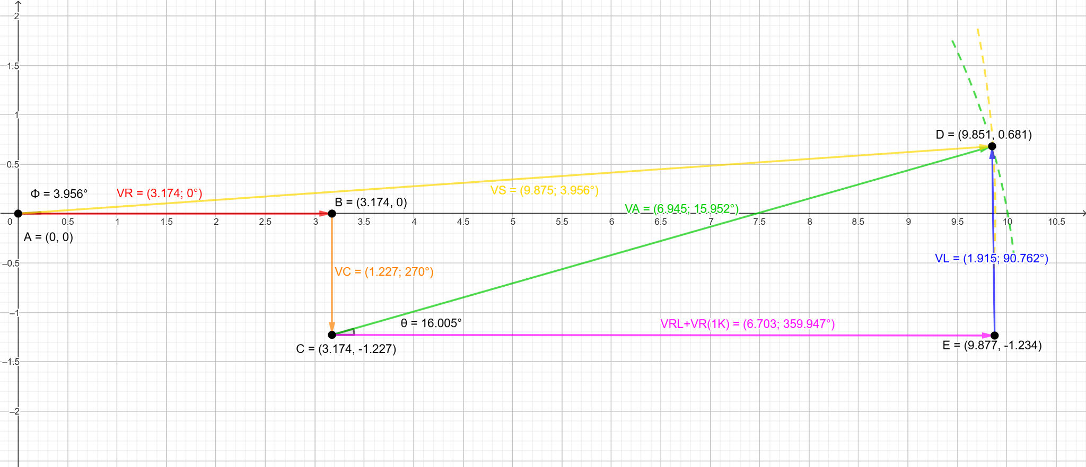

Figure 2.5 (RLC Phasor Diagram)

**2.6** Power Calculations

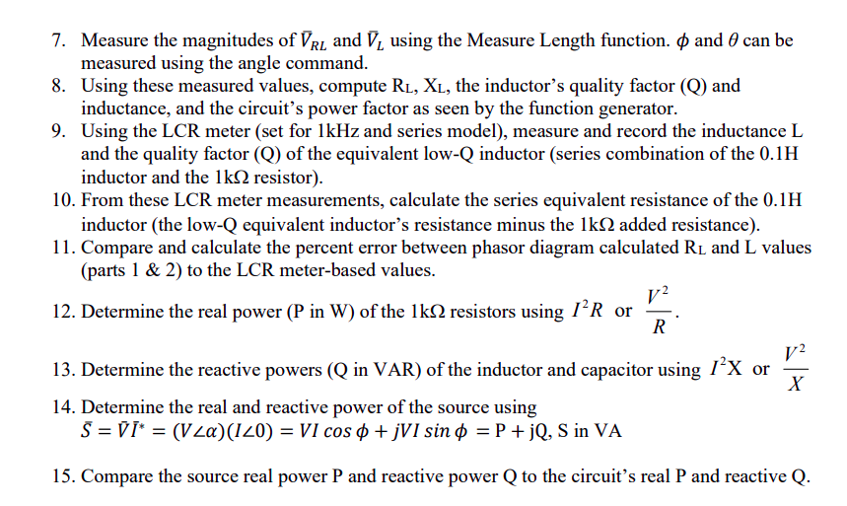

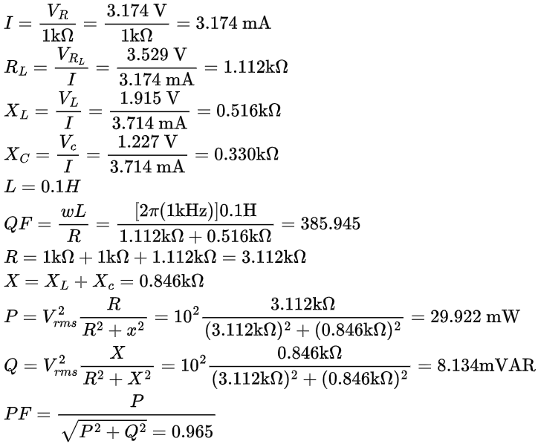

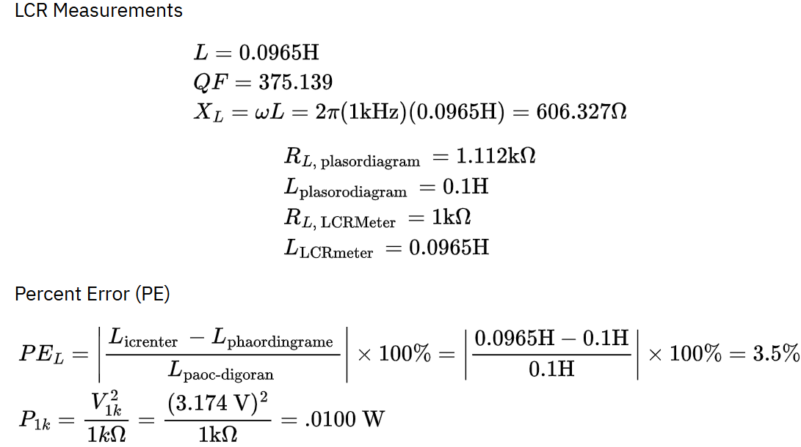







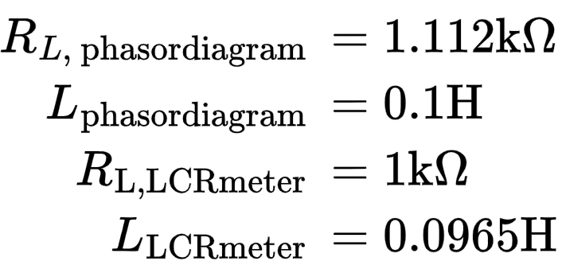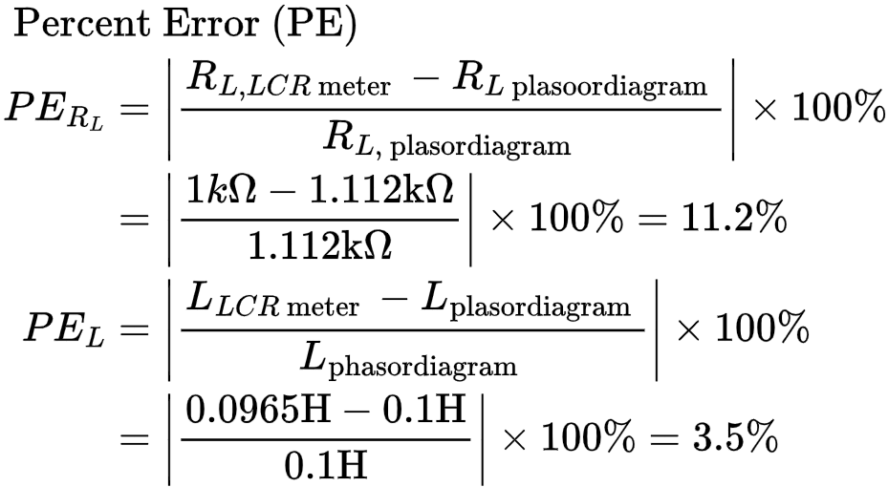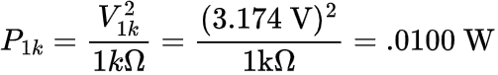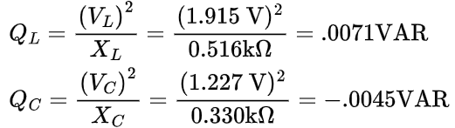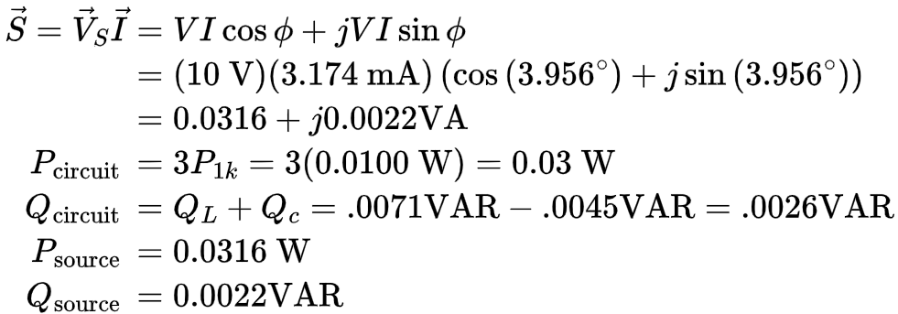

Both real and reactive power of both the source and the circuit are similar to the

hundredths for real power and thousandths place for reactive power.



**Conclusion**

The experiment successfully achieved its objectives by constructing accurate phasor diagrams, confirming Kirchhoff's Voltage Law, and analyzing AC steady-state behavior in series RL and RLC circuits. Inductor parameters, including inductance (L), resistance (RL), and quality factor (Q), were determined, and power factors were calculated. Comparisons between measured and calculated values demonstrated consistency, validating the experimental approach and highlighting the accuracy of the techniques employed. The phasor diagrams provided valuable insight into the phase relationships between voltage and current, emphasizing the effects of inductive and capacitive reactance on circuit behavior.

Additionally, the experiment underscored the significance of real, reactive, and apparent power in understanding energy transfer within AC circuits. The systematic procedures used, such as voltage measurements and phasor construction, demonstrated practical applications of theoretical concepts, bridging the gap between calculation and real-world circuit analysis. These results not only reinforce the importance of precise measurement techniques but also lay a foundation for more advanced studies in AC circuit design and analysis.