## 

## 

## EE 242-02

## Electrical Engineering Department

## Lab #3

## Maximum Power Transfer

## Report Delivered on: 02-07-25

## Lab Partners: Allen Dinh, David Rock, Alan Odnoblyudov

## Group 1

**Introduction**

This lab aimed to achieve maximum power transfer in an AC steady-state circuit. Initially, the circuit consisted of a function generator, a 5mH inductor, and a complex load (with some resistance and capacitance), all in series. The load was later replaced with a purely resistive load.

**Equipment List**

* 1 5 mH Inductor
* 2 Resistor Decade Box
* 2 Capacitor Decade Box, 1F range with 0.1 and 0.01F steps
* 1 Keysight EDU33121A Function Generator
* 1 Keysight EDU34450A Digital Multimeter
* 1 Keysight DSOX1202G Digital Storage Oscilloscope
* 2 Bags of Short Leads
* 3 BNC-Double Banana
* 1 5 mH High-Q Inductor
* 2 Banana-Banana Leads

**Procedure**

1. Set up the circuit with a function generator, inductor, and decade resistor and capacitor boxes.
2. Configure the function generator to produce a 5 V RMS sine wave at 2.5 kHz with "HIGH Z" output.
3. Adjust the capacitor (CL) in steps of 0.1 µF until the Lissajous pattern on the oscilloscope forms a diagonal line, indicating in-phase voltage across the load resistor (RL).
4. Record the optimal CL value where maximum load power occurs and ensure the voltages are in phase.
5. Vary the load resistor (RL) from 20 Ω to 150 Ω in 10 Ω increments, record the voltage drop across RL, and calculate the average power dissipation for each setting. Additionally, measurements with 1Ω steps were taken within ±5Ω of theoretical maximum resistance value.
6. Identify the RL value that gives the maximum power dissipation and use it to determine the Thevenin resistance of the function generator (RG).
7. Modify the circuit by removing the capacitor (CL) for a purely resistive load configuration.
8. Repeat the process of varying RL from 20 Ω to 150 Ω in 10 Ω increments, measuring the voltage drop, and calculating power dissipation.
9. Determine the RL value that maximizes power for the purely resistive load.
10. Compare experimental values of RL and maximum power with theoretical calculations, noting any discrepancies and providing justifications.

**Data**

**Section 1: Maximum Power Transfer and Function Generator Internal Impedance**

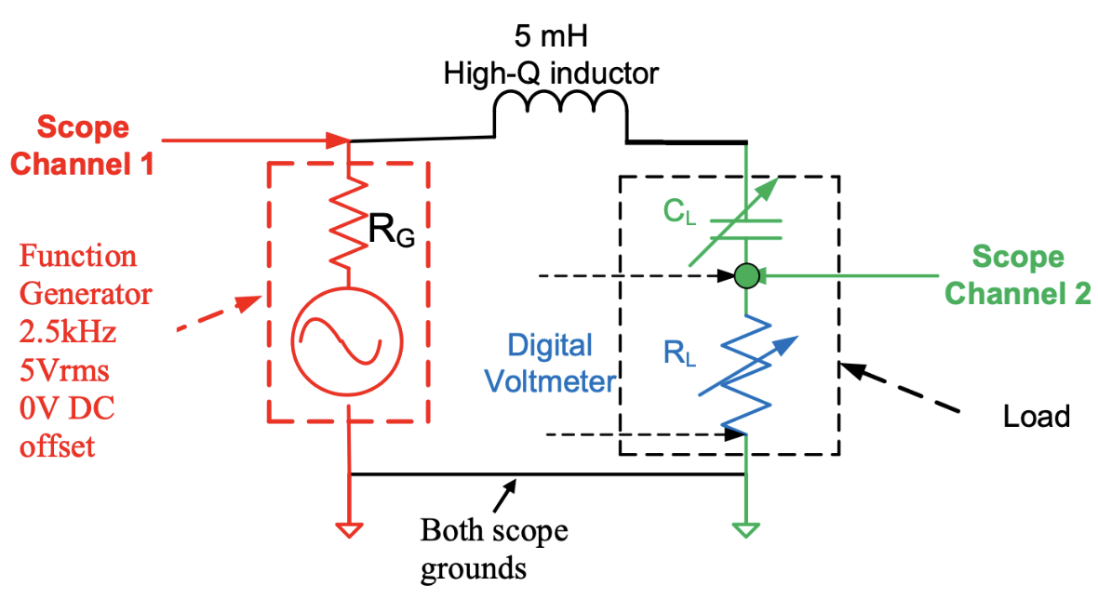

Figure 1.1: Schematic of Series RLC

1.1 Determining CL for source voltage and VRL to be in phase (0o)

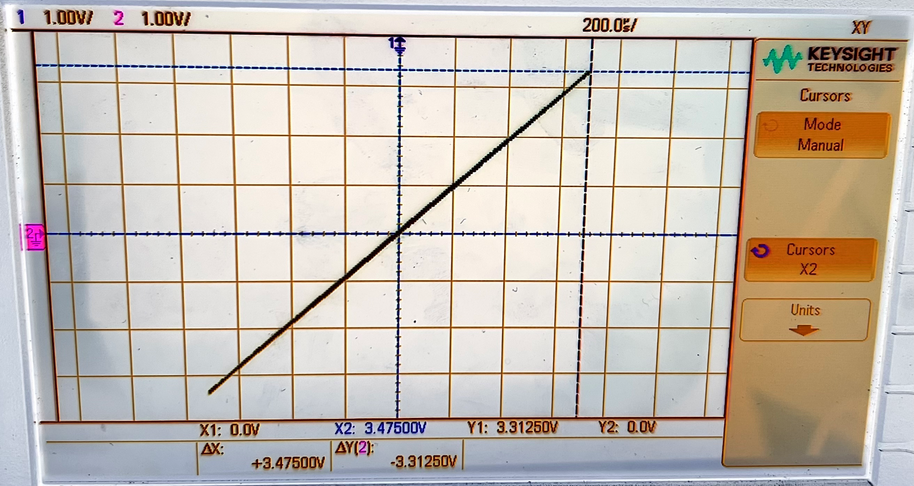

Figure 1.2: Lissajou Plot of Vsource (Channel 1) and VRL (Channel 2) for a CL Value of 0.813 uF

1.2 Plotting PRL vs RL and recording greatest PRL to the nearest 1 ohm

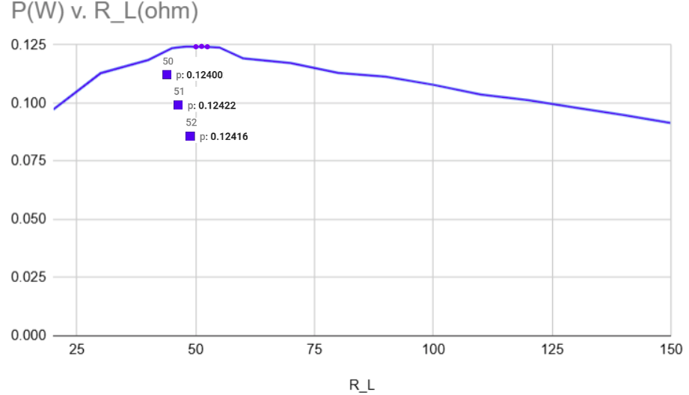

Figure 1.3: Plot of Pload(W) vs. RL(Ohm) with a 0.813uF capacitor in the load. The three highest power values for both cases are labeled with their corresponding resistance values.

**Section 2: Maximum Power Transfer for Purely Resistive Load**

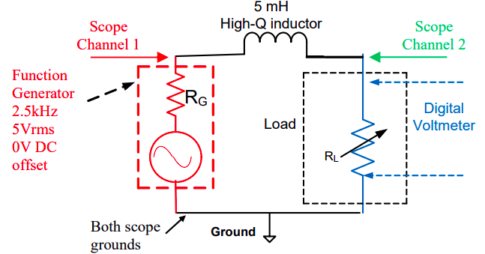

Figure 2.1: Schematic of series RL

2.1 Plotting average dissipated power in RL vs RL and recording peak power RL value to the nearest 1 ohm

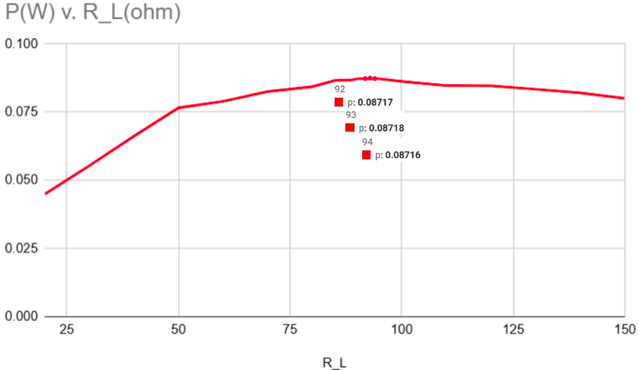

Figure 2.2: Plot of Pload(W) vs. RL(Ohm) with a purely resistive load. The three highest power values for both cases are labeled with their corresponding resistance values.

**Discussion**

**Section 1: Maximum Power Transfer and Function Generator Internal Impedance**

1.1 Determining CL for source voltage and VRL to be in phase (0o)

We know that Vsource and VRL are in phase (0o) by the following:

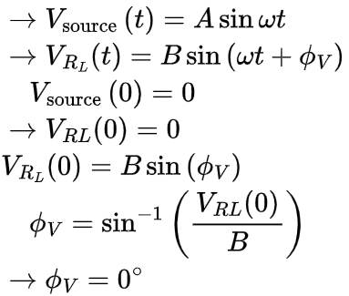











1.2 Determining the function generator’s Thevenin resistance (output resistance) RG from Figure 1.3

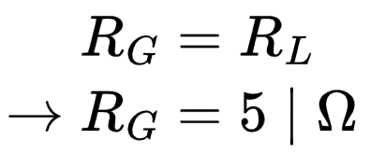 

1.3 Using information from Figure 1.2 and Figure 1.3 to determine ZL for maximum power transfer

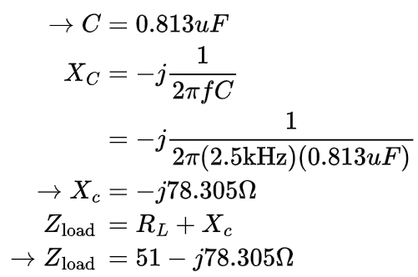







1.4 Comparing the experimentally obtained ZL value for maximum power transfer against its theoretical value (in prelab)

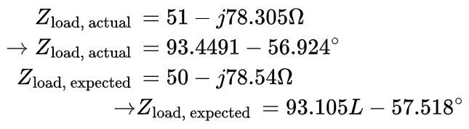





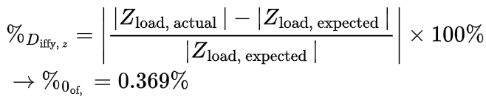



**Section 2: Maximum Power Transfer for Purely Resistive Load**

2.1 Comparing the value of RL for maximum power transfer to its expected value (in prelab)

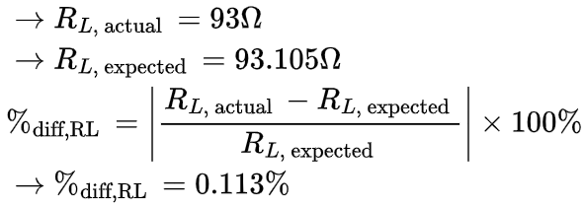





2.2 Using the inductor’s nominal value and the function generator’s internal resistance (obtained in Section 1.3 of this report) to calculate the theoretical value of RL for maximum power transfer

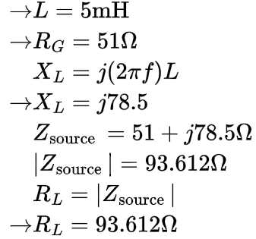

2.3 Comparing experimental vs. theoretical values for maximum power delivered to the load

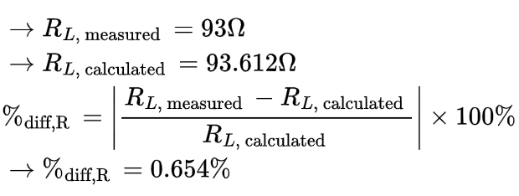



2.4 Justify differences between measured and calculated values

Equipment tolerance and measurement discrepancies.

**Conclusion**

From Figure 1.3 and Figure 2.2:

* The maximum power for the complex load was found to be 0.1242 W using a 51Ω resistor, while the maximum power for the purely resistive load was 0.08718 W using a 93Ω resistor.
* The percent difference between theoretical and measured load impedance was 0.369% for maximum power transfer of complex load.
* For the purely resistive load, the percent difference between the theoretical and measured values of its impedance was 0.113%.
* Impossible to achieve 0% error, due to discrepancies between nominal and actual component values (manufacturing process typically produce reactive components within ±5% tolerance)