## 

## 

## EE 242-02

## Electrical Engineering Department

## Lab #4

## Three Phase Networks

## Report Delivered on: 02-14-25

## Lab Partners: Allen Dinh, David Rock, Alan Odnoblyudov

## Group 1

**Introduction**

This lab deals with the simulation of three-phase systems. Using LTspice, we constructed a three-phase circuit based on pre-lab component values. The analysis included determining line currents, measuring the phase difference between the source voltage and line current, and calculating total system losses.

**Equipment List**

* LTspice 24.0.12

**Procedure**

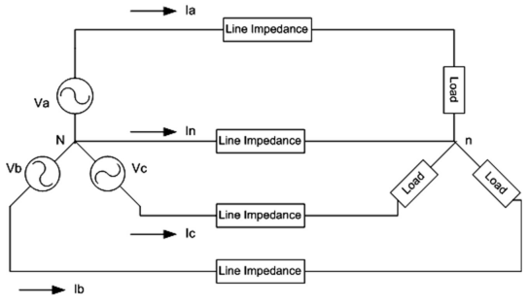

Figure 1: Assume that the three-phase circuit is balanced, where each voltage source has a magnitude (peak value) of 170V at 60Hz. The line impedance is (1 + j10) Ω, and the load impedance is (20 + j20)Ω.

1. Create an LTSpice circuit from Figure 1
2. Print the source three-phase voltage waveforms.
3. Print the load three-phase voltages.
4. Print the source Van and the current Ia waveforms and determine the angle between them. Also determine the power factor seen by the source. Is it leading or lagging?
5. Determine the system’s total losses.
6. Determine the three-phase system efficiency.
7. Print the circuit diagram.

**Data**

1.1 Printing the circuit diagram

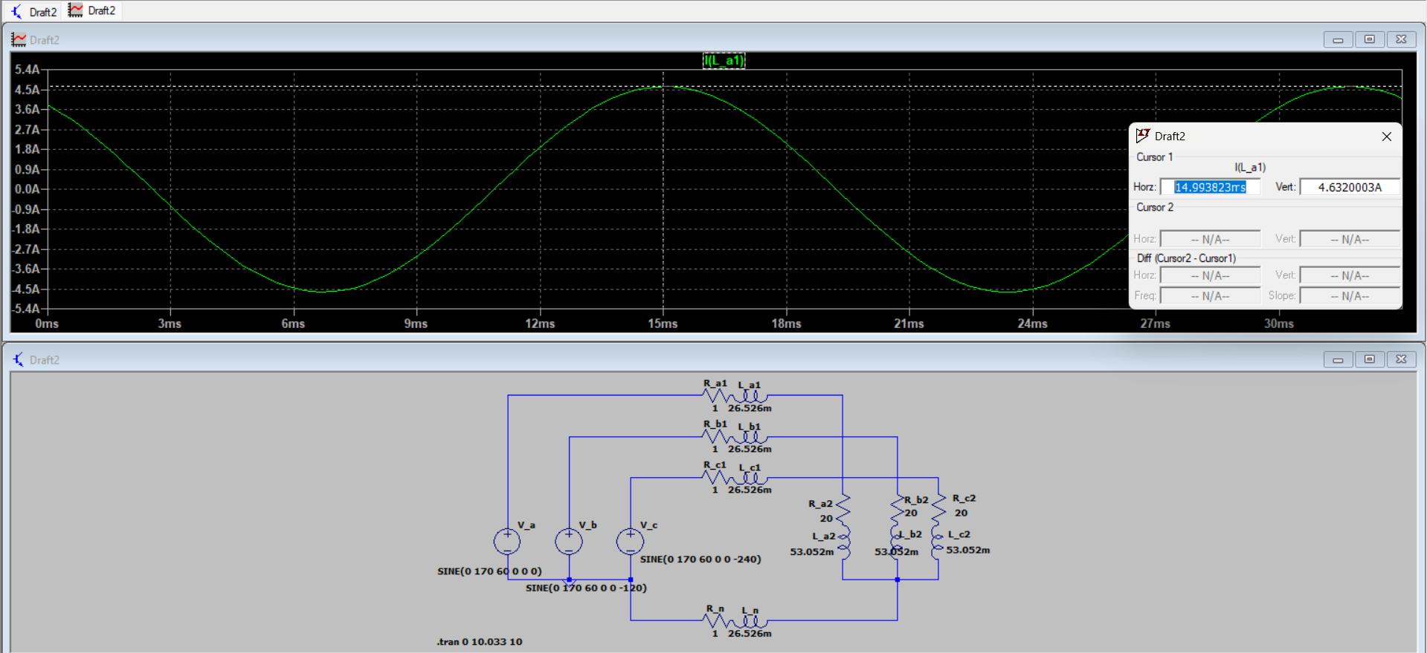

Figure 1.1: LTspice Schematic of Prelab4 three-phase circuit

1.2 Printing the source three-phase voltage waveforms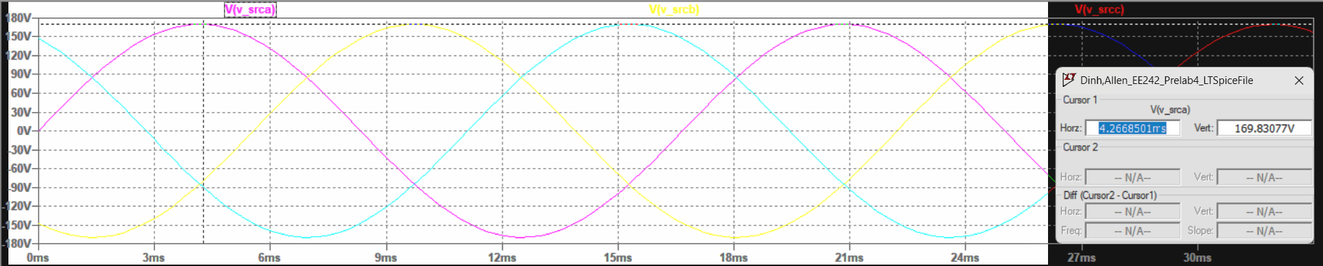

Figure 1.2.1: Voltage across source “a”, “b”, and”c”, with peak voltage of “a” (purple channel) at steady-state (169.83077 V)

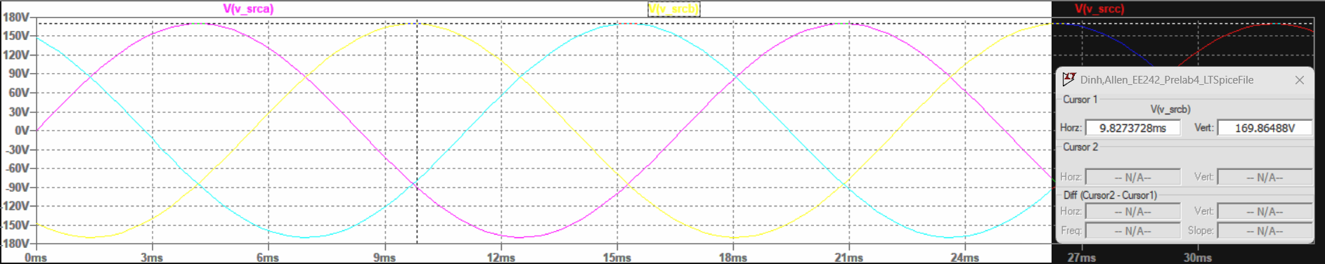

Figure 1.2.2: Voltage across source “a”, “b”, and”c”, with peak voltage of “b” (yellow channel) at steady-state (169.86488 V)

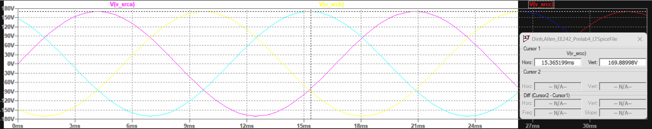

Figure 1.2.3: Voltage across source “a”, “b”, and”c”, with peak voltage of “c” (blue channel) at steady-state (169.88998 V)

1.3 Printing the load three-phase voltages

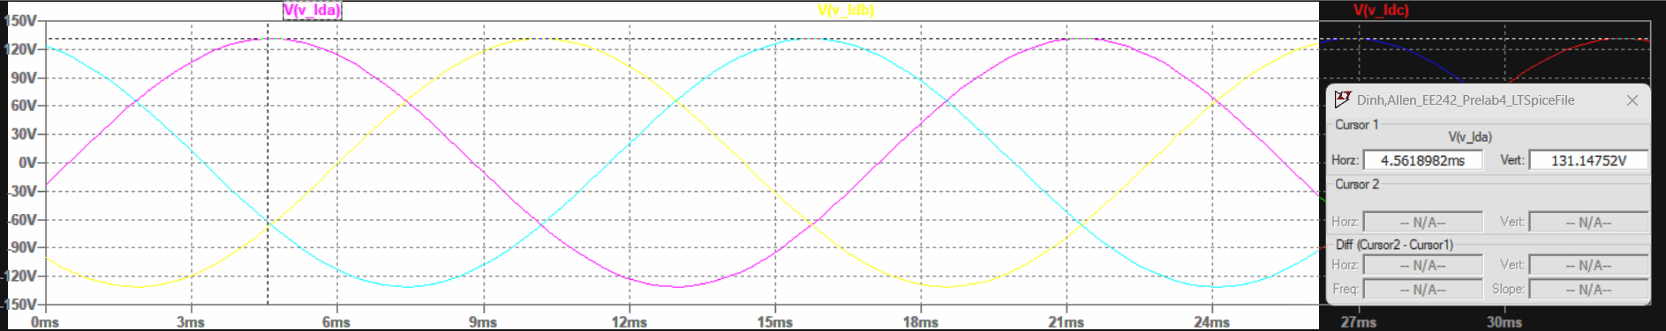

Figure 1.3.1: Voltage across load “a”, “b”, and “c” with peak voltage of “a” (purple channel) at steady-state (131.14752 V)

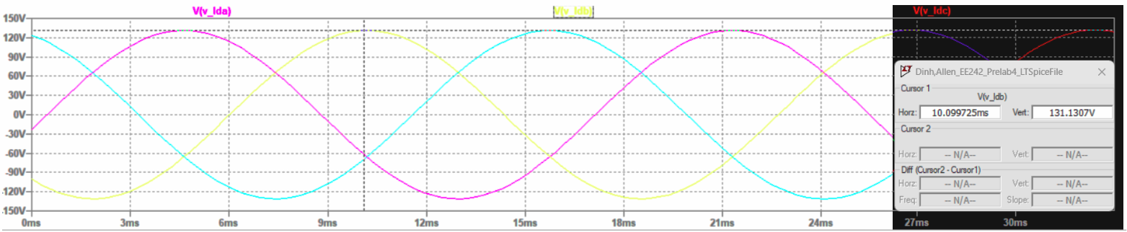

Figure 1.3.2: Voltage across load “a”, “b”, and “c” with peak voltage of “b” (yellow channel) at steady-state (131.1307 V)

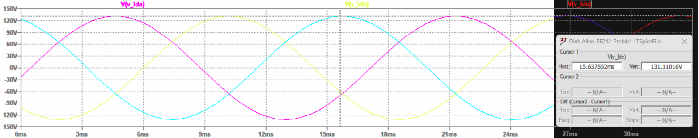

Figure 1.3.3: Voltage across load “a”, “b”, and “c” with peak voltage of “c” (blue channel) at steady-state (131.11016 V)

1.4 Printing the source Van and the current Ia waveforms

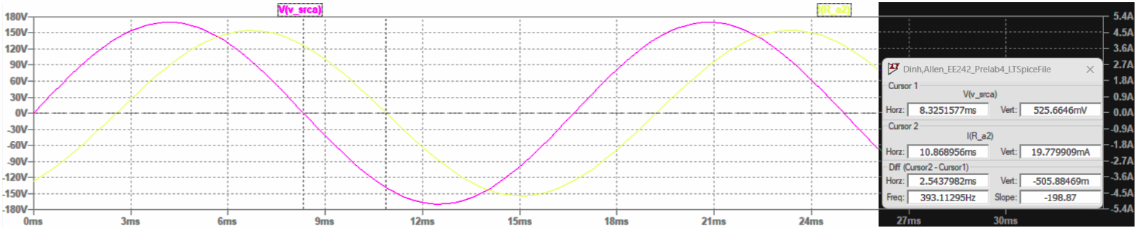

Figure 1.4.1: Voltage through source “a” (purple channel) and current across “a” components (yellow channel), with a time difference of 2.5437982ms

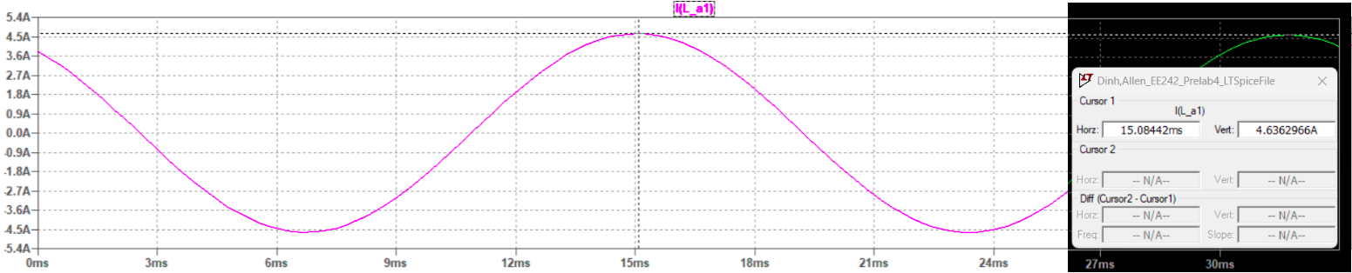

Figure 1.4.2: Current through “a” components and its peak amperage of 4.6362966 A at steady-state

**Discussion**

1.1 Determining the angle between the source Van and the current Ia

Using the time difference measured between Van and Ia in figure 1.4.1, we have:

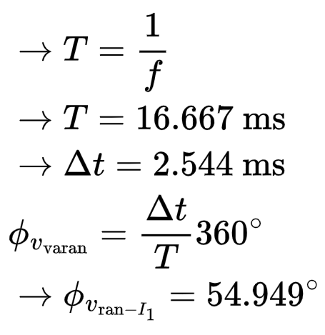





1.2 Determining the power factor seen by the source and whether it is leading or lagging



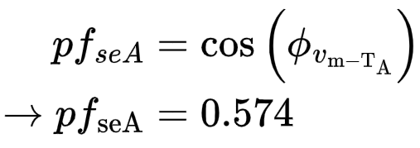

The power factor is lagging, as inductors are the only reactive components in the circuit.

1.3 Determining the system’s total losses

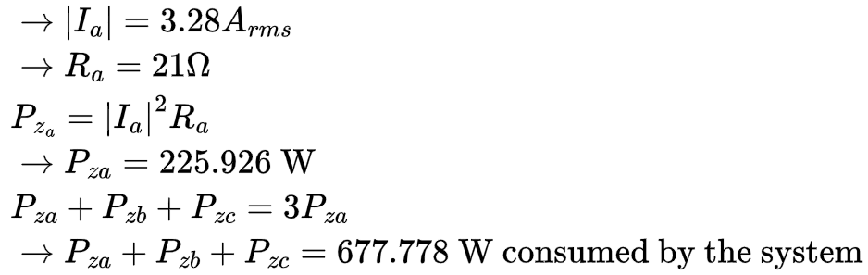









1.4 Determining the three-phase system efficiency

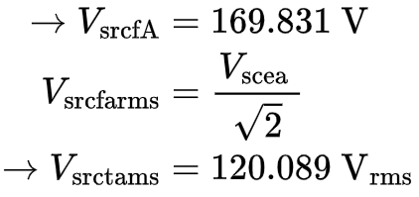





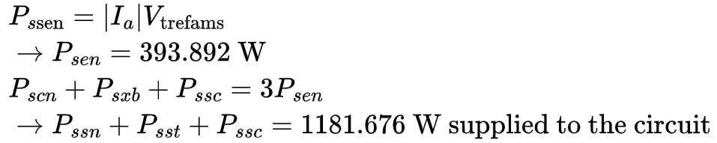







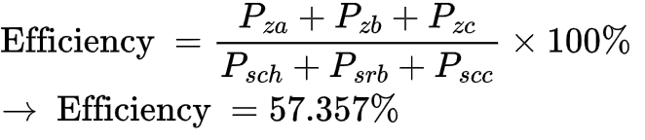



**Conclusion**

The results are summarized in the table below

| Calculation Type | Resulting Value |
| --- | --- |
|  | 54.949° |
|  | 0.574 |
| System Losses | 677.778W |
| Three Phase Efficiency | 57.357% |