## 

## 

## EE 242-02

## Electrical Engineering Department

## Lab #5

## Low-Pass and High-Pass Filters

## Report Delivered on: 02-21-25

## Lab Partners: Allen Dinh, David Rock, Alan Odnoblyudov

## Group 1

**Introduction**

This experiment measures the frequency response of RC low-pass and high-pass filters by analyzing their transfer function magnitude and phase. The low-pass filter attenuates high frequencies, while the high-pass filter attenuates low frequencies. Voltage measurements will be taken across the source and the resistor/capacitor while varying the frequency of the source from 5 Hz to 25,000 Hz to compare experimental and theoretical results.

**Equipment List**

1 Keysight EDU33121A Function Generator

1 Keysight EDU34450A Digital Multimeter

1 Keysight DSOX1202G Digital Storage Oscilloscope

1 Resistor Decade Box

1 Capacitor Decade Box

3 BNC-Banana

1 Bag of short leads

2 Banana-Banana leads

**Procedure**

**Section 1. Transfer function magnitude and phase measurements of RC low-pass filter**

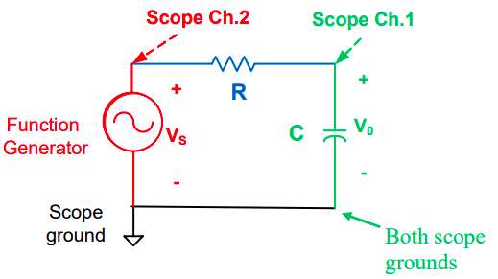

Figure 1: Low-pass filter schematic

1. Set up the circuit for the low-pass filter using R = 50kΩ and C = 0.02µF. Connect the circuit as shown in Figure 1. Set the function generator to High-Z output termination and adjust it to produce an 8V peak-to-peak sinusoidal waveform.

2. Measure the rms values of Vs and Vo using a digital multimeter. Record the phase difference of Vo relative to Vs.

3. Set the function generator frequency to the following values: 5 Hz, 25 Hz, 50 Hz, 250 Hz, 500 Hz, 2500 Hz, 5000 Hz, and 25000 Hz. Fine-tune the frequency to obtain ideal values at the half-power frequency and add additional rows if necessary.

4. Plot the transfer function magnitude and phase versus frequency using a logarithmic scale for frequency. Since the data is plotted, omit the table from the lab report.

5. Repeat steps 1 through 4 for the high-pass filter as shown in Figure 2.

**Section 2. Transfer function magnitude and phase measurements of RC high-pass filter**

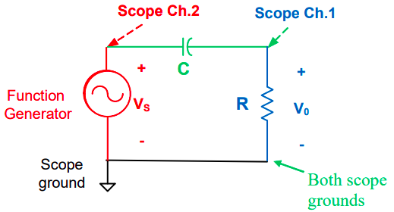

Figure 2: High-pass filter schematic

1. Open LTspice and create a new schematic for the low-pass filter. Select a voltage source, set it to small signal AC analysis, and set the amplitude to 1V.

2. Place the resistor and capacitor with values R = 50kΩ and C = 20nF. Connect all components using wires and ensure the circuit has a ground connection.

3. Set up AC analysis with a start frequency of 1 Hz and a stop frequency of 200 Hz. Adjust the range if necessary to capture the full response.

4. Place the voltage probe at the output and run the simulation. Print the circuit diagram and response.

5. Repeat steps 6 through 9 for the high-pass filter.

6. Determine the cutoff frequencies for both filters and compare the experimental, simulated, and theoretical values of the transfer function magnitude and phase at these frequencies. Note any discrepancies and provide explanations.

**Section 3. LTspice simulation, transfer function magnitude and phase responses of RC low-pass and high-pass filters**

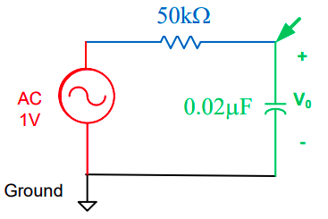

Figure 3: LTSpice Schematic of RC Low-Pass Filter (LPF)

1. From the File Menu of LTSpice, open “New Schematic”
2. Select voltage source: Edit Menu, select “Component” or F2
3. Select “Voltage” for a voltage source
4. Right click on source and select “Advanced”
   1. Select “Small Signal AC Analysis”
   2. Amplitude = 1
5. Select R and C from the Edit or Bar menu. Use the values specified in Figure 3.
6. Right click allows component value and unit specification (ohms and uF, etc.) Use ‘u’ for micro.
7. After placing all components on the schematic, add connections using the “wire” option, pencil icon.
8. Place the source ground.
9. Under “Simulate: select Run and then select AC Analysis
   1. Linear
   2. 20
   3. Start: 1Hz
   4. Stop: 200Hz
   5. Adjust (as necessary) start and stop frequencies to show complete LPF or HPF responses
10. Place the voltage probe at the circuit output and left click.
11. Repeat all above steps for the high-pass filter, HPF.
12. Print the LPF and HPF circuit diagrams and characteristics. Verify legibility.
13. Determine the cutoff frequencies (fc) for both the LPF and HPF (note |H(fc)| and H(fc) values for both circuits) and compare to theoretical values.

**Data**

**Section 1.1 Transfer function magnitude and phase measurements of RC low-pass filter**

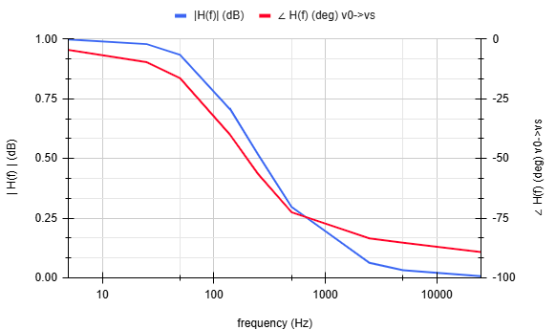

Figure 1.1.1: The experimental transfer function’s magnitude and phase vs. frequency (LPF)

Table 1.1.1: Fine tuning the frequency (nearest 0.1Hz) to obtain |H| = 1/sqrt(2) = 0.7071 (LPF)

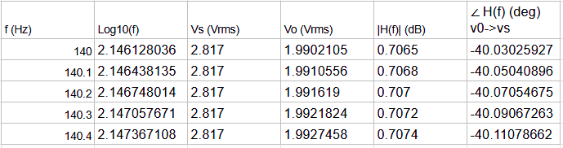

**Section 1.2 Transfer function magnitude and phase measurements of RC high-pass filter**

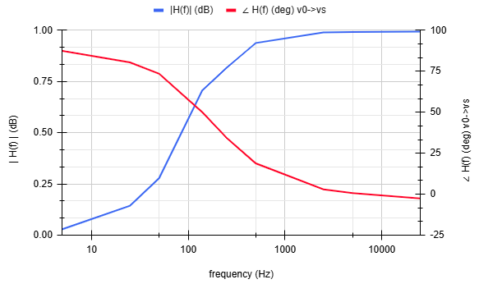

Figure 1.2.1: The experimental transfer function’s magnitude and phase vs. frequency (HPF)

Table 1.2.1: Fine tuning the frequency (nearest 0.1Hz) to obtain |H| = 1/sqrt(2) = 0.7071 (HPF)

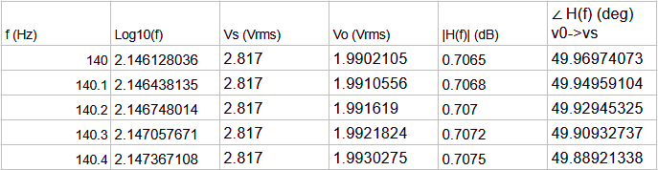

**Section 1.3. Calculated transfer function magnitude and phase plots for LPF/HPF in prelab**

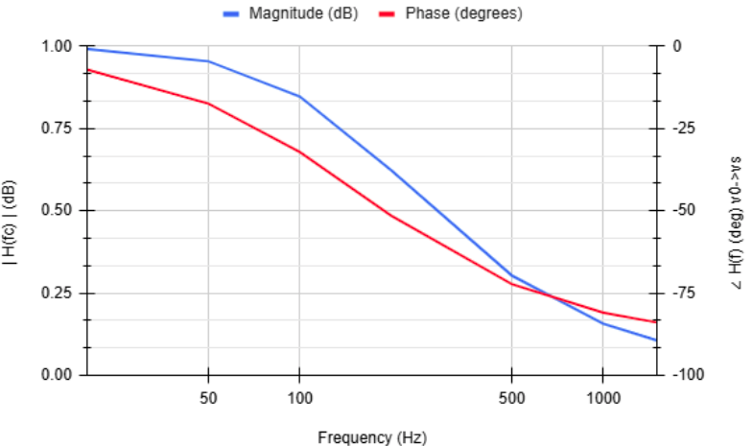

Figure 1.3.1: The prelab transfer function’s magnitude and phase vs. frequency (LPF)

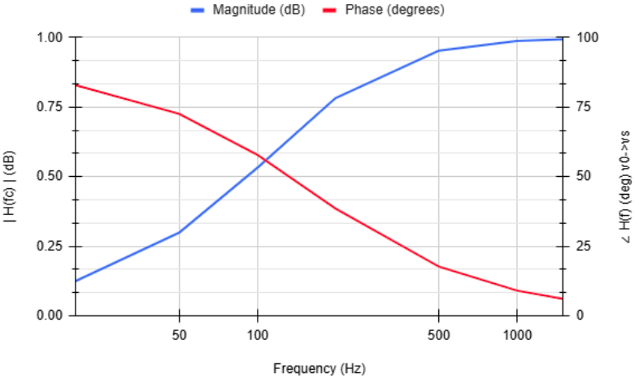

Figure 1.3.2: The prelab transfer function’s magnitude and phase vs. frequency (HPF)

**Section 2.1. LTspice simulation, transfer function magnitude and phase responses of RC low-pass filter**

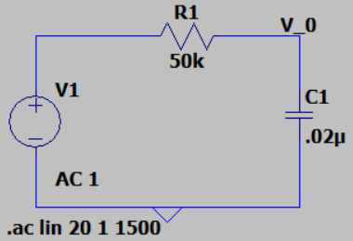

Figure 2.1.1: LTSpice schematic of RC low-pass filter

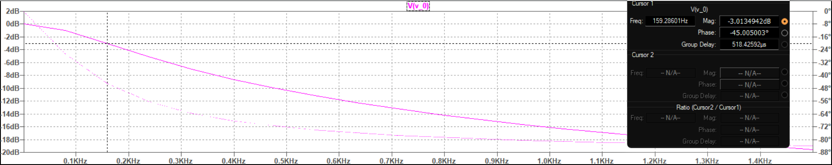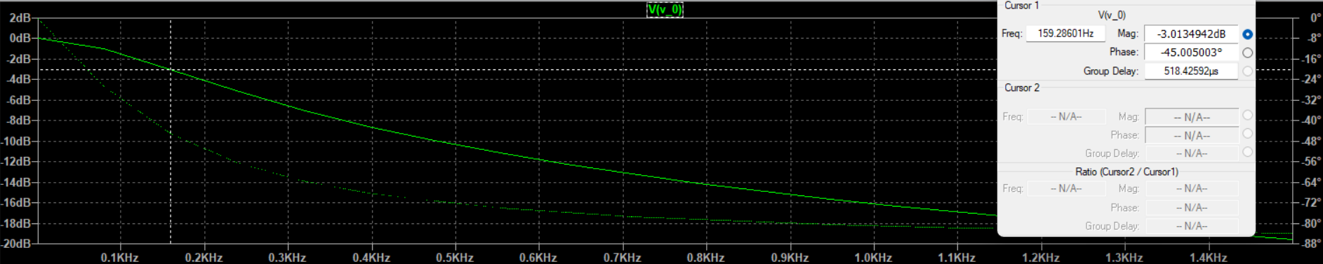

Figure 2.1.2: Transfer function magnitude and phase vs. frequency (complete LPF response)

**Section 2.2. LTspice simulation, transfer function magnitude and phase responses of RC high-pass filter**

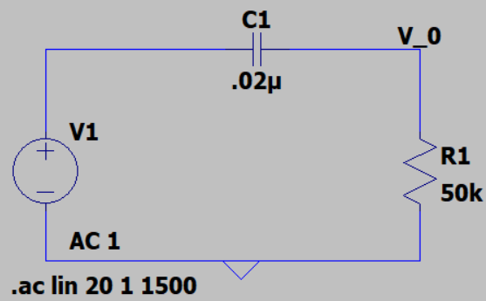

Figure 2.2.1: LTSpice schematic of RC high-pass filter

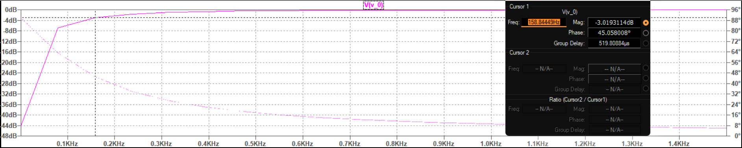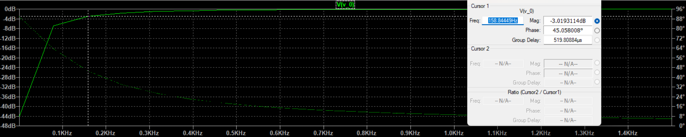

Figure 2.2.2: Transfer function magnitude and phase vs. frequency (complete HPF response)

**Discussion**

**Section 1. Transfer function magnitude and phase measurements of RC low-pass and high-pass filters**

1. Compare experimental measurements to calculated transfer function magnitude and the phase

plots in the prelab. Cite reasons for all differences.

Referring to figures 1.1.1, 1.2.1, 1.3.1, and 1.3.2:

* The curvatures of experimental and prelab magnitude vs frequency plots mostly follow the same upward/linear trend with asymptotes at 0 dB and 1 dB.
* The curvatures of experimental and prelab phase vs frequency plots also show little distinction

2. Justify percent differences between measured and calculated values for the half power

frequencies.

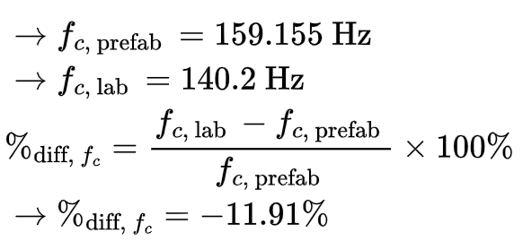





For both the low-pass and high-pass filters, the half-power frequencies are identical. The experimental half-power frequency deviates from the expected value by -11.91%, likely due to component tolerances. Measurement errors from the KeySight instruments are minimal, as they offer precision to four decimal places of the unit measured.

3. Why is fc called the ‘half power’ frequency?

At the half-power frequency, the power in the RC circuit is reduced to half of its maximum value. However, the measured half-power deviates by -6.25% from the expected value, due to the discrepancy of the measured half-power frequency.

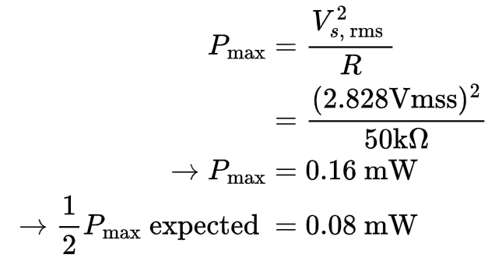



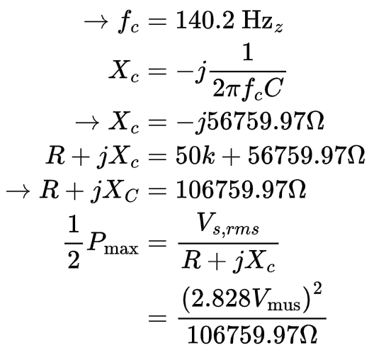







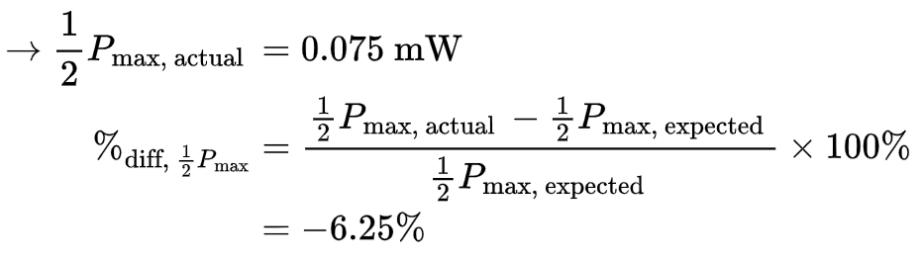



4. Why is the transfer function magnitude 1/sqrt(2) or 0.707 of the peak magnitude at fc?

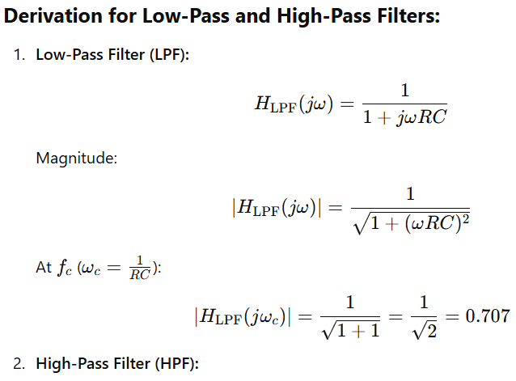



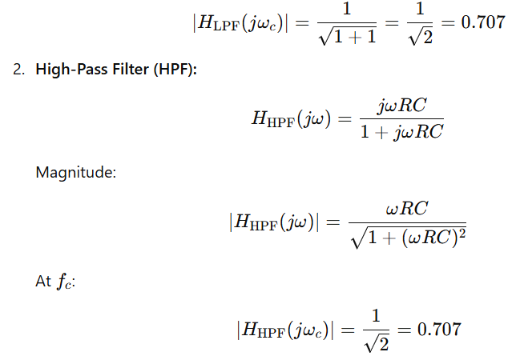





The transfer function magnitude is 1/sqrt(2) or 0.707 of its peak magnitude at the cutoff frequency (fc) because this is the frequency at which the power of the signal drops to half of its maximum value.

5. What is the transfer function’s phase at this frequency? (both LPF and HPF).

The transfer function’s phase at fc = 140.2 Hz is -40.071o for LPF and 49.929o for HPF.

6. Compare the ideal values for |H(fc)| and ∠ H(fc) (deg) v0->vs at the half-power frequencies. Cite reasons for any discrepancies.

Comparing |H(fc)| and ∠ H(fc) prelab and lab values (LPF):

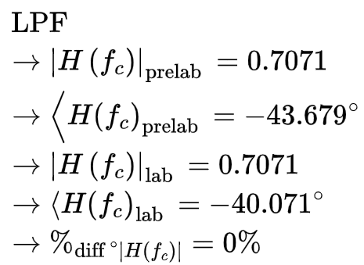 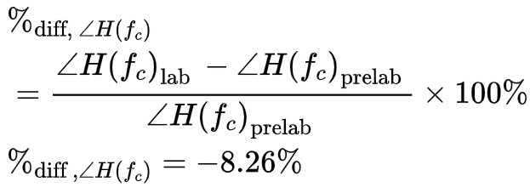

Comparing |H(fc)| and ∠ H(fc) prelab and lab values (HPF):

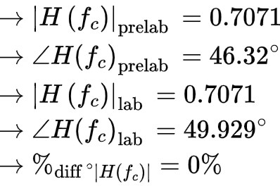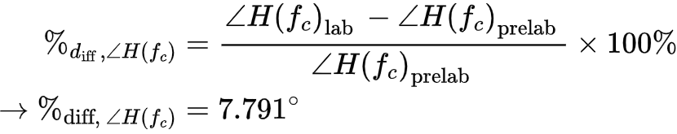

These approximately +/- 8% discrepancies are likely due to the resistor or capacitance box tolerances.

**Section 2. LTspice simulation, transfer function magnitude and phase responses of RC low-pass and high-pass filters**

7. Determine the cutoff frequencies (fc) for both the LPF and HPF (note |H(fc)| and ∠H(fc) values for both circuits) and compare to theoretical values.

LPF comparison (prelab to LTSpice):

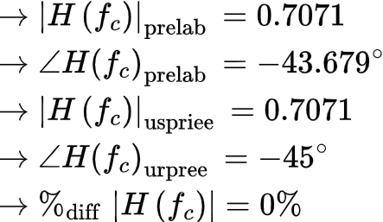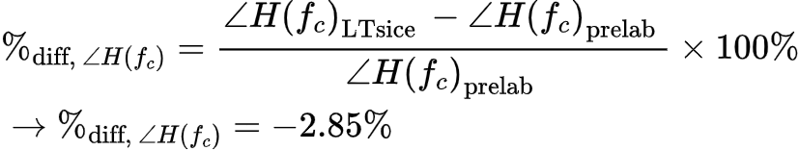



HPF comparison (prelab to LTSpice)

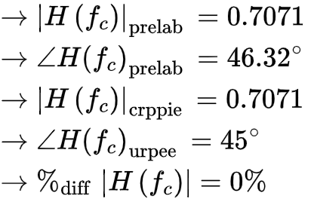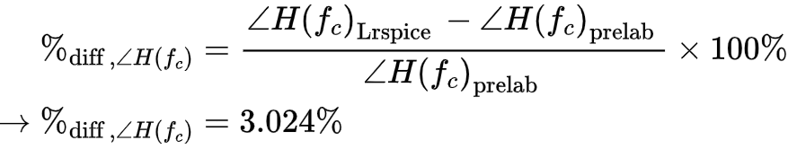

**Conclusion**

| **Percent Error Results; Prelab vs Lab** | **Error** |
| --- | --- |
| *f*c | -11.91% |
| ½ Pmax | -6.25% |
| LPF ∠H(*f*c) | -8.26% |
| HPF ∠H(*f*c) | 7.79% |
| HPF & LPF |H(*f*c)| | 0% |
| **Percent Error Results; Prelab vs LTSpice** | **Error** |
| LPF ∠H(*f*c) | -2.85% |
| HPf ∠H(*f*c) | 3.02% |

Note: 0% error for HPF & LPF |H(*f*c)| due to having a fixed point that defines cutoff frequency or the -3db point.