## 

## 

## EE 242-02

## Electrical Engineering Department

## Lab #6

## Parallel Resonance

## Report Delivered on: 02-28-25

## Lab Partners: Allen Dinh, David Rock, Alan Odnoblyudov

## Group 1

**Introduction**

This experiment includes real resistive losses by modeling capacitors and inductors as parallel combinations of ideal components and a resistor. The frequency-dependent quality factor Q measures how these losses affect circuit performance. By analyzing parallel resonance under practical conditions, this experiment validates theoretical predictions and shows why accurate component modeling is important.

**Equipment List**

1 Keysight EDU33121A Function Generator

1 Keysight EDU34450A Digital Multimeter

1 Keysight DSOX1202G Digital Storage Oscilloscope

1 Extech 380193 LCR Meter

1 Inductor Decade Box (Set for 5mH)

2 Resistor Decade Box

1 Capacitor Decade Box

1 Bag of short leads

5 Banana-Banana leads

3 BNC-Banana leads

**Procedure**

**Section 1. Parallel RLC Circuit**

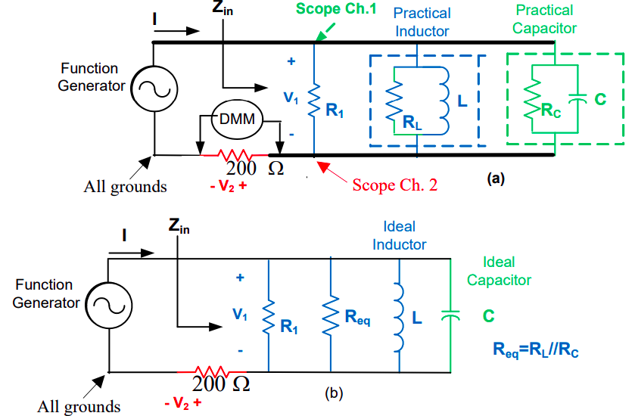

Figure 1: Parallel RLC Equivalent Circuit

1. Use the LCR meter to measure capacitance Cp and dissipation factor D at 1kHz for the 5µF capacitor using the parallel model. (Note that = 2πf = 2π1000 = 6,282 rad/sec)
2. Obtain the parallel-model resistance Rp using the formulas below:



1. Use the LCR meter to measure inductance LP and quality factor Q for the 5mH inductor using the parallel model at 1kHz. Obtain the parallel-model resistance RP using the formulas below:



1. Construct the circuit of Figure 1a. Note, thick lines represent short lead connections. The equivalent circuit is shown in Figure 1b.
2. Set R1 to 500Ω and calculate the following:



Note that R in equation (2) is R1 in parallel with Req. Use the LCR meter to measure L and C.

1. For R1 = 500Ω, maintain |V2| = 0.5Vrms, adjust the frequency from 600Hz to 1,200Hz and measure input transfer impedance Zin. Note that the 200Ω current-sense resistor is not included in Zin.



1. Develop a table with columns for frequency, |V1|, |Zin|, and ∠Zin. Use the oscilloscope Math utility to display the V1 phase (Ch 1 – Ch 2) relative to I (Ch 2/200): Phase(M -> 2). Increase data point resolution around the resonant frequency for improved accuracy
2. Use a computer program to plot |Zin| vs. frequency.
3. On the same graph, plot the phase of Zin vs. frequency.

**Section 2. Parallel RLC Circuit, LTSPICE Simulation**

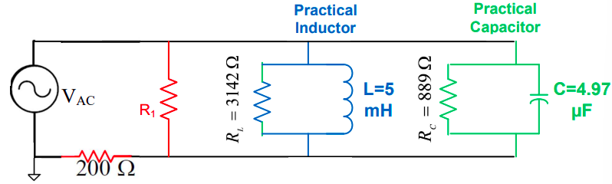

Figure 2: Parallel RLC Equivalent Circuit

1. Press File on the menu bar, select “New Schematic”: Opens a new schematic
2. Press F2, select current (current source)
3. Right click on the source and select “Advanced”:
   1. Under “Small signal AC analysis,” set AC Amplitude to 1 (V)
4. Press R, L, or C to place resistors, inductors, or capacitors. Press control-R to rotate, escape (Esc) to stop. Use values shown in the above figure. For L and C models, use specified values for the parallel resistors. For R1 assign ∞ (large), 500Ω, and 100Ω.
5. Right click to define the component value. Use (n) for nano-, (u) for micro-, (m) for milli-.
6. Connect all components using the “wire” option, pencil icon
7. Verify source ground connection.
8. Under “Simulate: select Edit Simulation Cmd, then AC Analysis tab
   1. Type of sweep: Linear
   2. Number of points: 200
   3. Start frequency: 500 (Hz)
   4. Stop frequency: 1500 (Hz)
9. Press Simulate (runner icon)
10. Inside the plot display window, press control-A, double-click on the voltage node
    1. Change plot color (difficult to see light green trace): right click on V(n001), change color to blue
11. Print the circuit schematic and the two filter response plots. (R1 -> ∞ and 500Ω).
    1. Add cursors to verify key parameters
    2. Compare simulated results to theoretical predictions
    3. Justify all discrepancies

**Data**

Section 1. Parallel Resonant RLC Circuit

1.1 Measuring Input Transfer Impedance Zin at R1 = 500 ohms and | V2 | = 0.5 Vrms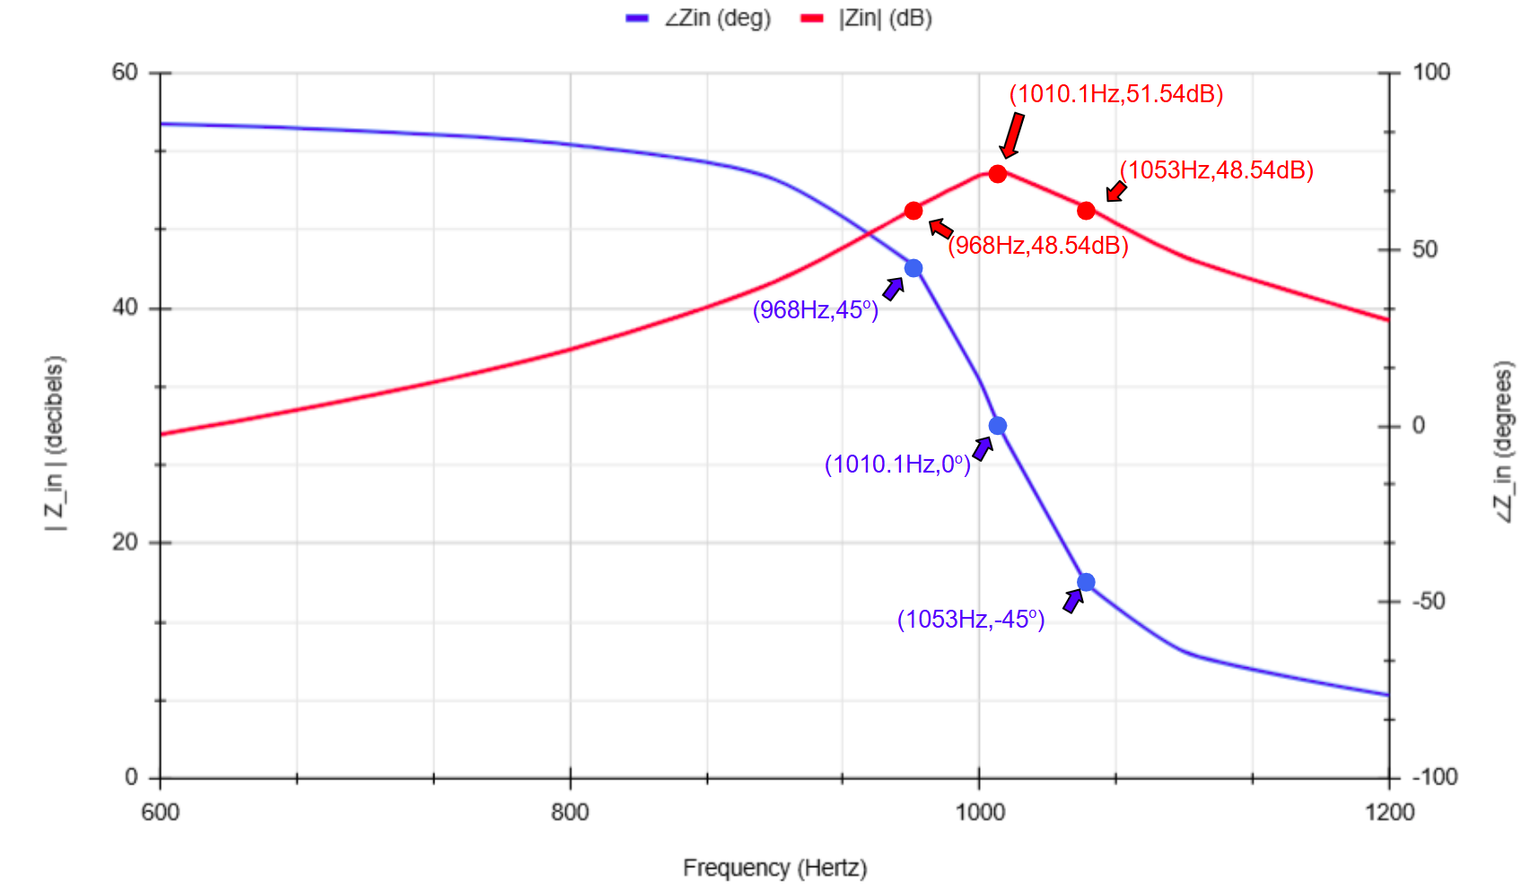

Figure 1.1: Zin (dB), ∠Zin (degrees) v. Frequency (Hz) Plot

Table 1.1: From Figure 1.1, the Key Frequencies and Their Respective Decibel/Degree Values

|  | 968 Hz (Lower fc) | 1010.1 Hz (f0) | 1053 Hz (Upper fc) |
| --- | --- | --- | --- |
| | Zin | (dB) | 48.54 | 51.54 | 48.54 |
| ∠Zin (degrees) | 45 | 0 | -45 |

Section 2. Parallel Resonant RLC Circuit

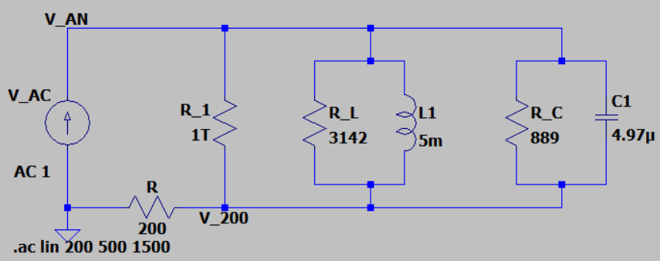

Figure 2.1: Parallel RLC Equivalent Circuit, Where R1 = 1T Ohms (Significantly Large)

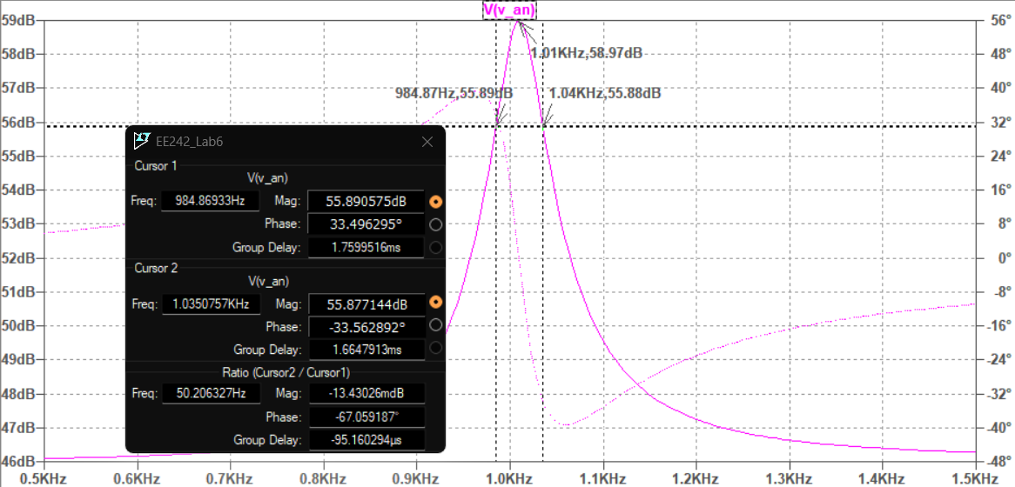

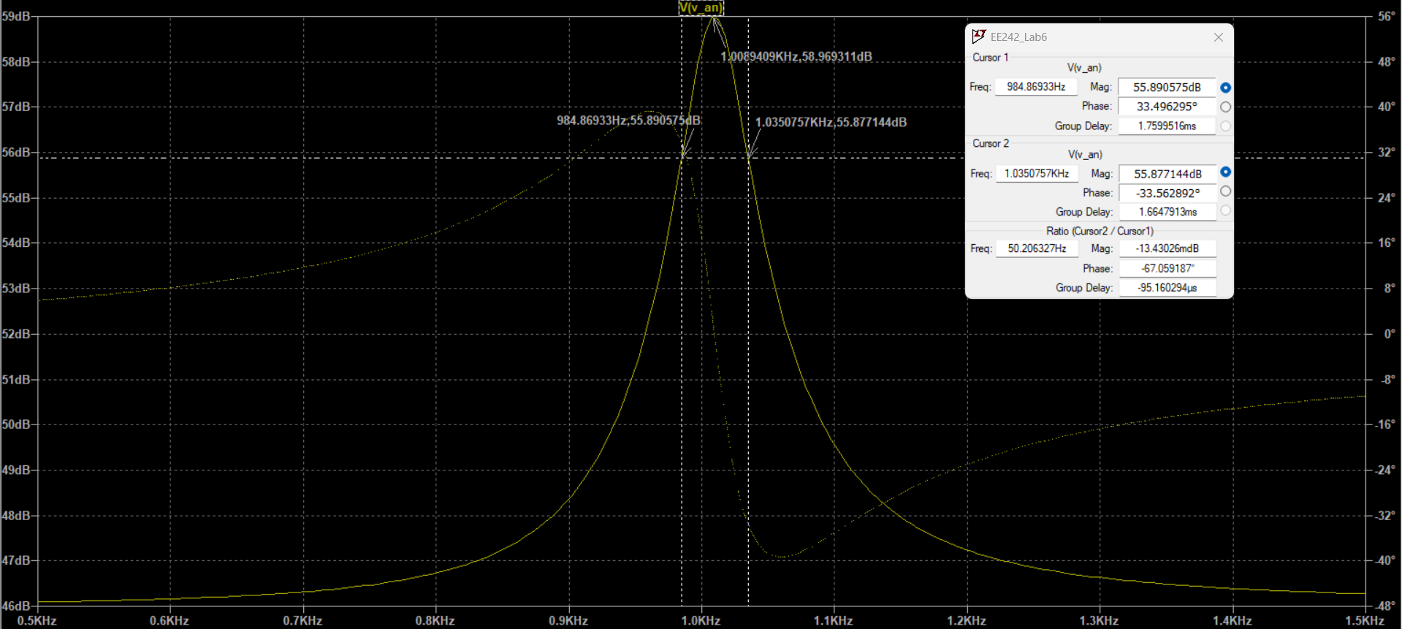

Figure 2.2: | Zin | (dB) v. Frequency of Circuit in Figure 2.1

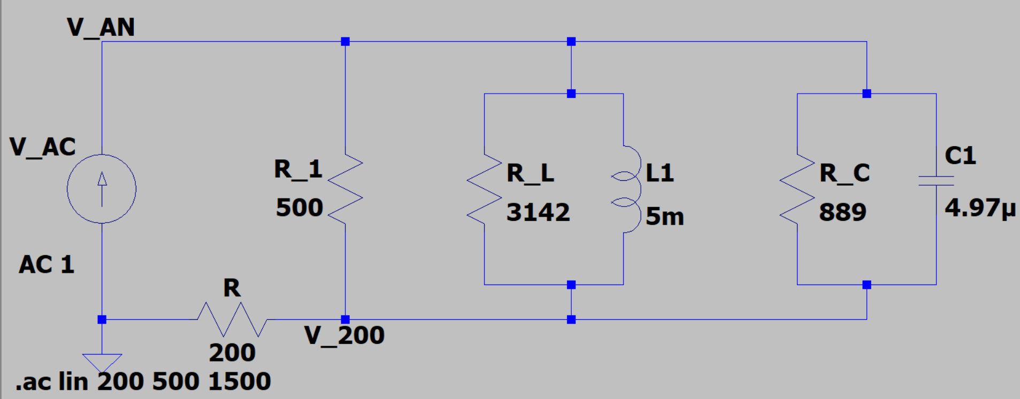

Figure 2.3: Parallel RLC Equivalent Circuit, Where R1 = 500 ohms

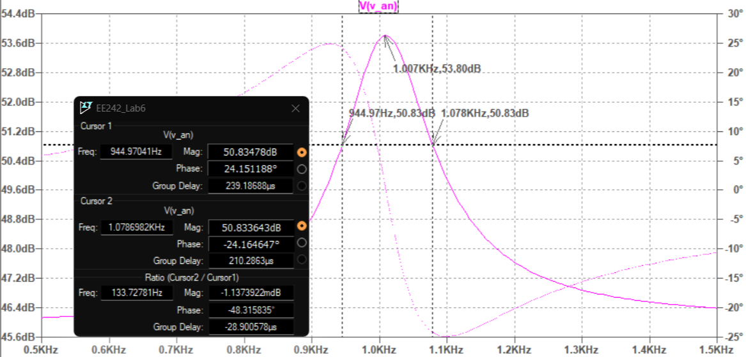

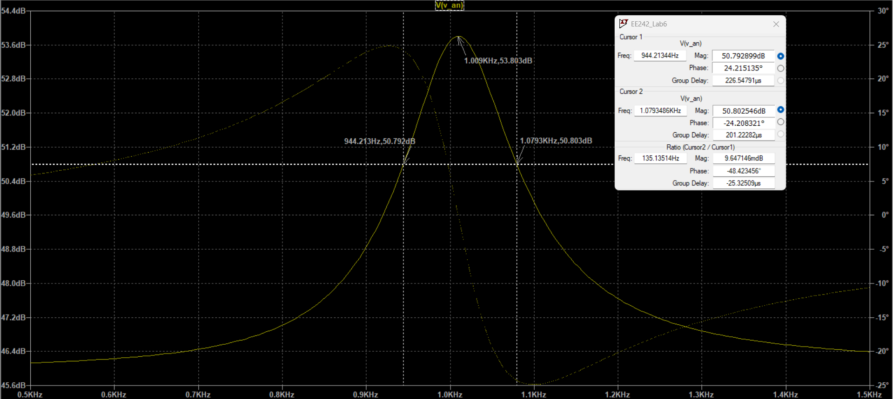

Figure :

Figure 2.4: | Zin | (dB) v. Frequency of Circuit in Figure 2.3

Table 2.1: Key values from Figure 2.2 and Figure 2.4

| R1 (ohms) | Lower fc (Hz) | Upper fc (Hz) | f0 (Hz) | B (Hz) |
| --- | --- | --- | --- | --- |
| 500 | 944.21 | 1079.30 | 1009.11 | 135.14 |
| ∞ | 984.87 | 1035.43 | 1009.09 | 50.21 |

**Discussion**

Section 1. Parallel Resonant RLC Circuit

1.1 Measuring via LCR Meter: Capacitance CP and D at 1kHz for the 5uF Capacitor Using Parallel Model

-> Cp = 5.004 uF

-> D = 0.0087

1.2 Obtaining Parallel-model Resistance Rp

-> w = 6,282 rad/s

Rp = Xc / Dp

= 1 / (w * C * Dp )

-> Rp = 3656.50 ohm (parallel to capacitor)

1.3 Measuring via LCR Meter: Inductance LP and Q at 1kHz for the 5mH Inductor Using Parallel Model

-> Lp = 5.108 mH

-> Q =96.530

1.4 Obtaining Parallel-model Resistance Rp

Rp = XL * Qp

= wL * Qp

-> Rp = 2672.97 ohm (parallel to inductance)

1.5 Calculating Req.

Req = RL || RC

-> Req = 1544.136 ohm

1.6 Calculating w0, B, Q0 at R1 = 500 ohm

w0 =

-> w0 = 6254.836 rad/s

f0 =

-> f0 = 995. 488 Hz

R = R1 || Req

-> R = 377.699 ohm

B = 1 / ( R * C )

= 1 / ( 377.699ohm * 5.004uF )

-> B = 529.099 Hz

Q0 = w0 / B

-> Q0 = 11.822T

1.7 Comparing |V1| vs. Frequency and |Zin| vs. Frequency for a Given R1 Value

∣V1​∣ follows a similar trend to Zin since V1=ZinI. Both increase towards resonance, reaching a peak at f0​ = 995.49 Hz then decrease beyond the resonant frequency.

1.8 Comparing f0 from Figure 1.1 to Expected f0 from Section 1.6

-> f0,actual = 1010.1 Hz

-> f0,expected = 995.49 Hz

%diff,f_0 = [ ( f0,actual - f0,expected ) / f0,expected ] * 100%

-> %diff,f_0 = 1.47%

1.9 Comparing Zin at Resonance from Figure 1.1 to the Theoretical Value

-> Zin,actual = 51.54 dB

-> Zin,expected = 58.2075 dB

%diff,Z_in = [ ( Zin,actual - Zin,expected ) / Zin,expected ] * 100%

-> %diff,Z_in = -11%

1.10 Comparing |Zin| at Resonance and Calculated Req || R1

Zin,actual = 51.54 dB

-> Zin,actual = 377.572 ohms

-> Req || R1 = 377.699 ohm

%diff,(Z_in),(R_eq||R_1) = [ ( Zin,actual - Req || R1 ) / Req || R1 ] * 100%

-> %diff,(Z_in),(R_eq||R_1) = -0.03%

1.11 Measuring Bandwidth B from Figure 1.1

B = 1053 Hz - 968 Hz

-> B = 85 Hz

1.12 Comparing Measured B with B = 1 / ( R * C )

-> Bcalculated = 529.099 Hz

%diff,B = [ ( B - Bcalculated ) / Bcalculated ] * 100%

-> %diff,B = -83.93%

1.13 Describing the parallel RLC filter behavior (i.e.: low-pass, high-pass, band-pass, or band-stop) with Justification

* At low frequencies, the inductor acts as a short circuit and the capacitor as an open circuit, causing most of the input voltage to appear across the LC combination, resulting in a high output voltage.
* At high frequencies, the capacitor acts as a short circuit and the inductor as an open circuit, again leading to a high output voltage across the LC combination.
* At resonance (f0), the parallel LC circuit has very high impedance, forcing most of the input voltage to drop across the resistor and leaving low output voltage across LC. This effectively attenuates the resonant frequency, rejecting it.
* Since the output is taken across the LC combination, the circuit functions as a band-stop (notch) filter, rejecting signals at f0 while allowing low and high frequencies to pass.

**Conclusion**

| %diff,f_0 | 1.47% |
| --- | --- |
| %diff,Z_in | -11% |
| %diff,(Z_in),(R_eq||R_1) | -0.03% |
| %diff,B | -83.93% |