Name:- Medhansh K PRN:- 122A8035

Batch:- B2

Experiment 6

**Aim:** To implement MP (McCulloch Pitts Model) neuron model from AND operation

# Theory:

The MP neuron, or McCulloch-Pitts neuron, is a foundational, simplified model of a biological neuron, introduced in 1943 by Warren McCulloch and Walter Pitts, that laid the groundwork for artificial neural networks. It functions as a binary threshold device, summing weighted inputs and producing a binary output (0 or 1) based on whether the sum exceeds a threshold.

* Simplified Model:

The MP neuron is a highly simplified abstraction of a biological neuron, focusing on its basic computational function rather than its complex biological details.

* Binary Inputs and Outputs:

It operates with binary inputs (0 or 1) and produces a binary output (0 or 1), representing a "fire" or "not fire" state.

* Weighted Summation:

Each input to the MP neuron is assigned a weight, and the neuron sums the weighted inputs.

* Threshold Comparison:

The summed value is then compared to a threshold value.

* Output:

If the weighted sum is greater than or equal to the threshold, the neuron "fires" (output 1); otherwise, it remains silent (output 0).

* Foundation for Neural Networks:

The MP neuron's concept of a threshold logic unit served as a crucial building block for the development of artificial neural networks.

* Limitations:

The MP neuron has limitations, including its inability to model complex, continuous functions and its reliance on fixed weights and thresholds.

* Logical Operations:

Despite its simplicity, the MP neuron can be used to implement basic logical operations like AND, OR, and NO

# Code :

def mp_neuron(x1, x2, w1=1, w2=1, threshold=2): # Calculate the weighted sum of inputs weighted_sum = w1 * x1 + w2 * x2

# Apply the threshold function if weighted_sum >= threshold:

return 1 else

return 0

# Test the MP neuron with all combinations of x1 and x2 (AND gate truth table) for x1 in [0, 1]:

for x2 in [0, 1]:

output = mp_neuron(x1, x2)

print(f"Input: x1={x1}, x2={x2} -> Output: {output}")

# Output:

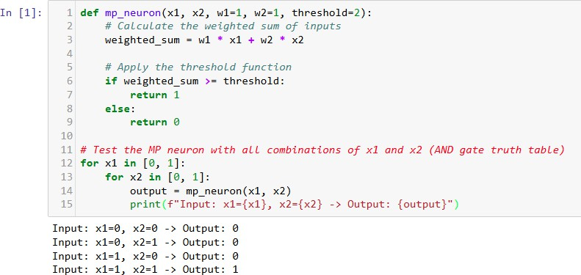

**Conclusion:**

AND operator using MP neuron implemented successfully.