AI-Powered Survey Platform
Technical Architecture, Data Model & Workflows
Prepared for: Durgesh | June 23, 2026

1. Tech Stack & Rationale
- Frontend & API: Next.js (React) — single codebase for the survey builder, respondent UI, and API routes; deploys free on Vercel's hobby tier.
- Database, Auth, Storage: Supabase — managed Postgres, built-in authentication, and file storage, all on a free tier sufficient for a showcase.
- AI layer: Claude API called from a server-side orchestrator for survey generation, sentiment/theme analysis, conversational follow-ups, and verdict reports. This is the one component with real per-use cost — kept low during the showcase phase by capping usage.
- Hosting: Vercel (frontend/API) + Supabase (data) — both free tier, both upgradeable without a re-platform when this becomes a paid product.

2. System Architecture
Three layers: client apps (builder + respondent-facing survey), an application layer handling business logic and AI orchestration, and a data layer for storage, auth, and files. The AI orchestrator is the only component that talks to the external LLM API, keeping API keys and prompt logic server-side.
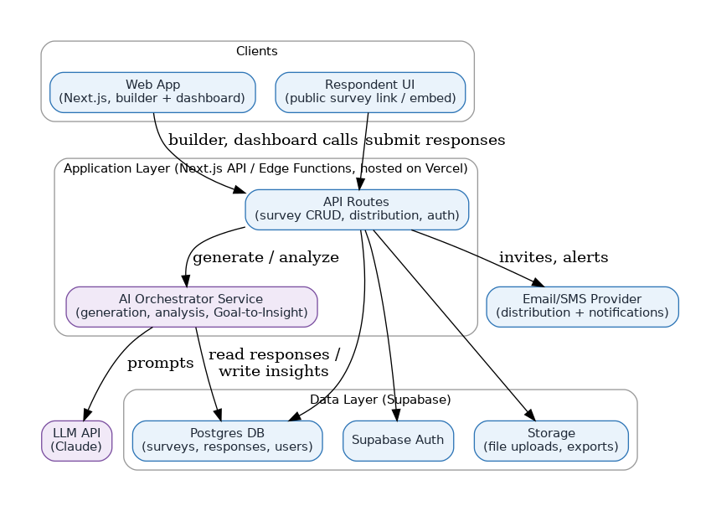
Figure 1 — System architecture
AI feature flag: every AI-related UI element and API route is gated behind a single server-side environment-variable flag (e.g. AI_FEATURES_ENABLED), read at the server layer only. When unset/false, AI tabs, buttons, and modals do not render — they are conditionally excluded server-side (Next.js server components / route handlers), not merely hidden with CSS — and the corresponding API routes return 404 rather than a disabled state. Nothing in the shipped client bundle reveals that AI capability exists. Flipping the flag (on request only) and redeploying is the entire reveal mechanism — no in-app toggle is exposed in this phase.

3. Data Model (Simplified ERD)
Core entities for the showcase scope. Multi-tenant from day one (organizations → users) so the later move to paid SaaS doesn't require a schema migration.
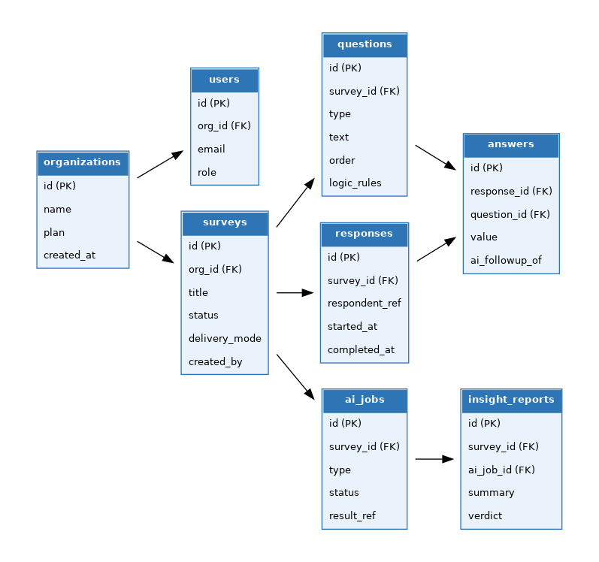
Figure 2 — Entity relationships
ai_jobs tracks every AI generation/analysis task (status, type, result reference) so usage can be metered per organization later for billing. insight_reports stores the AI-generated verdict separately from raw dashboard stats so it can be exported or shared on its own.

4. Accounts & Roles
Showcase scope uses four roles. Single organization per user account for now — the schema (org_id on the users table) can move to multi-org later via an additive join-table migration without a rebuild, if/when that's needed.
Role | Survey Build/Edit | Publish | View Results & Reports | Manage Team/Billing
Owner/Admin | Yes | Yes | Yes | Yes
Editor | Yes | Yes | Yes | No
Viewer/Analyst | No | No | Yes | No
Respondent (no account) | — | — | — | —
Permission checks are role-driven, not feature-hardcoded, so a 5th role (e.g. an Editor scoped to specific surveys only) can be added later as a new permission set rather than a code change.

4.1 Signup & Onboarding Journey
First-time signup auto-creates an organization with the signing-up user as Owner. Onboarding branches based on how much direction the user already has — mirroring the three survey-creation entry points.
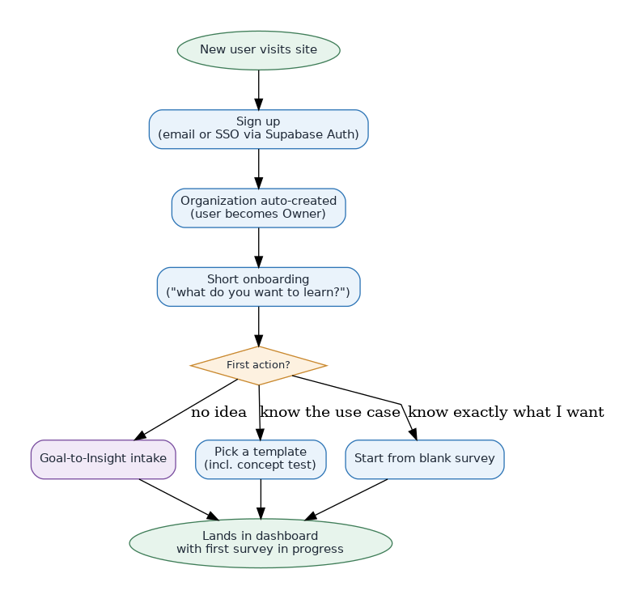
Figure 7 — Signup & onboarding journey

4.2 Team Invite & Role Assignment
Owner invites teammates by email and assigns a role at invite time. The invited person joins the same organization (no separate org creation) and gets access scoped to that role.
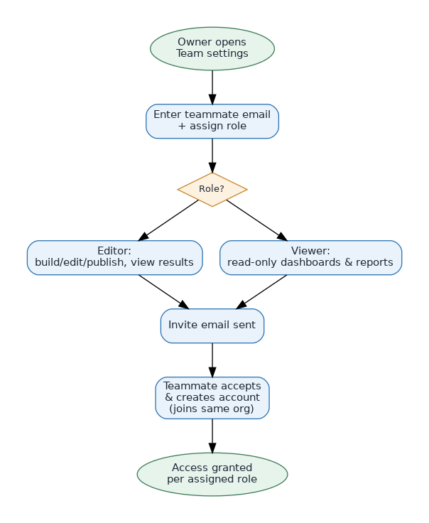
Figure 8 — Team invite & role assignment

5. Core Workflows

5.1 Survey Creation Flow
Covers all three entry points: manual building, single-prompt AI generation, and the full Goal-to-Insight intake for users with no survey-design experience.
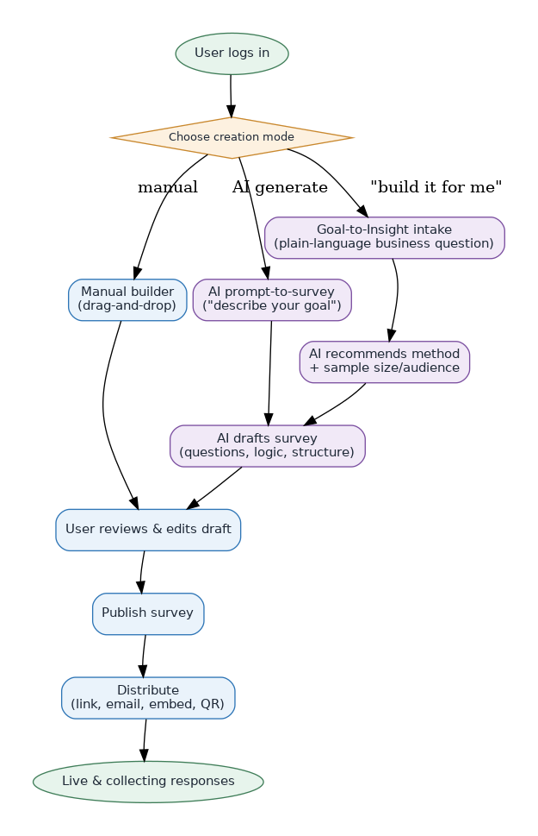
Figure 3 — Survey creation flow
Once a survey exists, the builder organizes work into seven tabs: Overview (response/completion stats), Build (the 3-pane question editor with inline AI Actions per question), Logic (Skip Logic, Compound Logic with named variables, Show/Hide Questions, Show/Hide Options), Configuration (quality settings and survey controls), Share (distribution), Insights (live analytics once responses arrive), and Expert Review (AI scan for bias/length/structure issues before publish). All seven tabs exist for every survey regardless of creation entry point.

5.2 Respondent Flow (Conversational Mode)
The classic, all-questions form is the default respondent experience for every survey. Conversational (chat-style) delivery is an opt-in mode the creator switches on per survey from the Build tab — once enabled, the respondent instead gets one question at a time, and every open-text answer is evaluated by AI before deciding whether a contextual follow-up question is worth inserting.
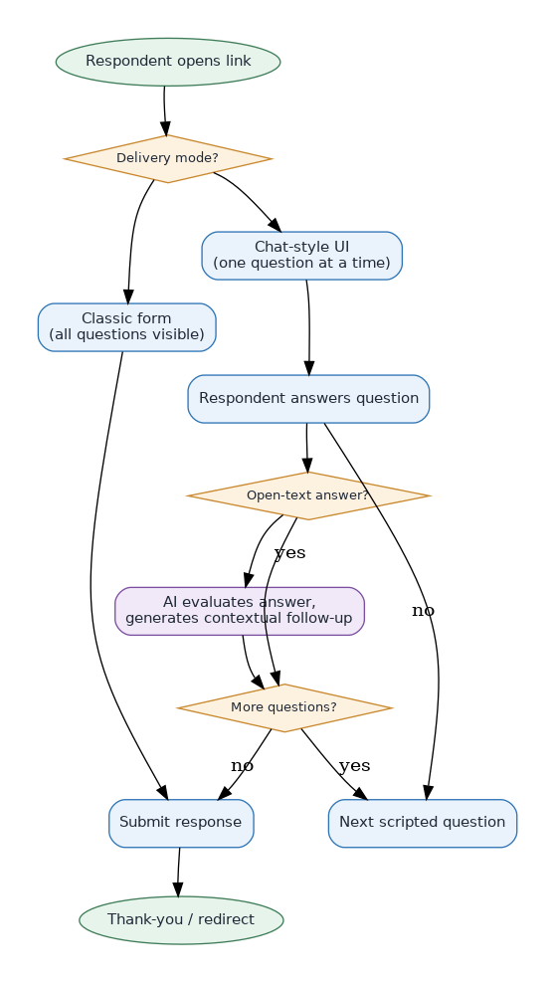
Figure 4 — Respondent flow

5.3 AI Analysis Pipeline
Runs after responses are collected, either triggered manually or automatically once a target sample size is hit. Response-quality filtering happens before sentiment/theme analysis so low-quality responses don't skew results.
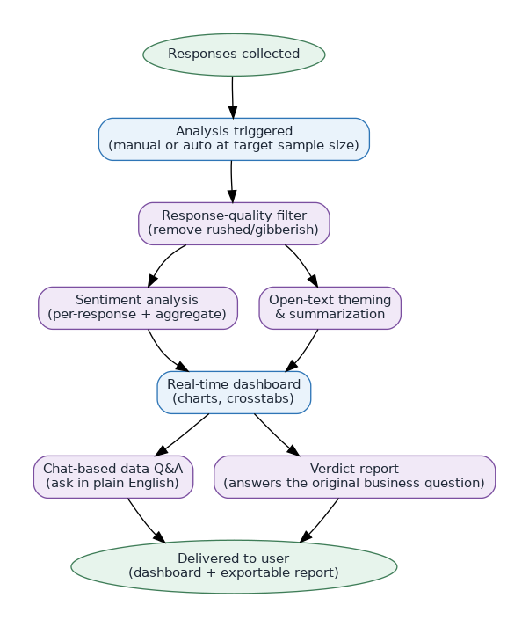
Figure 5 — AI analysis pipeline

5.4 Goal-to-Insight: End-to-End Flow
The flagship flow for users with “no idea where to start.” The user states a business question; AI handles method selection, survey construction, distribution monitoring, and ends with a verdict report that directly answers the original question rather than just presenting charts.
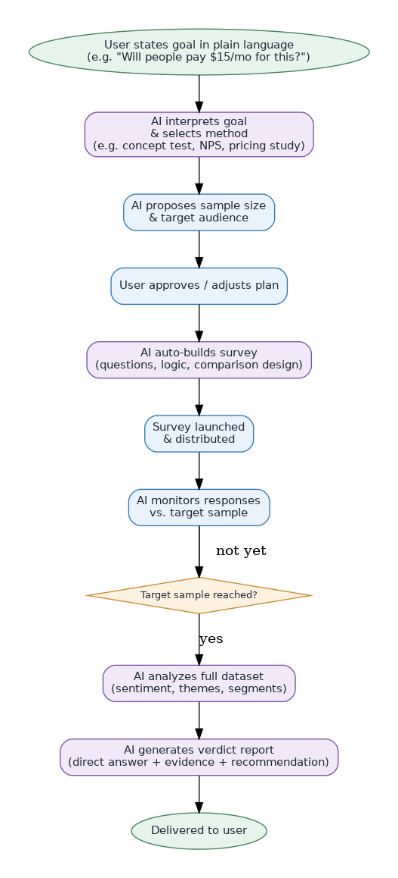
Figure 6 — Goal-to-Insight flow

6. Showcase Build Scope
Per our discussion, the showcase prioritizes depth on a few standout capabilities over breadth across the full feature matrix:
- Core manual survey builder (essential question types, basic logic)
- AI prompt-to-survey generation
- Conversational respondent delivery mode
- AI response analysis (sentiment + theming + dashboard)
- A working teaser of Goal-to-Insight (single demo scenario, e.g. a concept test)
Everything else in the original MVP feature spec (multi-channel distribution, integrations, synthetic audiences, multi-language sentiment, etc.) remains on the documented roadmap for after the showcase validates interest.

7. Next Steps
- Prototyping: build clickable HTML/React prototypes of the builder, respondent chat UI, and analysis dashboard for review before writing production code.
- Development: implement against this architecture and data model in Next.js + Supabase.
- Deployment: free-tier Vercel + Supabase, with a usage cap on AI calls to keep costs near zero during the showcase.

