AI-Powered Survey Platform
Master Product Requirements Document (PRD)
Prepared for: Durgesh | June 23, 2026

1. Purpose & Scope
This is the master PRD for the full product — every module, submodule, the admin panel, and the API/integration architecture, for a web application with an admin panel (subscription management, role management) at a level matching QuestionPro, Qualtrics, SurveySparrow, SurveyMonkey, and Typeform.
This document builds on two prior deliverables and does not repeat their diagrams: “Survey_Platform_MVP_Feature_Spec.docx” (competitor comparison, MVP feature priorities) and “Survey_Platform_Architecture_and_Workflows.docx” (system architecture, data model, roles, and the core user/respondent/AI-analysis/Goal-to-Insight journeys). New material here: the full module map, the admin panel spec, and the API/integration layer with its own flowcharts.

2. Product Module Map
Full product scope, including modules beyond the showcase build. Status reflects what's in the near-term showcase vs. later roadmap.
Module | Submodules | Status
Survey Builder | Manual builder; AI prompt-to-survey; Goal-to-Insight intake; template library (incl. concept testing); logic engine (branching/piping/randomization/compound logic with named variables); survey configuration (quality settings, close date, response limit); AI Expert Review; theming & branding. Organized as Overview / Build / Logic / Configuration / Share / Insights / Expert Review tabs | Showcase
Distribution | Web link; embed/widget; email invites; QR code; SMS; social sharing; offline app | Showcase: link/embed/email. Roadmap: SMS/social/offline
Respondent Experience | Classic form mode (default for every survey); conversational chat mode (opt-in, enabled per survey); AI-generated follow-ups; accessibility (WCAG 2.1 AA) | Showcase
Response & Data Mgmt | Response storage; partial-response capture; quality filtering; CSV/Excel export; GDPR export/delete tools | Showcase core; GDPR tooling roadmap
AI Analysis | Sentiment analysis; theme extraction/summarization; chat-based data Q&A; verdict report generator; crosstabs/TURF | Showcase: sentiment/theme/verdict. Roadmap: crosstabs/TURF
Dashboards & Reporting | Real-time response dashboard; custom report builder; scheduled report delivery | Showcase: real-time dashboard. Roadmap: scheduling
Admin Panel | Subscription & billing; role & user management; org settings/branding; usage & AI-cost monitoring; audit logs; white-label/custom domain; SSO/SAML | Showcase: billing, roles, settings, monitoring. Roadmap: white-label, SSO
Integrations & API | Webhooks; Zapier/Slack connectors; CRM connectors; public REST API; developer API keys | Showcase: webhooks. Roadmap: Zapier/CRM/public API

2.1 Question Types
Tiered the same way as everything else: a lean showcase set, then roadmap.
Tier | Question Types
Showcase (P0) | Single choice, multi-select, dropdown, short text, long text, rating scale, NPS, Likert/matrix grid, yes/no, ranking, date/time, contact & demographic fields
P1 | Slider, image choice, file upload, semantic differential (bipolar scale), constant-sum/point allocation, statement/content block (no-input)
P2 (research-grade) | MaxDiff (best-worst scaling), signature capture, CAPTCHA/verification block, card sort

2.2 Survey Logic Types
Tier | Logic Types
Showcase (P0) | Skip/display logic; compound logic with named variables (e.g. $user_segment, $satisfaction_score) for multi-condition AND/OR rules; show/hide questions; show/hide options; piping (insert prior answer into later text); validation (required, format, min/max); randomization (question & option order)
P1 | Quota & screening logic (terminate/redirect); scoring logic (quizzes, lead scoring); AI-powered dynamic branching (sentiment-based path adjustment, per Architecture doc)
P2 (research-grade) | Loop & merge (repeat a question block per list item); carry-forward (carry prior selections into next question's choice list)

3. Admin Panel
The admin panel is the org Owner's control surface — distinct from the survey builder. It covers everything needed to run this as a commercial SaaS product once the showcase validates interest.

3.1 Subscription & Billing
- Plan tiers: Free / Starter / Pro / Enterprise, each with response-volume and AI-call quotas (mirrors QuestionPro's free-tier-to-paid ladder).
- Billing provider: Stripe handles checkout, recurring billing, invoicing, and payment-method storage — Stripe Checkout link is the actual money-movement; the app never executes a transaction itself.
- Usage metering: every AI job (generation, analysis, follow-up, verdict report) is logged against the org so usage can be compared to plan quotas and used for overage billing later.
- Self-serve upgrade/downgrade: plan changes take effect immediately; downgrades are deferred to the next billing cycle to avoid mid-cycle feature loss.
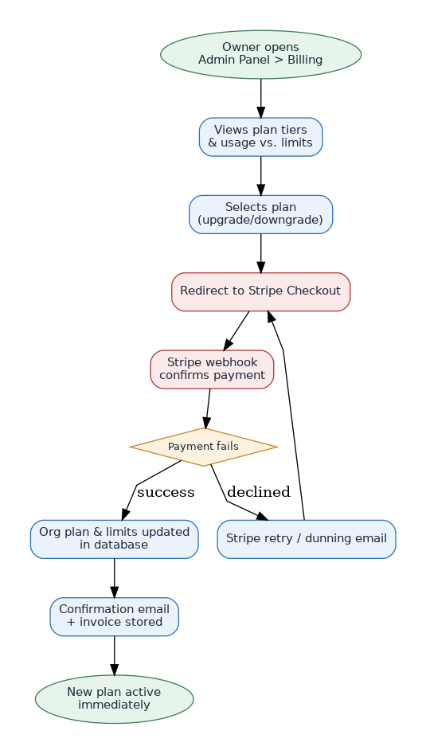
Figure 1 — Subscription & billing flow

3.2 Role & User Management
Builds on the Owner/Editor/Viewer roles and team-invite journey already defined. The admin panel adds the management surface: change a role, revoke access, and see an audit trail of who did what.
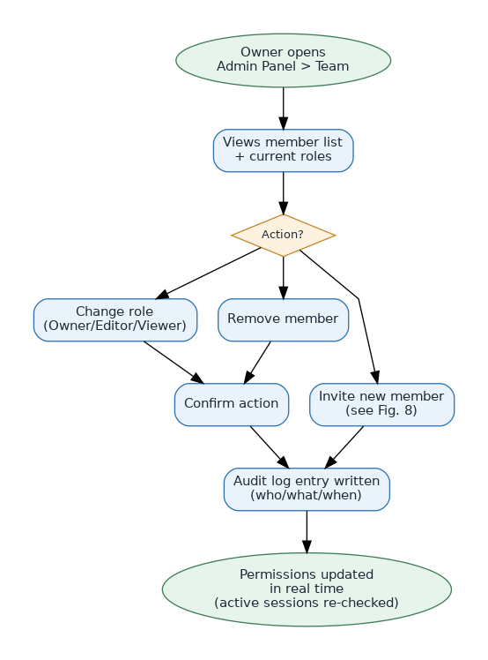
Figure 2 — Role management flow

3.3 Org Settings & Monitoring
- Org profile & branding: logo, colors, default survey theme.
- AI usage dashboard: per-org view of AI calls/cost against quota — protects margins as this becomes a paid product.
- Audit log viewer: searchable history of role changes, billing changes, and survey publish/delete actions.
- Custom domain & white-label: roadmap item for Pro/Enterprise tiers (matches Qualtrics/QuestionPro enterprise offerings).

4. API & Integration Architecture
Three layers: an internal API the web app itself calls, external services the platform depends on, and outbound/inbound integrations for third-party systems.
API Group | Example Endpoints | Auth
Surveys | GET/POST /api/surveys, /api/surveys/:id/publish | Session (Supabase Auth)
AI Jobs | POST /api/ai/generate, POST /api/ai/analyze | Session + server-side LLM key
Responses | POST /api/responses (public), GET /api/surveys/:id/responses | Public token (respondent) / Session (org)
Billing | POST /api/billing/checkout, /api/billing/webhook | Session (Owner) / Stripe signature
Team | GET/POST /api/team, PATCH /api/team/:userId/role | Session (Owner)
Public API (roadmap) | GET /v1/surveys/:id/responses | API key (per-org, scoped)
External dependencies: Claude API (AI generation/analysis), Stripe (billing), Supabase (auth/database/storage), an email/SMS provider (invites + notifications). All external calls are server-side only — no provider keys are ever exposed to the browser.

4.1 Outbound & Inbound Integrations
Outbound: platform events (response submitted, survey completed, AI report ready) fan out to configured webhooks, Zapier/Slack, and CRM connectors, with retry-with-backoff on failure. Inbound (roadmap): a scoped public REST API lets external systems pull survey results programmatically using a per-org API key.
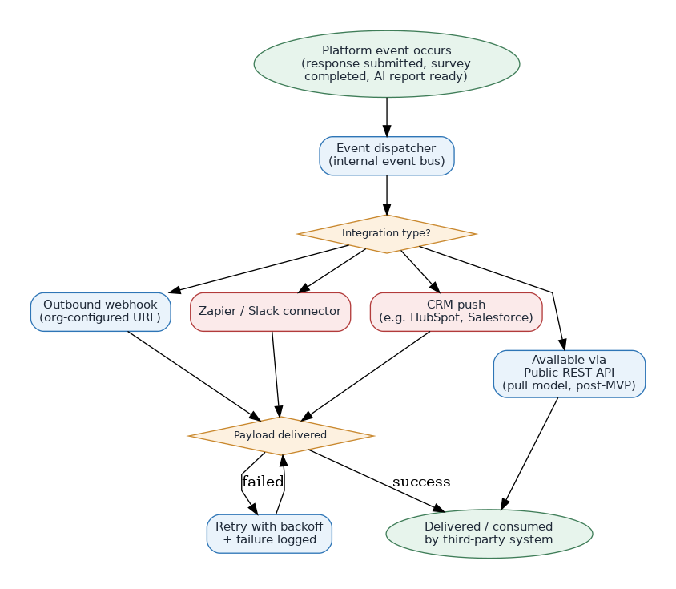
Figure 3 — API & webhook integration flow

5. Advanced Features Roadmap (Competitive Parity)
Features that exist in the leading platforms but sit outside the showcase scope — sequenced for after the showcase validates interest.
Feature | Reference Competitor | Tier
Crosstabs & TURF analysis | QuestionPro | Pro/Enterprise
Pivot tables | QuestionPro, Qualtrics | Pro/Enterprise
Data weighting (match sample to population) | Qualtrics | Pro/Enterprise
Regression analysis | Qualtrics | Enterprise
Correlation analysis | Qualtrics | Enterprise
Heat map analysis | Qualtrics, QuestionPro | Pro/Enterprise
Synthetic audiences / AI-moderated research | Qualtrics, Typeform Research Flow | Enterprise
Multi-language sentiment (50+ languages) | SurveyMonkey | Pro/Enterprise
SSO/SAML | Qualtrics, SurveyMonkey Enterprise | Enterprise
White-label / custom domain | QuestionPro, SurveySparrow | Pro/Enterprise
Offline data collection (mobile app) | QuestionPro | Pro/Enterprise
Public REST API & developer keys | All five | Pro/Enterprise
Crosstabs/pivot/weighting are feasible in the main app's data layer. Regression, correlation, and heat maps need a real statistics engine — default plan is a small Python analytics service (pandas/statsmodels) called from the main backend, deployable on a free tier alongside the rest of the stack, rather than reimplementing statistics in JavaScript.

6. Cost Strategy: Free Tier Throughout Showcase
Every service in this PRD is chosen to have a genuinely free tier sufficient for a showcase, confirmed below. The Python analytics service (for regression/correlation/heat maps) follows the same rule — hosted on a free tier (e.g. Render's free web service or a Vercel Python function) rather than a paid one.
Service | Role | Free Tier?
Vercel | Frontend + API hosting | Yes — Hobby plan
Supabase | Database, Auth, Storage | Yes — Free plan
Stripe | Billing (only charged when a real subscription is paid) | Yes — no monthly fee, % fee only on real transactions
Python analytics service | Regression, correlation, heat maps | Yes — deployable on a free-tier host
Email/SMS provider | Invites & notifications | Yes — free tiers exist (low volume) for showcase traffic
The one cost that cannot be made free is the LLM API (Claude) for every AI generation/analysis call — this is a real per-token cost regardless of provider. Confirmed approach: during the entire build phase, every AI feature is developed and tested against mocked/stub responses — no live API key is wired in, so the build stays at genuine $0. Real LLM integration is deferred as a deliberate, separate step (Phase 4 in the build sequence — see Feature Spec doc), taken only when explicitly requested, starting with the cheapest model and a hard spending cap. The usage-metering already built into the Admin Panel (Section 3.1) gives early visibility into exactly what that cost would be before it's ever passed on to a paying customer.

7. Related Documents
- Survey_Platform_MVP_Feature_Spec.docx: competitor comparison and showcase-vs-roadmap feature prioritization.
- Survey_Platform_Architecture_and_Workflows.docx: system architecture, data model/ERD, roles & permissions matrix, and the core journeys (onboarding, survey creation, respondent flow, AI analysis pipeline, Goal-to-Insight, team invite).

