Treatment-Chain: A peer-to-peer Electronic Medical Record sharing and intelligent insights system
TEAM: MEDI-LEDGER
MEMBERS: DEEPENDRA SINGH RAJPUT
DEEPJYOTI ROY
AAYUSH SHRIVASTAVA

PROBLEM
With the rapid progress of Artificial Intelligence as the Moore’s Law progressed and the numerous use-cases of this technology been observed in the field of Healthcare. But, adaptation of Artificial Intelligence in any domain requires large data set based upon the problem. Unfortunately, in field of healthcare it is a policy of not sharing the records of the patients publicly which may be an impediment in solving various problems like predicting the most effective drug for an unknown disease, Observing the affect any drug on a subject, predicting the spread of pandemic on population and so on. In simple words, here is the problem of sharing the records publicly while maintaining the anonymity of the necessary information as well as the identity of the subject(patient) involved. Thus, only the necessary information can be shared with the parties involved in research in health care domain.

APPROACH
For solving the problem described above, the approach involves the implementation of block chain and artificial intelligence together.
Here are the steps involved in the approach:
JOINING THE NETWORK
1.There will be a decentralized peer-to-peer network, presented are a platform.

Step 1: Peer to Peer Network as platform
2. The participating peers will be hospitals. They need to join the network after verifying their identities based upon their respective resident countries. The way a country verifies its hospital varies so is the data hospital need to provide for verification.
Step 2: Hospital will send verification data based upon country
Step 3: The system will contact the necessary server for verification based on country.


3.After a successful verification, the wallet will be generated by the system which will contain the digital signature for the hospital. And hospital will become the part of the network.


Step 4: After successful verification, the system will generate wallet.
Step 5: The Hospital will join the network while being anonymous.

4.After Hospital joins the network, it will do the peer discovery. The peer discovery in the network will be done through Dynamic Domain Name Servers. Hospital will first connect to the longest lived peers. Hospital will broadcast its external IP address to those peers. In return it will download Electronic Medical Record(EMR)[s] generated so far.
Step 7: Hospital will broadcast its address to those peers.

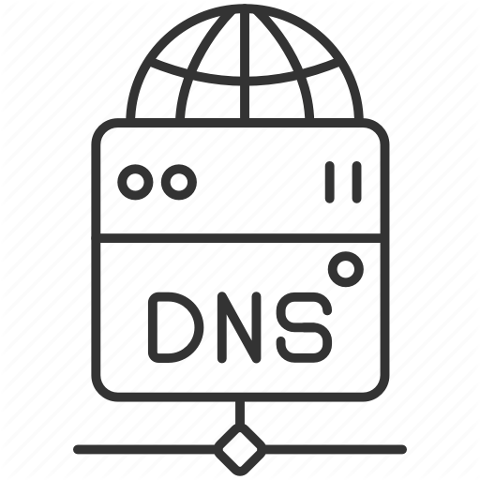

Step 6: The system will load IP address of longest lived peers.
Step 8: Download EMRs

GENERATING ELECTRONIC MEDICAL RECORD
a. All start with the patient wish to admission to hospital. They need to join using the Mobile(handheld) devices. By describing their native country and Citizen Identification Code. If successfully verified as the citizen the system will generate a wallet that contains patient digital signature. This signature will be persistent.

If successfully verified as citizen
Step c: The system will generate wallet
Step d: Wallet stored.



Step a: Use choose country and give ID.
Step b: System chooses appropriate server and sent ID for verification

b. Admit Transaction: In this type of transaction patient who intends to admit in a hospital, (e)The patient will scan the QR code in hospital.(f) This process will send the identity certificate[cipher] of the patient digitally signed by patient. (g)In return hospital will send the admission certificate signed by Hospital Digital Signature, contains identity of patient timestamped that certifies patient has been admitted.
c. Treatment Transaction: In this type of transaction patient will be scan QR code for the purchasing the medicines(hospital authorized chemist). The user will transact money for the medicine which will be calculated through the data fetched from the QR code. This type of transaction will contain the reference to admit transaction(if first transaction) or the most recent treatment trasnsaction.
d.Discharge Transaction: This type of transaction will happen at the time of patient getting discharge from the hospital. This transaction will contain the discharge certificate which has the identity certificate of patient, along with the reference to the last treatment transaction happened. This transaction will be done by hospital to the patient.
e.Mining: Mining means verification of the transactions and collecting all the transaction with correct references to form a EMR. In the decentralized network everybody should be given equal opportunity to generate EMR. This problem can be solved using Reusable Proof-of-Work Consensus Protocol. The one will solve this puzzle successfully by consuming thier electricity first will get the opportunity to generate EMR.
f. System of Incentives: Since it is always a need to have incentives in place for the hospitals in place for thier participation in contributing to the systems by transactions and generating the EMRs by giving away their CPU power (and thus electricity).
The incentives will be calculated whenever an EMR is generated. The process for calculating an incentive will be based on the Information Entropy as invented by Shanon. The inverse of the Information Entropy calculated is equal to the VALUE OF INFORMATION.
There will be a currency that is needed to calculate dominant value of the information. The currency will be 1 cure.
^{=> 0.0000001 vaccine = 1 cure}
^{=> 1/ I(EMR) = V}
I = Information Entropy Function;
^{V = Information Value;}
^{=> C = V * (1 vaccine)}
^{C = cures calculated;}
The calculated cures will be then distributed among the producer and consumer and the creator by the following ratio.
=> X C = ɑ * X + β * X + γ * X
^{X = calculated cure[s].}
ɑ = 29.997 ( the part of domination given to producer);
β = 69.993 ( the part of domination given to consumer);
γ = 0.01 ( the part of domination given to creator);
Here producer is the hospital who owns the transactions for the EMR and the consumer who generated EMR by gave away their CPU power. The creator will be the developer who owns the key of the creator record( the first dumb-record) in the system.

RESEARCHING ON ELECTRONIC MEDICAL RECORDS
Step i. Just like Hospitals, Medical Research Institutes should also be register to the system similar to the way hospital being shown (Step 1- 8).
Step ii. After registration medical institute will also own the wallet that will contain their digital signatures.
Step iii. The system will have the portal in place to search for the diseases which are known and in response system will give headers of the EMRs containing that particular disease tag. For the diseases which are unknown (they contain the unknown tag along with the symptoms) on the headers.
Step iv. They can have the headers and can download only those EMRs from the peers in the network which they choose to research.
Step v. The system will contain many Machine Learning algorithms and visualization models in place in order to find the nature of the data and choosing the appropriate machine learning algorithm to build model.
Step vi. There will be the system of incentives for this researchers too. As they are giving their processing powers for building the machine learning model. The incentive will based upon how much valuable the model is. This value will be based upon the testing accuracy of the model .
^{=> C = X * T/ n * β}
^{X = Total value of chosen EMRs}
T = testing accuracy in of model
^{n = number of chosen EMR}
Step vii. The EMRs which will be chosen for building machine learning models will be distributed to the ratio of 70 is to 30 for training and testing purpose respectively.
^{IMPORTANT ASPECTS}
- Hospital can able to generate the EMR for the first without spending any cures.
- After the signature appeared on the EMRs they have to spend 20% of their currency they owe in the system.
- The patient can have multiple anonymous identities through cartographic keys. In simple way one unique for one hospital.
- The patient as long as owe all the keys and certificate by number of hospitals they are treated. They can claim their dissatisfaction by revealing their keys they own for particular hospital[s]. This is a way of transparency to the consumer.
- The research institute and hospital cannot own multiple wallets if they ever lose their wallet, they will lose every asset they own in the system.
- The research institute only for the first time can generate currency in the system once their signature being revealed in the system. They have to broadcast the asset(machine learning model) reference as the number of users will use they will earn the share equated to half every time.
- Patients can store their medical history in any persistent device/cloud by encrypting it with the wallet.
- The chances of Denial of Service attack is less in the network because it is very unlikely to find the consistent duration pattern for EMR generation.
^{CONCLUSION}
This kind of record sharing system can be valuable in any problem area where identities can be hidden. The participation in the system can be increased by correctly implementing the consensus mechanism.
The acceleration of research on the sensitive is also possible for the same time while using principle of least privilege, i.e., revealing only the necessary information for research.
This system can be served to generate revenue by knowing correct value of the secured assets generated/mined within the system.

