

Architecture Design Specification

Netflix IMF Utility (DPP and iTunes format)
Version 1.0
Revision History
Date | Revision Type | Revision # | Comments | Initials
08/29/2016 | Major | 1 |  | GG

Contents
Revision History 2
Contents 3
1 Overview 4
1.1 Document’s Purpose 4
1.2 Product Purpose 4
1.3 Assumptions and Limitations 4
1.4 Source Code 4
2 Common Architecture 5
2.1 Separating Common logic and Configurable conversion 5
2.2 Common IMF processing Workflow for all formats 6
2.3 Command Line Interface 7
2.4 Config.xml 8
2.5 Conversion.xml 10
2.6 Program Language 15
2.7 XML Schema and Referenced XML files 15
3 DPP Architecture 16
3.1 User Input 16
3.2 External Tools 16
3.3 Workflow 17
4 iTunes Architecture 18
4.1 User Input 18
4.2 External Tools 19
4.3 Workflow 19
4.4 Video Format List 19
4.5 Chapters.xml 20
4.6 Audiomap.xml 21

Overview

Document’s Purpose
The document is intended to specify the architecture design for software product IMF Utility with format plugins for DPP and iTunes.

Product Purpose

- Have some basic IMF media conversion utilities built to handle flat file creation from a specified CPL within the IMF package.
- These utilities will end up in the open source domain, and use of the FFmpeg project as the transcoder is appropriate for this case.
- Conversion will be one way from IMF to specific flat file formats.

Assumptions and Limitations
- DPP and iTunes format only
- FFmpeg will be used as much as possible
FFmpeg is not extended with formats
- BMXLib will be used for DPP generation
- Netflix IMF verification tool (Photon) will be used
- IMF App2 (2e) is used (JPEG2000 and uncompressed video)
- TTML subtitles (data essence) only are converted to STL (DPP) or iTT (iTunes). Ancillary essences are not transcoded.
- Linux is the main platform

Source Code
Source code can be found at GitHub repository.

Common Architecture
The section defines common architecture of IMF Utility applicable for all formats.

Separating Common logic and Configurable conversion
- IMF Utility contains business logic common for all formats and related to IMF processing, while conversion and transformation (specific for each format) is performed by external tools.
- The business logic common for all formats and related to IMF processing (see Section 2.2):
  - reading input parameters
  - validating CPL (using external Photon tool)
  - analyzing CPL (a sequence of segments/resources to generate the output virtual track)
  - executing conversion operations using external tools
- A sequence of actions to be performed for conversion is specific for each format and contained in a special conversion.xml file (see Section 2.5).
  - In what follows each single action specified in conversion.xml is denoted by Conversion Operation.
  - Each Conversion Operation is a call of an external tool responsible for conversion.
  - Each Conversion Operation is actually a template with Template Parameters specific for each operation and format. The Template Parameters are replaced by real values by the Utility (see Section 2.5.1)
  - It’s possible to configure in conversion.xml how Conversion Operations are executed (see Section 2.5.3)
    - once or for each segment
    - subsequently or in a pipeline
- Separating common business logic and format-specific conversion has the following advantages:
  - Simplifies support of new formats
    - Example: supporting XDCAM in future
  - Allows managing conversion logic specific for each format easily
    - Example: maintain both DPP and XDCAM independently
  - Allows controlling transformation steps (Conversion Operations)
    - Example: change what actions and in what sequence are required for conversion to DPP
  - Allows controlling what external tools are used at each step
    - Example: use FFmpeg or an external encoder for encoding
  - Allows supporting new external tools
    - Example: OS X native codecs instead FFmpeg codecs
  - Simplifies support and maintenance of the utility
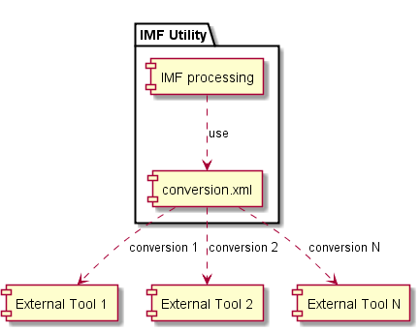  Pic.1: Separating business logic and conversion (abstract) | 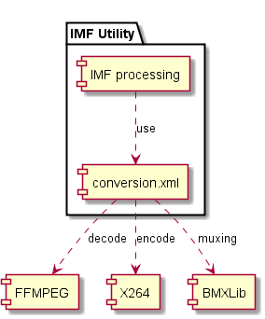  Pic.2: Separating business logic and conversion (example)

Common IMF processing Workflow for all formats
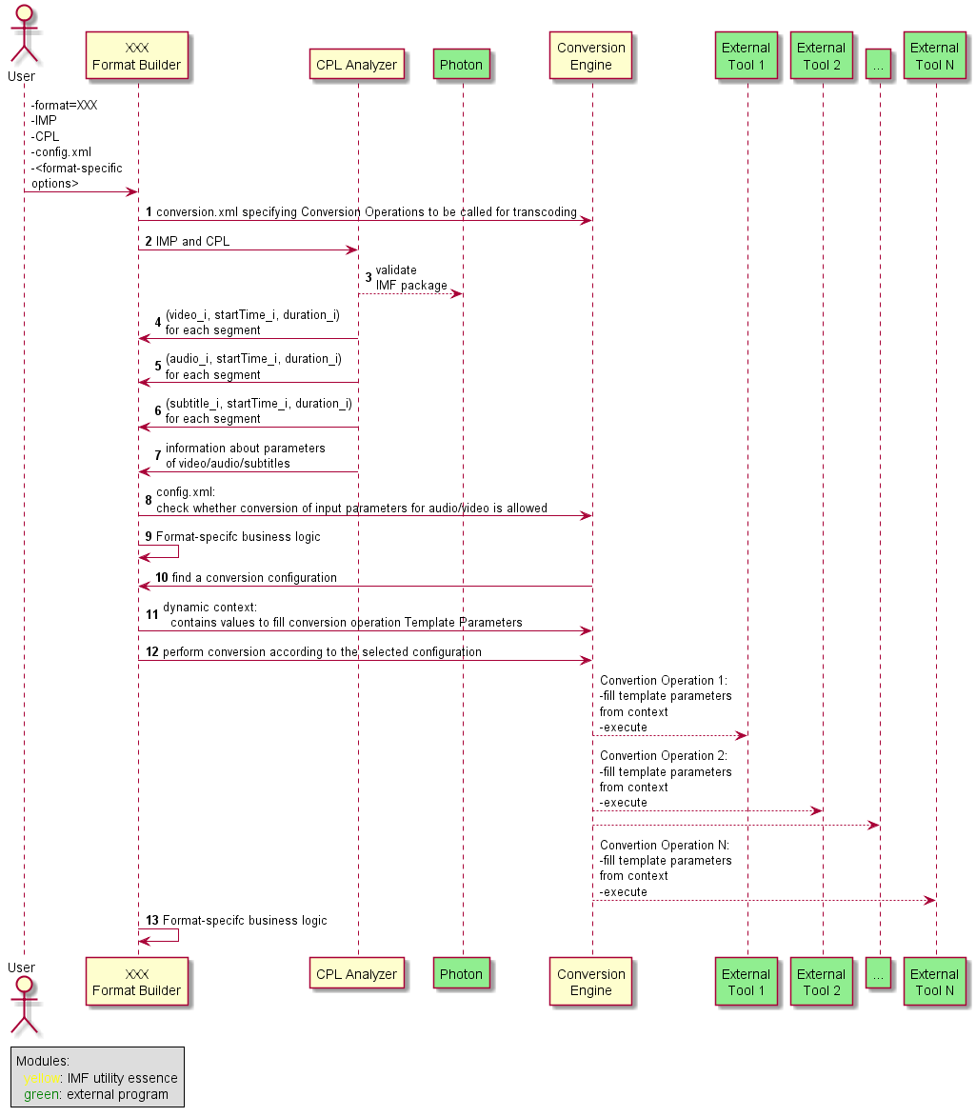

- Analyze conversion.xml containing Conversion Operations to be called for transcoding (see Section 2.5)
- Analyze input IMP and CPL
- Validate input IMP and CPL using an external tool (a wrapper for Netflix Photon)
- For each video resource from each CPL’s segment:
  - find a corresponding video essence
  - get start time and duration (in edit units)
  - convert edit units to timestamps
  - => (video_i, startTime_i, duration_i)
- For each audio resource from each CPL’s segment:
  - find a corresponding audio essence
  - get start time and duration (in edit units)
  - convert edit units to timestamps
  - => (audio_i, startTime_i, duration_i)
- For each subtitle (data) resource from each CPL’s segment:
  - find a corresponding data essence
  - get start time and duration (in edit untis)
  - convert edit units to timestamps
  - => (subtitles_i, startTime_i, duration_i)
- Get the information about source parameters for video and audio (for example, fps, size, audio sample rate, audio channel layout etc.)
- Compare source parameters (for example, aspect_ratio, fps, etc.) with the destination ones. If they don’t match, check whether we can perform conversion (it’s specified in input config.xml, see Section 2.4).
- Format-specific business logic if needed.
- Find an appropriate configuration depending on the format and input
- Create a Dynamic Context based on source parameters and data from conversion.xml. The dynamic context will be used to fill Conversion Operation Template Parameters (see Section 2.5.1)
- Sequentially execute all Conversion Operations from the conversion configuration.
For each Conversion Operation (which is actually a template) replace all Template Parameters with actual values from Dynamic Context (see Section 2.5.1)
- Format-specific business logic if needed.

Command Line Interface
Usage:
- <IMF Utility> <format> [common options] [format options]

Arguments:
- format:
  - sets a format for conversion
  - possible values
    - dpp
    - itunes
  - mandatory

Common options:
- --imp <string>:
  - location of an input IMF package
  - the IMF Package is a directory containing the following:
    - ASSETMAP.xml
    - PKL.xml
    - one or more complete CPLs
    - essence track files
  - IMF package must be complete (it will be validated by the Utility). It means that all of the asset references of all the CPLs described in the IMP are also contained in the IMP
  - can be redefined in config.xml

  - mandatory in “convert” (default) mode
- --cpl <string>:
  - CPL location within the input IMP
  - location of a CPL file within the IMF Package directory (--imp)
  - the specified CPL file will be used for flat file creation.
  - mandatory in “Transcode” (default) mode
  - can be redefined in config.xml
- –c, --config:
  - config.xml file location (see Section 2.4)
  - mandatory in “convert” (default) mode
- -w, --working-dir:
  - a path to the working directory where conversion is performed and output flatten file(s) are placed
  - if the directory doesn't exist, it will be created
  - mandatory in “Transcode” (default) mode
  - can be redefined in config.xml
- -l,--log-level:
  - log level
  - possible values
    - error
    - warn
    - info (default)
    - debug
- -h, --help:
  - prints help

Formats specific options described below in the corresponding for each format sections (see Section 3.1 for DPP and Section 4.1 for iTunes format).

Config.xml
- Config.xml is an input parameter for the utility (in convert mode)
- Config.xml contains the following required data:
  - Path to all external executables. May be used in both code and conversion.xml Template Parameters (see Section 2.5.1).
- Config.xml contains the following optional data:
  - Whether a silent conversion to format destination audio/video parameters should be performed if the input parameters don’t match.
    - Conversion is allowed if not specified in config.xml explicitly.
    - The user may want to disallow conversion in some special cases (for example, if video fps doesn’t match).
  - Path to conversion.xml file.
    - If not specified, then a default one distributed with the utility is used.
    - If the user wants to change default transcoding logic as specified in conversion.xml distributed with the utility, it can either edit the default conversion.xml or create an alternative conversion.xml. In the latter case this option is needed.

Example
<?xml version="1.0" encoding="UTF-8"?>
<Config xmlns="http://config.imfutility.netflix.com">

<!--
<imp>/home/media/Chimera25_FTR_C_EN_XG-NR_20_4K_20150608_OV</imp>
<cpl>CPL_38f1005f-e24d-4aaa-93a8-2a5676387b17.xml</cpl>
<workingDirectory>/tmp/imf-conversion-output</workingDirectory>
-->

<!--
Path to external executables.
-->
<externalTools>
<tool id="ffmpeg">ffmpeg</tool>
<tool id="ffprobe">ffprobe</tool>
<tool id="bmx">raw2bmx</tool>
<tool id="mxf2raw">mxf2raw</tool>
<tool id="x264">x264-10bit</tool>
<tool id="as-02-unwrap">as-02-unwrap</tool>
<!--<tool id="ttml-to-stl">ttml-to-stl.jar</tool>-->
<!--<tool id="imf-validation">validation path</tool>-->
</externalTools>

<!--
Allows/disallows silent conversion to format destination parameters if the input doesn't match.
Conversion is allowed by default (if not specified here explicitly)
-->
<!--
<conversionParameters>
<param name="bitDepth">yes</param>
<param name="frameRate">yes</param>
<param name="size">yes</param>
<param name="pixelFormat">yes</param>
<param name="bitsSample">yes</param>
<param name="sampleRate">yes</param>
</conversionParameters>
-->

<validateImf>true</validateImf>
<cleanWorkingDir>false</cleanWorkingDir>
<deleteTmpFilesOnExit>true</deleteTmpFilesOnExit>
<deleteTmpFilesOnFail>false</deleteTmpFilesOnFail>

</Config>

Definition
- /Config/{imp,cpl,workingDirectory}
  - if set, they redefine corresponding command line options: --imp, --cpl, --working-dir
- /Config/externalTools (required)
  - Container of external tools list
- /Config/externalTools/tool
  - describes external tool executable file (with absolute path or from system PATH) that can be executed in a Conversion Operation by @id
  - @id internal name of external tool that will be used in Conversion Operation as %{tool.<@id>}
- /Config/conversionParameters
  - contains media parameters that should be matched against destination parameters
  - if not matched then conversion will be interrupted
  - by default input parameters are not verified against destination parameters, just converting if possible
- /Config/conversionParameters/param
  - specify parameter that should be matched to destination parameter by @name
  - @name contains parameter name and should be equal %{dest.<paramName>}
- /Config/validateImf
  - if set then input IMF package will be verified that it is a valid IMF package
  - transcoding will be interrupted if IMF package is not valid
- /Config/cleanWorkingDir
  - if set to “true” then working directory will be wiped after transcoding done
- /Config/deleteTmpFilesOnExit
  - if set to “true” then temporary files will be deleted after transcoding successfully done
- /Config/deleteTmpFilesOnFail
  - if set to “true” then temporary files will be kept after transcoding failure done

Conversion.xml
- Convertion.xml contains a sequence of operations (Conversion Operations) to be executed for transcoding to each supported destination formats.
- Conversion.xml is distributed with the utility. It’s possible to use an alternative conversion.xml (see Section 2.4).

Media Information
- Conversion Operation can require some media parameters that are absent in CPL but can be obtained from media files/assets directly.
- Conversion configuration provides specific for video/audio /subtitles/data streams media info execution commands that will be executed before any conversion operation
  - <mediaInfoCommandVideo>command to get media info for video stream</mediaInfoCommandVideo>
  - <mediaInfoCommandAudio>command to get media info for audio stream<mediaInfoCommandAudio>
  - <mediaInfoCommandSubtitle>
command to get media info for data/subtitle streams
</mediaInfoCommandSubtitle>
  - For all these configurations %{dynamic.mediaInfoInput} will contains input media source
- Ancillary streams information can be get using generic media info execution configuration
  - <mediaInfoCommandOthers>
<mediaInfoCommand name="data1"> command to get media info for …</mediaInfoCommand>
</mediaInfoCommandOthers>

Template Parameters
- Each Conversion Operation is actually a template for execution of an external program with some Template Parameters.
- Each Template Parameter has the following form: %{parameterContext.parameterName}
- Template parameters are replaced in the code with real values according to the {parameterContext}:
  - “tool” context:
    - Defines an external tool to be used for conversion.
    - Can be used in any Conversion Operation.
    - {parameterName} must be equal to one of the <tool>’s id attributes from the <externalTools> section in config.xml (see Section 2.4)
    - The actual Template Parameter value is equal to the value of the corresponding <tool> in config.xml
  - “tmp” context:
    - Defines some temporary parameters to be used during conversion (for example, tmp files)
    - Can be used in any Conversion Operation.
    - The list of all tmp context values is specified in conversion.xml for each format in the following form: <param id=”ID”>value</param>
    - {parameterName} must be equal to one of the tmp <param>’s id attributes specified for the format in conversion.xml.
    - The actual Template Parameter value is equal to the value of the corresponding <param> in conversion.xml
  - “dest” context:
    - Defines parameters specific for output media
    - Can be used in any Conversion Operation
    - The list of all destination context parameters (//defaultDestContext and/or //destContexts/destContext) is specified in conversion.xml for each format in the following form: <param name=”PARAM_NAME”>value</param>
  - “dynamic” context:
    - Defines parameters specific for the input CPL and essences in general (not for each segment)
    - Can be used in any Conversion Operation.
    - The list of parameters is calculated in the code for the input CPL in a key:value form.
    - {parameterName} must be equal to the parameter key.
    - The actual Template Parameter value is equal to the calculated dynamic parameter value
    - Can be calculated in conversion.xml directly like variable and supports the following operations represented by attributes
      - concat
        - boolean
        - if true then append string value to parameter value
      - deleteOnExit
        - boolean
        - affected only when value represent a file
      - concatWhitespace
        - boolean
        - affected only at concat option
        - concat value with trimmed white spaces
      - add
        - integer
        - increments value to “add” value
  - “seq” context:
    - Defines parameters specific for each sequence of the input CPL
    - Can be used in sequence-specific Conversion Operations only
    - The list of parameters is calculated in the code for the sequence the Conversion Operation is executed for
    - Supported parameters:
      - uuid
      - num
      - type
      - language
      - channels_num
  - “segm” context:
    - Defines parameters specific for each segment of the input CPL
    - Can be used in segment-specific Conversion Operations only
    - The list of parameters is calculated in the code for the segment the Conversion Operation is executed for
    - Supported parameters:
      - uuid
      - num
  - “resource” context:
    - Defines parameters specific for each resource of segment of the input CPL
    - Can be used in segment-specific Conversion Operations only
    - The list of parameters is calculated in the code for the segment the Conversion Operation is executed for
    - Supported parameters:
      - num
      - uuid
      - trackFileId
      - essenceDescId
      - essence
      - editRate
      - repeatCount
      - repeat
      - startTimeTC
      - startTimeEU
      - startTimeMS
      - endTimeTC
      - endTimeEU
      - endTimeMS
      - durationTC
      - durationEU
      - durationMS
      - offsetMS
      - startTimeFrameEU
      - durationFrameEU
      - channels_num
      - bits_per_sample
      - sample_rate
      - channels_layout
      - soundfield_group_id
      - width
      - height
      - bit_depth
      - pixel_format
      - frame_rate
      - lang

Conversion Operation Execution Modes
- Relation between input and output of each Conversion Operation in a sequence:
  - Input/output is provided through Template Parameters (usually some files) from either “dynamic” or “tmp” contexts (see Section 2.5.2)
    - Default mode
  - Input/output is redirected to stdin/stdout and organized in a pipeline.
    - A sequence of commands participating in the pipeline must be wrapped in a <pipe> tag.
    - In a simplest case, the output of the first Conversion Operation goes to a pipe and becomes an input for the second Conversion Operation:
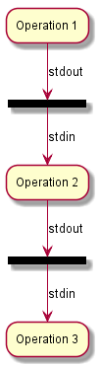
    - It’s possible that the first operation in the pipeline consists of a sequence of sub-operations, so that the output of each sub-operation for the sequence is redirected to the input of the second operation in the pipeline. A sequence of sub-operations must be wrapped in a <cycle> tag in this case.
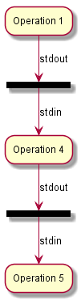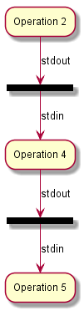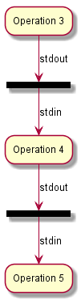
- How many times each Conversion Operation should be executed.
  - Once (default behavior): <execOnce>
  - In a cycle for each sequence: <execEachSequence>
    - Sequence type must be specified (audio, video, subtitles).
    - “seq” context template parameters can be used (see Section 2.5.1)
  - In a cycle for each segment: <execEachSegment>
    - “segm” context template parameters can be used (see Section 2.5.1)

For, If and Conditional Types
- All Conversion Operation (except “for” and “if”) and dynamic parameters have “if” and “unless” boolean attributes to manipulate execution sequence, if “if” is set true or “unless” set false then Conversion Operation will be executed
<execOnce name="muxing_mov" if="%{dynamic.hasAudioAndVideo}">
%{tool.ffmpeg} -i %{tmp.videoEncoded} -i %{dynamic.mainAudio}
-c:v copy -c:a copy
%{dynamic.destSource}
</execOnce>
- To calculate dynamic parameters in conversion.xml “for” Conversion Operation can be used
  - “for” can contains only dynamic parameters, “execOnce” and nested “for” elements
  - Can be used only in <formatConfiguration> element
<for iterator="i" to="%{dynamic.testCounter}">
<dynamicParameter name="accum" concat="true" concatWhitespace="true">
Parameter value = %{dynamic.test%{i}}
</dynamicParameter>
</for>
- “if” Conversion Operation can be used as usual conditional block (“else” branch not supported)
  - Can be used only in <formatConfiguration> element
<if test="%{dynamic.hasAudio}">
<execOnce name="print_message">
%{tool.echo} "Media file has audio stream."
</execOnce>
</if>

Conversion of video/audio input parameters to format destination ones.
- Input config.xml contains information whether each source audio/video parameter (such as fps, pixel format, etc.) can be converted to a destination format if it doesn’t match (see Section 2.3)
- Conversion.xml contains destination audio/video parameter values
- For each parameter which is not allowed to be silently converted, IMF Utility business logic compares source parameter value (calculated from CPL) and the destination one (as specified in configuration.xml)
- If they are not equal and conversion is not allowed, then utility reports and error and transformation job is aborted.

Example
<?xml version="1.0" encoding="UTF-8"?>
<conversion xmlns="http://conversion.imfutility.netflix.com">

<imfValidation>
%{dynamic.validateTool} <command line>...
</imfValidation>

<formats>
<format name="test">

<tmpContext>
<param id="videoEncoded" deleteOnExit="true">output.mov</param>
</tmpContext>

<defaultDestContext name="default">
<!-- audio params -->
<param name="sampleRate">48000</param>
<param name="bitsSample">24</param>
</defaultDestContext>

<destContexts>
<destContext name="hd1080i2997">
<param name="width">1920</param>
<param name="height">1080</param>
<param name="frameRate">30000/1001</param>
<param name="interlaced">true</param>
<param name="aspectRatio">16/9</param>
</destContext>
</destContexts>

<mediaInfoCommandVideo>
%{tool.ffprobe} <command line>...
</mediaInfoCommandVideo>
<mediaInfoCommandAudio>
%{tool.ffprobe} <command line>...
</mediaInfoCommandAudio>
<mediaInfoCommandSubtitle>
%{tool.ffprobe} <command line>...
</mediaInfoCommandSubtitle>

<mediaInfoCommandOthers>
<mediaInfoCommand name="trailer">
%{tool.ffprobe} <command line>...
</mediaInfoCommand>
</mediaInfoCommandOthers>

<formatConfigurations>
<formatConfiguration name="main">

<if test="%{dynamic.hasVideo}">

<execEachSequence type="video" name="encodeVideo">
<pipe>
<cycle>
<execOnce name="generate_black_frame">
%{tool.ffmpeg} <command line>...
</execOnce>
<execEachSegment name="decode_video">
<execOnce name="decode_video">
%{tool.ffmpeg} -y
-ss %{resource.startTimeTC}
-t %{resource.durationTC}
-i %{resource.essence}
-map 0:0 -an
-vf scale=%{dest.width}:%{dest.height},fps=%{dest.frameRate}
-pix_fmt yuv422p16le
-f rawvideo
-
</execOnce>
</execEachSegment>
<execOnce name="generate_black_frame">
%{tool.ffmpeg} <command line>...
</execOnce>
</cycle>
<execOnce name="encode_video" unless="%{dynamic.isOSX}">
%{tool.ffmpeg} <command line>...
</execOnce>
<execOnce name="encode_video" if="%{dynamic.isOSX}">
%{tool.prenc} <command line>...
</execOnce>
</pipe>
</execEachSequence>
</if>

<execOnce name="muxing_mov" if="%{dynamic.hasVideo}">
%{tool.ffmpeg} -i %{tmp.videoEncoded}
-c:v copy
%{dynamic.destSource}
</execOnce>

<!-- Subtitle processing -->
<for iterator="i" from="0" count="%{dynamic.ttmlCount}">
<dynamicParameter name="itt-%{i}" deleteOnExit="true">
itt-%{i}.itt
</dynamicParameter>

<dynamicParameter name="ttmlToIttParams">
-t %{dynamic.ttml-%{i}} -o %{dynamic.itt-%{i}}
</dynamicParameter>

<execOnce name="convert_ttml_to_itt">
%{dynamic.ttml-to-itt} %{dynamic.ttmlToIttParams}
</execOnce>
</for>

</formatConfiguration>
</formatConfigurations>
</format>

</formats>
</conversion>

Definition
Conversion.xml example is described transcoding video only with subtitles conversion. Below provided explanation of major Conversion Operations and configurations (XPath notation will be used to unify element representation):
- //defaultDestContext describes audio destination options
- //destContext/@name[. = "hd1080i2997"] provides video destination options with named configuration that can be used in code to find destination video options
- //if/@test[. = "%{dynamic.hasVideo}"] executes if %{dynamic.hasVideo} dynamic variable has boolean “true” value
- next major block where video conversion is processed can be described in the pseudo code for better understanding
// calls when data written to stdin from stdout another process
read_data_from_stdin_callback {
encode video data
write to output file
}

for seq in cplSequences[@type = “video”] {
run encode_video if isOSX %{tool.prenc} else %{tool.ffmpeg}
register read_data_from_stdin_callback

run generate_black_frame to write black frame data to stdout
for segm in seq.segments[] {
// decode resource
run decode_video with
inputFileName:%{resource.essence}
startTimeCode:%{resource.startTimeTC}
durationTimeCode:%{resource.durationTC}
write decoded data to stdout
}
run generate_black_frame to write black frame data to stdout
}
- after video transcoding tmp output file exists
- mux tmp output file video stream to destination media output file name
- when video processing done, executed subtitles conversion in “for” loop
  - “for” body will be executed %{dynamic.ttmlCount} times

Program Language
- IMF Utility business logic language: Java.
- C/C++ or any other language may be used for external utilities, such as FFmpeg encoder wrappers.

XML Schema and Referenced XML files
All pointed XML and them XML Schema files are located in source code and can be used to get detailed information about corresponding XML document.

DPP Architecture
The section defines architecture of IMF Utility specific to DPP format.

User Input
DPP specific options
- -m, --mode <string> [mode_options]:
  - An operation to be executed for the format.
  - Possible values:
    - convert
      - performs transcoding to DPP format
    - metadata
      - generates an empty metadata.xml to be filled by the user. The metadata.xml is a template for DPP metadata (Section 3.4). Empty metadata values will not be inserted
    - audiomap
      - generates a default audiomap.xml (Section 3.5)
  - If not specified, then “convert” is assumed
- “convert” mode options:
  - --metadata <string>:
    - metadata.xml location
  - --audiomap <string>:
    - audiomap.xml location
  - –o, --output <string>:
    - output file name without .mxf extension
- “metadata” mode options:
  - –o, --output <string>:
    - output metadata.xml location
- “audiomap” mode options:
  - –o, --output <string>:
    - output audiomap.xml location

External Tools
- Netflix Photon
  - https://github.com/Netflix/photon
  - will be used for verification of IMF packages
  - most probably we will have to write a wrapper and call it as an external program
  - the wrapper source code and build instructions will be distributed
- asdcplib-as02
  - https://github.com/DSRCorporation/asdcplib-as02
  - fork of CineCert asdcplib
  - will be used for extracting TTML from MXF
  - will distribute the source code and build instructions
- FFmpeg
  - https://www.ffmpeg.org/
  - will be used as a main transcoder tool
  - will be called as an external program
  - ffmpeg will not be redistributed, but build instructions for each platform will be provided
- BMXLib
  - https://sourceforge.net/p/bmxlib/home/Home/
  - will be used for conversion to DPP (AS-11) format
  - will be called as an external program
  - BMXLib will not be redistributed, but build instructions for each platform will be provided
- videolan x264 encoder
  - http://www.videolan.org/developers/x264.html
  - will be used as encoder to x264 (AVC Intra 100)
  - will be called as an external program
  - x264 will not be redistributed, but build instructions for each platform will be provided

Workflow
- The DDP workflow follows a common IMF processing workflow as defined in Section 2.2.
- DDP-specific business logic:
  - IMF utility processes input metadata.xml and generates a text file with metadata which is passed to BMXLib

Metadata.xml
metadata.xml file represents minimum metadata set of DPP metadata and should be filled by user according to Minimum Metadata Set specification. This metadata will be muxed to resulting MXF file.

Audiomap.xml
audiomap.xml defines EBU audio layout required by DPP audio specification. User can set custom audio layout with custom channel mapping or IMF Utility will guess about audio layout basis on information from a CPL.

Example
<?xml version="1.0" encoding="UTF-8" standalone="yes"?>
<AudioMap xmlns="http://audiomap.dpp.imfutility.netflix.com">
<EBUTrack>
<Number>1</Number>
<CPLVirtualTrackId>urn:uuid:850bd841-5c4a-4b02-b853-5ce1afbb3629</CPLVirtualTrackId>
<CPLVirtualTrackChannel>1</CPLVirtualTrackChannel>
</EBUTrack>
<EBUTrack>
<Number>2</Number>
<CPLVirtualTrackId>urn:uuid:850bd841-5c4a-4b02-b853-5ce1afbb3629</CPLVirtualTrackId>
<CPLVirtualTrackChannel>2</CPLVirtualTrackChannel>
</EBUTrack>
<EBUTrack>
<Number>3</Number>
</EBUTrack>
<EBUTrack>
<Number>4</Number>
</EBUTrack>
</AudioMap>

Definition
The audiomap example defined above represents audio track allocation R48: 2a option:
- 4 EBU tracks
- 1 and 2 tracks are mapped to real virtual track with corresponding channels
- 3 and 4 tracks contain silence data

iTunes Architecture
The section defines architecture of IMF Utility specific to iTunes format.

User Input
iTunes specific options:
- -m, --mode <string> [mode_options]:
  - An operation to be executed for the format.
  - Possible values:
    - convert
      - performs transcoding to iTunes package format
    - metadata
      - generates an partially filled iTunes package metadata.xml to be filled completely by the user
    - chapters
      - generates a default chapters.xml (Section 4.5)
    - audiomap
      - generates a default audiomap.xml (Section 4.6)
  - If not specified, then “convert” is assumed
- “convert” mode options:
  - --vendor-id <string>:
    - vendor identifier
    - can only contain alphanumeric characters, must be at least six ASCII characters in length, and can contain underscores (“_”)
    - mandatory
  - --metadata <string>:
    - metadata.xml location
    - Optional. If not set then a basic metadata.xml will be generated
    - metadata.xml of target iTunes package can be incomplete because some mandatory elements can be empty. For example: preview (trailer) and artwork (poster) assets can be not set. It should be filled manually.
  - –p, --package-type <string>:
    - a destination iTunes package type: film or tv. Latest versions (5.2) of specifications are supported
    - optional, default value is “film”
  - –f, --format <string>:
    - destination encoded video format
    - Optional. If not set then it will be calculated automatically based on the source video information, package type and according to iTunes source profiles
    - supported formats can be found in Section 4.4
  - --trailer <string>:
    - trailer asset location
    - processed only for “film” package type
    - Optional. If set then must be a MOV container
  - --poster <string>:
    - poster asset location
    - Optional If set then must be a JPG file
  - --chapters <string>:
    - chapters.xml location
    - processed only for “film” package type
    - Optional
  - --cc <string>:
    - a path to external closed captions
    - only SCC captions are supported according to iTunes Asset Guide
  - –sub <string> <string> <string> ….
    - a paths to external subtitles
    - processed only for “film” package type
    - input files must have one of extensions: xml, ttml, itt
    - maximum 13 files (iTunes supported only 13 languages, one file for one language)
    - if not set, then only CPL TTML will be processed. Otherwise only the specified TTML will be converted to ITT
  - --fallback-locale <string>:
    - main locale for iTunes package
    - must fit pattern xx, xx_XX (or xx-XX)
    - Optional, will be used if CPL or metadata locale is not set
  - --audiomap <string>:
    - audiomap.xml location
    - audiomap.xml defines iTunes audio configuration to use and contains audio stream mapping for the configuration
    - Optional. If not set, then audio configuration will be chosen according to input audio. Only the mainAudio will be used. Option 3 and Option 6 only are considered as candidates
- “metadata” mode options:
  - –p, --package-type <string>:
    - a destination iTunes package type: film or tv. Latest versions (5.2) of specifications are supported
    - optional, default value is “film”
  - –o, --output <string>:
    - output metadata.xml location according to package type
- “chapters” mode options:
  - –o, --output <string>:
    - output chapters.xml location
- “audiomap” mode options:
  - –o, --output <string>:
    - output audiomap.xml location

External Tools
- Netflix Photon
  - https://github.com/Netflix/photon
  - will be used for verification of IMF packages
  - the wrapper source code and build instructions will distributed
- asdcplib-as02
  - https://github.com/DSRCorporation/asdcplib-as02
  - fork of CineCert asdcplib
  - will be used for extracting TTML from MXF
  - will distribute the source code and build instructions
- FFmpeg
  - https://www.ffmpeg.org/
  - will be used as a main transcoder tool
  - will be used as a ProRes encoder on Linux and Windows
  - will be called as an external program
  - ffmpeg will not be redistributed, but will provide build instructions for each platform
- Netflix ProRes Encoder
  - https://github.com/DSRCorporation/prores-encoder-mac
  - will be used on OS X as a ProRes encoder tool instead FFmpeg on Linux and Windows
  - will be called as an external program
  - the source code and build instructions will be distributed

Workflow
- The iTunes workflow follows a common IMF processing workflow as defined in Section 2.2.
- iTunes -specific business logic:
  - IMF utility processes specific input parameters for iTunes package and does necessary checks of input parameters
  - Creates iTunes package directory and put required content
    - Only one dialect of the audio and subtitle languages is supported in iTunes package. But IMF package may contain multiple virtual streams for the same language.
In this case Utility will report a warning and process only the first stream (audio/captions) for a language. All other audio/caption streams for the same language will be skipped.
  - Locale choosing:
    - if only metadata or only audiomap (main audio locale) is set then locale is used from the one for all assets (excepts subtitles and cc) locales and metadata locales
    - if metadata and audiomap (main audio locale) is set and locales don’t match warning is produced about metadata locale and main source locale
    - otherwise default locale is get from main audio essence descriptor or from locale list of CPL else default locale (en-US) that can be overwritten by fallback locale
  - If metadata.xml was set then it will be copied and updated/created existing/missing elements. Otherwise basic metadata.xml will be generated. Manual fixing of generated metadata.xml may be required.
  - Audiomap.xml is used to define an audio channel assignment and mapping of source tracks/channels to the output ones. If no audiomap.xml is provided – then channel assignment will be guessed from the input tracks layout.
  - Add a black frame at the beginning and at the end of each video with corresponding audio silence data.

Video Format List
We always encode to Apple ProRes 422 (HQ profile).

Format | Profile | Package Type | Frame size | fps | Interlaced/Progressive
hd1080p30 | HD | Film and TV | 1920x1080 | 30 | progressive
hd1080i2997 | HD | Film and TV | 1920x1080 | 29.97 | interlaced
hd1080p2997 |  |  |  |  | progressive
hd1080p25 | HD | Film and TV | 1920x1080 | 25 | progressive
hd1080p24 | HD | Film and TV | 1920x1080 | 24 | progressive
hd1080i23976 | HD | Film and TV | 1920x1080 | 23.976 | interlaced
hd1080p23976 |  |  |  |  | progressive
hd720p30 | HD | TV | 1280x720 | 30 | progressive
hd720i2997 | HD | TV | 1280x720 | 29.97 | interlaced
hd720p2997 |  |  |  |  | progressive
hd720p25 | HD | TV | 1280x720 | 25 | progressive
hd720p24 | HD | TV | 1280x720 | 24 | progressive
hd720i23976 | HD | TV | 1280x720 | 23.976 | interlaced
hd720p23976 |  |  |  |  | progressive
sdtvntsc480i2997 | SD TV NTSC | TV | 640x480 | 29.97 | interlaced
sdtvntsc480p2997 |  |  |  |  | progressive
sdtvntsc480p24 | SD TV NTSC | TV | 640x480 | 24 | progressive
sdtvntsc480p23976 | SD TV NTSC | TV | 640x480 | 23.976 | progressive
sdtvpal576p25 | SD TV PAL | TV | 720x576 | 25 | progressive
sdtvpal576p24 | SD TV PAL | TV | 720x576 | 24 | progressive
sdtvpal576p23976 | SD TV PAL | TV | 720x576 | 23.976 | progressive
sdfilmntsc480i2997_16_9 | SD Film NTSC | Film | 720x480 encoded pixels; for display 853x480 (16:9) | 29.97 | interlaced
sdfilmntsc480p2997_16_9 |  |  |  |  | progressive
sdfilmntsc480p24_16_9 | SD Film NTSC | Film | 720x480 encoded pixels; for display 853x480 (16:9) | 24 | progressive
sdfilmntsc480p23976_16_9 | SD Film NTSC | Film | 720x480 encoded pixels; for display 853x480 (16:9) | 23.976 | progressive
sdfilmntsc480i2997_4_3 | SD Film NTSC | Film | 720x480 encoded pixels; for display 640x480 (4:3) | 29.97 | interlaced
sdfilmntsc480p2997_4_3 |  |  |  |  | progressive
sdfilmntsc480p24_4_3 | SD Film NTSC | Film | 720x480 encoded pixels; for display 640x480 (4:3) | 24 | progressive
sdfilmntsc480p23976_4_3 | SD Film NTSC | Film | 720x480 encoded pixels; for display 640x480 (4:3) | 23.976 | progressive
sdfilmpal576p25_16_9 | SD Film PAL | Film | 720x576 encoded pixels; for display 1024x576 (16:9) | 25 | progressive
sdfilmpal576p24_16_9 | SD Film PAL | Film | 720x576 encoded pixels; for display 1024x576 (16:9) | 24 | progressive
sdfilmpal576p23976_16_9 | SD Film PAL | Film | 720x576 encoded pixels; for display 1024x576 (16:9) | 23.976 | progressive
sdfilmpal576p25_4_3 | SD Film PAL | Film | 720x576 encoded pixels; for display 768x576 (4:3) | 25 | progressive
sdfilmpal576p24_4_3 | SD Film PAL | Film | 720x576 encoded pixels; for display 768x576 (4:3) | 24 | progressive
sdfilmpal576p23976_4_3 | SD Film PAL | Film | 720x576 encoded pixels; for display 768x576 (4:3) | 23.976 | progressive

Chapters.xml

Example
<?xml version="1.0" encoding="UTF-8"?>
<input_chapters basedir="../../chapters" xmlns="http://netflix.com/imf/itunes/chapters">
<timecode_format>24/999 1000/nonDrop</timecode_format>
<input_chapter>
<start_time>00:00:00:00</start_time>
<title locale="en-US">Chapter 1</title>
<file_name>chapter01.jpg</file_name>
</input_chapter>
<input_chapter>
<start_time>00:00:00:10</start_time>
<title locale="en-US">Chapter 2</title>
<file_name>chapter02.jpg</file_name>
</input_chapter>
</input_chapters>

Definition
- Basedir attribute represents directory path where chapter files will be located
- timecode_format contains time code format that used to describe chapter start time
- Each chapter should contain
  - start_time – chapter start time and format according to the timecode format of metadata.xml video asset
  - title – chapter title in corresponding locale
  - file_name – chapter file name in the following format: chapterXX.jpg, where XX – [01: 99]
- Chapters should be provided in chapter order: 01, 02, …, 99

Audiomap.xml

Example
<?xml version="1.0" encoding="UTF-8"?>
<audiomap xmlns="http://netflix.com/imf/itunes/audiomap">
<mainAudio locale="de-DE" name="main-audio.mov">
<Option6/>
</mainAudio>

<alternativeAudio locale="ja" name="audio_JA.mov">
<Option6>
<Track1>
<L>
<CPLVirtualTrackId>urn:uuid:850bd841-5c4a-4b02-b853-5ce1afbb3629</CPLVirtualTrackId>
<CPLVirtualTrackChannel>1</CPLVirtualTrackChannel>
</L>
<R>
<CPLVirtualTrackId>urn:uuid:850bd841-5c4a-4b02-b853-5ce1afbb3629</CPLVirtualTrackId>
<CPLVirtualTrackChannel>2</CPLVirtualTrackChannel>
</R>
</Track1>
</Option6>
</alternativeAudio>
</audiomap>

Definition
- mainAudio describes film’s audio and it’s mandatory
- alternativeAudio describes additional audio files for a film for different languages
  - optional;
  - a number of alternativeAudio items depends on supported languages (one file per language)
- Options and channel elements are defined according to iTunes audio channel assignment as defined in Requirements and iTunes Video and Audio Asset Guide 5.2.
The only exception is that we don’t support 1B, 1C and 1D audio channel assignments because
  - FFmpeg supports only 1A channel layout for LPCM codec (it always assumes Option 1a for 5.1 LPCM, and there is no way to change the channel assignment for 5.1).
  - iTunes specification assumes one of 1A, 1B, 1C or 1D options, so it looks like it’s sufficient to support only one of them (we’re going to support 1A as it works correctly with FFmpeg).
- If Option element is empty, then input channels from each subsequent virtual audio track defined by CPL will be matched to corresponding output Option channels.

