**User guidelines for running TSE (Time-Series Estimator – for DSSAT models) software**

**Emir Memic1 (University of Hohenheim, Stuttgart, Germany),**

**May 2020**

**1E-mail: emir.memic@uni-hohenheim.de; emir_memic@windowslive.com)**

Detailed User Guidelines will be provided soon. In case of urgent questions/Bugs contact author of the program.

This cultivar coefficients optimisation program was developed and tested with DSSAT4.7 CROPGRO-Soybean model.

The program was partially tested with CERES-Maize and Wheat models.

The program was designed and written to enable optimisation of cultivar coefficients of all available crop models in DSSAT4.7 shell.

1. The TSE concept and error minimisation methods overview (direct take out from paper: Memic at al. 2020 – in submission process) 2

1.1 nRMSE (Check Box) (direct take out from paper: Memic at al. 2020 – in submission process) 3

1.2 Multiple treatment based goodness of fit criteria (direct take out from paper: Memic at al. 2020 – in submission process) 4

1.3 RW-nRMSE (Check Box) 4

1.4 Range reduction – generating coefficient combinations (direct take out from paper: Memic at al. 2020 – in submission process) 7

2. General TSE program settings overview 9

3. Running TSE program 15

# 1. The TSE concept and error minimisation methods overview (direct take out from paper: Memic at al. 2020 – in submission process)

The program was developed and tested with DSSAT 4.7

The TSE requires functional experimental files in DSSAT4.7 such as complete File-X, weather file, soil profile, functional species file, ecotype file, cultivar file, File-T, and File-A.

The program setup and overall run is split in three steps. In the first step (Figure 1; Step 1) the File-X treatment(s) (can consider multiple treatments) that will be used for computation of the cultivar coefficients is (are) selected by a user. At this stage user can select optimisation of the phenology- and growth-related cultivar coefficients separately. Phenology-related coefficients in CROPGRO-Soybean are optimised in the first step. The optimisation of the phenological events (onset of flowering and physiological maturity) is not based on time-series observations and as such is easier to optimise (by minimising the difference between simulated and observed day of onset of flowering or physiological maturity). Focus of this paper is estimation of the growth-related cultivar coefficients based on time-series observations and using error minimisation between simulated and observed values of total crop dry weight, grain weight dry matter, leaf weight dry matter, etc.

Based on the selected treatment, data of File-T is read in and all treatment corresponding observations (all available in-season observations) are saved in a temporary File-T for later comparison with simulation outputs. In this step (Figure 1 Step 1.) initial ranges of selected cultivar coefficients and related incremental steps are defined by the user.

The allowed range of cultivar coefficients are defined by the user in one of the TSE input files based on literature and previously determined cultivars (similar studies) within the desired cultivar group. The initial coefficient ranges and incremental steps are read into the TSE interface mask to enable the user to modify the ranges and increment steps if deemed necessary during the cultivar coefficients estimation procedure.

In the second step (Figure 1; Step 2) the model execution is prepared. The model is executed for each given coefficient combination (and is executed for as many cultivar coefficient combinations as defined in the Coefficient combination preparation in Step 1, Figure 1). After each model run simulated output values are extracted from the model simulation outputs (PlantGro.OUT file) as time-series and saved in a summary output file containing both simulated and observed outputs. In the last step (Figure 1 Step 3.) the summary output file is analysed and the coefficient combination indicating the lowest average nRMSEs is selected as optimum.

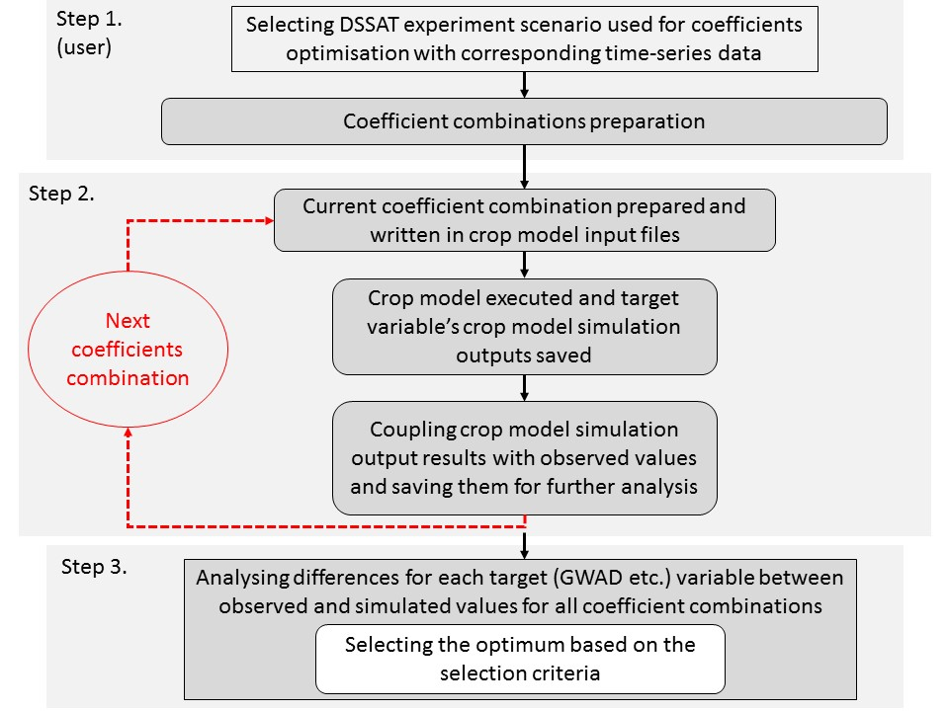

Figure 1: Flow chart showing overall program run in three steps (GWAD – grain weight)

Depending on the selected coefficient ranges and incremental steps, the number of combinations can vary. The more combinations that have to be tested, the longer the program will take to execute the model. Time to execute the model will also increase with the number of available observations in File-T. The time required for running the simulation scenarios can create practical problems for using the tools (time constraint). To overcome this limitation a range reduction method can be used.

## ***1.1 nRMSE*** (Check Box) (direct take out from paper: Memic at al. 2020 – in submission process)

The *nRMSE* is a simplified selection criterion that is applicable across multiple target variables with different scales. The coefficients (n *coefficient combinations*) are estimated across multiple target variables and provided for each target variable, with the aim of a low *nRMSE* over all variables (Eq. 1).

(1)

The selection of the coefficient combination with the lowest nRMSEs average across all target variables proves to be a good solution (Table 4, AVG-nRMSE=0.12).

Table *4* The *nRMSE* - simplified example of varying one of the cultivar parameters affecting growth (G) related target variables (GWAD, LAID, CWAD, and LWAD) of Gainesville 1978 treatment with calculated nRMSEs for multiple target variables (each) and optimum selection based on the average nRMSE (AVG-nRMSE) over multiple target variables.

|  |  |  |  |  |  |  |
| --- | --- | --- | --- | --- | --- | --- |
| **LFMAX**  **(G** -Growth**)** | **nRMSE** | | | | **AVG**  **nRMSE** | |
| **GWAD** | **LAID** | **CWAD** | **LWAD** |
| 0.8 | 0.208 | 0.22 | 0.185 | 0.203 | 0.204 |  |
| 0.912 | 0.131 | 0.153 | 0.119 | 0.146 | 0.137 |  |
| 1.024 | **0.082** | 0.145 | 0.109 | 0.144 | **0.12** | **0.12** |
| 1.136 | 0.078 | 0.171 | 0.137 | 0.173 | 0.14 |  |
| 1.248 | 0.109 | 0.209 | 0.178 | 0.211 | 0.177 |  |

*LFMAX* – CROPGRO coeff., *GWAD* - grain weight, *LAID* - leaf area index, *CWAD* - tops weight, *LWAD* - leaf weight

## 1.2 Multiple treatment based goodness of fit criteria (direct take out from paper: Memic at al. 2020 – in submission process)

As shown in Table 5 for each treatment the same cultivar coefficient minimum, maximum and increment step (0.85-1.15 [0.75], for LFMAX) are passed into the crop model cultivar file and the model is executed. For each cultivar coefficient (LFMAX) value crop model is executed and average nRMSE over four target variables (GWAD, LAID, CWAD and LWAD) are calculated. Single treatment “optimums” are localised but ignored in calculation of the Multi treatment based “optimum” (Table 5). For each coefficient value multi treatment based average (Multi-TRT Average) of single treatment normalised RMSE (AVG-nRMSE) averages are calculated. Based on lowest Multi-TRT Average ([TRT1+TRT2]/2) value multi-treatment based cultivar coefficient is selected (Multi-TRT Average=0.253, LFMAX=0.85, Table 5) as “optimum”.

Table 5 Gainesville 1979-1984 treatments with LFMAX cultivar coefficient variations.

|  |  |  |  |  |  |  |  |  |  |  |
| --- | --- | --- | --- | --- | --- | --- | --- | --- | --- | --- |
| **Single treatment “optimums”** | | | |  | **Multi treatment based “optimum”** | | | | |  |
| Year | TRT | LFMAX | AVG  nRMSE |  | Year | TRT | LFMAX | AVG  nRMSE | Multi-TRT  Average |  |
| 1979 | 1 | **0.85** | 0.126 |  | 1979 | 1 | **0.85** | 0.126 |  |  |
| 1979 | 1 | 0.925 | 0.15 |  | 1984 | 2 | **0.85** | 0.38 | 0.253 | **0.253** |
| 1979 | 1 | 1.0 | 0.18 |  | 1979 | 1 | 0.925 | 0.15 |  |  |
| 1979 | 1 | 1.075 | 0.208 |  | 1984 | 2 | 0.925 | 0.358 | 0.254 |  |
| 1979 | 1 | 1.15 | 0.232 |  | 1979 | 1 | 1.0 | 0.18 |  |  |
| 1984 | 2 | 0.85 | 0.38 |  | 1984 | 2 | 1.0 | 0.349 | 0.264 |  |
| 1984 | 2 | 0.925 | 0.358 |  | 1979 | 1 | 1.075 | 0.208 |  |  |
| 1984 | 2 | 1.0 | 0.349 |  | 1984 | 2 | 1.075 | 0.346 | 0.277 |  |
| 1984 | 2 | **1.075** | 0.346 |  | 1979 | 1 | 1.15 | 0.232 |  |  |
| 1984 | 2 | 1.15 | 0.348 |  | 1984 | 2 | 1.15 | 0.348 | 0.29 |  |

*LFMAX-*explained in Table 3*, TRT*-treatment, *AVG-nRMSE*-average of normalised RMSE over four target variables (grain weight, leaf area index, Tops weight, Leaf weight)

## 1.3 RW-nRMSE (Check Box)

A *Relative Weight -nRMSE* (*RW-nRMSE*) complementary method was developed with priority ranks (1 to 4). A rank can be assigned to each target variable separately, where 1 is the most accurate and 4 the least accurate, in relative terms. Each accuracy rank has weight coefficient assigned to it in the TSE code (Table 6), rank 1 with weight coefficient of 0.01 and rank 4 with values 0.04 used in selection criteria. With ranks each target variable’s accuracy can be selected, giving users more flexibility in terms of target variable prioritisation in the cultivar coefficients estimation process (Table 6), as shown in the following example with gwad having rank 1 and the other target variables rank 4.

Table 6 RW-nRMSE method target variable ranking with weight coefficients

|  |  |  |
| --- | --- | --- |
| **RW-nRMSE** | | |
|  | **Rank** | **Coefficient weight** |
| LAID | 4 | 0.04 |
| CWAD | 4 | 0.04 |
| LWAD | 4 | 0.04 |
| GWAD | **1** | **0.01** |

Initially the weight coefficients are defined (by ranking) for creating a mathematical threshold used in the program (Figure 2a). The initial selection criteria was set to 0.0 (Figure 2a). With the initial selection criteria the *while* loop (flow controlling statement executed repeatedly until specified conditions are meet in the programming language) is initialised (Figure 2b). Within the *while* loop, the *if* condition is set for finding an overall statistically acceptable solution (Figure 2c). The *while* loop will be stopped only if the calculated nRMSEs for multiple target variables satisfies the RW-nRMSE selection criteria.

If accurate grain yield is the goal (other target variables less accurate) of the optimisation then the relative weight coefficients based on RW-nRMSE criteria (Table 6) gwad rank 1 and the other three variables rank 4 offers more accurate results of gwad target variable. The rank 1 for gwad and rank 4 for laid, cwad and lwad initializes RW-nRMSE mathematical threshold in to code for while loop first run of 0.01 for nRMSE-gwad and 0.04 for nRMSE-laid-cwad-lwad. In practice this means when the first loop run is searching through calculated nRMSEs for all target variables only coefficient combinations that have calculated nRMSE-gwad lower than 0.01 and nRMSE-laid-cwad-lwad lower than 0.04 is selected as optimum. If in first while loop run none of the coefficient combinations have calculated nRMSE as defined with relative weights the while loop is restarted for the second time with new mathematical threshold for nRMSE-gwad lower than 0.02 and nRMSE-laid-cwad-lwad lower than 0.8. If the newly formed mathematical threshold doesn’t provide coefficient combination with calculated nRMSEs the while loop will be started again with nRMSE-gwad mathematical threshold of 0.03 etc. until coefficient combination providing calculated nRMSEs for target variables is located.

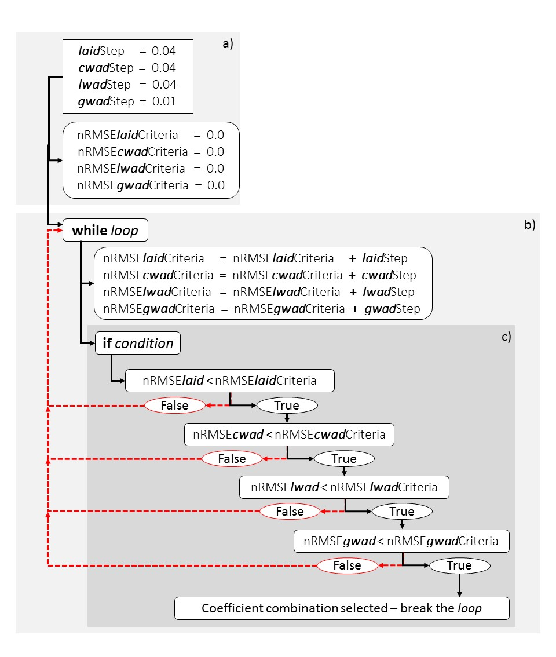

Figure 2 The RW-nRMSE cultivar coefficient combination selection method

With RW-nRMSE-gwad rank 1 and RW-nRMSE-laid-cwad-lwad rank 4 while loop with if conditions is repeated 8 times (Table 7) with desired LFMAX coefficient of 1.136 providing the most accurate simulations for grain weight (gwad). This coefficient values is different from the one selected with simple nRMSE criteria results shown in Table 5.

Table *7* The *RW-nRMSE* - simplified example of varying one of the cultivar parameters with calculated nRMSEs for multiple target variables demonstrating selected combinations with target variable with relative weights ranking in TSE.

|  |  |  |  |  |  |
| --- | --- | --- | --- | --- | --- |
|  | **nRMSE** | | | |  |
| **LFMAX (G)** | **gwad** | **laid** | **cwad** | **lwad** | **AVG-nRMSE** |
| 0.8 | 0.208 | 0.22 | 0.185 | 0.203 | 0.204 |
| 0.912 | 0.131 | 0.153 | 0.119 | 0.146 | 0.137 |
| 1.024 | 0.082 | 0.145 | 0.109 | 0.144 | **0.12** |
| 1.136 | **0.078** | 0.171 | 0.137 | 0.173 | 0.14 |
| 1.248 | 0.109 | 0.209 | 0.178 | 0.211 | 0.177 |

G – *growth*, gwad - *grain weight*, laid - *leaf area index*, cwad - *tops weight*, lwad - *leaf weight*

## 1.4 Range reduction – generating coefficient combinations (direct take out from paper: Memic at al. 2020 – in submission process)

The cultivar coefficient estimation process consist of varying cultivar coefficient values and checking either statistical or visual fit of simulated outputs and field observations in order to determine coefficient combination providing the best agreement between simulated and observed values. Various cultivar coefficients have potentially wide ranges (Min and Max values difference) with huge amount potential values in between depending on increment steps (Inc). Wide coefficient ranges can result in huge number of coefficient variations after each crop model has to be executed, that can last hours or days, resulting in impractical cultivar coefficient optimisation tools. This so called *Exhaustive coefficient variation* (Table 6) can be used to systematically investigate coefficient ranges in search for coefficient values that provides the best visual or statistical fit (eg. CSDL coefficient Min=10.0, Max=14.0, Inc=0.2, and SLVR Min=200, Max=400, Inc=10) of coefficient ranges with systematic increment steps. In these simple examples it can be seen that for coefficient range 10.0-14.0 with increment step 0.2 in total 21 coefficient variation is executed for CSDL coefficient. For SLVR cultivar coefficient with range 200-400 with increment step 10 in total 21 coefficient variations are executed (Table 6). In order to overcome time losses in the process of cultivar coefficients estimation Range reduction method was implemented (Table 6).

For given examples in Table 6 for each given coefficient range in first round greater increment steps are used and based on the lowest AVG-nRMSE coefficient is selected (CSDL=12, SLVR=350). In second round new coefficient ranges with narrower increment steps are executed and based on lowest AVG-nRMSE new coefficient “optimums” are selected (CSDL=12.4, SLVR=330). In third round new coefficient ranges are formed and final coefficient values are selected based on lowest AVG-nRMSE (CSDL=12.4, SLVR=330). Through range reduction 48% less coefficient combinations are executed when compared to exhaustive coefficient variations. The range reduction method as described in Table 6 is expected to retain systematic optimum localisation approach (achievable with exhaustive gridding variation), and provide more realistic coefficients when compared to random generation of cultivar coefficients for allowed ranges.

Table 6 Comparison examples of exhaustive coefficient variation and range reduction method with total number of coefficient variations

|  |  |  |  |  |  |  |  |  |  |  |  |
| --- | --- | --- | --- | --- | --- | --- | --- | --- | --- | --- | --- |
| **Coeff.** | **Exhaustive variation** | | |  | **Range reduction method** | | | | | | |
| **CSDL** |  |  |  |  |  |  |  |  |  | |  |
|  | Min | 10.0 |  |  |  |  |  |  |  | |  |
|  | Max | 14.0 |  |  |  |  |  |  |  | |  |
|  | **Inc** |  | **+0.2** |  | **+ 1.0** |  | **± 0.4** |  | **± 0.2** | |  |
|  |  |  | 10.0 |  | 10.0 |  |  |  |  | |  |
|  |  |  | 10.2 |  | 11.0 |  | 11.6 |  |  | |  |
|  |  |  | … |  | **12.0** | **→12.0** | 12.0 |  | 12.2 | |  |
|  |  |  | 13.8 |  | 13.0 |  | **12.4** | **12.4** | **12.4** | | **→12.4** |
|  |  |  | 14.0 |  | 14.0 |  |  |  | 12.6 | |  |
| Number of combinations: | | | 21 |  | 5 |  | 3 |  | 3 | |  |
|  | **Total** |  | **21** |  | **11** | | | | |  | |
|  |  |  |  |  |  | | | | | | |
| **SLVR** |  |  |  |  |  |  |  |  |  | |  |
|  | Min | 200 |  |  |  |  |  |  |  | |  |
|  | Max | 400 |  |  |  |  |  |  |  | |  |
|  | **Inc** |  | **+10** |  | **+ 50** |  | **± 20** |  | **± 10** | |  |
|  |  |  | 200 |  | 200 |  |  |  |  | |  |
|  |  |  | 210 |  | 250 |  |  |  | 320 | |  |
|  |  |  | … |  | 300 |  | **330** | **330** | **330** | | **→330** |
|  |  |  | 390 |  | **350** | **→350** | 350 |  | 340 | |  |
|  |  |  | 400 |  | 400 |  | 380 |  |  | |  |
| Number of combinations: | | | 21 |  | 5 |  | 3 |  | 3 | |  |
| **Total** | | | **21** |  | **11** | | | | | |  |

*CSDL* and *SLVR* – explained in Table

# 2. General TSE program settings overview

The program was developed (in Windows environment, for use on Windows) as standalone and has no specific installation requirements. All required files for running the program are shared with TSE.zip file. Before using the program user should look into three README files (in TSE directory: README.txt, README_UserGuidlines.doc and README_Important info about Beta version 1.0.txt) shared with the program.

Date stamp

The gitHub_TSE_[date_stamp].zip file has to be unzipped as gitHub_TSE_[date_stamp] working directory. From gitHub_TSE_[date_stamp] directory **TSE** folder copied to the Tools directory -> C:\DSSAT47\Tools

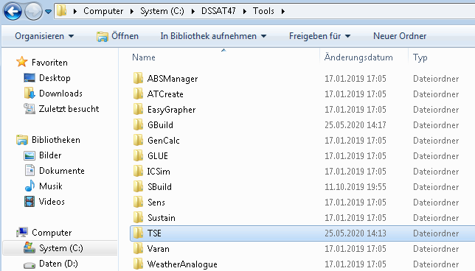

In folder TSE **->** C:\DSSAT47\Tools\TSE

**TSE_calibrator_DSSAT.exe** <- windows runnable has to be **executed as Administrator**.

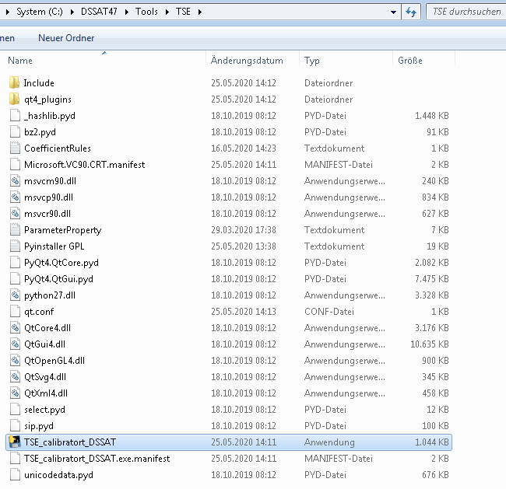

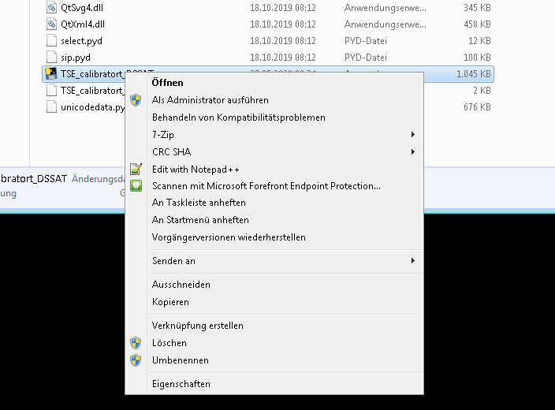

**VERY IMPORTANT:**

1. PlantGro.Out crop model outputs are coupled to those in File-T (growth-related) time-series in-season observations
2. Evaluate.Out crop model outputs are coupled to those in File-A (phenology-related) as DAY observations
3. If sub-model (eg. WHAPS) is initialised in the File-X, the calibrator will not work! (in File-X in *SIMULATION CONTROLS in GENERAL line, column SMODEL **do not initialise sub-models!**)
4. Only variables such as LAID, CWAD, GWAD etc. initialised in first time occurring “**@TRN….”** line in File-T is actively used by TSE
5. For multi TRT optimisations only target variables simultaneously available in all File-T/s (for corresponding File-X/s Treatments) are accessible for optimisation
6. If PrameterProperty.txt is NOT in the C:\DSSAT47\Tools\TSE folder, **P**/**G** (**P**henlology/**G**rowth-related flags) are not available!
7. T-file observations (all in-season observations available including 0 are used, only -99 values are ignored by program) used for estimating the optimum genetic coefficient (phenology- and growth-related)
8. The program is matching DOY from T-file with those in the PlantGro.OUT. If you setup in the X-file reporting frequency for example every fifth day and exact observation DOY is not present in the PlantGro.OUT as it is written in the T-file, the program will not be able to match them for comparing simulated and observed.

After model run finished and before you click “**Exit Interface and all Running Threads**” push button you can open GBuild and check visual and statistical fit (RMSE, d-statistics within GBuild) of the experiment file executed with the “optimum” genetic coefficient combination found in the last model run. With GBuild you open PlantGro.OUT from C:\DSSAT47\TSE_workspace directory, because TSE will create parallel files it requires in this folder, without modifying the original files in DSSAT directory.

The more coefficients are “activated” (used in estimation process) the longer will optimisation last. **For each new coefficient and additional increment step (Inc.) number of model runs will increase exponentially** (can be checked in “show comb-s” push button.

The green box (green list widget box in the interface) is where the experiment file and treatments for optimising cultivar coefficients are selected. Multiple treatments can be selected (multiple treatment/experiment selection is done by: **Ctrl**+ **mouse left button click** and for each treatment selected and optimised optimal combination is saved in the as intermediate computation files

**C:\DSSAT47\TSE_workspace\Compute**\**RMSE-Outputs.txt**

The optimiser program is NOT modifying core DSSAT files in their original directories…

The optimiser program is creating additional directory **TSE_workspace** (**C:\DSSAT47\TSE_workspace**) and modifying the cultivar file in that directory.

**Program run is considered: Start- TSE_calibrator_DSSAT.exe executed until** “**Exit Interface and all Running Threads**” push button is pressed. Any form of optimisation done in-between is temporary saved in the temporary cultivar file in TSE_workspace directory.

**After TSE program is started (TSE_calibrator_DSSAT.exe executed) all modifications on Cultivar file are conducted in C:\DSSAT47\TSE_workspace. During one program run (until** “**Exit Interface and all Running Threads**” push button is pressed**) different coefficients (or different target variables) can be optimised one after another or simultaneously and cultivar changes will be saved if accepted as “optimums” in cultivar file in C:\DSSAT47\TSE_workspace. If user is satisfied with the cultivar coefficient values based on nRMSE fit or visual fit cultivar coefficient combination should be copied to C:\DSSAT47\Tools\Genotype located cultivar file, MANUALLY. If TSE program is started again without saving the combination in C:\DSSAT47\Tools\Genotype located cultivar file new TSE program start will copy original C:\DSSAT47\Tools\Genotype located cultivar file and overwrite your working cultivar file in C:\DSSAT47\TSE_workspace.**

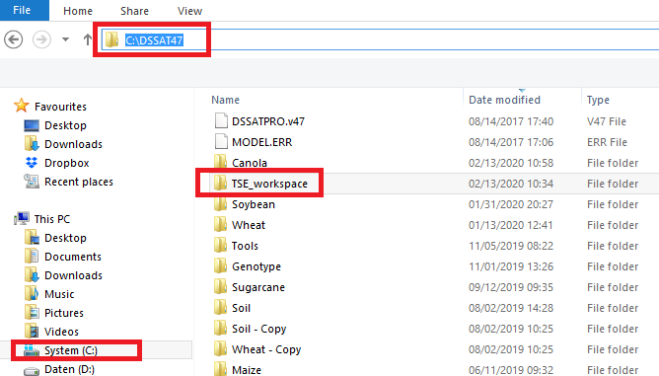

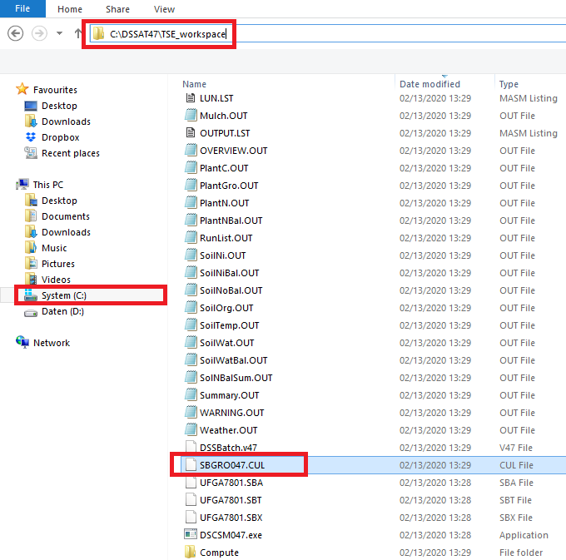

The original cultivar is saved as **“!Old_timestamp_cultivarID….”** and the new one is saved in that working cultivar file (in **TSE_workspace**) and model is executed.

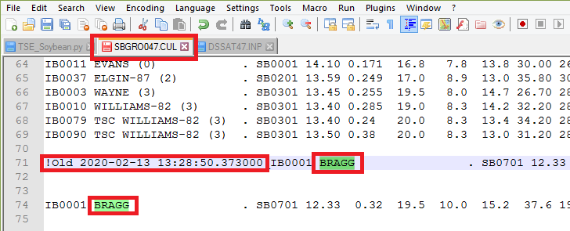

With **GBuild** PlantGro.Out can be opened **in TSE_workspace** directory to see how good new combination is. If more than one experiments were used (if Multi-TRT) combination was found, all used treatments can be seen in Gbuid simultaneously…

**For example:**

Every time **TSE_calibrator_DSSAT.exe** is executed original cultivar (SBGRO047.CUL) file from C:\DSSAT47\Genotype will be copied to C:\DSSAT47\TSE_workspace directory, and overwrite cultivar file in that directory (if exist, if not then just copy it). If user wants to keep the genetic coefficient combination, it has to be copied to the original cultivar file in C:\DSSAT47\Genotype directory into SBGRO047.CUL **manually**.

# 3. Running TSE program

**(The steps of preparing the estimator for run are enumerated)**

1. **If directory path shown is “C:\DSSAT47”, do NOT modify! If the path is not “C:\DSSAT47” then navigate to it and select it. It will be explained soon in the Software Guidelines in details.**
2. **Select desired model and Initialize it!**
3. **Select cultivar from model corresponding list.**
4. **Select File/s-X from list containing selected cultivar.**
5. **Select corresponding Treatment/s based on the File/s-X containing selected cultivar.**
6. **Execute selected treatment/s with DSSAT model to check if core DSSAT files are runnable, and select Default/Advanced.**
7. **Select optimisation of Phenology/Growth -related coefficients and corresponding methods.**
8. **Selecting desired coefficients and coefficient ranges and increment steps.**
9. **Check if optimisation software setup is correct.**
10. **Run the model!**
11. **Reset coefficient ranges or estimate Multi treatment based cultivar coefficient combination!**

Interface

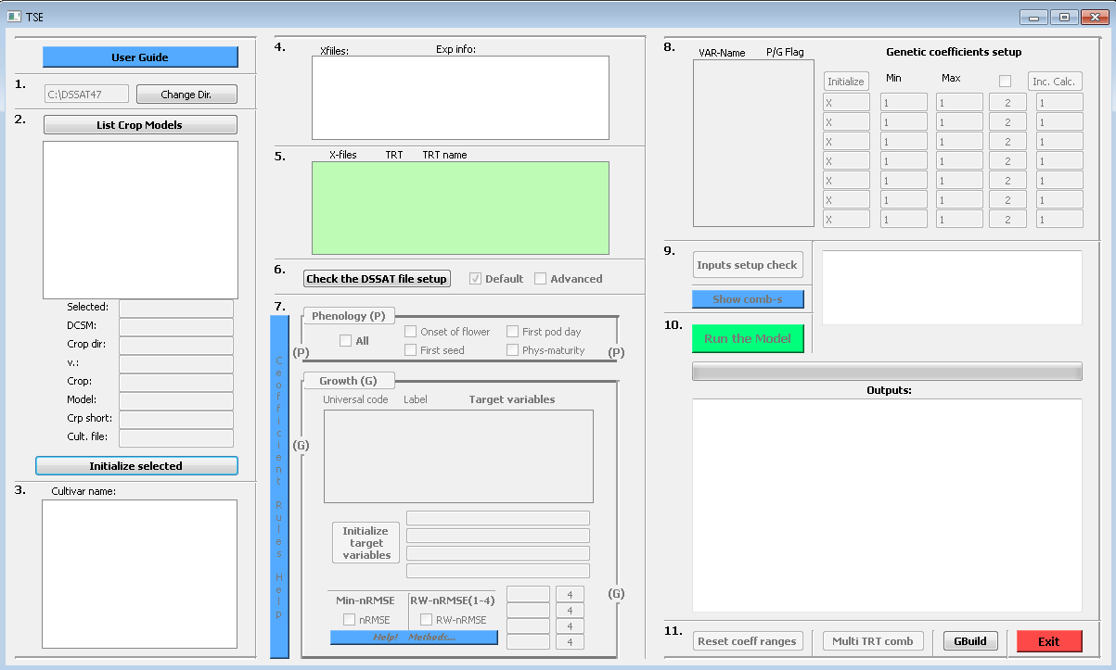

**1. Do NOT modify!**



**2. Select desired model and Initialize selected!**

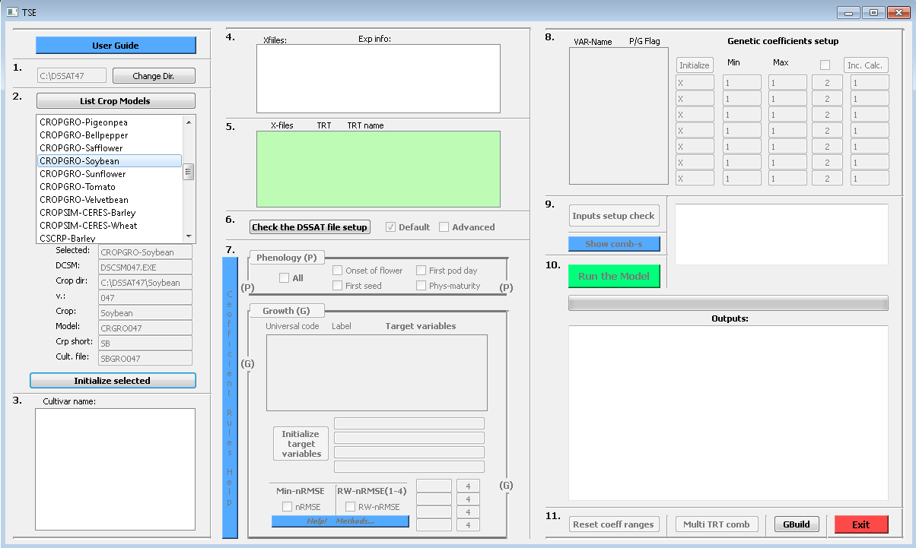

**3.** **Select cultivar from model corresponding list.**

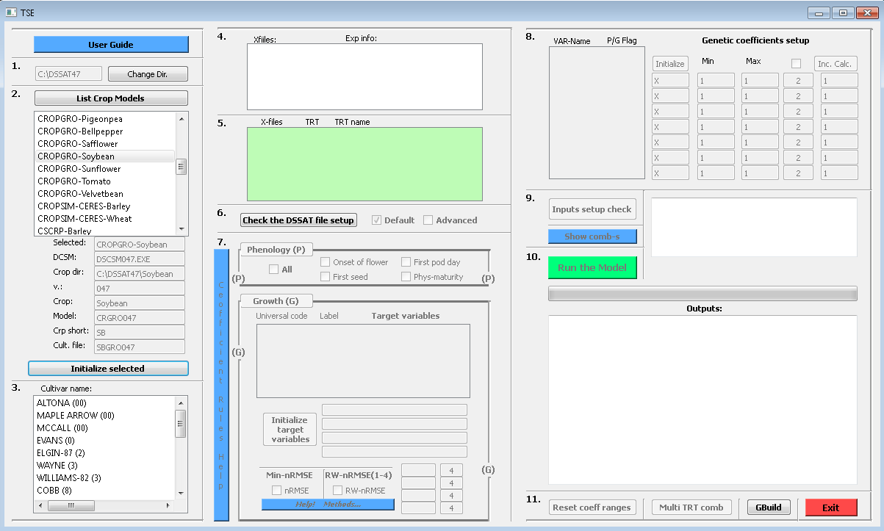

**4. Select File/s-X from list containing selected cultivar.**

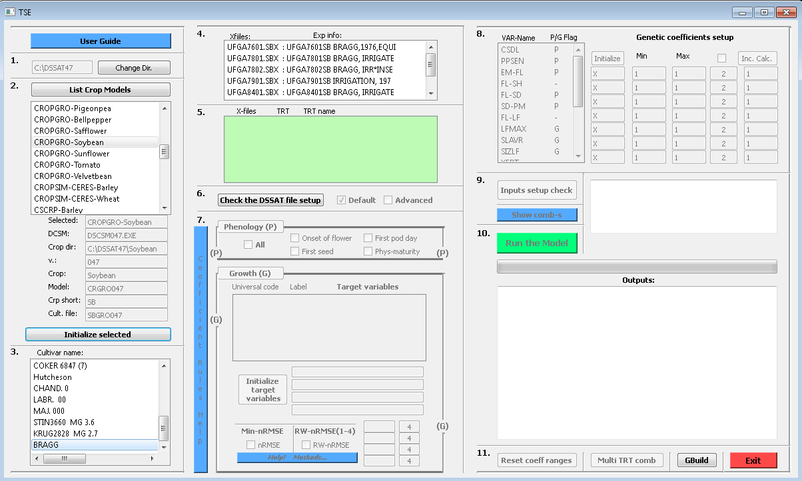

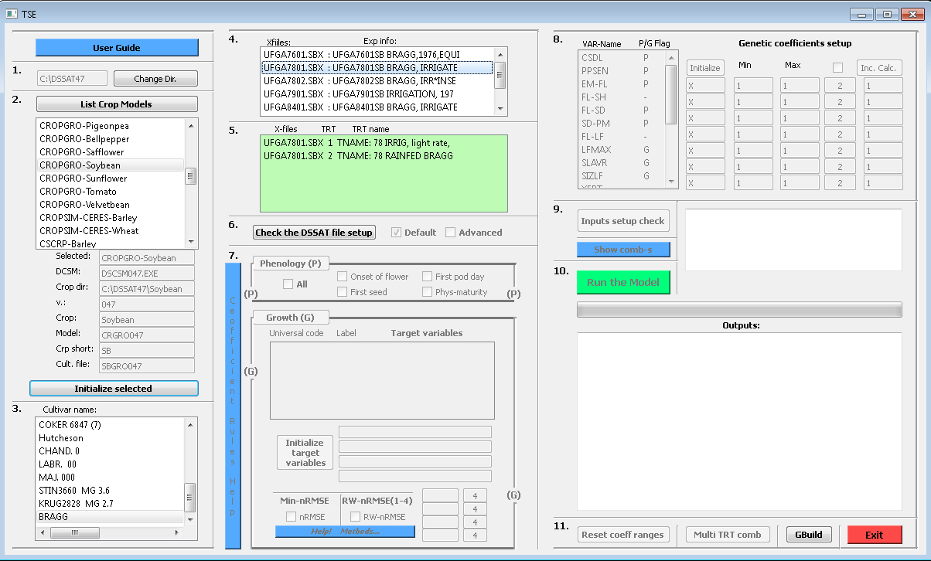

**5. Select corresponding Treatment/s based on the File/s-X containing selected cultivar.**

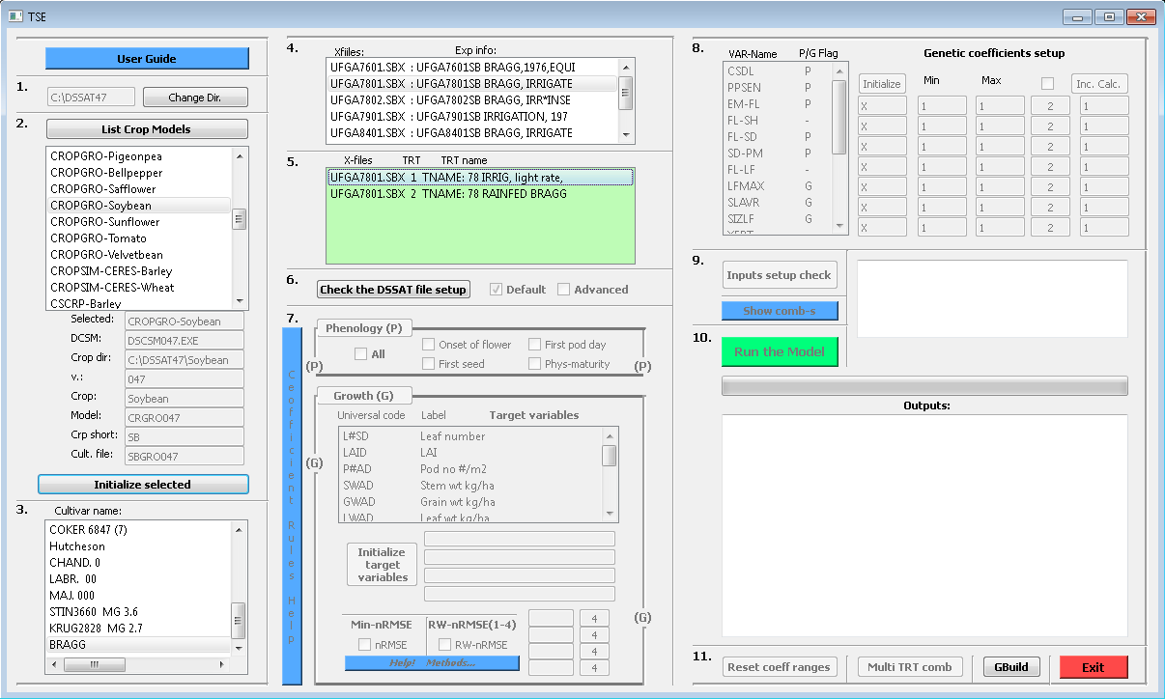

**6. Execute (Check the DSSAT file setup) selected treatment/s with DSSAT model to check if core DSSAT files are runnable, and select Default/Advanced.**

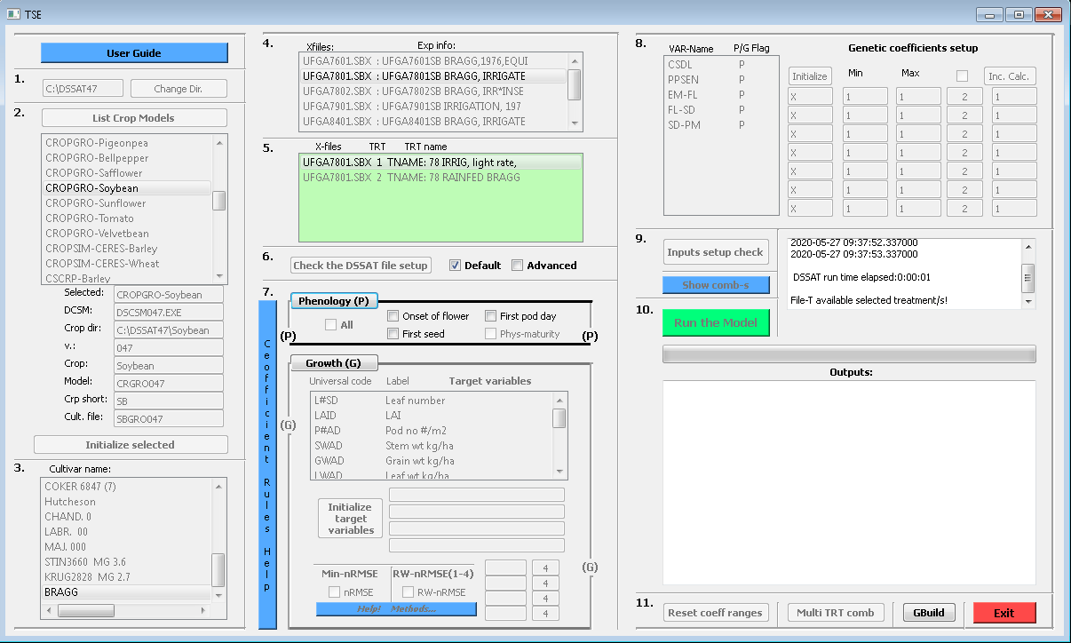

**7. Select optimisation of Phenology/Growth -related coefficients and corresponding methods.**

**In this step error minimisation method (nRMSE or RW-nRMSE) is selected**

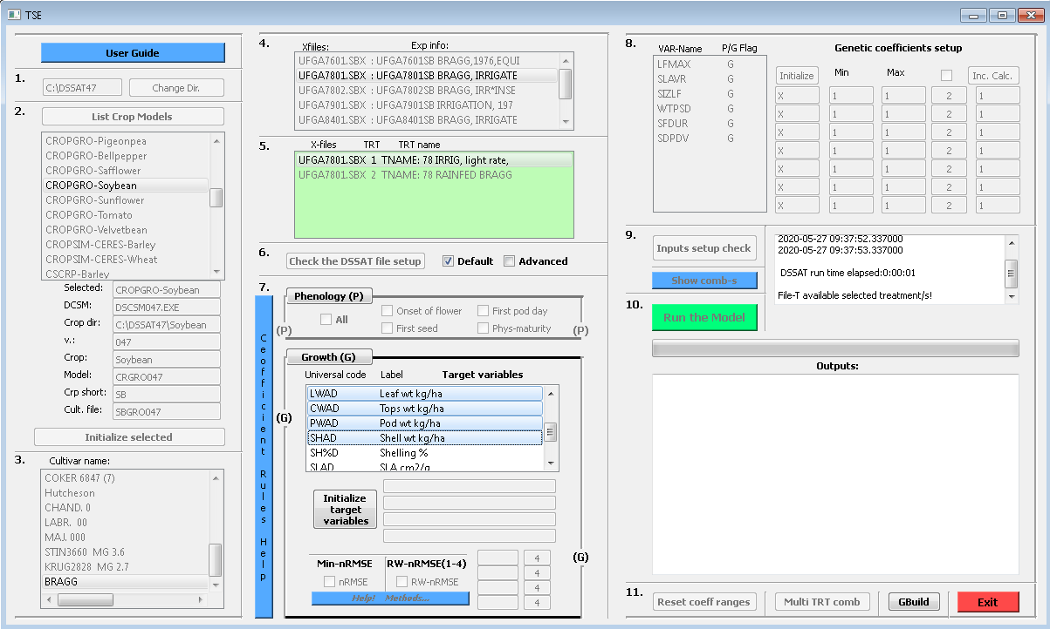

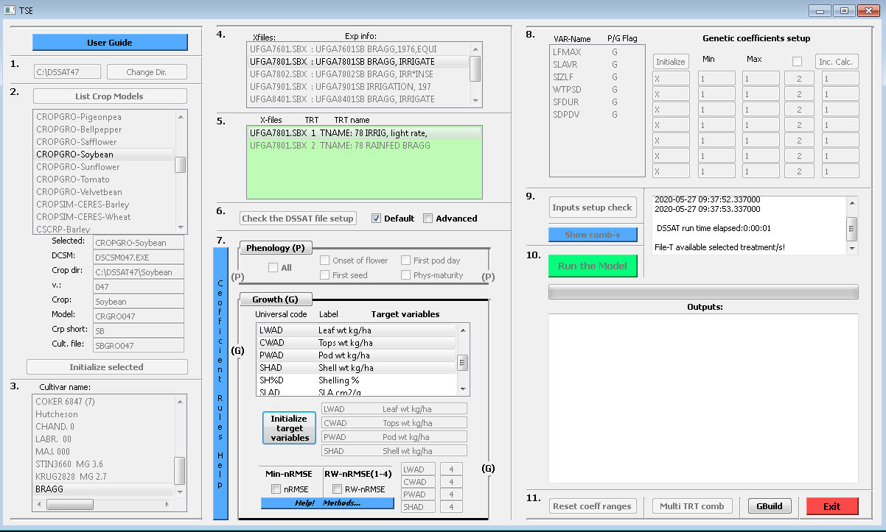

**8. Selecting desired coefficients and coefficient ranges and increment steps.**

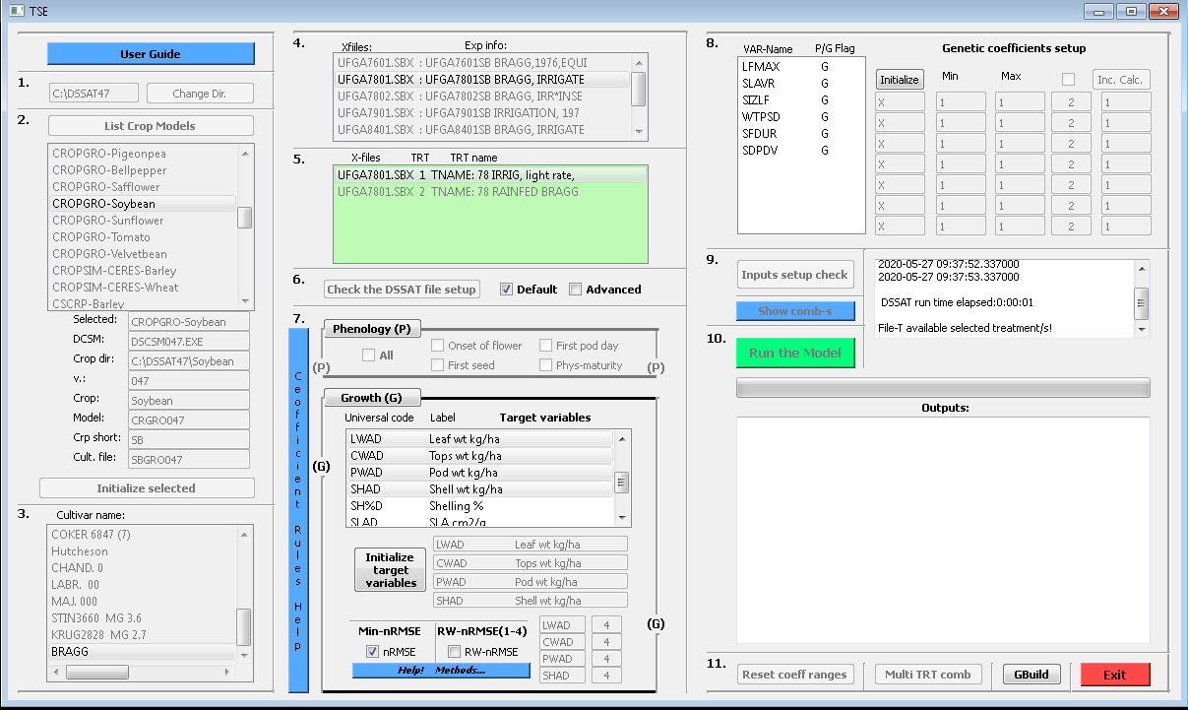

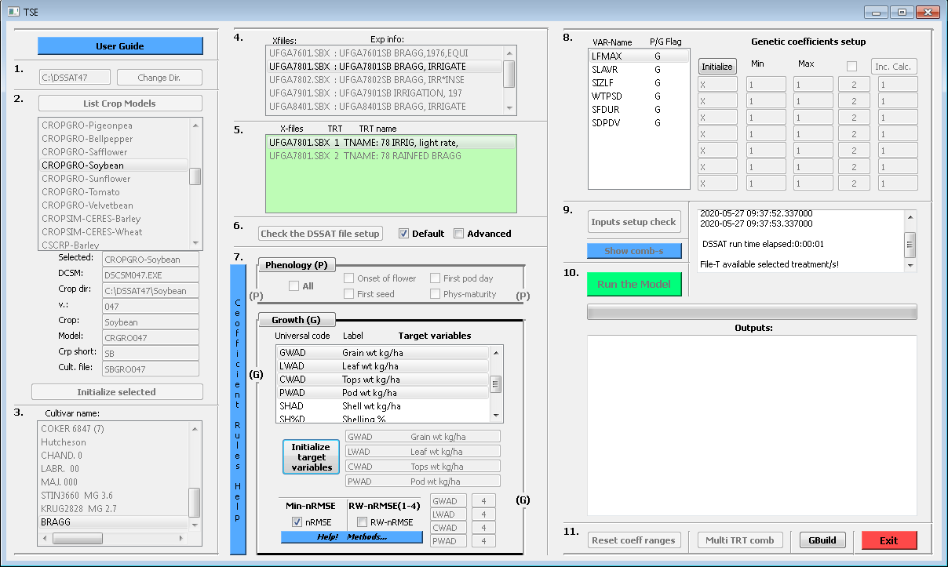

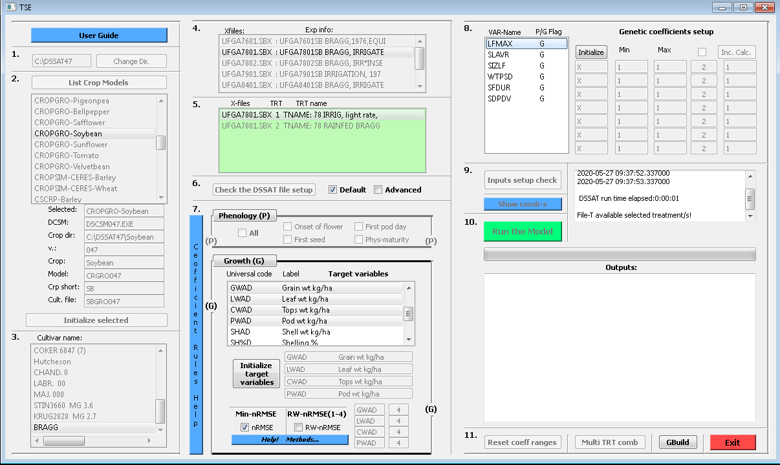

After selecting desired coefficients in step 8. from list widget window Initialize push button will initialize coefficient Labels in edit boxes and populate Min/Max coefficient ranges with min/max value available in corresponding cultivar file for selected cultivar coefficient. Automatically this will create simple range of Min/Max value with two coefficient combinations that are going to be passed into cultivar file, where after each model is executed. If the user wants more combinations in between given Min/Max range **Check Box** next to the Inc. Calc. has to be **Checked** and number of desired coefficient combinations between Min/Max can be given. After giving the desired number of combinations between Min/Max increment step is calculated by Inc. Calc. push button [(Max-Min)/number of combinations]. If user would like to modify Min/Max values it can be done directly (manually) in edit boxes below Min/Max labels in step 8. If Min/Max are modified based on the number of combinations after Inc. Calc. push button is clicked new Min/Max and Inc. values are calculated and populated in corresponding edit boxes in step 8.

Example 1. With one coefficient (range and increment)

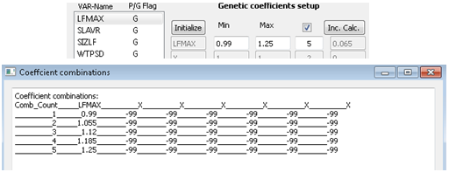

Example 2. With two coefficients (ranges and increments)

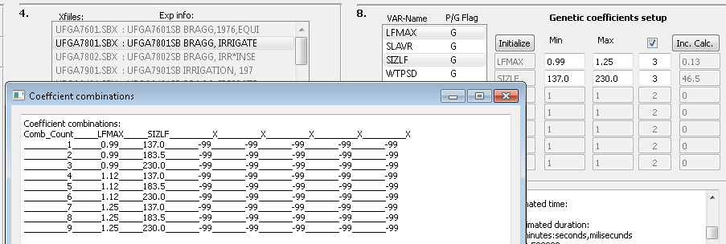

If you want to fix the value of some coefficient, in other words not to vary it during the program run, then you set Min and Max to equal value (same value in the Min edit box as in the Max value edit box).

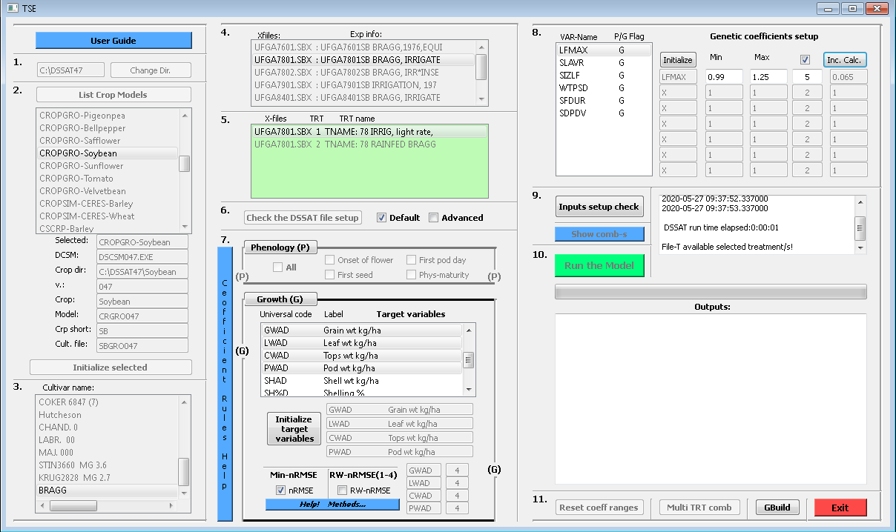

**9. Check if optimisation software setup is correct.**

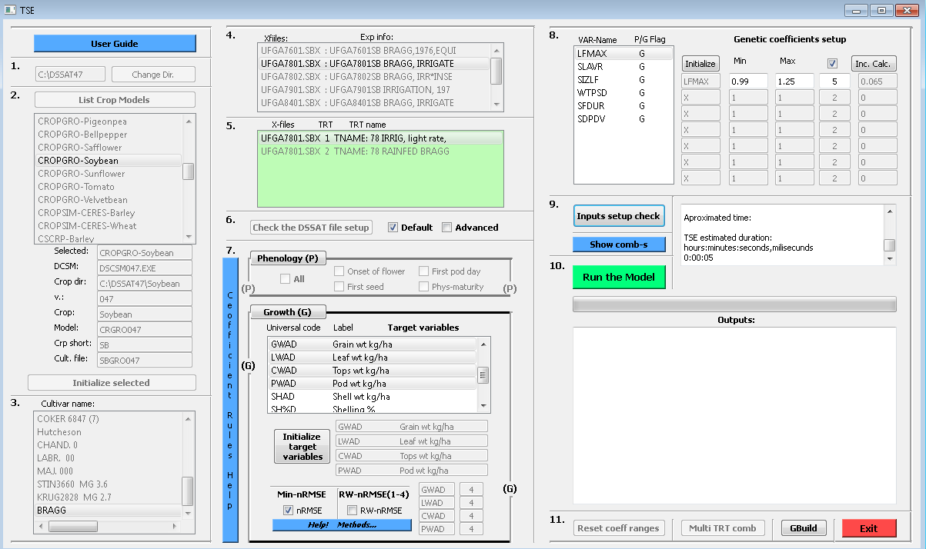

**10. Run the model!**

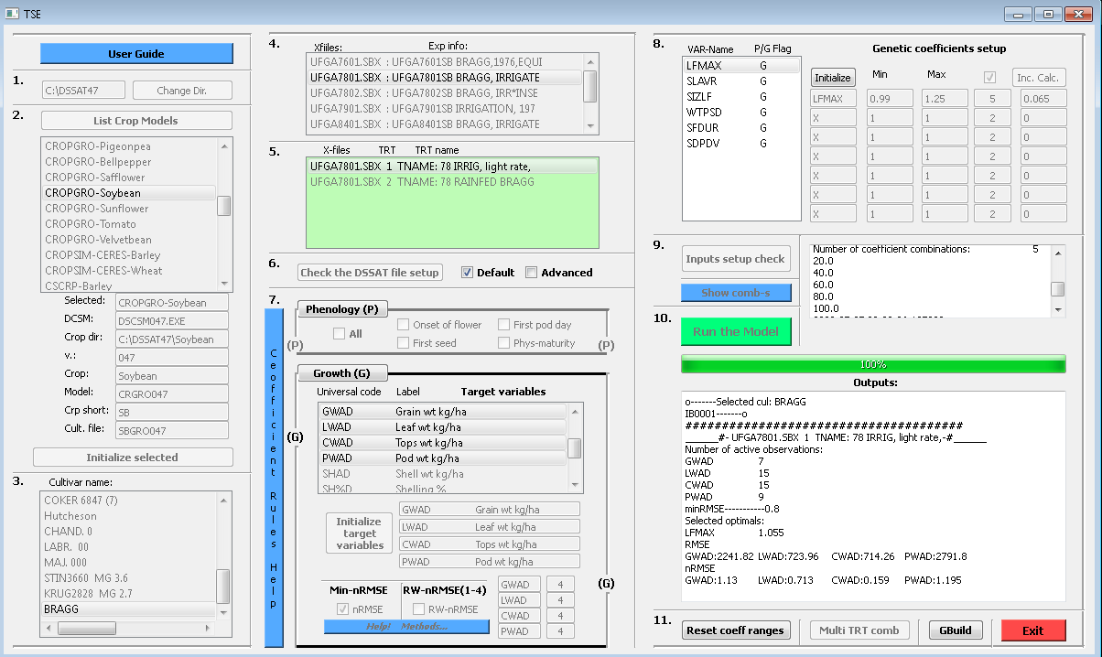

**11.**

1. **Reset coefficient ranges or estimate**

If “optimal” coefficient combination is found based on wide ranges and big increment steps this button will take those “optimums” and set new Min/Max range based on “optimum’s” values (“optimum” coefficient value * 0.25 and new Min=”optimum” – (“optimum”*0.25), Max=”optimum” + (“optimum”*0.25). Increment steps are calculated based on the desired number of combinations in between.

1. **Multi treatment based cultivar coefficient combination!**

If Multi-TRT is selected this button will select coefficient values as described in the publication: .

1. **Execute Gbuild**

Again if the PlantGro.Out in TSE_workspace is open with GBuild visual and statistical fit across all used experiments of coefficient optimisation can be seen in GBuild.

1. **Exit the program and all running threads**