# Instructions for Installing the OpenInfobutton Responder

### Software Dependencies/Pre-installation Requirements

1. Java 1.6 JDK or above - JDK 1.7 is recommended. The application was developed and tested on:
   1. Oracle’s Java JDK version 1.7.0_45
   2. Server-side Java version "1.7.0_51"
2. Java Servlet container. The application was developed and tested most thoroughly using Apache Tomcat 7.0.12.
3. Maven 3.X
4. Git (optional – can download the project artifacts from the github site without installing git)
5. MySql 5.5 or above. Earlier versions are likely ok but have not been tested.
6. UMLS account to access the Web Services API
   1. [https:/uts.nlm.nih.gov/home.html#apidocumentation](https://uts.nlm.nih.gov//home.html#apidocumentation)
   2. https:/uts.nlm.nih.gov/home.html

### Ubuntu/Linux Commands to Download/Install Dependencies

server-apps]% sudo apt-get install openjdk-7-jdk

server-apps]% sudo apt-get install tomcat7

server-apps]% sudo apt-get install maven

server-apps]% sudo apt-get install git

server-apps]% sudo apt-get install mysql-server

server-apps]% sudo apt-get install mysql-workbench

### Download the project

This step is only necessary if you have not already downloaded the Open Infobutton yet. The Open Infobutton Responder software comes bundled with it (same git repository/download).

opt]% sudo git clone <https://github.com/VHAINNOVATIONS/Innovation-182.git> -b master

opt]% sudo chown –R oibmanager:oibmanager Innovation-182

### Database Schema Creation

From the command line, change to the oib-responder/oib-rdbms-model-v0.2 directory and run the following scripts to prepare the database (for help - http://dev.mysql.com/doc/refman/5.6/en/mysql.html):

oib-rdbms-model-v0.2]% sudo service mysql start

oib-rdbms-model-v0.2]% mysql –u *your_mysql_user* –p *your_mysql_password* < create-oib-model-mysql.sql

##### *UMLS username and password:*

Then use a text editor to edit oib-app-property-inserts.sql to edit the end of the first two lines changing “ADD UMLS USER HERE” and “ADD UMLS PASSWORD HERE” to the UMLS username and password for you institution. Then save the document changes and continue running the scripts:

oib-rdbms-model-v0.2]% mysql –u *your_mysql_user* OIB < oib_app_property_inserts.sql

oib-rdbms-model-v0.2]% mysql –u *your_mysql_user* OIB < oib-asset-inserts.sql

oib-rdbms-model-v0.2]% mysql –u *your_mysql_user* OIB < oib-asset-property-inserts.sql

oib-rdbms-model-v0.2]% mysql –u *your_mysql_user* OIB < oib-request-parameter-inserts.sql

oib-rdbms-model-v0.2]% mysql –u *your_mysql_user* OIB- < oib-value-set-inserts.sql

oib-rdbms-model-v0.2]% mysql –u *your_mysql_user* OIB- < oib-value-set-code-inserts.sql

##### *Database jdbc settings – driver, url, username and password:*

Complete the database and UMLS Terminology Service settings in the following files:

1. oib-responder/oib-rest-responder/src/main/webapp/jdbc.properties
2. oib-responder/oib-index-manager/src/main/resources/app.properties

##### *Build the project*

Navigate on the command line to the oib-responder directory and type the following commands:

oib-responder]% mvn clean install

.

... this will take a few minutes. You should see a bunch of jars getting downloaded, tests running, and then finally a “SUCCESS” when it is done.

When a successful build has completed, a war file is created in the following directory:

oib-responder/oib-rest-responder/target/openInfobutton.war

Copy this file to your Java servlet engine app directory. If you use Tomcat copy the file to the Tomcat webapps directory and *start tomcat*. Then try the following URL in a browser that supports Atom feeds (Firefox is a good option):

<http://localhost:8080/openInfobutton/responder?mainSearchCriteria.v.c=48447003&mainSearchCriteria.v.cs=2.16.840.1.113883.6.96&taskContext.c.c=PROBLISTREV>

If you are using Firefox, you should get back an atom feed that looks something like the following:

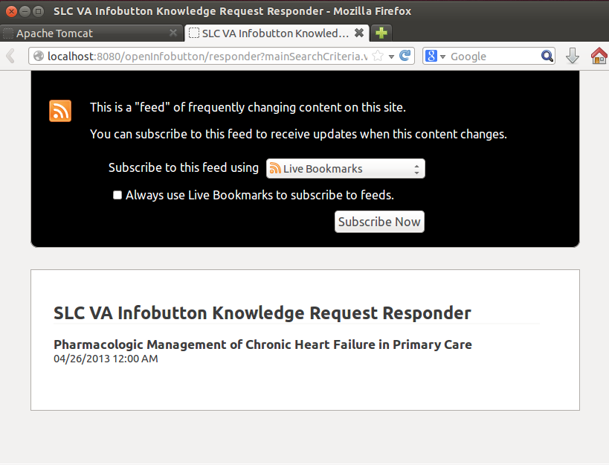

You can select the “View Page Source” to view the XML Atom feed:

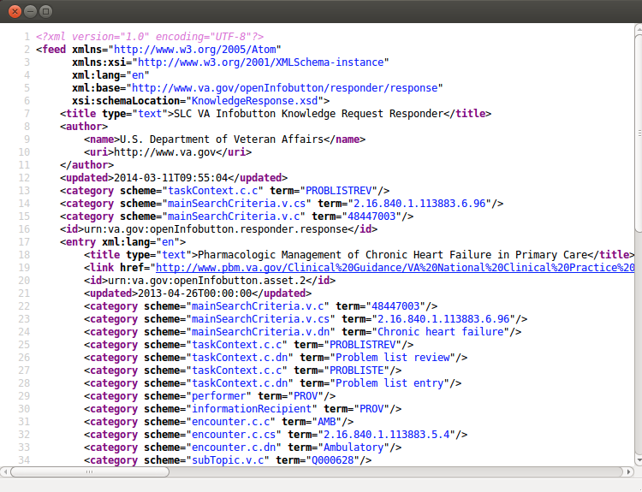

If you see this, the install was successful!

### Functional Testing

To fully validate that the service is working properly, try the URLs in the following document:

oib-responder/docs/OpenInfobutton-Responder-Functional-Tests.xlsx

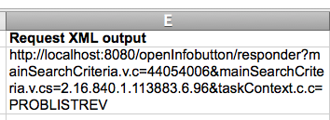

Then verify the response contains the URLs in the “Response” column as follows:

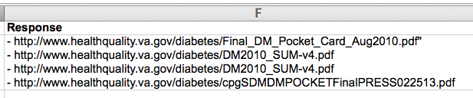

Each of these URLs are located in the atom feed under the xpath /feed/entry/link node.

### Troubleshooting

If you see an error, verify the following:

1. Your browser supports Atom feeds, or try Firefox
2. The Tomcat server is running – check localhost:8080 in your browser (if the default page has not been disabled – a standard security measure).
3. The MySQL/database is running and was setup properly
   1. Login using a MySQL client like MySQL Workbench and look for OIB schema, tables (OIB_ASSET, OIB_ASSET_PROPERTY, OIB_APP_PROPERTY, OIBREQUEST_PARAMETER, OIB_VALUE_SET, OIB_VALUE_SET_CODE), and that each of the tables has data.
   2. Check the database properties setup in the section “Database jdbc settings”
4. The project download version is correct. It should be the master branch – in the root directory of the downloaded project try the following git command and verify the “*” is next to the master branch.

Innovation-182]% git branch

* master

development

...etc

If the start is on another branch, either check the git documentation to change and/or checkout the master branch, or delete the project and retry the “Download the Project” instructions

1. The project maven build was successful - retry the build (mvn clean install) and validate it ends with something similar to:

[INFO] ------------------------------------------------------------------------

[INFO] BUILD SUCCESS

[INFO] ------------------------------------------------------------------------

[INFO] Total time: 15.306s

[INFO] Finished at: Tue Mar 04 10:36:33 MDT 2014

[INFO] Final Memory: 21M/57M

[INFO] ------------------------------------------------------------------------

If the maven build results do not look like this, check the preceding failure messages carefully. All of the resources selected for this project should be freely available online, but every once in a while there is a hiccup in the system that requires a simple rebuild.