PRACTICAL 1

Converting a Machine Learning Notebook into a Flask ML System
AIM: To convert a machine learning model developed in a Jupyter Notebook (.ipynb) into a structured, modular, and deployable Flask-based machine learning application with model serialization, input validation, prediction functionality, and a web interface.

Requirements
- Python 3.10 or 3.11
- Jupyter Notebook or Google Colab
- VS Code or another Python IDE
- Flask, Scikit-learn, Pandas, NumPy, Joblib and pytest

ML system architecture
Notebook / training script → trained model pipeline → model.pkl → Flask routes and validation → web interface and REST API.

Step 1 - Create the environment
mkdir <Project name>
cd <Project name>
python -m venv venv

.\venv\Scripts\Activate.ps1

pip install flask scikit-learn pandas numpy joblib pytest
pip install gunicorn
pip freeze > requirements.txt

Step 2 - Train and serialize the model
If a suitable fitted pipeline already exists in your notebook, reuse it and preserve its preprocessing steps. Otherwise, create train_model.py.

Expected: the program prints evaluation metrics and creates model.pkl. Metrics vary with the generated data and training process.
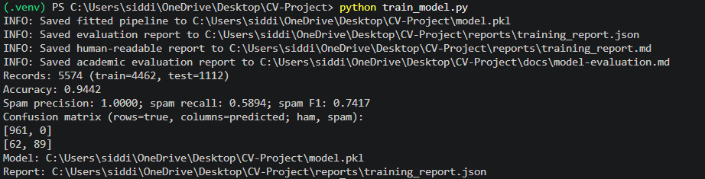

Step 3 — Create the project structure
Project File Structure :
For example (Replace it with your project):
mlops-house-price/
├── app.py
├── train_model.py
├── model.pkl
├── requirements.txt
├── .gitignore
├── Dockerfile
├── README.md
├── templates/
│ └── index.html
├── static/
│ └── style.css
└── tests/
└── test_app.py

Step 4 - Develop app.py
Code – app.py
(Create atleast 3 routes. / , /health , /prediction , etc.)

Step 5 – HTML\CSS interface
(Create Basic UI)

Step 7 - Run and test the application
python app.py
# Open http://127.0.0.1:5000

curl http://127.0.0.1:5000/health

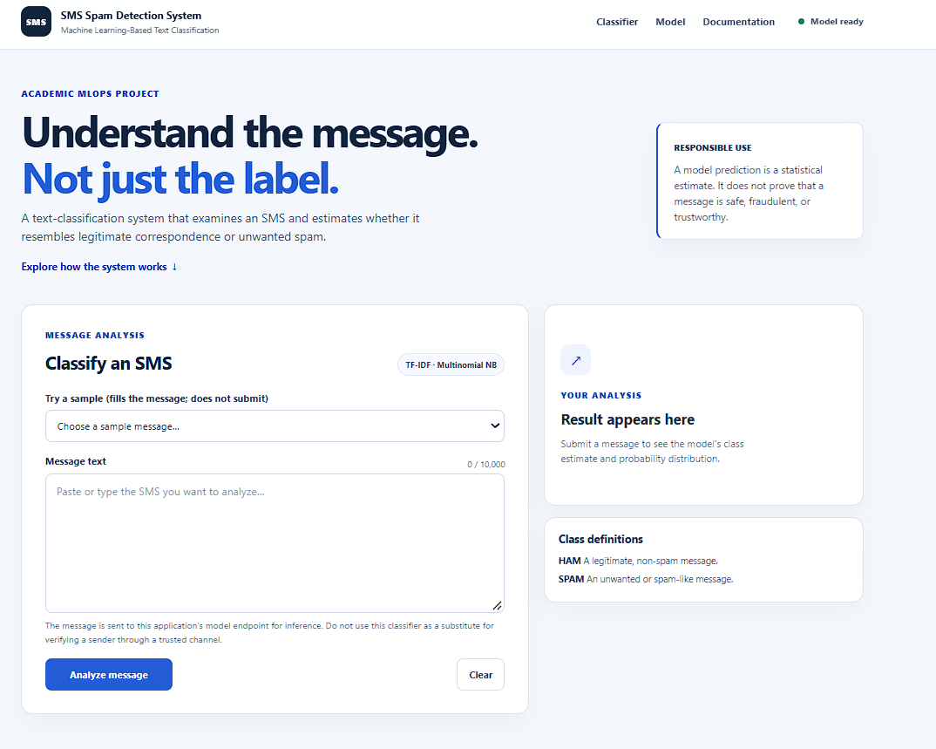

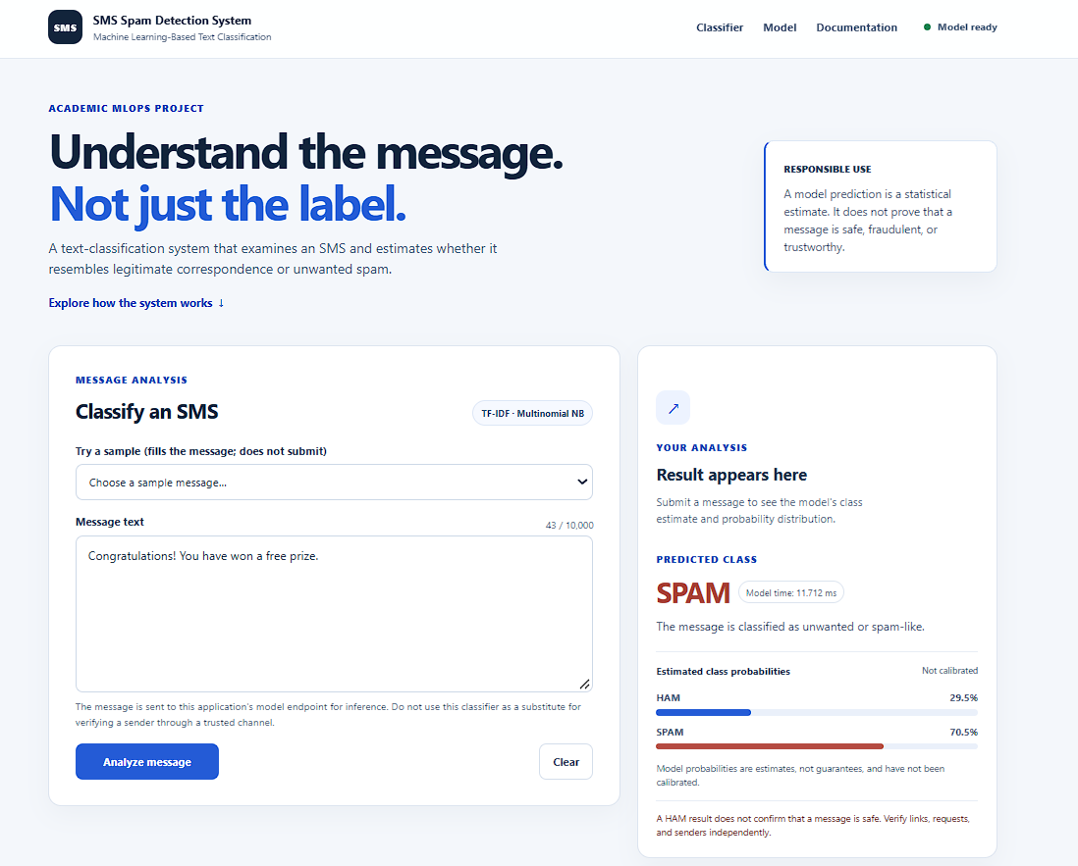

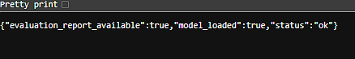

Step 8 - Create .gitignore
For example :
venv/
.venv/
__pycache__/
*.py[cod]
.pytest_cache/
.env
*.pem

PRACTICAL 2

Dockerizing the Machine Learning System
AIM: To create a Dockerfile for the Flask-based machine learning application, build a Docker image, run the image as a container, and verify the application’s functionality in an isolated and reproducible environment.

Requirements
- Completed Practical 1 project
- Docker Desktop or Docker Engine installed and running
- Flask application and model artifact available

Step 1 — Understand Docker
Dockerfile: instructions for building an image. Docker image: packaged application, model and dependencies. Docker container: a running or stopped instance of an image.

Step 2 — Create the Dockerfile

Step 3 — Create .dockerignore
For example(Replace it if needed):
venv/
.venv/
__pycache__/
.git/
.pytest_cache/
.env
*.pem
.ipynb_checkpoints/

Step 4 - Build the image
docker --version
docker info

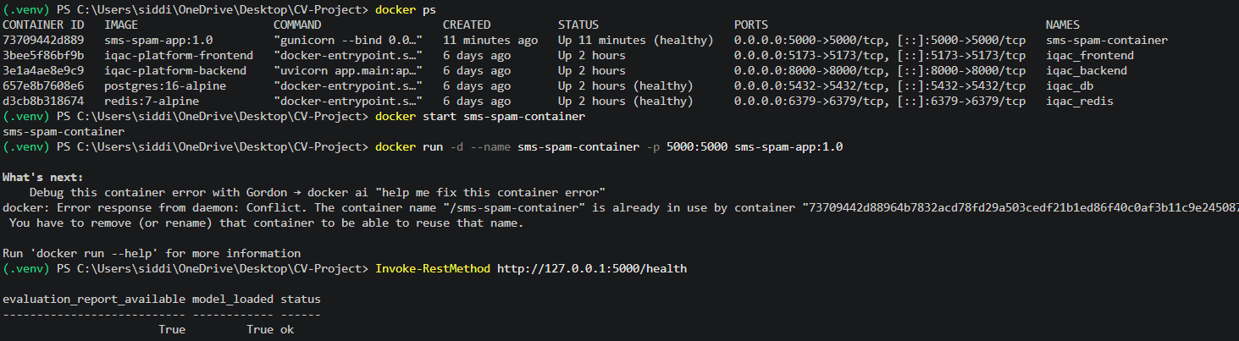
docker build -t <tag>:1.0 .
docker images

Step 5 - Run the container
docker run -d --name <name> -p 5000:5000 <tag>:1.0
docker ps
docker logs <name>

Open http://localhost:5000 and test a prediction.

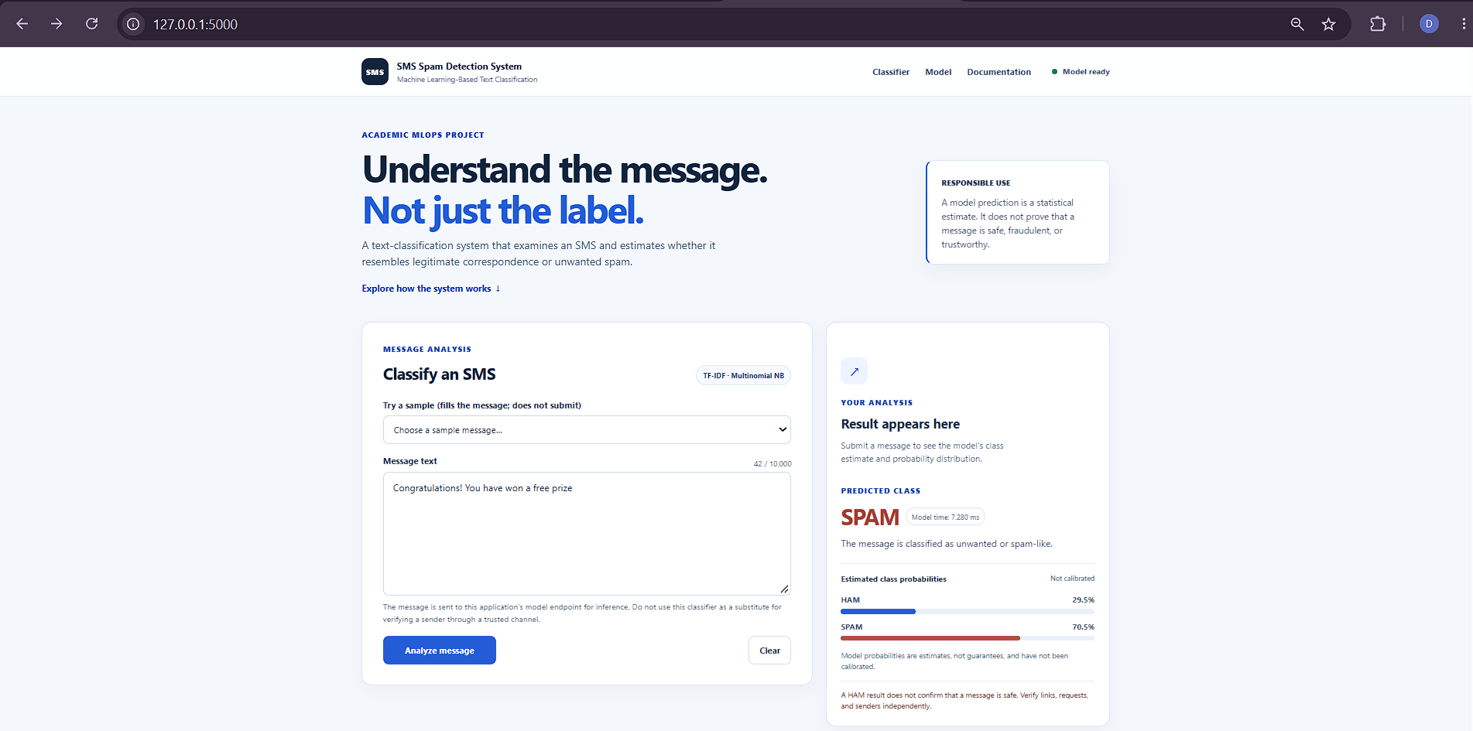

Step 6 — Test, stop and remove the container
curl http://localhost:5000/health
docker inspect house-price-app
docker stop house-price-app
docker start house-price-app
docker rm -f house-price-app

PRACTICAL 3

Deploying the Dockerized ML System on AWS EC2
AIM: To deploy the Dockerized machine learning application on an Amazon EC2 virtual machine by configuring an instance, networking and security rules, installing Docker, transferring the application image, and verifying remote access to the deployed system.

Requirements
- AWS account with EC2 permissions
- Docker image from Practical 2
- SSH client and a secure key pair
- Small Ubuntu EC2 instance appropriate for the application

Step 1 - Select AWS region
- Open https://console.aws.amazon.com/ and sign in.
- Open EC2 and select a region, for example Asia Pacific (Mumbai), ap-south-1.
- Open the EC2 dashboard.

Step 2 - Launch an EC2 instance
- Select Launch instance and enter mlops-house-price-server as the name.
- Choose an Ubuntu Server LTS AMI.
- Select a small general-purpose instance type compatible with the application and account quota.
- Create or select an SSH key pair and securely store the private key.
- Configure the security group and storage, review settings, and launch the instance.
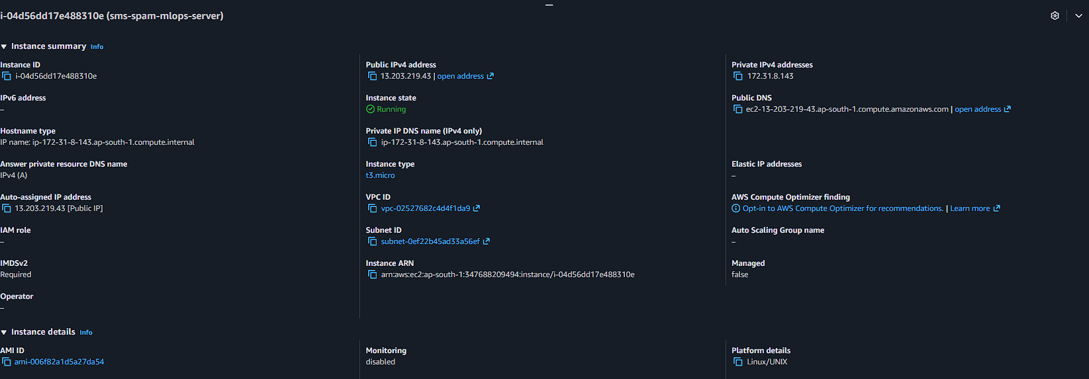
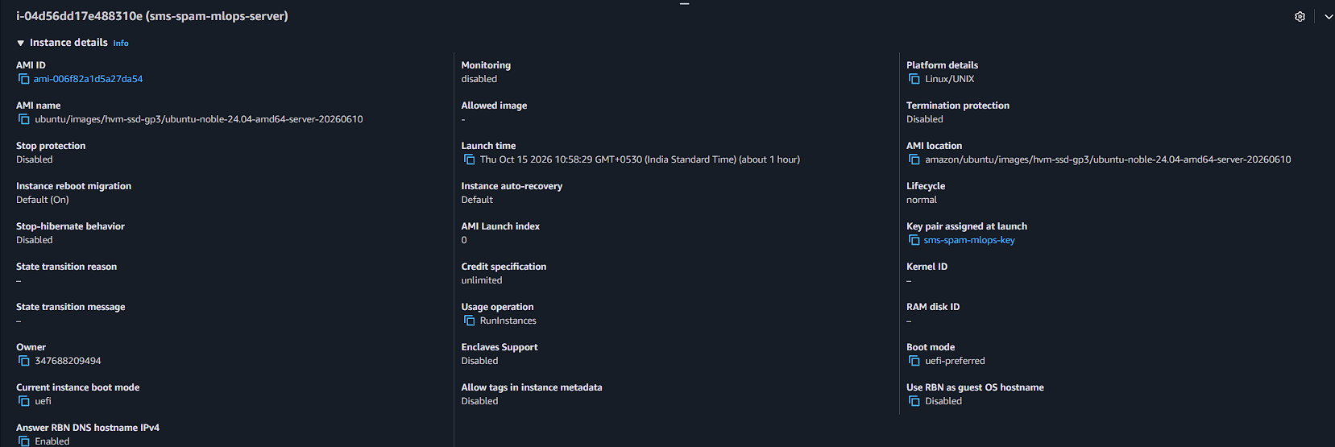
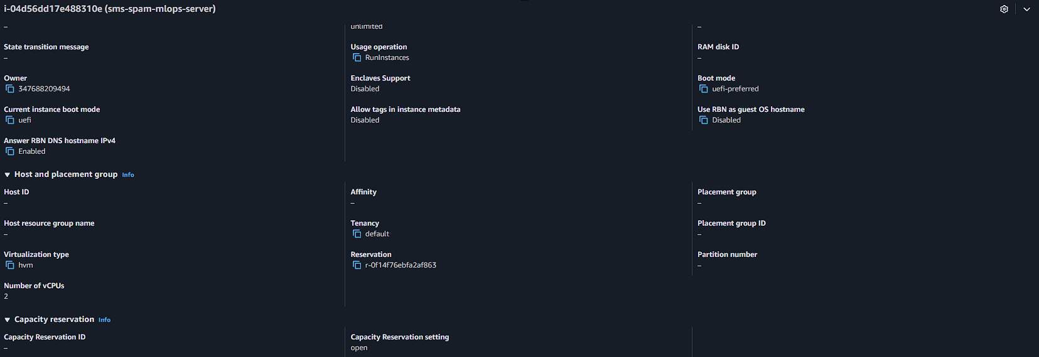

Step 3 - Configure the security group
Rule | Port | Source | Purpose
SSH | 22 | Your public IP /32 | Remote administration
Custom TCP | 5000 | Trusted client range; 0.0.0.0/0 only if public lab access is required | Application access

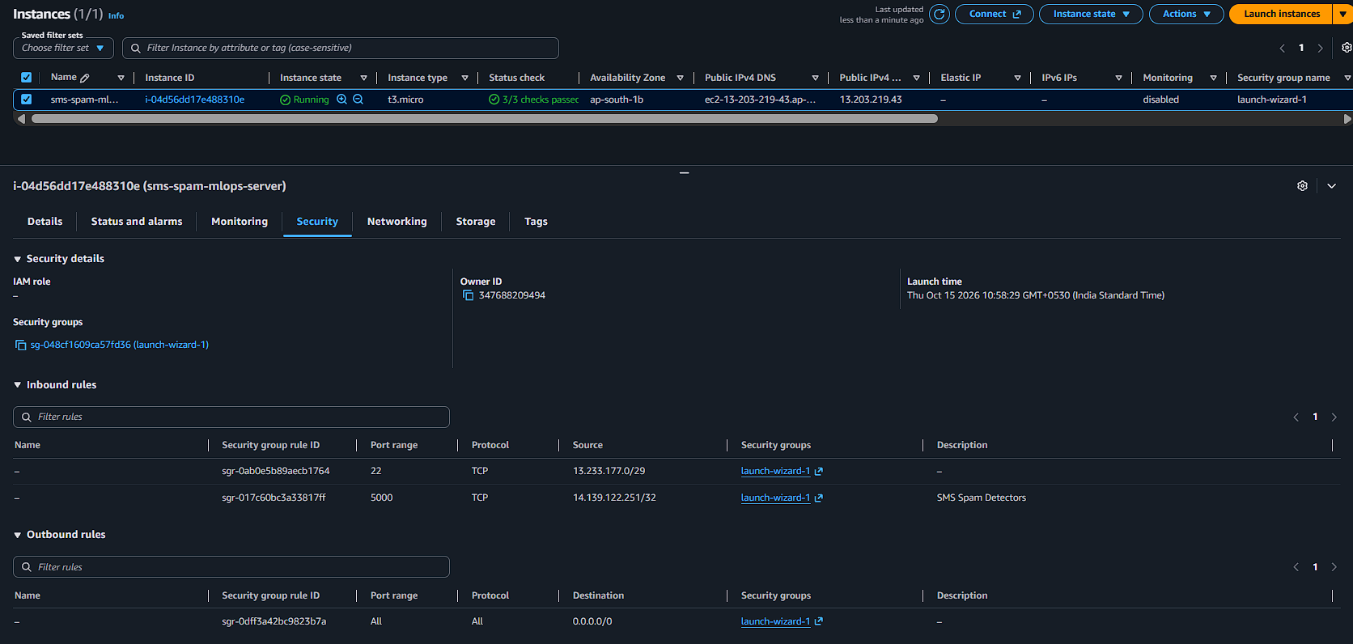

Step 4 - Connect by SSH
ssh -i <keyname>.pem ubuntu@YOUR_EC2_PUBLIC_IP

Replace YOUR_EC2_PUBLIC_IP with the actual address shown in the console.
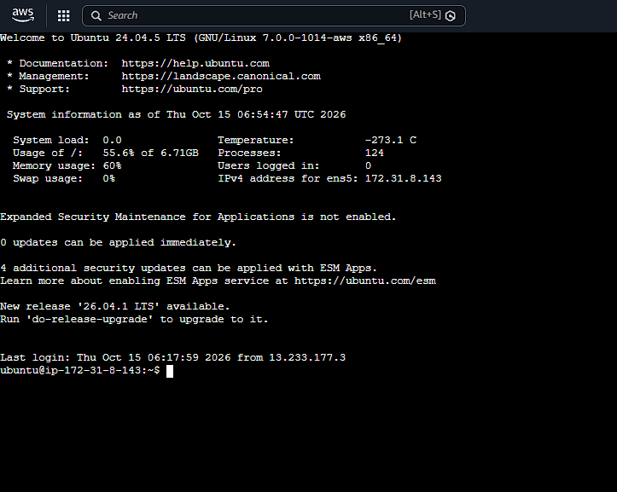

Step 5 – Check\Install and Login Docker
sudo apt update
sudo docker --version
sudo docker info
docker login -u <your_username>

If not installed;
sudo apt install -y docker.io
sudo systemctl enable --now docker

[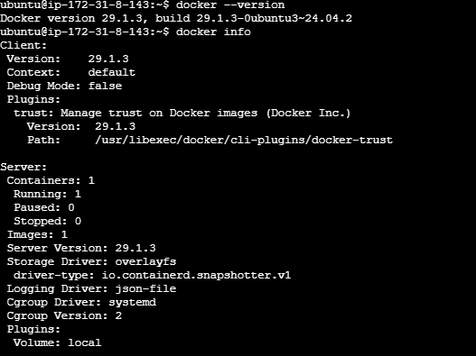

Step 6 - Transfer the Project files to EC2 instance
On your local machine
scp -i <key>.pem <files> ubuntu@YOUR_EC2_PUBLIC_IP:/home/ubuntu/

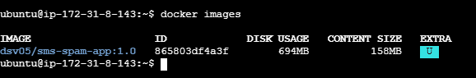

Step 7 — Build Images and Start the container

sudo docker build -t <tag>:1.0 .
sudo docker images

sudo docker run -d \
--name <name> \
--restart unless-stopped \
-p 5000:5000 \
<tag>:1.0

sudo docker ps
sudo docker logs house-price-app

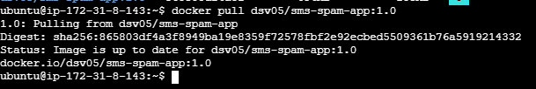

Step 8 — Verify remote access
Open http://YOUR_EC2_PUBLIC_IP:5000 and http://YOUR_EC2_PUBLIC_IP:5000/health. Replace the placeholder with the actual public IPv4 address.
If the page does not open, check instance status, security group rules, docker ps, docker logs house-price-app, and whether the app listens on 0.0.0.0:5000 inside the container.

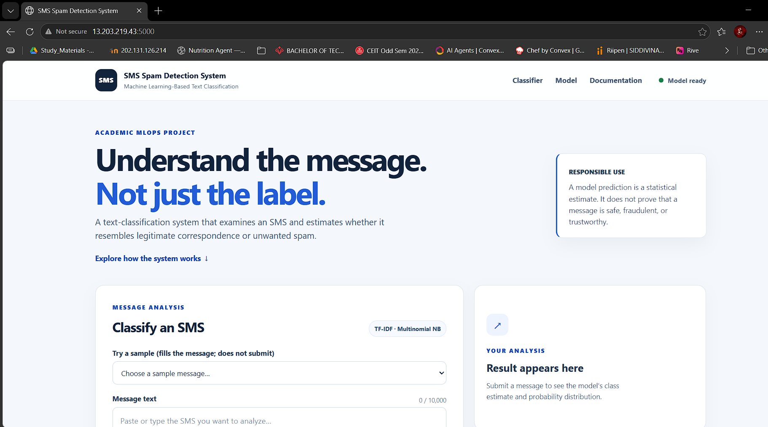

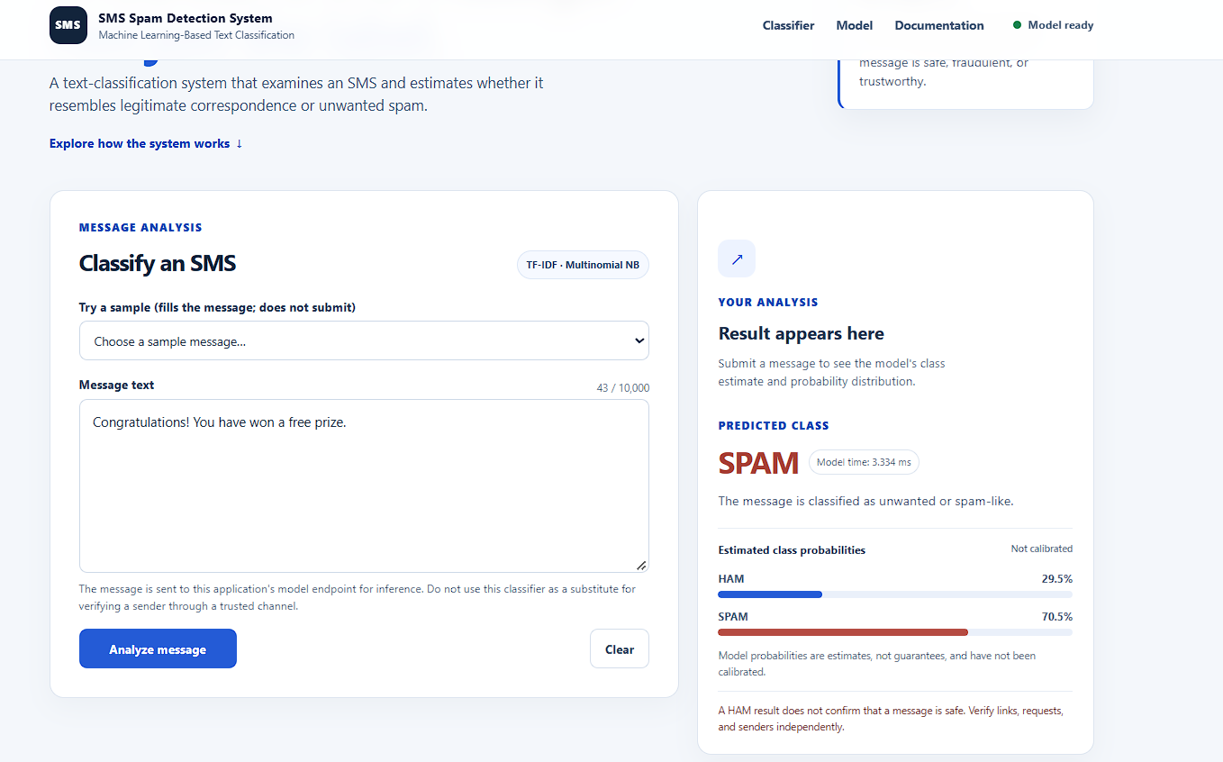

PRACTICAL 4

Deploying the Same ML System on Google Cloud Platform
AIM: To deploy the same Dockerized machine learning application on Google Cloud Platform by creating a Compute Engine virtual machine, configuring network access, installing Docker, importing the existing image, and validating the deployed application’s prediction functionality.

Requirements
- Google account and GCP project
- Billing account linked where required
- Docker image from Practical 2
- Permissions to create Compute Engine instances and firewall rules

Step 1 — Create a GCP project
- Open https://console.cloud.google.com/ and sign in.
- Open the project selector and select New Project.
- Name the project <Project Name> and create it.
- Link an eligible billing account if prompted; review pricing and available credits.
[SCREENSHOT PLACEHOLDER ]
Newly created GCP project.

Step 2 — Enable Compute Engine
- Open Navigation Menu → Compute Engine → VM instances.
- Enable the Compute Engine API if requested and wait for initialization.
[SCREENSHOT PLACEHOLDER ]
Compute Engine dashboard with the correct project selected.

Step 3 — Create the virtual machine
- Select Create instance and name it.
- Choose a region and zone appropriate for the lab and budget.
- Select an Ubuntu LTS image, a suitable small machine type and boot disk size.
- Configure network access and create the VM.
[SCREENSHOT PLACEHOLDER ]
VM configuration showing name, region, machine type and boot disk.

Step 4 — Configure the firewall
- Open VPC network → Firewall and create an ingress firewall rule.
- Name it allow-ml-app-5000 and select the VPC network used by the VM.
- Set the intended target VM or network tag and allow TCP port 5000.
- Use a trusted client IP range when possible. If public access is required for the assignment, 0.0.0.0/0 permits all IPv4 sources.
Ensure the rule applies to the intended VM. Avoid exposing administrative ports unnecessarily.
[SCREENSHOT PLACEHOLDER]
GCP firewall rule showing TCP port 5000 and the configured source range.

Step 5 — Connect using SSH
- Return to Compute Engine → VM instances.
- Wait until the VM is available and click SSH next to the VM.
- Wait for the browser-based terminal to connect.
[SCREENSHOT PLACEHOLDER]
Browser-based SSH terminal connected to the GCP VM.

Step 6 — Check\Install and Login Docker
sudo apt update
sudo docker --version
sudo docker info
docker login -u <your_username>

If not installed;
sudo apt install -y docker.io
sudo systemctl enable --now docker

[SCREENSHOT PLACEHOLDER]
Docker installation verified on the GCP VM.

Step 7 — Transfer and import the image
Save the Docker image locally, then use Google Cloud CLI. Install and authenticate gcloud locally if necessary.
gcloud compute scp <files>\
<VM_Name>:~/ \
--zone=YOUR_VM_ZONE \
--project=YOUR_GCP_PROJECT_ID

# Run in the VM's SSH terminal

Replace YOUR_VM_ZONE and YOUR_GCP_PROJECT_ID with actual values. Artifact Registry is an alternative for repeated releases.
[SCREENSHOT PLACEHOLDER]
Docker image imported on the GCP VM.

Step 8 — Build Image and Run the container
sudo docker build -t <tag>:1.0
sudo docker images

sudo docker run -d \
--name <name>\
--restart unless-stopped \
-p 5000:5000 \
<tag>:1.0

sudo docker ps
sudo docker logs <name>

[SCREENSHOT PLACEHOLDER]
Running application container on GCP.

Step 9 — Verify the application
Copy the VM external IPv4 address and open http://YOUR_GCP_EXTERNAL_IP:5000 and http://YOUR_GCP_EXTERNAL_IP:5000/health. Test a prediction. If the page fails, verify the external IP, firewall rule, container status and logs.
[SCREENSHOT PLACEHOLDER]
ML application opened using the GCP external IP.

[SCREENSHOT PLACEHOLDER]
Successful prediction through the GCP deployment.

