***LINKERS_LINK ME***

***OUR IDEA***

* Bursary website where students (first years to postgraduates) can interact with various bursaries and companies that are willing to pay off students’ debts or give them a funding.

***SOCIAL PROBLEM***

* Every year or semester they are students who drop of out school because of funding, some are withdrawn by NSFAS and their sponsors, some are cash paying students and because of the family or maybe economy and employment issues they could not cover their fees any longer.
* Social issue: Lack of education due to lack of funds.

***SOLUTION***

* The aim is to link students with companies that offer bursaries to students. And we also provide them with links to apply for tertiary institutions based in South Africa.
* This website could help lots of students find sponsors and they will be able to get their qualifications.

***UML DIAGRAM***

***USE CASE DIAGRAM***

***SYSTEM ARCHITECTURE***

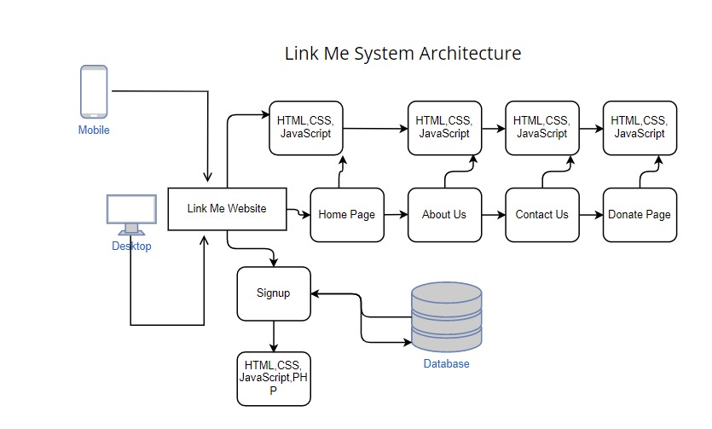

***HOME***

* Our home page has no restrictions, everybody can access the page.
* The page is like an introduction of our site.
* We have a chat bot tab where users will be will request for any kind of help and will the assisted within a minute on our site.
* And a gallery tab where we stored motivational and inspiring videos and photos. We believe that they will be assist most people.

***ABOUT US***

* On this page, we explained what our platform is about and how we are solving the lack of funds issue.
* We explained our goals and mission

***DONATE***

* We have a donate page that has a paypal system for donations that are going to made.
* Any personnel is welcome to and have access to the donate page to make donations and any amount is acceptable.
* These donations will assist students with registration fees as bursaries and sponsors tend to respond late to their applications therefore we will help them secure their spaces at tertiary while they wait.

***SIGN UP***

* New users can sign in and create an account on this page by inserting their name, surname , password and uploading an image for their profile.
* Existing users do not have to sign up, they can simply login on by clicking on the “login ” link to insert their name and password.

***CHATBOT***

* We included a chatbot to automatically assist users on the site when they need help. This way they will not have to wait for us to reply to their inquiries.

***GALLERY***

* Above is our gallery page. Where users can find motivational videos and images.

***OVERALL***

1. On each and very page we have included social media icons where users can find out more about LINK ME and there we will be assist lots of students with applications and any of their inquiries.

***LOG IN AND SIGN UP FOR THE DATABASE***

* Users have to sign up with their personal information and email. They have to set their password.
* The system will record all the valid information if invalid it will pop out an error message.
* Users can use their email and password to login to our system.
* System will check if information entered is valid. If so, they can access the bursaries and university pages.