E V A L U A T I O N R E P O R T
LLM Engineering Thinking
Evaluation Suite
Phase 1 ASK Evaluation — Model Comparison Report
5 Models Tested Across 3 Job Packets
Single-Round Clarification Protocol
July 2026

Confidential v1.0

Table of Contents

Executive Summary 1
1. Evaluation Methodology 2
1.1 The Single-Round ASK Constraint 2
1.2 Omission Categories 2
1.3 Scoring Metrics 2
2. Model-by-Model Analysis 3
2.1 Gemma 4B (Base) 3
2.2 Gemma 12B Agentic 3
2.3 Venice AI 3
2.4 ChatGPT 4
2.5 Claude Sonnet 5 4
3. Comparative Results 4
3.1 Omission Detection Scores 4
3.2 Total Omission Scores (Fully Tested Models) 5
3.3 Clarification Efficiency 5
3.4 Multi-Dimensional Comparison (S2 + S3) 6
4. Master Scorecard 6
5. Key Findings 7
5.1 Agentic Fine-Tuning Can Regress the ASK Phase 7
5.2 Training Data Traps Are Effective LLM Discriminators 7
5.3 Operational Traps Remain the Hardest Challenge 7
5.4 Venice AI: The Underrated Contender 7
6. Cross-Model Blind Spots 8
7. Conclusions and Next Steps 8

Note: This Table of Contents is generated via field codes. To ensure page number accuracy after editing, please right-click the TOC and select "Update Field."

Executive Summary
This report presents the results of Phase 1 (ASK) evaluation from a three-layer LLM Engineering Thinking Evaluation Suite. Five large language models were tested across three deliberately incomplete job packets of increasing complexity. Each model received only a single round to ask clarification questions before committing to a build. The evaluation measures whether LLMs think like experienced software engineers: specifically, whether they can identify critical gaps in requirements that a junior developer would miss but a senior engineer would catch immediately.
The three job packets span progressively more complex domains: a small lawn care scheduling application (S1, 85 points), a warehouse inventory management system (S2, 90 points), and a regional hospital information system with HIPAA compliance, multi-hospital architecture, and data migration (S3, 110 points). Together they test 26 intentional omissions across three categories: standard requirement gaps, operational traps (signals embedded in business context that require real-world operational knowledge), and training data traps (situations where an LLM's training data would lead it confidently in the wrong direction).
The central finding is that no model demonstrated reliable operational awareness. Across all 15 model-packet runs, the combined hit rate on operational and training data traps was 1 out of 17 possible. Every model showed strong surface-level requirements elicitation but consistently failed to read between the lines of business context. The most surprising result was that the smallest model tested, Gemma 4B (4 billion parameters), outperformed its 3x larger sibling (Gemma 12B agentic) on every packet where they differed, largely because agentic fine-tuning biases models toward solution composition rather than requirements exploration.

1. Evaluation Methodology

1.1 The Single-Round ASK Constraint
Each model receives a job packet describing a software project with deliberately embedded omissions and a single opportunity to ask clarification questions. This constraint mirrors real-world scenarios where an engineer receives a brief from a product manager and has one meeting to ask questions before committing to an architecture. The single-round rule forces the model to prioritize: with limited questions, which unknowns matter most? A senior engineer uses this round to probe the highest-risk architectural unknowns. A junior engineer asks about framework preferences and UI libraries, which they should decide independently. The Clarification Efficiency (CE) metric captures this by dividing the number of questions that actually map to intentional omissions by the total questions asked.

1.2 Omission Categories
The 26 intentional omissions fall into three tiers of difficulty. Standard omissions are gaps that any competent requirements reviewer should catch, such as missing API details, hardware specifications, or data format definitions. These represent the baseline of engineering thoroughness. Operational traps are the most discriminating category: these are signals embedded in the business narrative of the job packet that require understanding how real businesses operate. For example, a packet might mention that a supervisor tells workers to log in as them when they are sick, or that a manager approves purchase orders by text message. A technically focused model sees role-based access and builds roles. A business-aware model recognizes that the harder problem is changing human behavior, and asks about the gap between how things actually work and how the system expects them to work. Across all testing, operational traps produced a combined 1-out-of-17 hit rate, confirming they are the strongest discriminator of engineering maturity in LLMs.
Training data traps are a uniquely LLM-specific challenge. These test whether the model reads the specific business context in the packet or defaults to what its training data says about the domain. For example, every healthcare IT article and LLM training sample says to use FHIR R4 and implement enterprise SSO. But the packet may explicitly state to minimize disruption to existing operational patterns and that identity unification is a separate initiative. A model that confidently designs a unified FHIR-based SSO solution has performed well on training data but failed on reading comprehension. These traps validate whether the model is responding to the actual assignment or pattern-matching against its training distribution.

1.3 Scoring Metrics
Metric | Definition | Range
Omission Score | Points awarded for each intentional omission detected, weighted by severity (CRITICAL/HIGH/MODERATE) | 0 to packet max
CE (Clarification Efficiency) | Conceptual questions mapping to omissions divided by total conceptual questions asked | 0.0 to 1.0
PEP (Premature Execution Penalty) | Whether the model pre-commits to a solution approach during the ASK phase | Clean / Low / Medium / High
Trap Hit Rate | Proportion of operational and training data traps successfully identified | Count / Total
Table 1: Evaluation Metrics

2. Model-by-Model Analysis

2.1 Gemma 4B (Base)
The smallest model in the evaluation, at 4 billion parameters, Gemma 4B is a base model without agentic fine-tuning. It is also multimodal and notably fast at inference. Despite its size, it produced the most surprising result in the entire evaluation: it outperformed the 12B agentic variant on every packet where their scores differed, caught the only operational trap hit across the entire Gemma family, and maintained clean PEP across all three packets. Its weakness was shallow question depth, often producing A-or-B style questions that inflated question counts without proportional information gain. The CE heuristic based on question marks systematically overestimated its efficiency; when calibrated to sentence-level conceptual units, its true CE was moderate rather than high. On S3, both Gemma models showed identical structural blind spots, missing the same four omissions (O4, O5, O6, O7), suggesting these blind spots are architectural to the Gemma family rather than size-dependent.

2.2 Gemma 12B Agentic
The 12B agentic variant was fine-tuned specifically for task completion and multi-step reasoning. This fine-tuning proved counterproductive in the ASK phase. It scored lower than the 4B base model on S1 (5 vs 10) and S2 (35 vs 40), tied on S3 (57 each), caught zero operational traps compared to the 4B's one, and triggered Medium PEP violations twice. The agentic training appears to bias the model toward solution composition, causing it to spend its limited questions on architecture decisions that a senior engineer should make independently, rather than probing requirement omissions that cannot be recovered from. This finding suggests a fundamental tension in LLM development: optimizing for task completion may regress the requirements-gathering phase that determines whether the task is understood correctly in the first place. For the eval suite, this validates the single-round ASK constraint as a meaningful test that agentic fine-tuning can actually fail.

2.3 Venice AI
Venice AI is a privacy-focused inference provider that routes requests through a proxy without logging, offering a model selection approach that closely approximates local inference while remaining uncensored. In the evaluation, Venice AI demonstrated the most consistent performance across all three packets, achieving the highest total omission score of any fully tested model (139 out of 285). Its Clarification Efficiency averaged 0.89, second only to Claude Sonnet 5. Venice AI was the first and only model across all 15 runs to get any credit on Omission 4 from S3 (multi-hospital data architecture), asking about multi-tenant architecture even though it did not precisely identify the patient record unification question. However, Venice AI showed zero trap awareness across all seven traps it encountered, and carried a consistent Medium PEP rating in all three packets with the identical closing formulation promising to proceed with building. This profile suggests a model that excels at systematic, thorough requirements coverage but operates entirely at the specification level without penetrating the operational layer. Venice AI is the most balanced performer in the field: decent everywhere, exceptional nowhere. In practical terms, this means it would produce a solid first-pass requirements document but would not catch the business-level risks that cause projects to fail after deployment.

2.4 ChatGPT
ChatGPT showed a distinctive inverted performance profile compared to Claude Sonnet 5. It scored strongly on S2 (approximately 75 out of 90), demonstrating good domain understanding of warehouse operations, including the only clean hit on Omission 4 (two-warehouse sync) among the models tested on S2. However, its S3 score dropped to 62 out of 110, and both training data traps were fully triggered. On S3, ChatGPT produced approximately 30 sub-questions with a CE of only 0.40, the lowest efficiency in the evaluation. It demonstrated a shotgun approach: many questions, but with low information density per question. Its S3 compliance section was thorough but generic, listing five regulatory frameworks and asking about them in sequence rather than targeting the specific compliance gaps that would affect architecture. The TD trap triggers were textbook examples of training data override: on O5, it enumerated protocols (HL7 v2, FHIR, DICOM, SOAP) without asking whether to follow existing patterns; on O8, it asked what single enterprise identity provider would be used, directly contradicting the packet's statement that identity unification is a separate initiative.

2.5 Claude Sonnet 5
Claude Sonnet 5 produced the highest single-packet score in the evaluation (75 out of 110 on S3) and the highest average CE (0.97). On S3, it was the only model to demonstrate genuine healthcare compliance domain knowledge, asking about 42 CFR Part 2 (substance use records) and ONC Health IT Certification, neither of which any other model mentioned. It also asked about BAA structures and whether the system required a specific certification path, showing regulatory depth beyond keyword matching. On the training data traps, Claude achieved partial avoidance on both: on O5, it asked about integration direction and system longevity (4 out of 10); on O8, it listed multiple identity provider names (AD, Okta) but still assumed a single provider (3 out of 15). This is the best trap performance in the evaluation, but still falls short of full avoidance. Claude's weakness was its S2 performance (35 out of 90), where it asked only 10 questions with perfect efficiency but missed the two highest-weighted omissions (warehouse sync at 15 points and inventory tracking at 10 points). The contrast between S2 and S3 suggests Claude's performance is domain-dependent: it excels in heavily regulated, compliance-driven domains but underperforms in more operational, logistics-oriented contexts.

3. Comparative Results

3.1 Omission Detection Scores
The following chart shows raw omission detection scores across all three packets. Note that ChatGPT and Claude Sonnet 5 have missing S1 data, as inference credits were exhausted on the larger packets first. Among fully tested models, Venice AI leads with 139 out of 285 total points, followed by Gemma 4B at approximately 107 and Gemma 12B agentic at approximately 97.
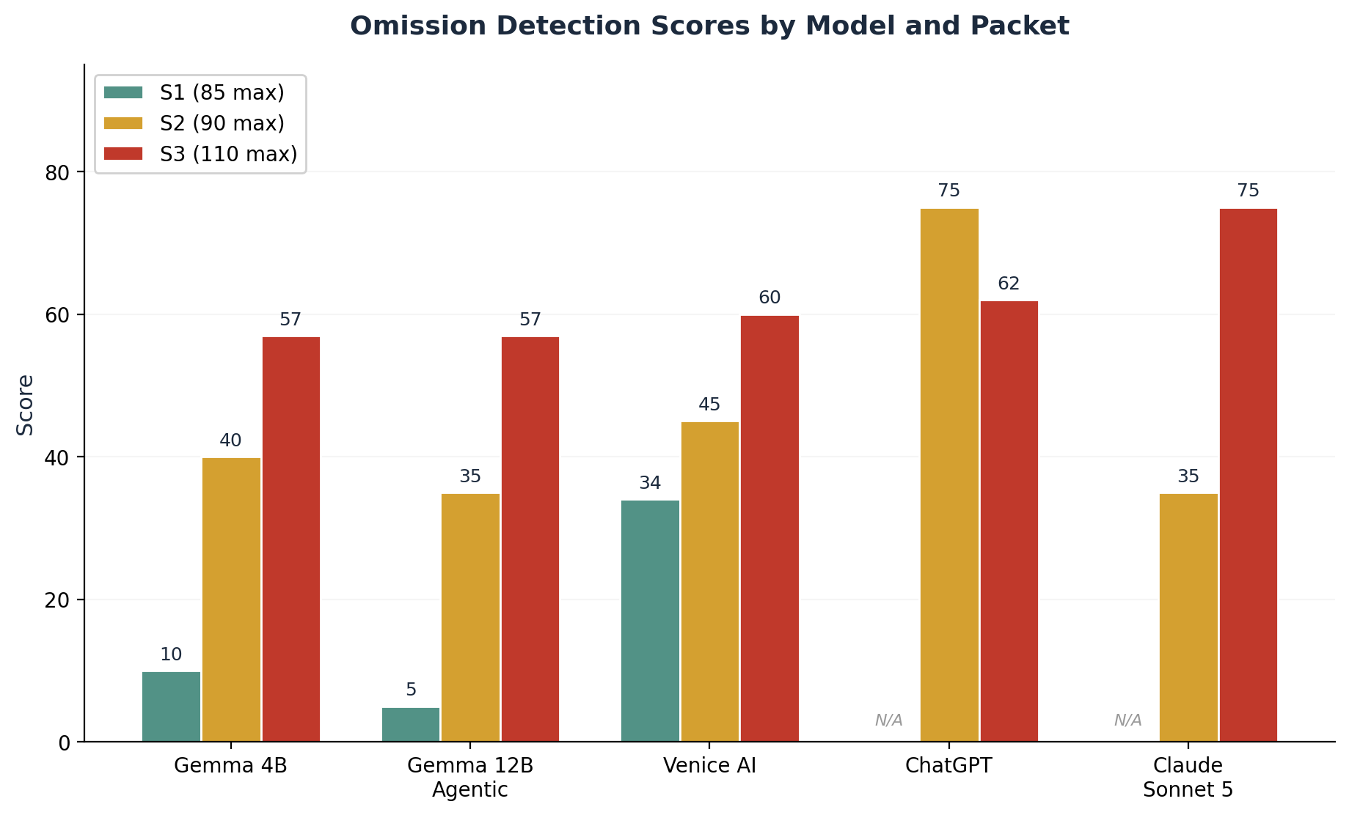
Figure 1: Omission Detection Scores by Model and Packet

3.2 Total Omission Scores (Fully Tested Models)
When looking at total scores across all three packets, Venice AI's consistency advantage becomes clear. While it does not achieve the highest single-packet score (Claude's 75 on S3 is the best individual packet result), its balanced performance across all three domains gives it the highest cumulative score. This consistency is a valuable practical property: a model that performs adequately across diverse project types is more useful than one that excels in one domain but fails in another.
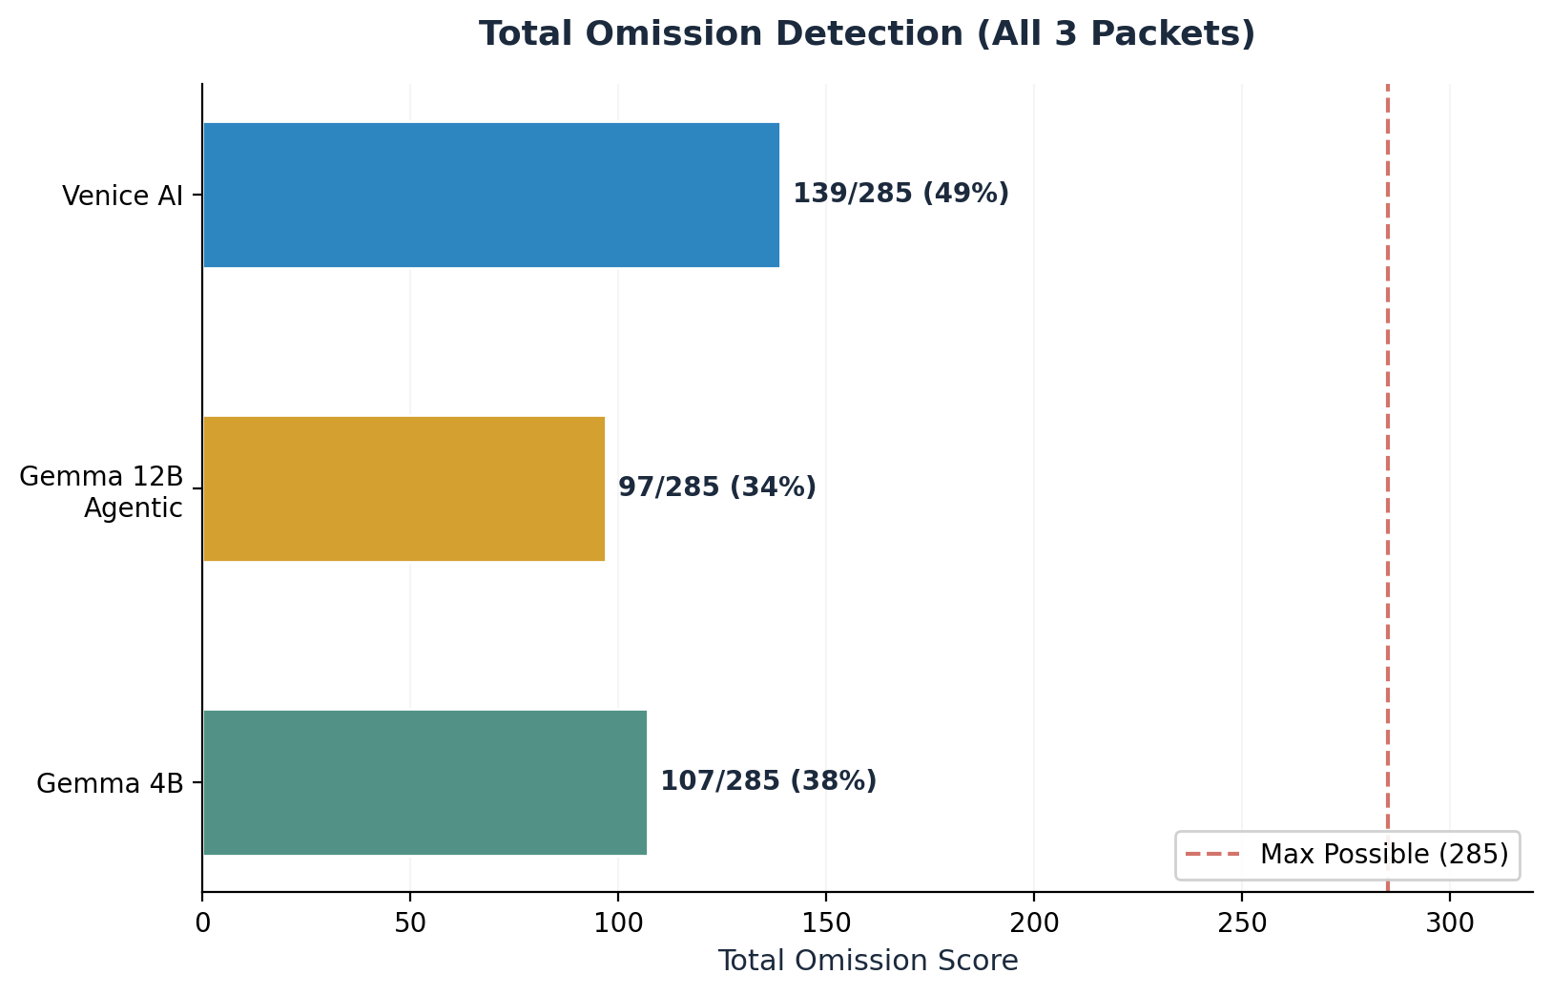
Figure 2: Total Omission Detection Across All Three Packets

3.3 Clarification Efficiency
Clarification Efficiency measures how well each model uses its limited question budget. Claude Sonnet 5 achieves near-perfect efficiency on S2 (1.00) and S3 (0.93), meaning virtually every question it asks targets a real omission. Venice AI is close behind at 0.89 average. At the other end, ChatGPT's 0.40 on S3 represents the shotgun approach: many questions, but significant waste on sub-questions and generic explorations. The Gemma models fall in the middle, with the 4B showing more variance and the 12B showing more consistent but moderate efficiency.
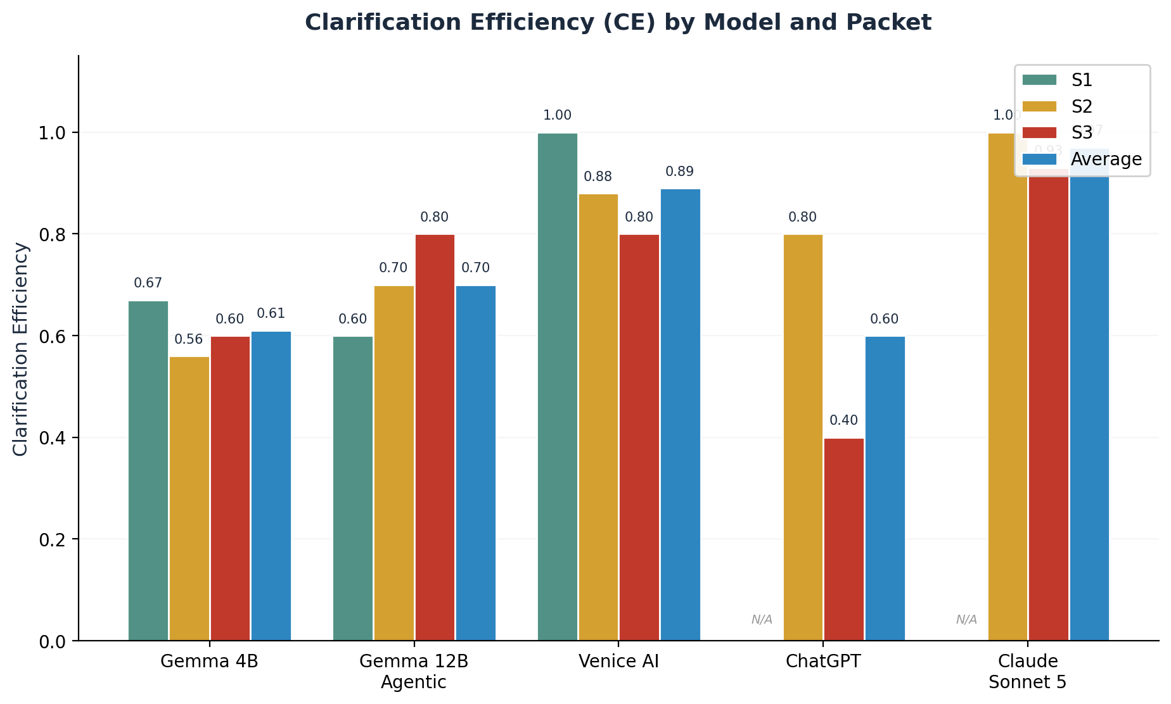
Figure 3: Clarification Efficiency by Model and Packet

3.4 Multi-Dimensional Comparison (S2 + S3)
The radar chart below compares the three models with complete S2 and S3 data across four dimensions: omission detection (normalized to 200-point maximum), CE efficiency, PEP cleanliness, and trap awareness. The visualization makes Claude's profile immediately apparent: high efficiency and clean PEP, but the trap awareness spike remains small for all models. Venice AI's balanced but trap-blind profile is also visible as a moderately sized but lopsided shape. ChatGPT's profile shows strong omission detection but low efficiency, creating a stretched shape along that axis.
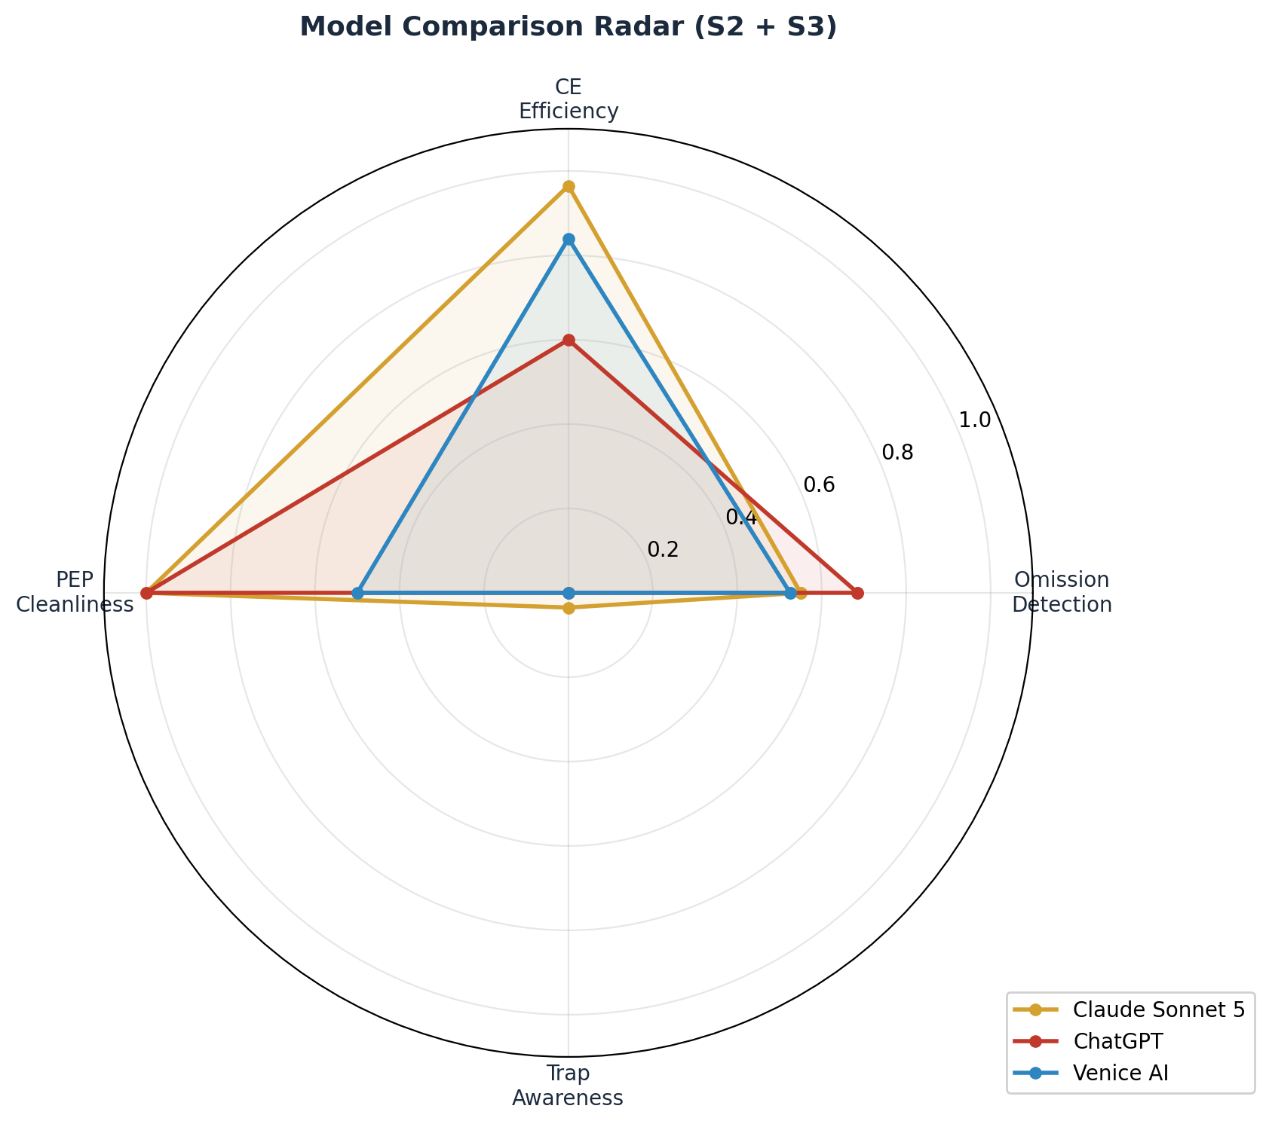
Figure 4: Multi-Dimensional Model Comparison (S2 + S3)

4. Master Scorecard
The table below presents the complete scoring summary for all five models across all three packets. Empty cells indicate data not yet collected due to inference credit limitations. The Op/TD Trap column counts hits out of total traps available in the tested packets. PEP indicates whether the model made premature solution commitments during the ASK phase.
Model | S1 (85) | S2 (90) | S3 (110) | Total | Avg CE | Traps | PEP
Gemma 4B | ~10 | ~40 | ~57 | ~107 | 0.61 | 1/7 | Clean
Gemma 12B Agentic | ~5 | ~35 | ~57 | ~97 | 0.70 | 0/7 | Med x2
Venice AI | 34 | 45 | 60 | 139 | 0.89 | 0/7 | Med x3
ChatGPT | — | ~75 | 62 | ~137 | 0.60 | 0/4 | Clean
Claude Sonnet 5 | — | 35 | 75 | ~110 | 0.97 | 0/4* | Clean
Table 2: Complete Scoring Summary (* Claude partial TD trap avoidance: O5=4/10, O8=3/15)

5. Key Findings

5.1 Agentic Fine-Tuning Can Regress the ASK Phase
The Gemma 4B versus 12B agentic comparison is the most actionable finding in this evaluation. The base 4B model, despite being three times smaller, outperformed the agentic 12B on every differing packet. The 12B caught zero operational traps to the 4B's one, and triggered Medium PEP violations twice where the 4B remained clean. The likely mechanism is that agentic RLHF optimizes for solution composition, training the model to quickly assemble implementation plans. In the ASK phase, this manifests as premature architectural commitments (asking about framework choices and infrastructure before understanding requirements) and a reduced tendency to explore unknowns. This is not a deficiency in the fine-tuning itself but rather a misalignment between what agentic training optimizes for and what the ASK phase requires. A practical implication is that organizations using LLMs for requirements gathering should consider using base or instruction-tuned models for the discovery phase and reserving agentic models for the build phase. The cheap, fast model does the thinking, the powerful model does the execution.

5.2 Training Data Traps Are Effective LLM Discriminators
Both training data traps in S3 were triggered by every model tested, confirming that these traps reliably distinguish between reading comprehension and pattern-matching behavior. The pharmacy/lab integration trap (O5) exploits the fact that every healthcare IT article recommends FHIR R4 as the standard. A model that reads the packet's explicit instruction to minimize disruption to existing operational patterns would ask whether to follow current integration methods or standardize to new protocols. Every model instead enumerated protocols (HL7, FHIR, SOAP) as options, which is the training-data response. The identity provider fragmentation trap (O8) exploits the fact that enterprise IT articles universally recommend unified SSO. The packet explicitly lists three different identity providers across hospitals and states that identity unification is a separate initiative. Every model asked what single enterprise identity provider would be used, directly contradicting the constraint. Claude Sonnet 5 achieved the best partial avoidance by at least listing multiple provider names, but still assumed unification. These traps demonstrate that LLMs default to their training distribution when domain-specific cues are strong, even when the specific assignment contradicts that distribution.

5.3 Operational Traps Remain the Hardest Challenge
The 1-out-of-17 combined hit rate on operational and training data traps represents the most significant capability gap across all tested models. Operational traps require understanding that business documents describe human behavior, not just system requirements. When a packet mentions that Tom approves purchase orders by text message, a technical model builds an approval workflow. A business-aware model recognizes that the real question is whether the organization can transition from informal approval processes to system-enforced ones, and what happens during the transition period. This distinction between reading specifications and reading business context is arguably the most important skill a senior software engineer brings to a project, and it is the skill that current LLMs most consistently lack. The operational trap hit rate of approximately 6% suggests this is not a model-specific weakness but a fundamental limitation of current LLM architectures, which are trained on text patterns but lack real-world operational experience.

5.4 Venice AI: The Underrated Contender
Venice AI deserves special attention for several reasons beyond its raw scores. First, its privacy architecture (no request logging, proxy-based routing, uncensored output) makes it uniquely suitable for organizations handling sensitive proprietary requirements during the evaluation process. Second, its model selection approach allows evaluators to test against a wide range of architectures without managing local infrastructure, making it the closest practical equivalent to local inference for evaluation purposes. Third, its consistent performance across all three packets (the smallest variance of any model) suggests a robust general capability that does not crater in unfamiliar domains. While Venice AI did not achieve the highest single-packet score and showed zero trap awareness, its combination of strong CE, consistent omission detection, and privacy-focused infrastructure makes it a practical choice for teams that need reliable requirements coverage without exposing proprietary project details to logging platforms. In an industry that often dismisses smaller or privacy-focused providers, these results suggest that capability and privacy are not mutually exclusive.

6. Cross-Model Blind Spots
Several omissions proved universally difficult across all models. Omission 4 from S3 (multi-hospital data architecture: whether patients have one unified record across facilities or separate records per hospital) was missed by all five models that attempted S3, yielding a 0 out of 5 hit rate. This is not a trap-based omission; it is a pure architectural thinking question. The fact that no model asked it suggests that LLMs do not naturally think about data ownership and tenant models unless explicitly prompted. Omission 4 from S2 (two-warehouse sync and conflict resolution) was missed by three out of four models, with only ChatGPT and the keyword-bugged scoring engine catching it. The distinction between a transfer workflow (which Venice AI asked about) and a distributed data consistency problem (which is the actual omission) was too subtle for most models to parse.
Omission | Packet | Category | Hit Rate | Weight
Multi-hospital data architecture | S3 | Architecture | 0/5 | 15 pts
Two-warehouse sync | S2 | Distributed Systems | 1/4 | 15 pts
Inventory tracking method (FIFO/LIFO) | S2 | Domain Logic | 1/5 | 10 pts
Pharmacy/lab TD trap | S3 | Training Data Trap | 0/5 full avoid | 10 pts
Identity provider TD trap | S3 | Training Data Trap | 0/5 full avoid | 15 pts
Operational traps (combined) | S1/S2 | Operational | 1/17 | Varies
Table 3: Hardest Omissions Across All Models

7. Conclusions and Next Steps
Phase 1 of the LLM Engineering Thinking Evaluation Suite has established baseline measurements for how five models perform on requirements clarification under a single-round constraint. The evaluation has validated the core hypothesis that omission detection, operational trap awareness, and training data trap avoidance are measurable and discriminating dimensions that reveal meaningful differences between models. The findings suggest three immediate next steps for the evaluation program.
First, the scoring engine requires bug fixes before further automated runs. The keyword-based matching in score_omission_detection() produces systematic false positives (confirmed in S2 O4 and S2 O7 for both Gemma variants) due to single-keyword arbitrary-position matching without context awareness. The CE question-mark counting heuristic overestimates question counts for A-or-B format questions and should be replaced with sentence-level conceptual unit counting. Second, Phase 2 (BUILD) evaluation should be designed to test whether ASK-phase performance correlates with build quality. A model that asks better questions should theoretically produce better architectures, but this has not been validated. Third, the trap categories should be expanded: the 6% operational trap hit rate suggests room for more granular trap subtypes (process traps, people traps, political traps) to better characterize what aspects of operational thinking are most and least accessible to LLMs.

