**HEPATITIS DATASET FINDINGS**

**Uni-Variate Analysis:**

1. Dataset is highly imbalanced. From the below figure it is clear that, almost 80% of data shows that the persons will live. So, dataset is highly biased

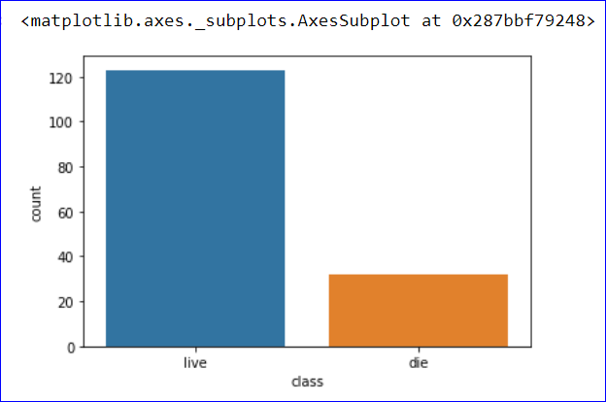

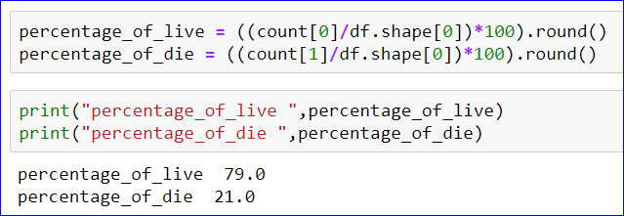

1. Count of Female in the dataset is high when compared to Male. Almost 90% of the dataset values corresponds to Female.

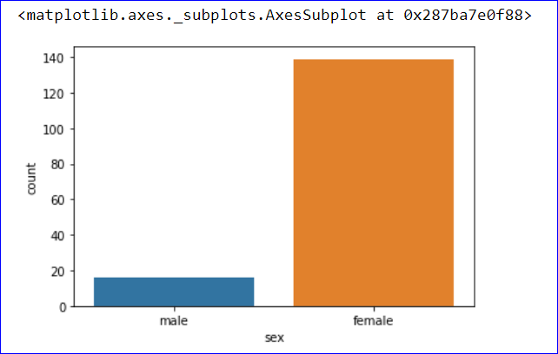

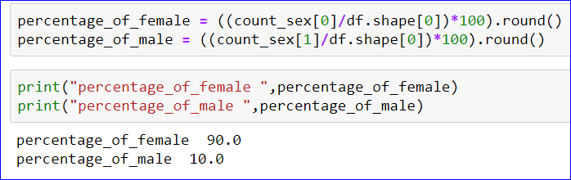

1. Converted Age into a categorical variable with four groups. And from the below figure it’s clear that the Dataset has a greater number of Adults and Old people i.e. people with age of above 25 is high

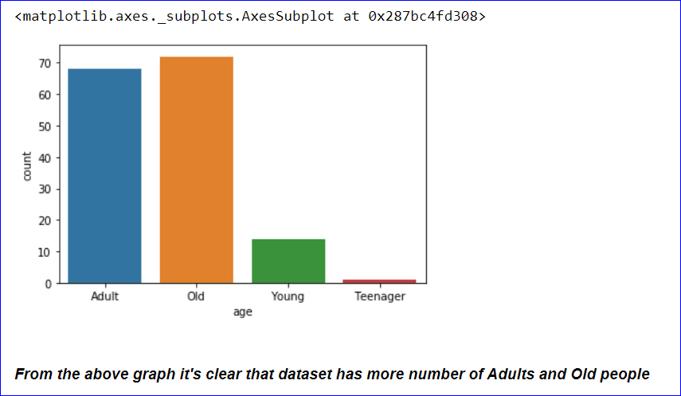

**Bi-Variate Analysis:**

1. Value of bilirubin is high among the Adults and Old people

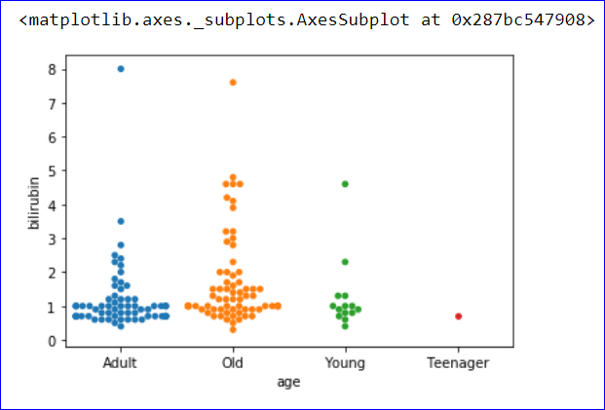

1. Value of “alk_phosphate” is high among Adults and Old. But at the same time a teenager also has a high value of “alk_phosphate”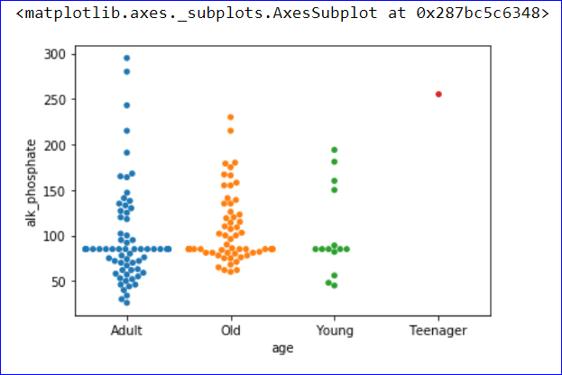
2. Value of “sgot” is high among adult and old people

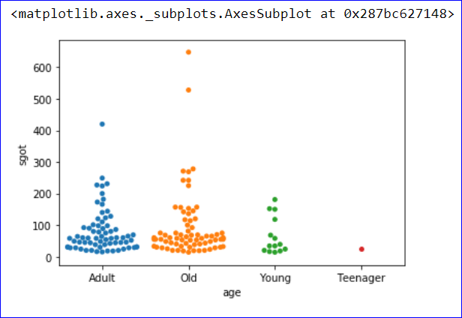

1. Average Value of “albumin” is between 3-5

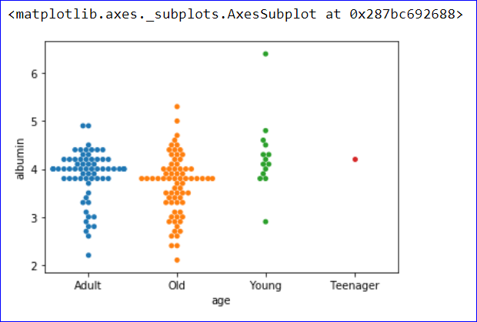

**Multi-Variate Analysis:**

1. From all the below figure, its clear that only the Adult and Old people die.

