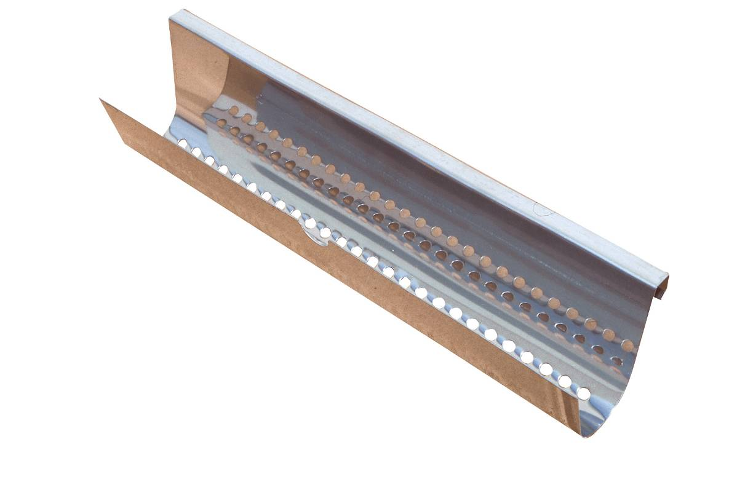

Data: 03/09/2013 | REV: 01

Dimensioni  Dimensions | mm. 420x85x100  mm. 420x85x100
Materiale componenti  Components material | Acciaio lamiera  Stainless steel metal sheet
Master  Master | 30 scatole in cartone 50x32x31 cm.  30 boxes in carton 50x32x31 cm.
Peso lordo master  Master gross weight | Kg. 24,1  Kg. 24,1

