# Report

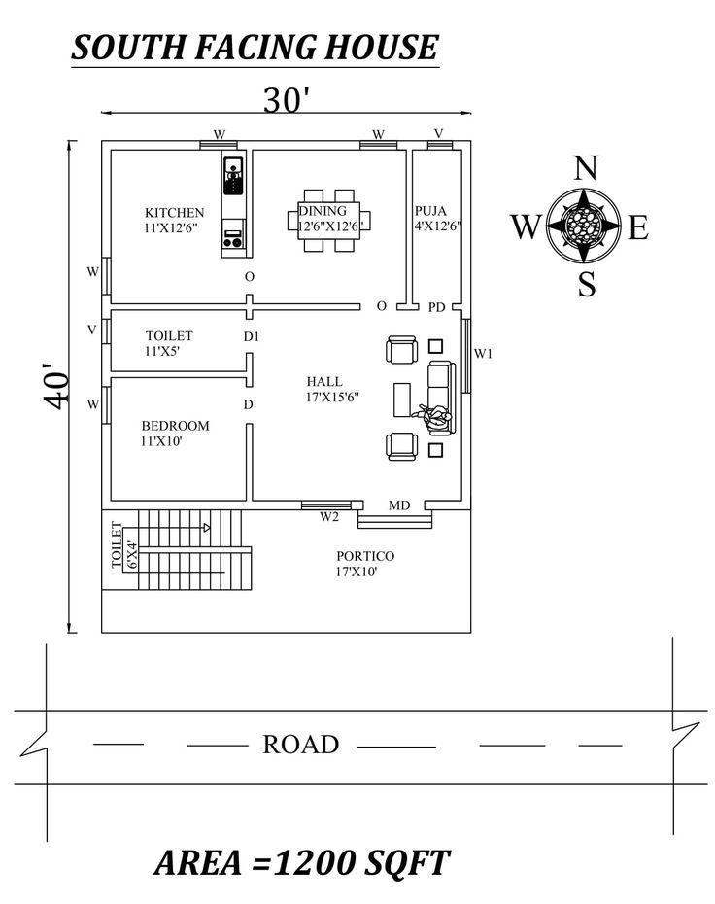

Floor_plan.jpeg

# Technical Report on South Facing House Floor Plan  
  
## 1. Introduction  
  
This report provides a detailed analysis of the floor plan for a south-facing residential house, measuring 30 feet by 40 feet, resulting in a total area of 1200 square feet. The layout is designed to optimize space utilization while ensuring functionality and comfort for its occupants.  
  
## 2. Orientation and Layout  
  
### 2.1 Orientation  
The house is oriented to face south, which is beneficial for maximizing natural light and ventilation. This orientation is particularly advantageous in warmer climates, as it minimizes direct sunlight exposure during peak hours.  
  
### 2.2 Dimensions  
- **Total Area**: 1200 sq. ft.  
- **Overall Dimensions**: 30 ft (width) x 40 ft (length)  
  
## 3. Room Specifications  
  
### 3.1 Kitchen  
- **Dimensions**: 11 ft x 12 ft 6 in  
- **Location**: Positioned in the northwest corner, allowing for efficient workflow and proximity to the dining area.  
  
### 3.2 Dining Area  
- **Dimensions**: 2 ft 6 in x 12 ft 6 in  
- **Location**: Adjacent to the kitchen, facilitating easy serving and interaction during meals.  
  
### 3.3 Puja Room  
- **Dimensions**: 4 ft x 12 ft 6 in  
- **Location**: Located near the dining area, providing a dedicated space for religious practices.  
  
### 3.4 Hall  
- **Dimensions**: 17 ft x 15 ft 6 in  
- **Location**: Centrally located, serving as the main living area, promoting social interaction and connectivity among rooms.  
  
### 3.5 Bedroom  
- **Dimensions**: 11 ft x 10 ft  
- **Location**: Positioned in the southwest corner, ensuring privacy and tranquility for occupants.  
  
### 3.6 Toilets  
- **Dimensions**:   
 - Main Toilet: 11 ft x 5 ft (adjacent to the bedroom)  
 - Additional Toilet: 6 ft x 4 ft (located near the entrance)  
- **Location**: Strategically placed for accessibility from common areas and private spaces.  
  
### 3.7 Portico  
- **Dimensions**: 17 ft x 10 ft  
- **Location**: At the front, providing a sheltered entryway and enhancing the aesthetic appeal of the house.  
  
## 4. Circulation and Accessibility  
  
The layout promotes efficient circulation, with clear pathways connecting all rooms. The positioning of doors and hallways facilitates easy movement throughout the house, ensuring accessibility for all occupants.  
  
## 5. Structural Considerations  
  
### 5.1 Load-Bearing Walls  
The design should incorporate load-bearing walls that align with the structural integrity of the building. The placement of walls should be evaluated to support the roof and upper floors, if applicable.  
  
### 5.2 Foundation  
A robust foundation is essential to support the weight of the structure and resist environmental forces. Soil testing should be conducted to determine the appropriate foundation type.  
  
## 6. Conclusion  
  
The proposed south-facing house design effectively utilizes space while ensuring comfort and functionality. The layout promotes natural light and ventilation, contributing to an energy-efficient living environment. Further structural analysis and engineering assessments are recommended to ensure compliance with local building codes and standards.  
  
## 7. Recommendations  
  
- Conduct a detailed structural analysis to confirm load-bearing capacities.  
- Consider energy-efficient materials and construction techniques.  
- Implement landscaping strategies to enhance outdoor spaces and improve aesthetics.  
  
This report serves as a foundational document for the development of the proposed residential structure, guiding future design and construction efforts.