Equipment Checkout System
Overview:
A Java Sing desktop application developed as part of a Software Engineering II course taken at DeVry University Online. The application allows technicians and administrators to manage equipment inventory, check equipment in and out, generate reports, and maintain persistent inventory using CSV files.

Features:
- User Authentication
- Role-based permissions
- Equipment inventory management
- Equipment checkout
- Equipment return
- CSV data persistence
- Inventory reporting
- Checkout history reporting

Technologies Used:
- Java
- Swing
- Object-Oriented Programming
- NetBeans
- CSV File Storage
- Git
- GitHub

Screen Shots:
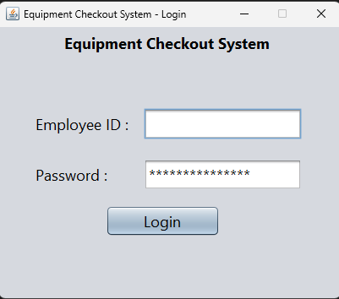
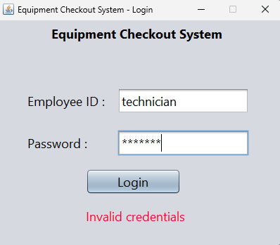

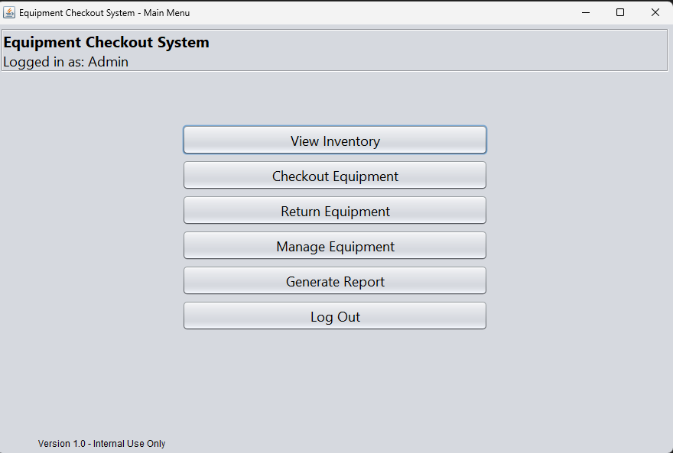
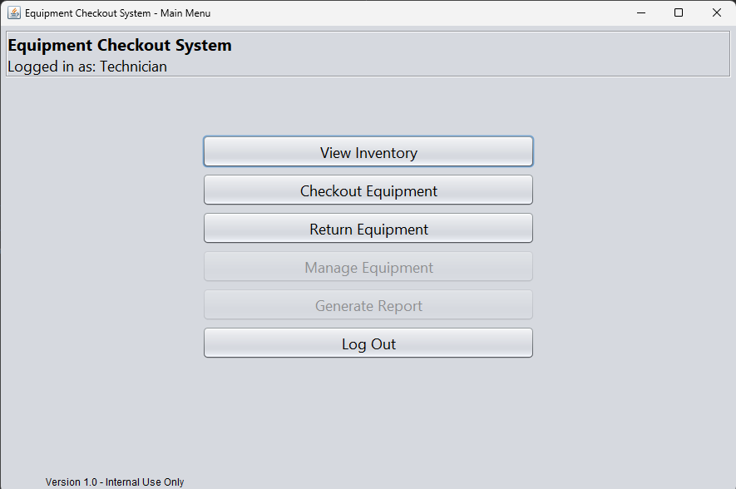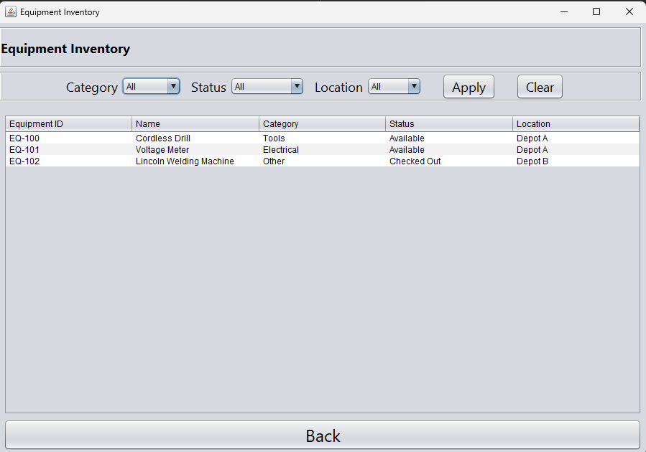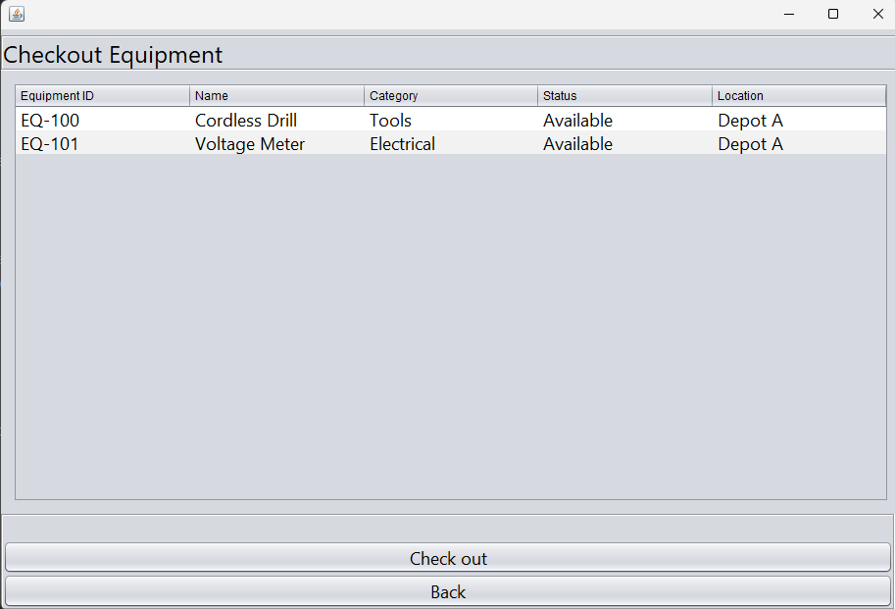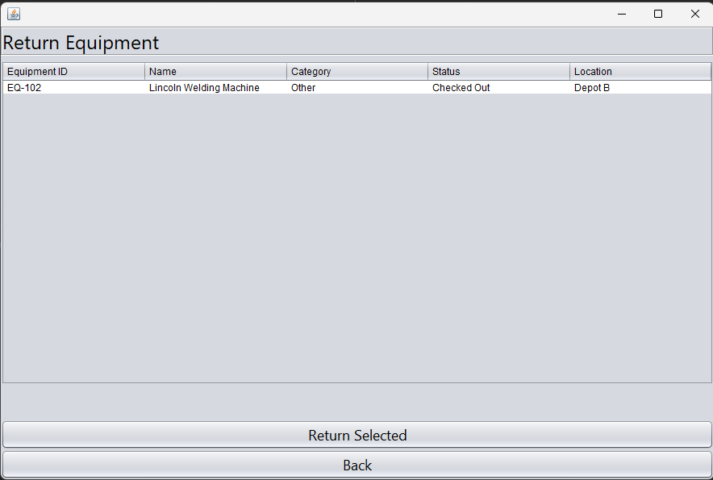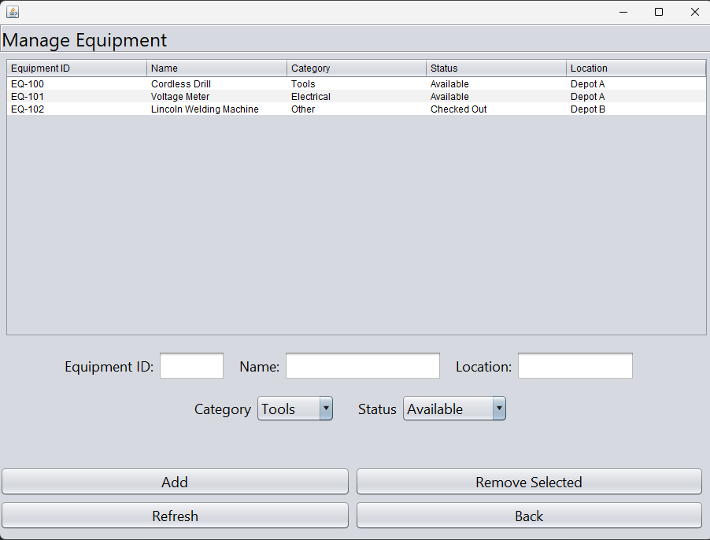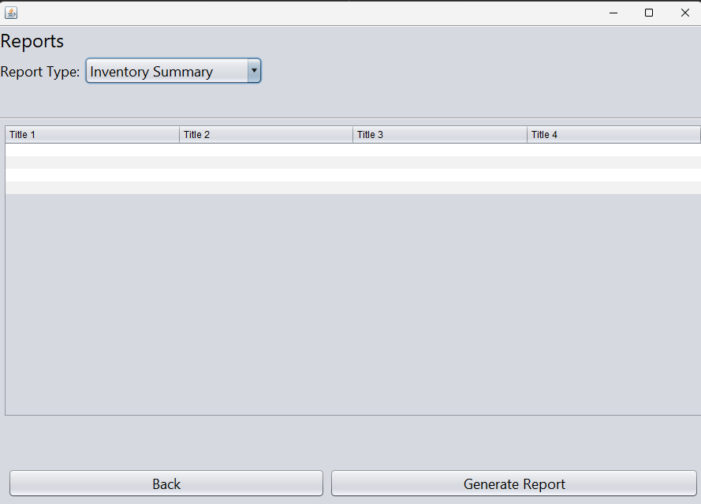

Documentation:
- Software Requirements Specification (IEEE 830)
- Software Design Specification (IEEE 1016)
- UML Diagrams
- Test Cases
- Test Reports

Future Improvements:
- Replace CSV storage with MySQL
- Password hashing
- Barcode scanner support
- Equipment reservation system
- User management
- Search functionality
- REST API backend
- JavaFX interface

