June 1, 2025

{Hiring_Manager}

{Company_Name}

{Company_Address}

{City_State_Zip}

Dear {Hiring_Manager},

{Body}

Warm Regards,

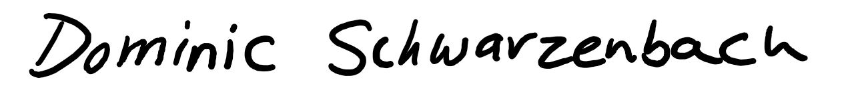



**Dominic A. Schwarzenbach**

Student, Texas ECB Honors

McCombs Business & Cockrell Engineering

[d.schwarzenbach@utexas.edu](mailto:d.schwarzenbach@utexas.edu)

linkedin.com/in/dominic-schwarzenbach