**October 12, 2018 POST 723 3:30 pm**

**G&G TGIF SEMINAR**

**Leonardo Uieda**

*Department of Earth Sciences, University of Hawai’i at Manoa*

**Machine Learning Lessons for Geophysics**

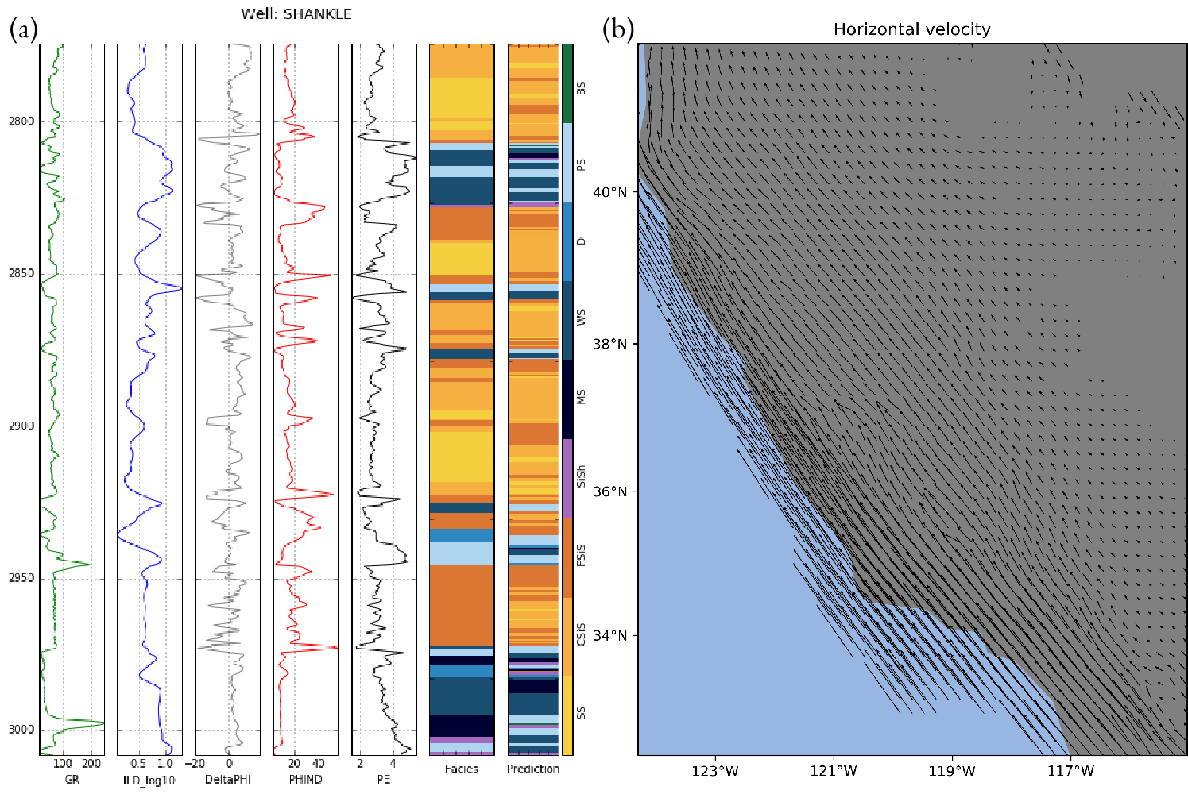

*Example machine learning applications: (a) predicting facies from well logs (b) automatically tuned gridding of GPS velocities.*

Machine learning is the new trend sweeping across the Earth Sciences. From the oil and gas industry to oceanography, these algorithms are being trained to solve previously unsolvable (or extremely tedious) problems. But what exactly is "machine learning" and what can be done with it? In this talk, I will present a brief high-level overview of some of the core concepts and interesting applications of machine learning methods to geoscience data. I will also explore some of the best practices and techniques that can be applied to geophysical inversion and interpolation methods, including a new method for gridding 3-component GPS data.