**September 14, 2018 POST 723 3:30 pm**

**G&G TGIF SEMINAR**

**Your I. Name**

*College of Basket Weaving, Surf City, Never-Never Land*

**This is Not an AGU Abstract:**

**Keep the Title Relatively Short and Accessible to a**

**Broad Earth-Science Audience**

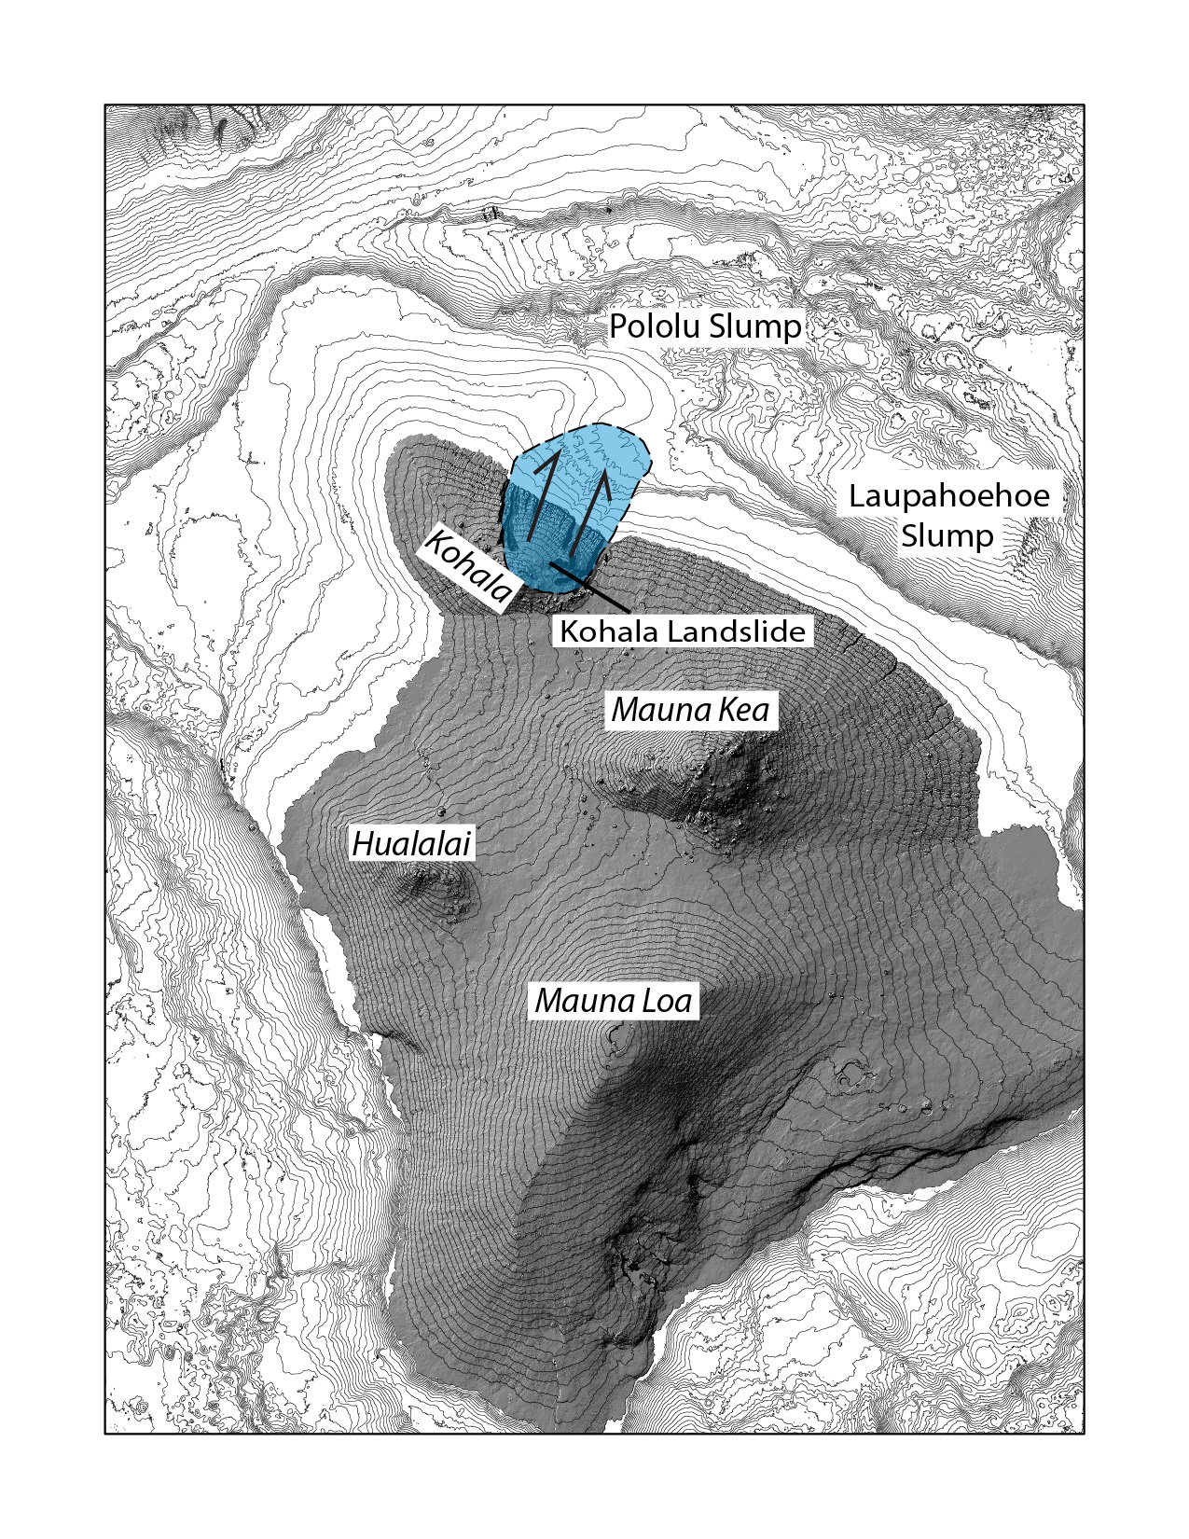

Keep the abstract short. Shoot for about 10 short-medium sentences in a single paragraph. This flyer will be posted in the POST elevator. Can a passenger spending up to 30 seconds in elevator read at least **most** of the abstract? These sentences should describing the nature of the problem or question, its importance, the work and approach you (under)took, and some clue about the outcome –- you are allowed to make this last a “teaser” to get people to come!

No math, no chemical formulas unless you absolutely need them, and a minimum of jargon are highly desired. The picture can be an interesting related image, a simple diagram, or even an uncomplicated plot.