Introduction

For this project, I will be looking to open a coffee shop near the new train station in New York city, Moynahin Train Hall.

Background:

Amtrak just opened a new train station in New York City across the street from Penn Station. This train station, Moynahin Train Hall, will need to be surrounded by places for tourists to shop, just as Penn Station is. Many tourists drink coffee so coffee shops will be needed.

Problem:

In order to know where and how to open this new coffee shop, we'll need to gather some information about the area. We'll need to see where around this new train station there is an area without any places to buy coffee. We'll also need to explore the existing local coffee places to see what is popular and unpopular among their visitors.

Interest:

Real estate developers deciding which type of building to build would be interested in this data. Potential other parties interested in opening coffee shops would also be interested. Additionally, tourists themselves would be interested just to figure out where they should go for coffee when they travel to and from this new train station.

Data

Initially, the address of Moynahin Train Hall was obtained by using Google.com. The latitude and longitude of Moynahin Train Hall were then found using geopy and searching by the address. Foursquare was the main soured of data used to discover information about local coffee shops which currently exist. The foursquare data was converted using json. Pd.jason_normalize() was used to create a dataframe. This process was then repeated for multiple locations. Folium and Matplotlib were used to make a map with colors. Below is an example of a dataframe created as described above:

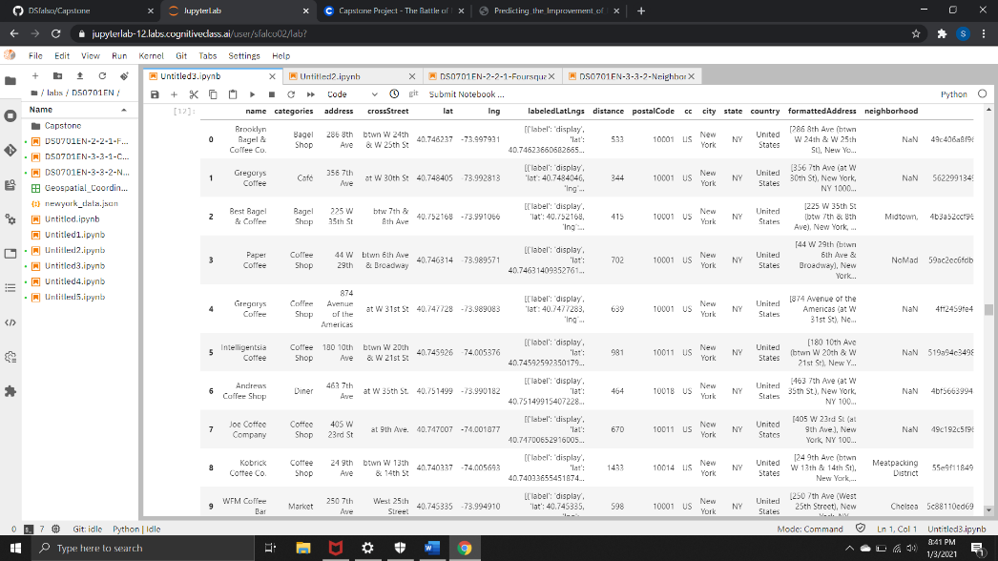

Methodology

First, we used the resources and methods described above to learn that the latitude and longitude for Moynahin Train Hall are (40.7506841010101, -73.99558068686868). With this data, we made a foursquare search for coffee shops in the area and turned it into a dataframe:



Next, this information was used to create a Folium map of coffee places located near Moynahin Train Hall.

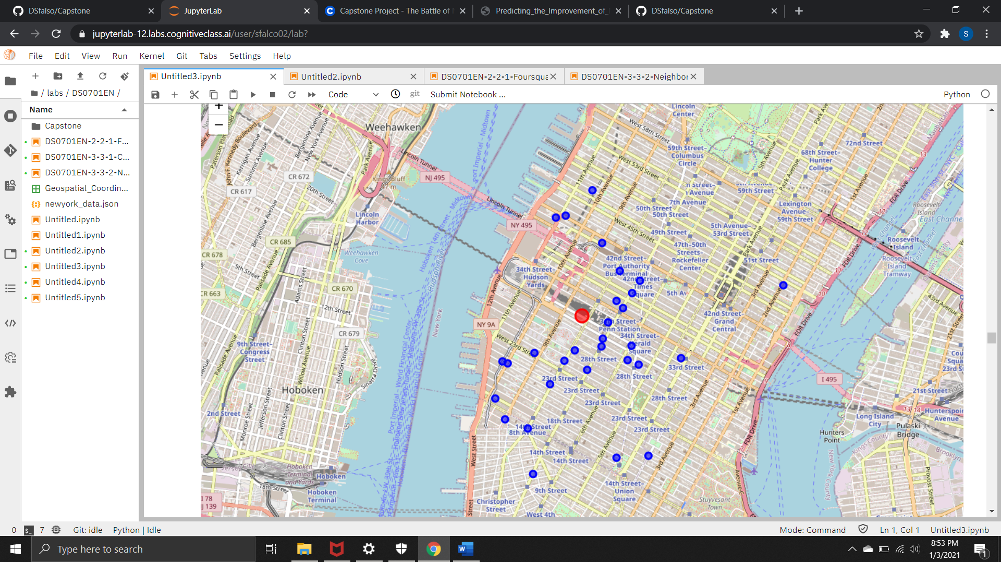

It looks like there are an abundance of places to get coffee to the east and south of the train station. The northeast side, however, has a lack of places to buy coffee.

Next, we took the id of the closest coffee place and did a foursquare search to learn about the restaurant and people’s opinions on it. The restaurant has a favorable rating so we’ll model our coffee shop after it. A search was done for reviews left by customers. Unfortunately, with this unpaid version of foursquare, only 1 tip could be generated. If more tips were available, we’d do a wordcloud to see why customers like this restaurant. We then searched for the restaurant’s menu, photos, prices, and hours to do further market research. A photo of this restaurant’s foursquare menu page is below:

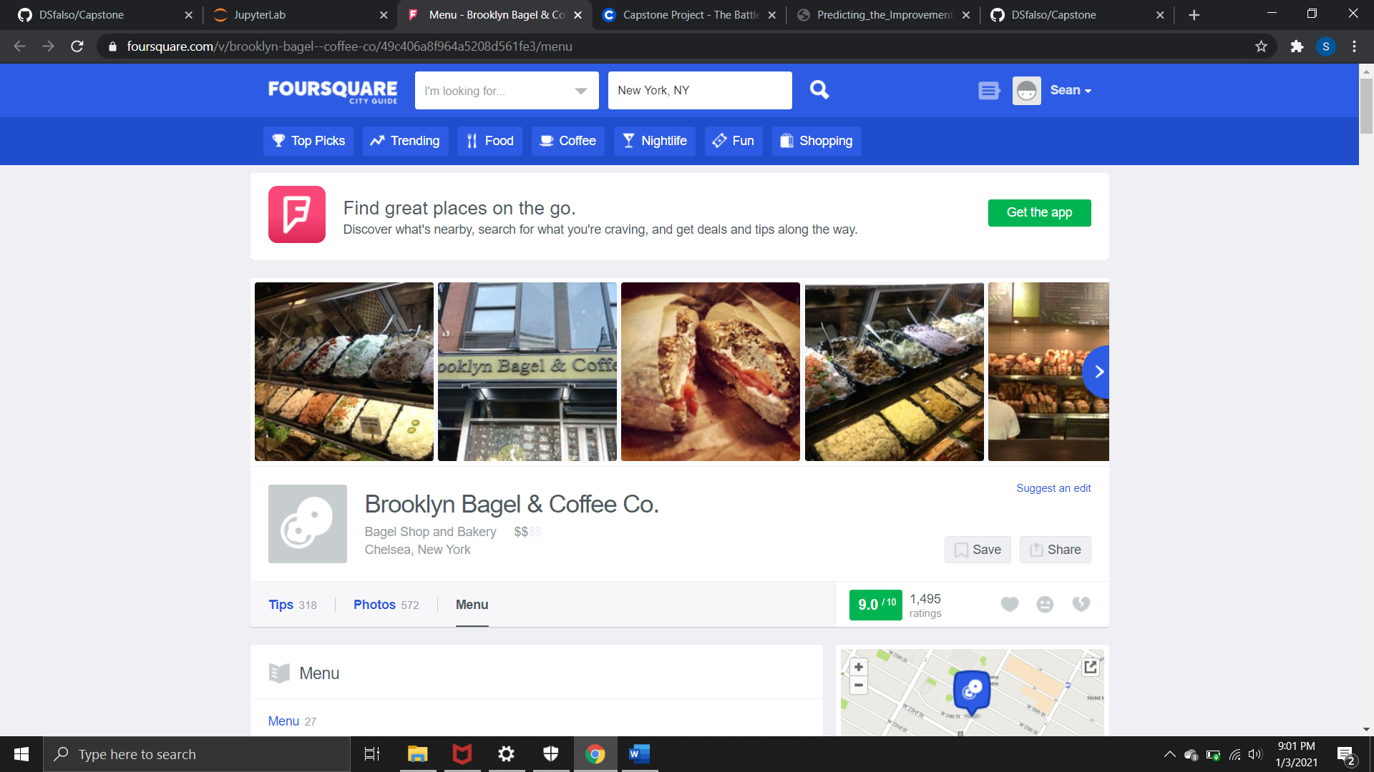

Next, we looked for a coffee place with a less favorable rating. Again, we searched for tips and, if we had the paid version, would do a wordcloud to see why customers do not like this establishment as much. We also searched for prices and hours so that we can set ours accordingly.

Conclusion

We learned from the map that the best place to put our coffee shop is near the northwest area of Moynahin Train Hall, as there are currently no coffee places in the area. From the first restaurant we learned that consumers like to have bagels with their coffee and what kind of toppings are enjoyed. With the paid version, much more information could be found with a wordcloud. We learned that prices for coffee are generally low in the area. Perhaps, we could open a luxury style coffee shop with higher prices and better products to try to capture a different market than our local competition. On the second coffee shop, we saw that cold brew coffee was popular with the reviewer. We could consider adding cold brew coffee as it could be a local preference. We learned that local coffee shops are generally open around 7 am. Perhaps we could go earlier to capture an earlier crowd without competition.