Explain and analysis (if necessary) all the query of project:

--admin_login

select * from admin_table where admin_name = $user_name

This query is used to check the data that we input existed in the admin table. If yes then it is a valid admin account. If not then it will tell us that the username or password is incorrect.

--admin_registration

SELECT * FROM admin_table WHERE admin_email = '$email';

INSERT INTO admin_table (admin_name, admin_email, admin_password) VALUES ('$username','$email','$password')

This query is used to check the data (email) that we input existed in the admin table. If yes, then it will tell us that the user already existed. If no then we insert the data.

--delete_brand

DELETE FROM brands WHERE brand_id = '$delete_id'

This query is used to delete brand from the table.

--delete_category

DELETE FROM categories WHERE category_id = '$delete_id'

This query is used to delete category from the table.

--delete_order

DELETE FROM orders WHERE order_id = '$delete_id'

This query is used to delete order from the table.

--delete_payment

DELETE FROM payments WHERE payment_id = '$delete_id'

This query is used to delete payment from the table.

--delete_product

DELETE FROM products WHERE product_id = '$delete_id'

This query is used to delete product from the table.

--delete_user

DELETE FROM user_table WHERE x = '$delete_id'

This query is used to delete user from the table.

--edit_brand

SELECT * FROM brands WHERE brand_id = '$brand_id'

UPDATE brands SET brand_title = '$brand_title' WHERE brand_id = '$brand_id'

This query check the existence current editing brand. By fetching that, it set the new value equal the old value (we do that to ensure that after update, the untouched part remain the same). After that, it update the new value.

--edit_category

SELECT * FROM categories WHERE category_id = '$category_id'

UPDATE categories SET category_title = '$category_title' WHERE category_id = '$category_id'

This query check the existence current editing category. By fetching that, it set the new value equal the old value (we do that to ensure that after update, the untouched part remain the same). After that, it update the new value.

--edit_product

SELECT * FROM products WHERE product_id = $edit_id

SELECT * FROM categories WHERE category_id = $product_category

SELECT * FROM brands WHERE brand_id = $product_brand

UPDATE products SET product_title = '$product_title',

                    product_description = '$product_description', product_keywords = '$product_keywords',

                    category_id = '$product_category', brand_id = '$product_brand', product_image1 = '$product_image1',

                    product_image2 = '$product_image2', product_image3 = '$product_image3', product_price = '$product_price'

                    WHERE product_id = $edit_id;

This query check the existence of current editing product. By fetching that, it set the new value equal the old value (we do that to ensure that after update, the untouched part remain the same). After that, it update the new value.

--insert_brand

SELECT * FROM brands WHERE brand_title = '$brand_title'

INSERT INTO brands (brand_title) VALUES ('$brand_title')

This query check the existence of the going to insert brand. If it is already existed, then do not insert. If not, then insert the new record.

--insert_categories

SELECT * FROM categories WHERE category_title = '$category_title'

INSERT INTO categories (category_title) VALUES ('$category_title')

This query check the existence of the going to insert category. If it is already existed, then do not insert. If not, then insert the new record.

--insert_product

INSERT INTO products (product_title, product_description, product_keywords, category_id, brand_id, product_image1, product_image2, product_image3, product_price, date, status)

            VALUES ('$product_title','$product_description','$product_keywords','$product_categories','$product_brands','$product_image1','$product_image2','$product_image3','$product_price',NOW(), '$product_status')

This query insert the new record from backend to the database.

--list_orders

SELECT * FROM user_orders JOIN user_table ON user_orders.user_id = user_table.user_id  ORDER BY order_id DESC

 WHERE order_status = '$order_status_filter'

AND order_date BETWEEN '$start_date' AND '$end_date';

This query is used to fetch the data from two table user_table and user_order. The web will present it after filter by date and status.

Analysis:

With index in order_date:

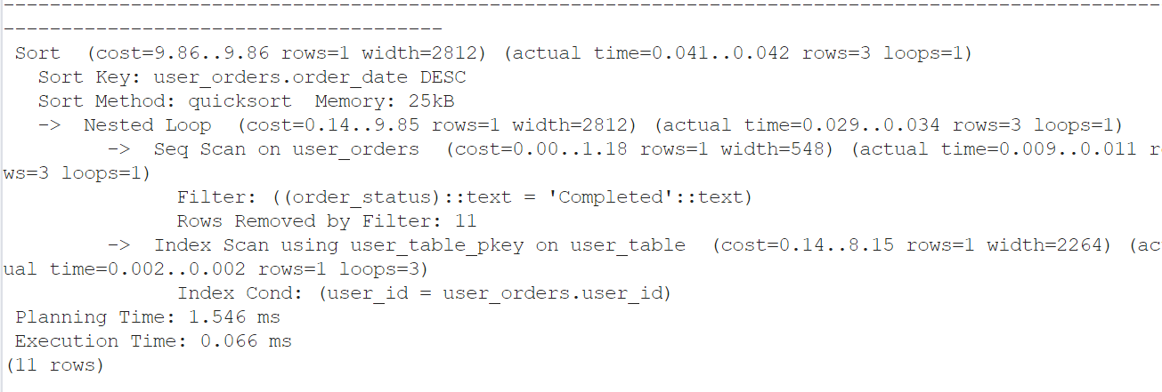

Without index in order_date.

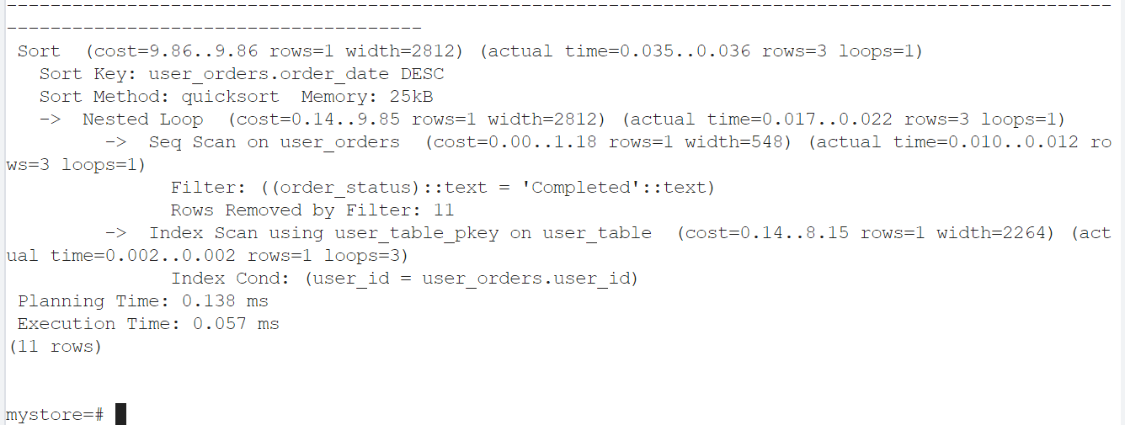

We can see that the speed have change a litter by adding index. The planning increase because the index btree did not increase the performance of the statement (btree only help improve the sorting and searching the left most column of index) .

--list_payment

SELECT * FROM user_payments JOIN user_orders ON user_payments.order_id = user_orders.order_id

WHERE payment_mode = '$payment_method_filter'

AND date BETWEEN '$start_date' AND '$end_date';

SELECT get_total_sales('$start_date', '$end_date', '$payment_mode_filter') AS total_sales;

This query is used to fetch the data from two table user_payment and user_order. The web will present it after filter by date and status.

Analysis:

Without index in payment date:

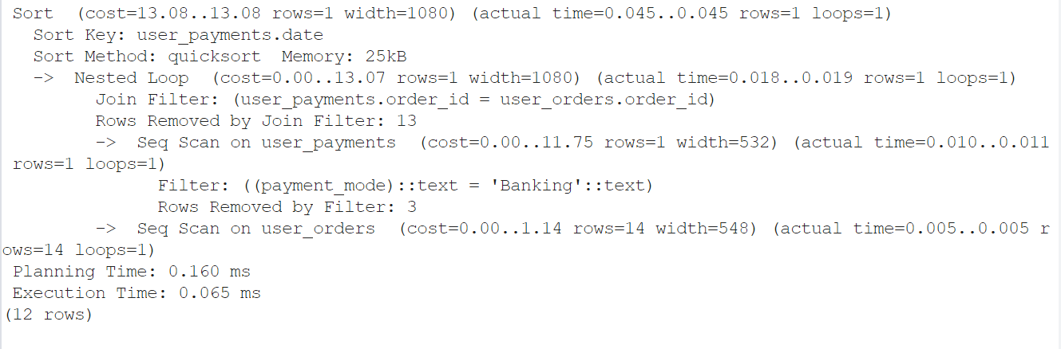

With index:

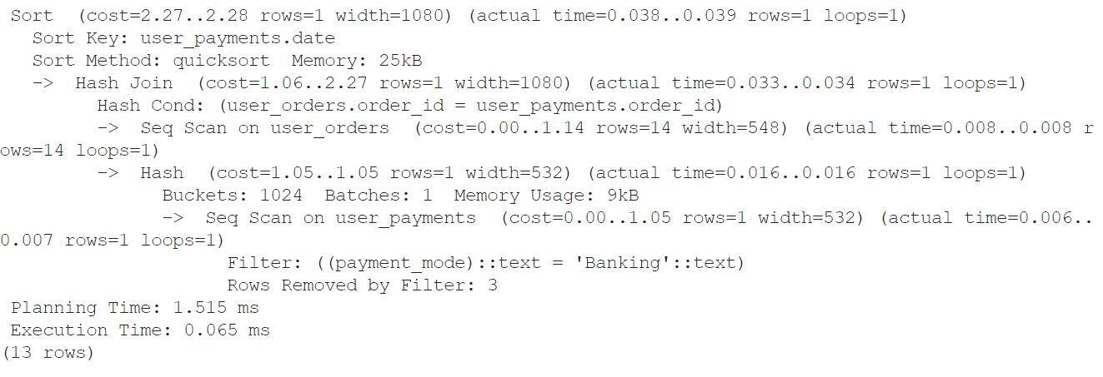

We can see that the speed have change a litter by adding index. The planning increase because the index btree did not increase the performance of the statement (btree only help improve the sorting and searching the left most column of index)

--list_user

SELECT * FROM user_table;

This query is used to fetch data from table user_table.

--view_brand

SELECT * FROM brands;

This query is used to fetch data from table brands.

--view_categories

SELECT * FROM categories;

This query is used to fetch data from table categories.

--view_products

SELECT * FROM products;

This query is used to fetch data from table products.

----Function

--get_product

SELECT * FROM products ORDER BY RANDOM() LIMIT 9 OFFSET 0;

This query is used to fetch 9 random record from table products.

--get_all_product

SELECT * FROM products ORDER BY RANDOM();

This query is used to fetch all the record from table products.

--filter

SELECT * FROM brands;

SELECT * FROM categories;

SELECT * FROM products WHERE 1=1

AND category_id IN ('" . implode("','", $category_ids) . "')

AND brand_id::int IN ('" . implode("','", $brand_ids) . "')

AND CAST(product_price AS FLOAT) >=  (float)$min_price

AND CAST(product_price AS FLOAT) <=  (float)$max_price

ORDER BY

    CAST(product_price AS FLOAT) ASC;

    CAST(product_price AS FLOAT) DESC;

    product_title ASC;

    product_title DESC;

    amount_sold DESC;

    amount_sold ASC;

First, we take the brand and categories to build a check box. After that, we start the filter. At first, if there are no brand, category or any other option selected, we take all the record. But if there are any selected brand or category, we add the condition to the query and fetching. Same with the max and min price. The order of presentation product is added if there is any input in sorting condition.

--search

SELECT * FROM products WHERE product_keywords LIKE '%$search_data_value%'

The query is used to fetch any record in product that have matching keyword include search_data_value.

--view_detail

SELECT * FROM products WHERE product_id=$product_id

We fetch all the information of the specific product.

--cart_function

SELECT * FROM cart_details WHERE ip_address='$ip' AND product_id='$get_product_id';

INSERT INTO cart_details (product_id,ip_address) VALUES ('$get_product_id','$ip')

We first check if the product already added to users card. If yes, then we refuse add the product to cart table. If yes then we insert the record.

SELECT CAST(SUM(p.product_price * c.quantity) AS NUMERIC(10, 2)) AS total_price

    FROM cart_details c

    JOIN products p ON c.product_id = p.product_id

    WHERE c.ip_address = '$get_ip_add';

We calculate the price of all item in the cart by select all the product in current (check condition by ip) then multiple the quantity save in cart and the price save in product.

Analysis:

With index in product_id and user_id:

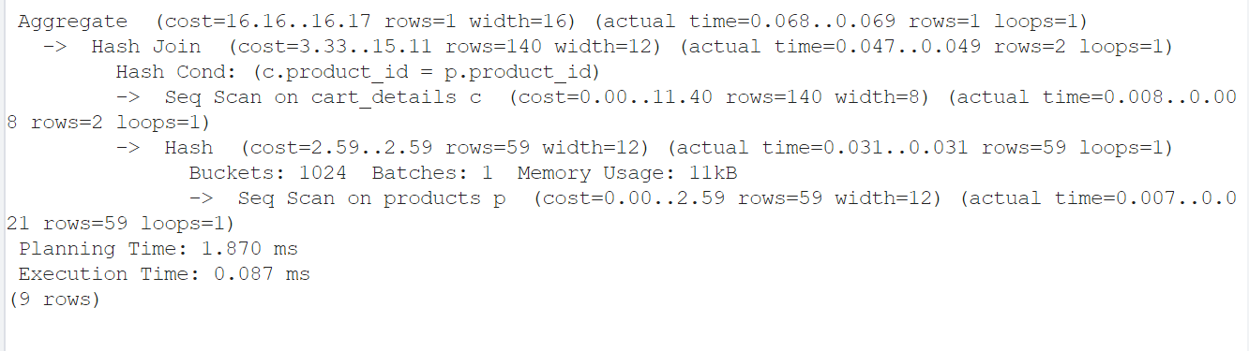

Without index:

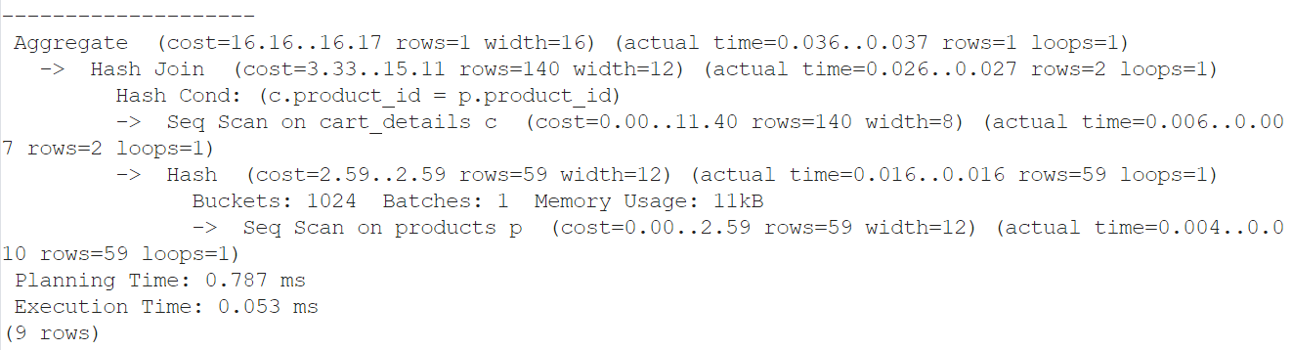

The time need to executed and planning reduce because the index in here improve the performance in searching that use the product_id (btree only help improve the sorting and searching the left most column of index).

----------

--confirm_payment

SELECT * FROM user_orders WHERE order_id = '$order_id';

INSERT INTO user_payments (order_id, payment_mode)

                    VALUES ('$order_id', '$payment_mode');

UPDATE user_orders SET order_status = '$complete' WHERE order_id = '$order_id'

We check the current order existence and set all current value to old value. The inpuy in payment will insert a new record in the payment table. After that, we update the status of the order.

--delete_account

DELETE FROM user_table WHERE username = '$username_session'

This query is used to delete the user account by user them self.

--edit_account

SELECT * FROM user_table WHERE username = '$user_session_name';

UPDATE user_table SET username='$username', user_email='$user_email',

                        user_image='$user_image', user_address='$user_address', user_mobile='$user_mobile'

                        WHERE user_id=$update_id;

We first fetch the record of current user from the database. After that, we set all current value to old value, and then we update the current value to the new value. We update the record.

--order

SELECT * FROM cart_details WHERE ip_address = '$get_ip_add';

SELECT * FROM products WHERE product_id = $product_id;

INSERT INTO user_orders (user_id, amount_due, invoice_number, total_products, order_date, order_status) VALUES ($user_id, $total_price, $invoice_number, " . count($order_info_values) . ", '$order_date', '$status');

DELETE FROM cart_details WHERE ip_address = '$get_ip_add';

Select all the record that match the ip in the cart_detail. With every product, loop through that and calculate the total price,… then insert the record in to the order_table.

When input in delete, remove that record from cart table.

--profile

SELECT * FROM user_table WHERE username = '$username';

Get the record of current user from the user_table and show all data. And call the order function and payment function.

--login

SELECT * FROM user_table WHERE username='$user_username';

SELECT * FROM cart_details WHERE ip_address='$user_ip';

This query is used to check the data that we input existed in the user table. If yes then it is a valid user account. If not then it will tell us that the username or password is incorrect.

--user_register

SELECT * FROM user_table WHERE username='$user_username' OR user_email='$user_email';

INSERT INTO user_table (username,user_email,user_password, user_image, user_ip, user_address, user_mobile)

    VALUES ('$user_username','$user_email','$hash_password','$user_image','$user_ip','$user_address','$user_contact');

This query is used to check the data (email) that we input existed in the users table. If yes, then it will tell us that the user already existed. If no then we insert the data.

--user_order

SELECT * FROM user_table WHERE username = '$username';

SELECT * FROM user_orders WHERE user_id = $user_id;

We use this to fetch all the data about order the user have by matching it with user_id of each record.