The Hebrew University of Jerusalem

Economics Department

Economics of Migration 57811



The Effect of Minimum Wage on Migration  
Evidence from the European Union

Submitted to: Dr. Michael Amior

Authors: Ofir Zeira (208546069) & Dan Shelef (207278607)

## Abstract

This paper is trying to add to the discussion surrounding the impact of minimum wage on migration. Here, we specifically investigate the internal migration between different countries in Europe. We are measuring how emigration and immigration are affected, separately, by minimum wage for multiple countries in the EU. In addition, we are looking into previous and following years to show preceding trends and to find delayed effects. We find both measures have a small but statistically significant positive relation with minimum wages in the years 2000-2015. That means the net migration is about zero.

## Introduction

The effect of minimum wage has been a hot topic among economists for years (e.g.: Card D., 1992; Dube et al., 2007; Allegretto et al., 2011). In the past, most of the research focused on its connection to employment level, but in the last decade or so more and more articles investigated the relationship between minimum wage and migration (e.g.: Minton & Wheaton, 2023; Edo & Rapaport, 2019). The direction of effect between, i.e. whether minimum wage increases or decreases migration, is also debated.

In theory, the impact of the minimum wage on labour migration is ambiguous (Ma, Li & Wu, 2024). On the one hand, higher minimum wages might increase unemployment which could cause emigration. On the other hand, higher minimum wages could increase the expected earnings and lead to higher immigration / lower emigration. In practice, different articles detected opposing results. Based on these existing findings, we believe more research into this subject is required and valuable.

In most studies that examine the relationship between minimum wage and migration, the USA is used as the main case study (e.g.: Boffy-Ramirez, 2013; Giulietti, 2014). This is for the following three main reasons:

1. The data is readily available.
2. There are differences between states when it comes to the minimum wage.
3. The migration cost is (relatively) low (which is an assumption in most models).

These three conditions could be considered a requirement for investigating the topic.

## Research Question

In our research into this topic, we were not able to find an article which used Europe as a case study. Our goal in this paper is to research exactly that: what is the effect of minimum wage on migration in Europe? Since it has not been studied before and the general subject is strongly debated, we believe that looking into additional case studies is important.

In our view, Europe answers the three requirements (data availability, different minimum wages and easy migration) as well. First, for countries in Europe in general and in the European Union in particular, the data is easily accessible and highly organized thanks to Eurostat (the statistical office of the EU). Second, there are differences between European countries regarding their minimum wage since each country is independent. Third, the cost of migration could be considered higher than in the US, but agreements between European countries lower that cost.

The European Union (EU) is a political and economic union of 27 countries that promotes the free movement of people, goods, services, and capital. In the context of migration, the EU grants its citizens the right to live and work in any member state without a visa or work permit. The EU currently has 27 member states, with the founding six joining in 1958, and the most recent member, Croatia, joining in 2013. Additionally, many of those countries and some others are part of the Schengen Agreement. The treaty was established in 1985 with the goal of abolishing border controls altogether, making migration even easier. We believe both treaties warrant considering migration costs low.

The main Challenge expecting us is with data, both with its size and its representativeness. Many European countries didn’t have a minimum wage enacted till rather recently and some still don’t. For example, Germany only has minimum wage since 2015. That shrinks our actual data size. In addition, we know Europe experienced an immigration shock because to the Arab spring, especially since 2015. We suspect this might impact migration trends significantly, so we need to either control for those changes or drop the data affected by it.

## Literature Review

The general question has been researched before in different ways, yet the results are inconclusive. Different methods have been applied on different data sets, which might be the cause of the different outcomes. Our paper explores a new data set (Europe) with the goal of finding strong correlation (in one direction or the other).

One article that explores a similar question (on which we based our methodology), is “Minimum Wages and Spatial Equilibrium: Theory and Evidence” (Monras, 2019). In the article, he gathered events of changes to the minimum wage in states in the United States of America between 1985 and 2012. Monras finds that low skilled workers tend to leave states that increase minimum wages.

The article “Minimum wages, earnings, and migration” (Boffy-Ramirez, 2013) also looks on the effect of minimum wage on internal migration in the USA. A regression resembling the one in Monras’ paper (2019) is used for the years 1994-2007, but the results seem contradictory. Here, higher minimum wage increases immigration: “*a dollar increase in the minimum wage is associated with up to a 26% increase in immigrant counts*”.

According to the article “Is the minimum wage a pull factor for immigrants?” (Giulietti 2014), minimum wage also affects international migration. Increase of the minimum wage causes an increase in the expected wage of low-skilled workers, thus increasing immigration.

Another article that explores the question using different methods and case study is “Minimum wage and internal labor migration: Evidence from China” (Shuang Ma et al., 2024). In this article they look at the migration status of individuals dependent on minimum wage, which changes between different counties. In addition, they perform a Diff-in-Diff regression between two comparable counties. They also run the same regression using an IV for minimum wage in the county (nighttime light intensity). The results are the same with all methods – increase in minimum wage reduces emigration.

There is an important difference between the first article and the rest of them. While in the first article the effect on migration is deduced from measurements done on the population (such as share of low-skilled workers), the other articles are looking on migration directly and only on one direction of it (either immigration or emigration).

## Economic Theory

We base our theory on the model proposed by Monras (2015).

Consider an economy consisting of two distinct regions. Both regions share the same production function, which utilizes land (K) and labour (L) to generate a final good that is freely traded. Land serves as a fixed factor of production, and it cannot be transferred between regions. In contrast, labour is perfectly mobile across regions.  
The production function exhibits constant returns to scale and is expressed as

Individuals make migration decisions based on expected income. When there is no unemployment, the expected income corresponds to the prevailing wage rate. If unemployment exists, expected income is determined as a weighted average of the unemployment benefits—weighted by the unemployment rate—and the wages received by employed individuals—weighted by the employment rate. We simplify the model by assuming unemployment benefits to be 0 in both regions.  
Therefore, an individual’s expected wage is

With being the unemployment rate and the wage the individual would earn in region . Simply put, an individual will choose to live in the region in which they maximise .  
We assume a standard downward sloping labour demand curve, which implies decreasing wages with increasing labour supply.

In a world without minimum wages, since both regions employ the same production function, we would expect labour to divide proportionally to the land in the regions, resulting in equal wages and no unemployment. This is a direct result of arbitrage considerations on the part of workers.

Results become more complicated once we assume minimum wage exists. Note that we assume workers earn their marginal product, and so low skilled workers earn lower wages. Therefore, after setting a minimum wage low-skilled workers earn minimum wage, which is higher than free-market wages. However, since setting minimum wage higher than the FM equilibrium causes a gap between labour supply and demand, it should also increase unemployment among low-skilled workers.

This results in an ambiguous effect on low skilled workers’ expected income – raising the minimum wage should increase their wage but also unemployment. Monras shows that whether the cumulative effect on migration is positively or negatively correlated with the minimum wage is dependent on individuals' utility functions and the exact composition of wages and unemployment benefits.

## Methodology

### 5.1 Main Regression

As discussed in the previous section, the effect of raising the minimum wage on labour movements to and from a given region is ambiguous. Therefore, we study the empirical correlation between the two variables using a two-way fixed effects model.  
The model examines how minimum wage changes in a certain country impact immigration and emigration from that country during the following time periods, while controlling for state and time fixed effects. Thus, our main regression model is

Where is the outcome of interest, mainly immigration and emigration in country during year . is the minimum wage at country during year , and are time- and country- fixed effects. Our coefficients of interest are the , as these represent the effect of the minimum wage during year on migration during years .  
The country fixed effects control for constant variation between the countries flows of migrants, while the time fixed effects control for major shocks to migration across Europe.  
We weigh the regression coefficients by each country’s population size.

Econometric literature (Angrist et al, 2013; among others) tells us that under certain assumptions, a TWFE model’s coefficients are identified as the average treatment effect. These two non-trivial assumptions are

1. Parallel Trends
2. No Anticipatory Effects

The first assumption states that if there were no changes to the minimum wage, migration to sample countries would change at the same rate (after controls). We assume GDP per capita and migrant community size to be the major factors impacting migrant decisions, and so after controlling for those parallel trends should hold.

No anticipatory effects should hold, as we assume migrants decide where to emigrate based on the current situation. Moreover, changes in minimum wages are a fairly politicized policy that might fluctuate as political regimes change and so are difficult to anticipate.

### 5.2 Controls

Along with the country and time fixed effects that are inherent to the TWFE model, we add several controls that might have a large impact on migration decisions:

1. GDP per capita – a common indicator of the standard of living. Individuals would prefer moving to countries with high standards of living (Jennissen & Roel 2003).
2. Size of immigrant population – many of the costs associated with migration might be alleviated by migrating to a community of migrants (e.g. Ortega & Peri 2013). Difficulties with language, bureaucracy, networking etc. become manageable for the migrant if there are many migrants in the country.  
   Additionally, some other factors that might impact migration decisions such as ease of transport or visa acquisition might be embodied within this statistic.
3. EU & Schengen member – the Schengen agreement enables free movement of labour between member states. Ortega & Peri (2013) show that being a part of the European Union increases migration flows. We suppose Schengen membership to have an additional effect.

## Data

To detect the effect of the minimum wage on migration we use data primarily acquired from Eurostat - the European Union’s official statistics agency.

For minimum wages we use the database earn_mw_cur which provides us with bi-annual data points of the monthly minimum wage for all European countries. The data is adjusted for purchasing power parities and listed in US Dollars. Of the 35 countries we examine, 29 have statutory minimum wage laws.   
This raises an interesting discussion about treating countries that don’t have a minimum wage. We can treat those countries by their face value – countries with static minimum wage. Those can serve as controls for countries that do employ minimum wage laws.   
On the other hand, workers in countries that don’t have minimum wage laws are usually covered by collective bargaining agreements (CBAs) that guarantee an effective minimum wage. Countries such as Austria, Italy and Finland all have >97% coverage by CBAs, and so workers there are practically guaranteed a salary above a certain threshold.  
Card (2021) discusses sectoral bargaining agreements and their effect on real wages. They describe how in Europe, sectoral agreements set wage floors on top of which employers add different “wage cushions” to individuals. Therefore, in a country with extremely high coverage of said agreements, it is reasonable to treat wage floors as a form of minimum wage.

Due to the lack of research and readily available data on CBAs, we chose the former method. However, it is a point to consider and warrants further research.

For migration data we primarily use the databases migr_imm8 and migr_emi2 showing immigration and emigration in every European country over the years. The datasets contain 35 countries and data from years 2000-2015 and is divided by sex. However, due to missing data in various databases, we have ~60-80% of potential country-year pairs.  
In 2015 due to the civil war in Syria, as well as other crises in the middle east and Africa, Europe experienced a large influx of refugees, and the crisis is still ongoing. We don’t examine datapoints from 2016 onwards since we worry that it will add unwanted noise to the data.

We suspect the effect of changes to minimum wage should be more pronounced among certain groups such as low-skilled workers or people from certain origins. Alas, the EU’s higher resolution datasets are extremely sparse, and we are unable to explore these research directions at this time.

For controls we use Eurostat’s tables for GDP per capita and migration stocks, which lists the part of a country’s population which was born outside of it.

## Analysis

### 7.1 Main Regression

The main variables of interest are the – the coefficients that describe how migration varies along with minimum wage in the previous and following years.

Our main regression regresses immigration and emigration over the minimum wage in previous and following years. We follow Monras’ specification of examining the 3 years prior and after each change. Note that we regress the migration over wages in changing years, which is equivalent to regressing migration after and before changing the MW.

We plot the estimates of the effect on migration 3 years before and after a change to MW (with controls)

**Figure 1: Immigration response to change in minimum wage**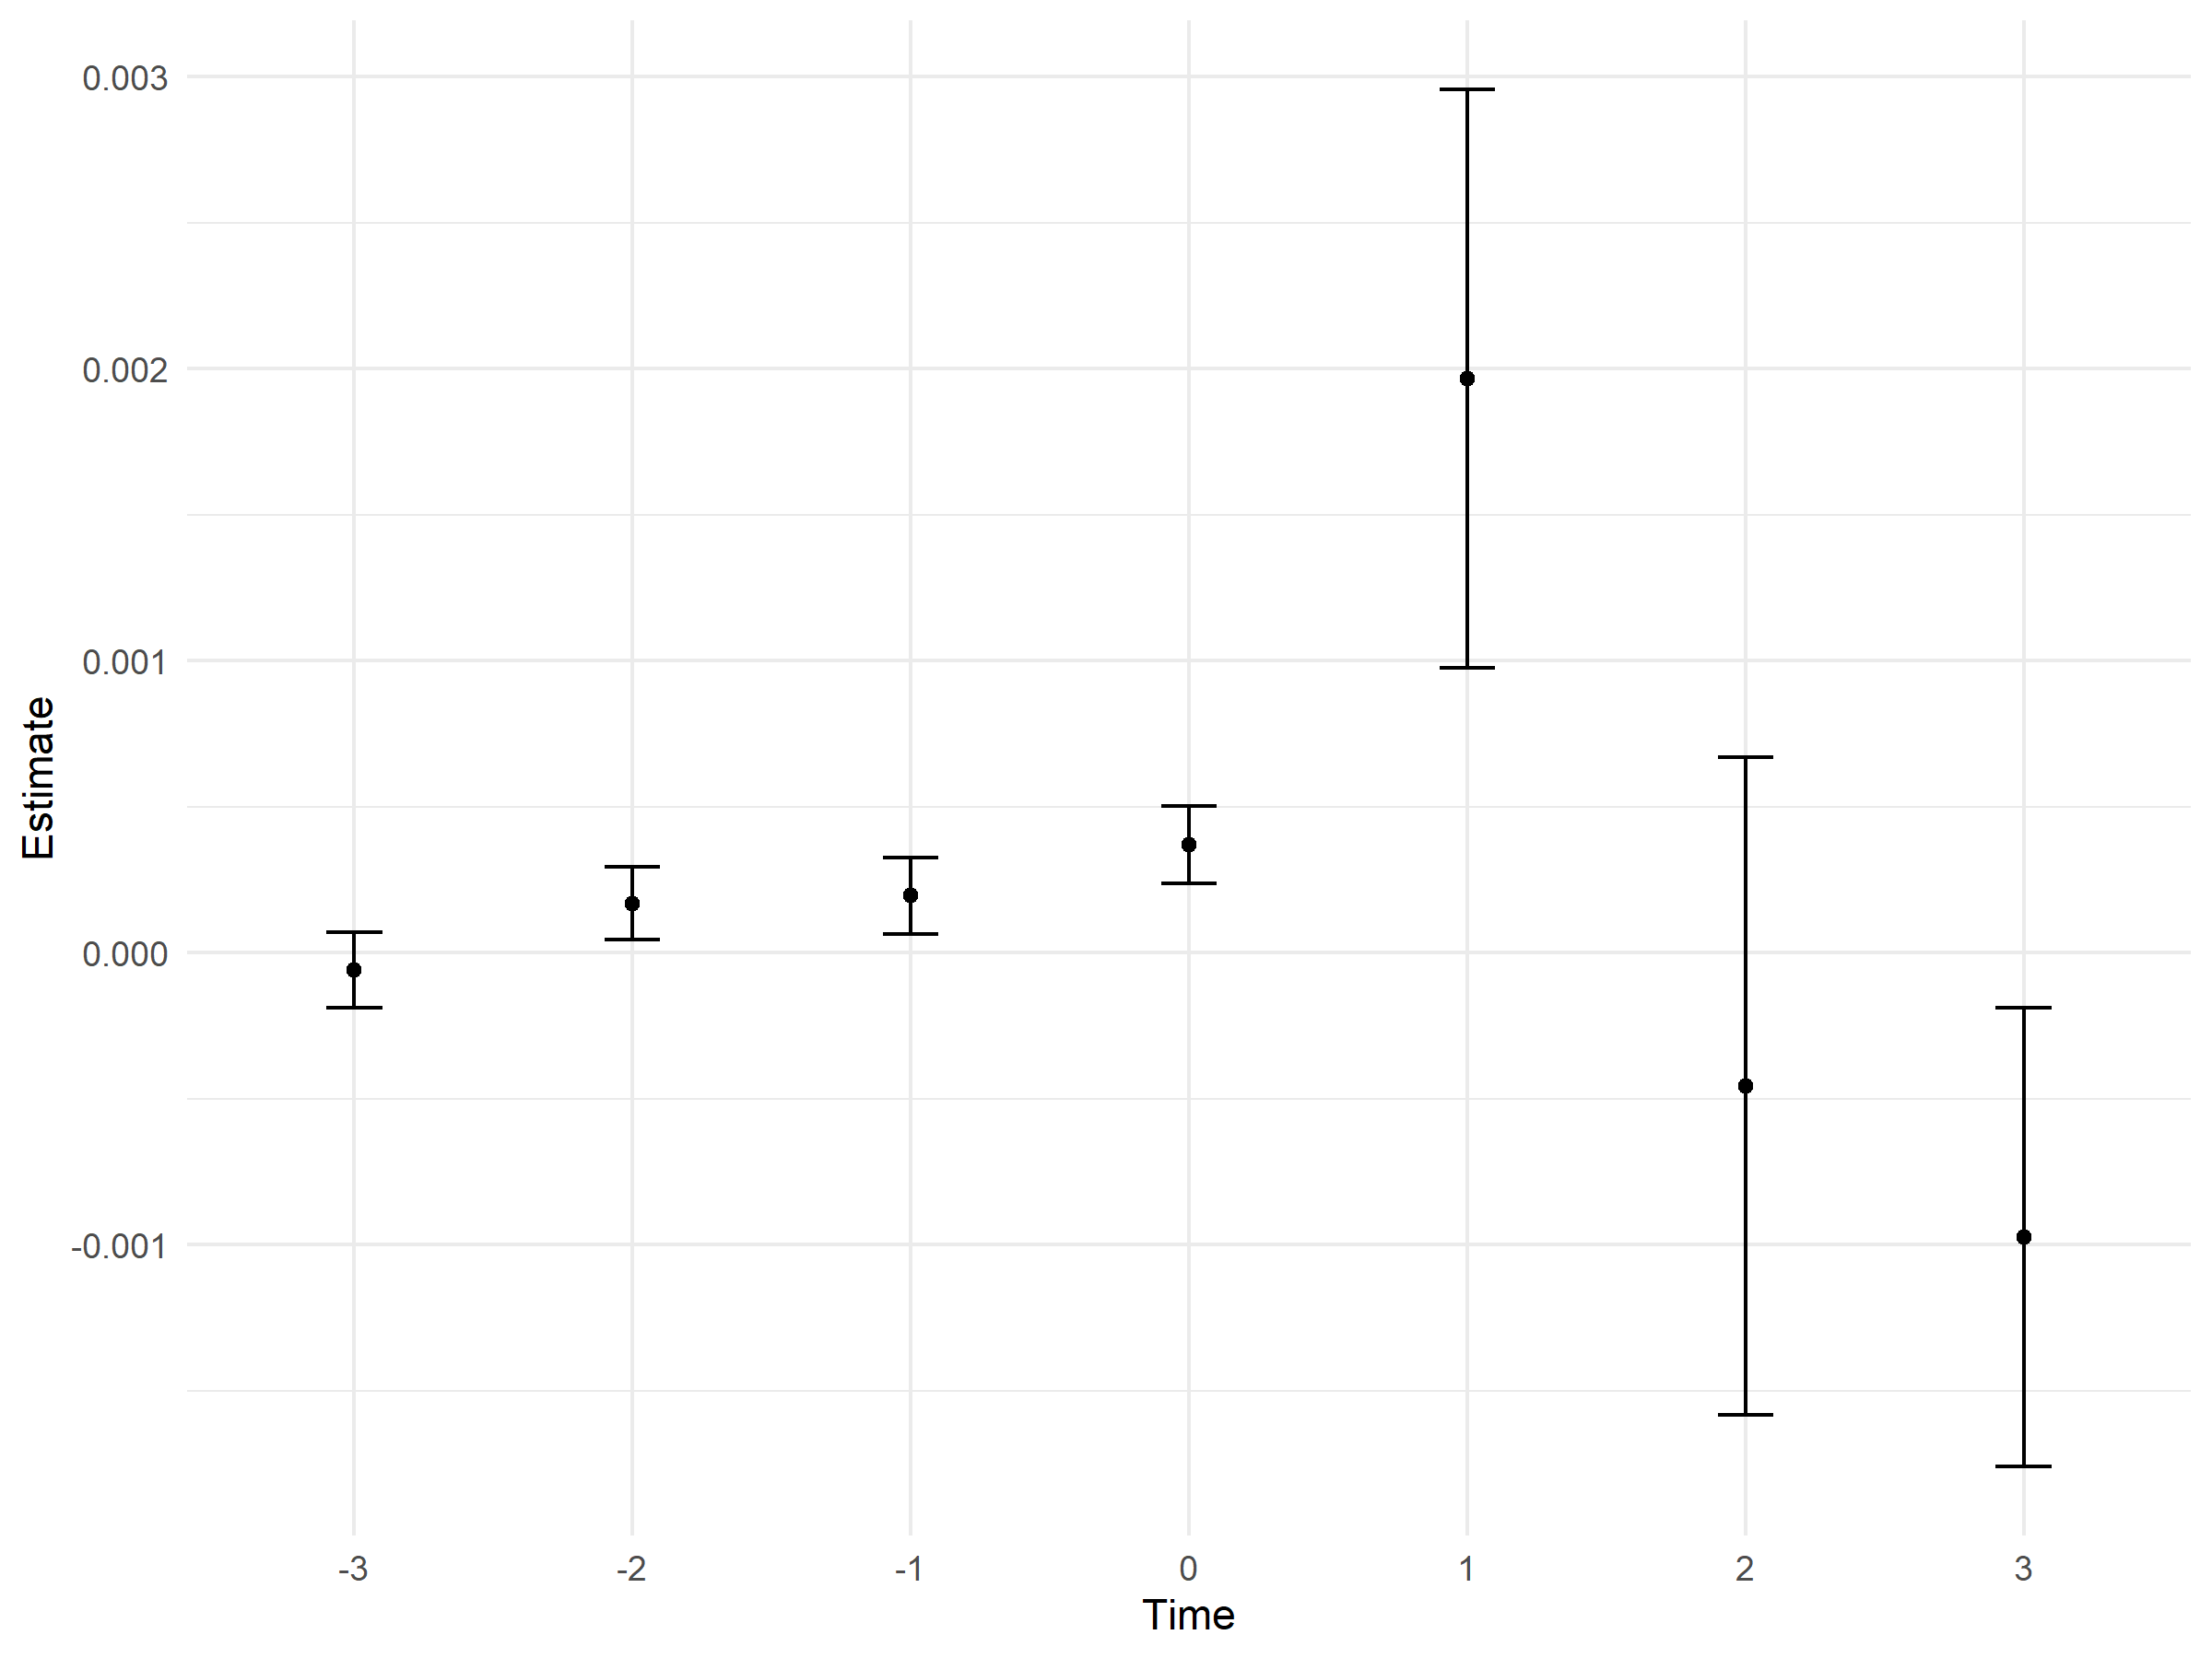

**Figure 2: Emigration response to change in minimum wage**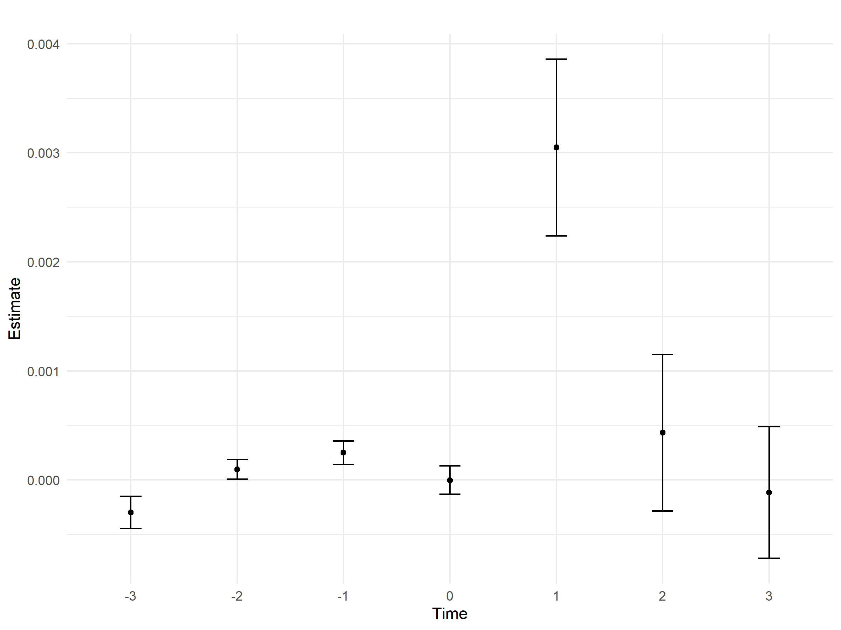

Before a change to the minimum wage occurs, we do not observe a significant change to migration. However, the year after raising the minimum wage there is a large increase in both in- and out-going migration to that country. During the 2 years following there is a decrease in migration, although smaller and not as statistically substantial.

**Table 1: Migration response to changes in minimum wage**

|  |  |  |  |  |  |  |
| --- | --- | --- | --- | --- | --- | --- |
| *Dependent variable:* | | | | | |  |
|  |  | | | | | |
|  | immigration (log) | | emigration (log) | | net (log) | |
|  | 1 | 2 | 3 | 4 | 5 | 6 |
|  | | | | | | |
| minimum wage (-3) | -0.0001 | -0.0001 | -0.001*** | -0.0003** | 0.001*** | 0.001** |
|  | -0.0002 | -0.0001 | -0.0002 | -0.0001 | -0.0002 | -0.0002 |
| minimum wage (-2) | 0.0002 | 0.0002 | 0.0001 | 0.0001 | 0.0001 | 0.0001 |
|  | -0.0002 | -0.0001 | -0.0002 | -0.0001 | -0.0002 | -0.0002 |
| minimum wage (-1) | 0.0004 | 0.0002 | 0.0004 | 0.0003** | 0.0003 | 0.0003 |
|  | -0.0003 | -0.0001 | -0.0003 | -0.0001 | -0.0002 | -0.0002 |
| minimum wage | 0.0003 | 0.0004*** | 0.00004 | 0 | 0.0003 | 0.0003* |
|  | -0.0004 | -0.0001 | -0.0004 | -0.0001 | -0.0003 | -0.0002 |
| minimum wage (+1) | 0.001* | 0.002** | 0.002*** | 0.003*** | -0.001 | -0.002 |
|  | -0.001 | -0.001 | -0.001 | -0.001 | -0.001 | -0.002 |
| minimum wage (+2) | -0.0001 | -0.0005 | 0.001 | 0.0004 | -0.0004 | -0.0003 |
|  | -0.001 | -0.001 | -0.001 | -0.001 | -0.001 | -0.002 |
| minimum wage (+3) | -0.001 | -0.001 | -0.001*** | -0.0001 | 0.001*** | -0.002* |
|  | -0.001 | -0.001 | -0.0004 | -0.001 | -0.0004 | -0.001 |
| Constant | 11.981*** | 9.737*** | 11.624*** | 15.697*** | 11.025*** | -0.869 |
|  | -0.222 | -1.127 | -0.2 | -1.38 | -0.316 | -3.139 |
|  | | | | | | |
| Country | Yes | Yes | Yes | Yes | Yes | Yes |
| Time | Yes | Yes | Yes | Yes | Yes | Yes |
| GDP | No | Yes | No | Yes | No | Yes |
| Migrant Stock | No | Yes | No | Yes | No | Yes |
| EU Member | No | Yes | No | Yes | No | Yes |
| Schengen Member | No | Yes | No | Yes | No | Yes |
| Observations | 494 | 381 | 486 | 378 | 361 | 267 |
|  | | | | | | |
| *Note:* | *p<0.1; **p<0.05; ***p<0.01 | | | | | |

Our results show that whether we add the aforementioned controls or not, we get a highly significant positive effect of raising the minimum wage over both immigration and emigration. This phenomenon occurs in the year after raising the minimum wage and subsides afterwards. Using the approximation of for small enough values of we can deduce that a 1% increase in minimum wages results in an increase of 0.2% in immigration and 0.3% in emigration the following year (after controls). The results are similar when dividing the data by gender.

While the effect seems to be slightly stronger for emigration, the two are in similar proportions. When observing net migration, the effect is not significant. This suggests that raising the minimum wage has twin effects - some workers lose their jobs and look for new opportunities somewhere else, while others see the higher minimum wage as an opportunity to increase their wage and immigrate into the country. In total the effect on migration appears to be either neutral or slightly negative, but it is caused by increased flows in both directions. This result is new, and was not observed in previous articles.

Boffy-Ramirez (2013) finds that a 1$ increase in the MW in the US can result in an 11-26% increase in net migration. Taking the federal MW in the US since 2014 which is 7.25$, this means an increase of 1% in the minimum wage will result in approximately 0.85-2% increase in migration. Giulietti (2014) approximates the effect of a 1% raise in the minimum wage on immigration to be ~0.3% on low-skilled migrants. However, he only looks at immigration and not emigration.  
Since our results contain both high- and low-skilled migrants, we expect the effect on low-skilled migrants to be stronger. This puts our estimation somewhere between those of Guilietti and Boffy-Ramirez. Even though we see strong changes in migration flows, based on our data we can’t conclude how the composition of migrant population changes and we believe this question should be researched further.

In Monras’ paper he suggested that when discussing the effect of minimum wages on labour markets, one should consider the impact on the movement of populations along with unemployment. Our analysis suggests that this net effect is neutral. Therefore, the conclusions from existing research regarding unemployment still stand.

### 7.2 Median Wage Effect on Migration

An immediate assumption one could make regarding the effect of minimum wage over migration is that it affects it directly through its effect on the median wage or some other wage statistic. We show that is not the case. We run a similar regression with the median wages as the main independent variable instead of MW to small and non-significant results.

**Table 2 – Effect of median wages on migration**

|  |  |  |  |
| --- | --- | --- | --- |
|  | | | |
|  | *Dependent variable:* | | |
|  |  | | |
|  | immigration (log) | emigration (log) | net (log) |
|  | (1) | (2) | (3) |
|  | | | |
| median wage (-3) | -0.0002 | -0.001*** | 0.001 |
|  | (0.0002) | (0.0002) | (0.0004) |
| median wage (-2) | 0.0004* | 0.0002 | 0.001* |
|  | (0.0002) | (0.0003) | (0.001) |
| median wage (-1) | -0.00004 | 0.00001 | -0.001 |
|  | (0.0002) | (0.0003) | (0.001) |
| median wage | 0.0002 | 0.0001 | -0.00002 |
|  | (0.0002) | (0.0002) | (0.001) |
| median wage (+1) | -0.00001 | 0.0002 | -0.0004 |
|  | (0.0002) | (0.0002) | (0.001) |
| median wage (+2) | -0.0002 | -0.0003 | 0.0001 |
|  | (0.0002) | (0.0002) | (0.0005) |
| median wage (+3) | 0.0001 | 0.0001 | 0.0001 |
|  | (0.0001) | (0.0001) | (0.0003) |
| Constant | 8.464*** | 15.778*** | -1.522 |
|  | (1.428) | (1.541) | (4.442) |
|  | | | |
| Country | Yes | Yes | Yes |
| Time | Yes | Yes | Yes |
| GDP | Yes | Yes | Yes |
| Migrant Stock | Yes | Yes | Yes |
| EU Member | Yes | Yes | Yes |
| Schengen Member | Yes | Yes | Yes |
|  | | | |
| Observations | 301 | 299 | 208 |
|  | | | |
| *Note:* | *p<0.1; **p<0.05; ***p<0.01 | | |

Unlike MW policy, which can be assumed to be exogenous to migration trends, this is not the case for median or first-decile wages. Rising wages cause a rise in expected wages, which in turn cause a rise in immigration. The increased immigration increases labour supply and decreases wages. This process will positively bias our results, meaning the effect of median wage still impacts migration significantly less than minimum wages. Appendix B shows similar results for first decile wages.

The results showing the negligible effect of median and decile wages on migration suggest interesting conclusions. One is that when migrants estimate their expected wages, they give higher weight to the MW than the median wage. This might be because migrants tend to be low-skilled or because of their lower bargaining power. Another possibility is that minimum wages serve as an estimation for migrants due to limited access to more precise data. In our research we don’t delve into the method migrants estimate their expected wages, but it might be an interesting question to pursue.

## Conclusions

To summarize:  
We study whether minimum wage changes influence migration flows between European countries. We found that minimum wage has a positive effect on both emigration and immigration that is most prominent a year after the change.

At first glance, it seems our results match with Boffy-Ramirez (2013) & Giulietti (2014) papers – minimum wage has a positive effect on immigration. However, a deeper look reveals another thing. According to Monras’ work (2022), the change in population is due to migration. That must mean there is an increase in emigration, as we observe as well. Both emigration and immigration are positively affected, but emigration has a slightly larger result. Simple subtraction will result with net negative migration, but according to our results, it is not statistically significant.  
Additionally, we show that minimum wage serves a bigger factor in migration decisions than median or first-decile wages.

There are two main conclusions deduced from these results. The first comes from the fact that the effect is positive for both directions of migration, which means changes to minimum wage cause some people to leave the country and others to move in. This might be attributed to heterogeneity among migrant populations, such as different wage expectations or utility functions. The second suggests that minimum wages serve as a b

Monras’ (2022) suggests that when examining the effect of minimum wage policies, one should consider the effect on the size of the population itself, not just unemployment. He proposed that unemployment might seem to not be affected because of omitted migration variables. Our research shows that the total effect on the size of the population is small and insignificant and suggests that previous conclusions regarding MW policy still hold.

There are many ways to enrich this paper.  
The first thing that comes to mind is enlarging the data set. We were limited to data from Eurostat, which is partial. Filling those holes and looking further back in history might provide us with more robust results. Another way to expand the data set is by using more recent years. As we stated in the paper, we used data before 2015 to avoid the great migration triggered by the Arab spring. It would be interesting to examine how this event changed the internal migration patterns of Europeans. Additionally, we can fill some of the holes in the minimum wage data by looking at effective MW set by collective bargaining agreements.  
It is also possible to expand our research by adding a division of the data set by income. The assumption is that people with different wages respond differently to minimum wage changes. This method might enable us to identify stronger effects on low-skilled migrants.  
Another avenue would be to delve deeper into the methods in which migrants estimate their expected wages, as discussed in section 7.2.

## References

* Allegretto, S.A., Dube, A. and Reich, M. (2011). Do Minimum Wages Really Reduce Teen Employment? Accounting for Heterogeneity and Selectivity in State Panel Data. Industrial Relations: A Journal of Economy and Society, 50: 205-240. <https://doi.org/10.1111/j.1468-232X.2011.00634.x>
* Angrist, J., Jörn-Steffen P. (2013). Mostly harmless econometrics: An empiricists companion. United States: Content Technologies Inc, 2013.
* Boffy-Ramirez, E. Minimum wages, earnings, and migration. IZA J Migration 2, 17 (2013). <https://doi.org/10.1186/2193-9039-2-17>
* Card, D. and Cardoso, A.R. (2022). Wage flexibility under sectoral bargaining. Journal of the European Economic Association, 20(5), pp.2013-2061. <https://doi.org/10.3386/w28695>
* Dube, A. (1998). Do minimum wages reduce employment? A case study of California, 1987-89. Industrial Relations Section, Princeton University. <https://www.nber.org/papers/w3710>
* Dube, A., Naidu, S., and Reich, M. (2007). The Economic Effects of a Citywide Minimum Wage. ILR Review, 60(4), 522-543. <https://doi.org/10.1177/001979390706000404>
* Edo, A. and Rapoport, H. (2019). Minimum wages and the labor market effects of immigration. Labour Economics, 61 <https://doi.org/10.1016/j.labeco.2019.101753>
* Giulietti, C. (2014). Is the minimum wage a pull factor for immigrants?. ILR Review, 67(3_suppl), pp.649-674. <https://doi.org/10.1177/00197939140670S308>
* Jennissen, R. (2003). Economic Determinants of Net International Migration in Western Europe. European Journal of Population / Revue Européenne de Démographie 19, no. 2: 171–98. <http://www.jstor.org/stable/20164223>
* Ma, S., Li, X. and Wu, X. (2024). Minimum wage and internal labor migration: Evidence from China. Journal of Economic Behavior & Organization, 226 <https://doi.org/10.1016/j.jebo.2024.106695>
* Minton, R. and Wheaton, B. (2022). Minimum Wages and Internal Migration1 (Vol. 20, pp. 45-46). Harvard Working Paper Series. <https://scholar.harvard.edu/sites/scholar.harvard.edu/files/robertminton/files/mw_and_migration_3.pdf>
* Monras, J. (2019). Minimum wages and spatial equilibrium: Theory and evidence. Journal of Labor Economics, 37(3), pp.853-904. <https://www.journals.uchicago.edu/doi/abs/10.1086/702650>
* Ortega, F., and Giovanni, P. (2013). The Effect of Income and Immigration Policies on International Migration. Migration Studies 1, no. 1 (January 25, 2013): 47–74. <https://doi.org/10.1093/migration/mns004>

## Appendix

### Appendix A – Results Divided by Gender

**Table A.1 - Migration response to changes in minimum wage (Male)**

|  |  |  |  |  |  |  |  |  |  |
| --- | --- | --- | --- | --- | --- | --- | --- | --- | --- |
|  | | | | | *Dependent variable:* | | | | |
|  | | | | |  | | | | |
|  | | log(imm) | | | log(em) | | | log(net) | |
|  | (1) | | (2) | (3) | | (4) | (5) | | (6) |
|  | | | | | | | | | |
| wg_lead3 | -0.0001 | | -0.0001 | -0.001*** | | -0.0003* | 0.001*** | | 0.001* |
|  | (0.0002) | | (0.0001) | (0.0002) | | (0.0002) | (0.0002) | | (0.0003) |
| wg_lead2 | 0.0002 | | 0.0002 | 0.0001 | | 0.0001 | 0.0003 | | 0.0003 |
|  | (0.0002) | | (0.0001) | (0.0001) | | (0.0001) | (0.0002) | | (0.0003) |
| wg_lead1 | 0.0004 | | 0.0002 | 0.0004 | | 0.0002** | 0.0001 | | 0.0002 |
|  | (0.0003) | | (0.0001) | (0.0003) | | (0.0001) | (0.0002) | | (0.0002) |
| wg | 0.0003 | | 0.0004*** | 0.00005 | | 0.00000 | 0.0003 | | 0.0004 |
|  | (0.0004) | | (0.0001) | (0.0004) | | (0.0001) | (0.0003) | | (0.0002) |
| wg_lag1 | 0.001* | | 0.002** | 0.002*** | | 0.003*** | -0.001 | | -0.003* |
|  | (0.001) | | (0.001) | (0.001) | | (0.001) | (0.001) | | (0.001) |
| wg_lag2 | -0.0001 | | -0.001 | 0.0005 | | 0.0003 | 0.00000 | | 0.0004 |
|  | (0.001) | | (0.001) | (0.001) | | (0.001) | (0.001) | | (0.002) |
| wg_lag3 | -0.001 | | -0.001 | -0.001*** | | -0.0001 | 0.001** | | -0.003* |
|  | (0.001) | | (0.001) | (0.0005) | | (0.001) | (0.0004) | | (0.002) |
| Constant | 10.662*** | | 7.779*** | 10.397*** | | 13.855*** | 9.534*** | | -7.278*** |
|  | (0.236) | | (1.220) | (0.210) | | (1.452) | (0.326) | | (2.789) |
|  | | | | | | | | | |
| Country | Yes | | Yes | Yes | | Yes | Yes | | Yes |
| Time | Yes | | Yes | Yes | | Yes | Yes | | Yes |
| GDP | No | | Yes | No | | Yes | No | | Yes |
| Migrant Stock | No | | Yes | No | | Yes | No | | Yes |
| EU Member | No | | Yes | No | | Yes | No | | Yes |
| Schengen Member | No | | Yes | No | | Yes | No | | Yes |
|  | | | | | | | | | |
| Observations | 483 | | 373 | 471 | | 370 | 338 | | 257 |
| *Note:* | | | | | *p<0.1; **p<0.05; ***p<0.01 | | | | |

**Table A.2 - Migration response to changes in minimum wage (Female)**

|  |  |  |  |  |  |  |
| --- | --- | --- | --- | --- | --- | --- |
|  | | | | | | |
|  | *Dependent variable:* | | | | | |
|  |  | | | | | |
|  | log(imm) | | log(em) | | log(net) | |
|  | (1) | (2) | (3) | (4) | (5) | (6) |
|  | | | | | | |
| wg_lead3 | -0.0001 | -0.0001 | -0.001*** | -0.0003** | 0.001*** | 0.0002 |
|  | (0.0001) | (0.0001) | (0.0002) | (0.0001) | (0.0002) | (0.0002) |
| wg_lead2 | 0.0002 | 0.0002 | 0.0001 | 0.0001 | 0.0001 | 0.0001 |
|  | (0.0002) | (0.0001) | (0.0002) | (0.0001) | (0.0001) | (0.0002) |
| wg_lead1 | 0.0003 | 0.0002 | 0.0003 | 0.0003** | 0.0002 | 0.0001 |
|  | (0.0003) | (0.0001) | (0.0003) | (0.0001) | (0.0002) | (0.0002) |
| wg | 0.0002 | 0.0003** | 0.00003 | -0.00001 | 0.001* | 0.001*** |
|  | (0.0004) | (0.0001) | (0.0004) | (0.0001) | (0.0003) | (0.0002) |
| wg_lag1 | 0.001* | 0.002** | 0.002*** | 0.003*** | -0.001 | -0.001 |
|  | (0.001) | (0.001) | (0.001) | (0.001) | (0.001) | (0.002) |
| wg_lag2 | -0.0002 | -0.0005 | 0.001 | 0.0005 | -0.001 | -0.001 |
|  | (0.001) | (0.001) | (0.001) | (0.001) | (0.001) | (0.002) |
| wg_lag3 | -0.001 | -0.001 | -0.001*** | -0.0003 | 0.001*** | -0.002 |
|  | (0.0005) | (0.001) | (0.0004) | (0.001) | (0.0004) | (0.002) |
| Constant | 10.498*** | 7.571*** | 10.073*** | 13.717*** | 9.702*** | -0.057 |
|  | (0.223) | (1.165) | (0.195) | (1.420) | (0.306) | (2.312) |
|  | | | | | | |
| Country | Yes | Yes | Yes | Yes | Yes | Yes |
| Time | Yes | Yes | Yes | Yes | Yes | Yes |
| GDP | No | Yes | No | Yes | No | Yes |
| Migrant Stock | No | Yes | No | Yes | No | Yes |
| EU Member | No | Yes | No | Yes | No | Yes |
| Schengen Member | No | Yes | No | Yes | No | Yes |
|  | | | | | | |
| Observations | 483 | 373 | 471 | 370 | 345 | 260 |
|  | | | | | | |
| *Note:* | *p<0.1; **p<0.05; ***p<0.01 | | | | | |

### Appendix B – Effect of First Decile Wage on Migration

|  |  |  |  |
| --- | --- | --- | --- |
|  | | | |
|  | *Dependent variable:* | | |
|  |  | | |
|  | log(imm) | log(em) | log(net) |
|  | (1) | (2) | (3) |
|  | | | |
| income_lead3 | -0.0001 | -0.0003** | 0.0002 |
|  | (0.0001) | (0.0001) | (0.0003) |
| income_lead2 | 0.0003** | -0.0001 | 0.001** |
|  | (0.0001) | (0.0001) | (0.0003) |
| income_lead1 | -0.00001 | -0.00002 | 0.00003 |
|  | (0.0001) | (0.0001) | (0.0003) |
| income | 0.0002** | 0.0001 | -0.0001 |
|  | (0.0001) | (0.0001) | (0.0003) |
| income_lag1 | -0.0001 | 0.0001 | -0.001 |
|  | (0.0001) | (0.0001) | (0.0003) |
| income_lag2 | -0.00000 | 0.00001 | -0.0001 |
|  | (0.0001) | (0.0001) | (0.0003) |
| income_lag3 | 0.0001 | 0.0002 | -0.0004* |
|  | (0.0001) | (0.0001) | (0.0002) |
| Constant | 7.658*** | 12.895*** | 7.811* |
|  | (1.429) | (1.491) | (4.613) |
|  | | | |
| Country | Yes | Yes | Yes |
| Time | Yes | Yes | Yes |
| GDP | Yes | Yes | Yes |
| Migrant Stock | Yes | Yes | Yes |
| EU Member | Yes | Yes | Yes |
| Schengen Member | Yes | Yes | Yes |
|  | | | |
| Observations | 301 | 299 | 208 |
|  | | | |
| *Note:* | *p<0.1; **p<0.05; ***p<0.01 | | |

### Code

All code and data used in the article can be accessed at <https://github.com/DShelef/economics-of-migration>