Sensor based Smart Dustbin for status alert and dry/wet waste segregation
Dhruvil Sheth¹
Margi Panjvani²

With the increase in urbanization, the levels of waste generated has increased drastically. This poses a serious threat and requires an effective solution. Government has started various movements for cleanliness of the society. But an effective waste management system is required. Proper and timely collection of wastes and its disposal is not there in our country which causes overflow of dustbins and poses serious health threats to humans. This dustbin will notify when the bin is above a certain threshold and sends an alert when it is full. It will also segregate dry and wet waste using automated sensors. It will help to monitor the garbage using IoT and Embedded System Technology. There is no such system for segregation of wastes at urban level at present.

- Introduction

As government is making it compulsory to segregate the waste from the source itself this product is efficient to do so. Smart dustbin provides an easy and cost effective system for proper management of waste.

  - Overview of Project

This dustbin is provided with various sensors to automate the tasks which is to be done manually by the garbage collectors. Thus, it is time efficient. This dustbin involves only one time cost of deployment.

  - Our Contribution

We have studied various sensors which will help in automating several tasks. We have also estimated the cost of 1 unit by considering all the basic requirements. Next, we have generated a database which is going to help for further study related to type of wastes, their weights in particular areas.

2. Related Work

We have started implementing the project on ground basis by studying various features of Raspberry Pi and conducted some mini projects with it to analyse its study.

3. Proposed Approach

In many places, trucks are not available to collect waste while in some it goes empty. Bad odour is also a major problem along with unhygienic environment. The proposed system will talk about recent advancements to solve this problem in an efficient and cost effective manner.
The implementation starts with setting up of Raspberry Pi and connecting it with VNC for remote monitoring. We will be using VNC Viewer App for real time remote monitoring of the status of all the sensors.

3.1. Introduction

The purposes of the various sensors and devices are as followed:
Ultrasonic Sensor: To detect the incoming waste so that the lid opens automatically if the bin is not full, otherwise, displays message of bin full.
Moisture Sensor: To segregate the wastes into dry and wet category.
IR Sensor: Detection of the presence of waste and to check how much bin is filled.
Weight Sensor: To measure the weight of the waste generated.
Motor: Chemical sprinkler (preferably baking soda) to avoid bad smell.
Servo Motor: To open the lid of the dustbin.

  - . Block Diagram of Project
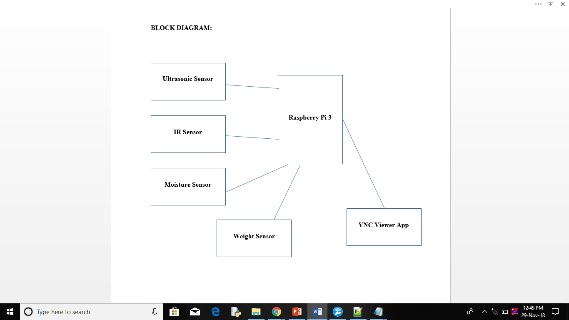

3.3. Schema

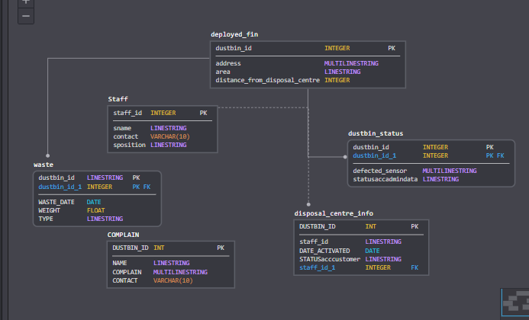

4. Experimental Setup

Three bins are placed in circular fashion with 120 degrees spacing between them. Based on the waste detected microcontroller activates stepper motor and the program is written for the stepper to rotate in clockwise and anticlockwise direction to select a particular bin.

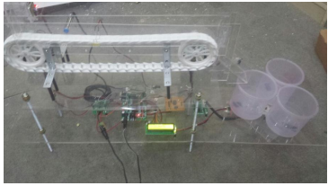

4.1. Screenshots of Android App or Website
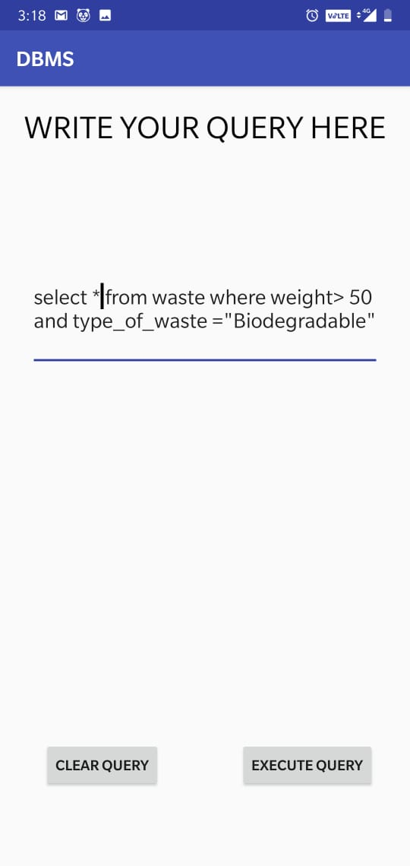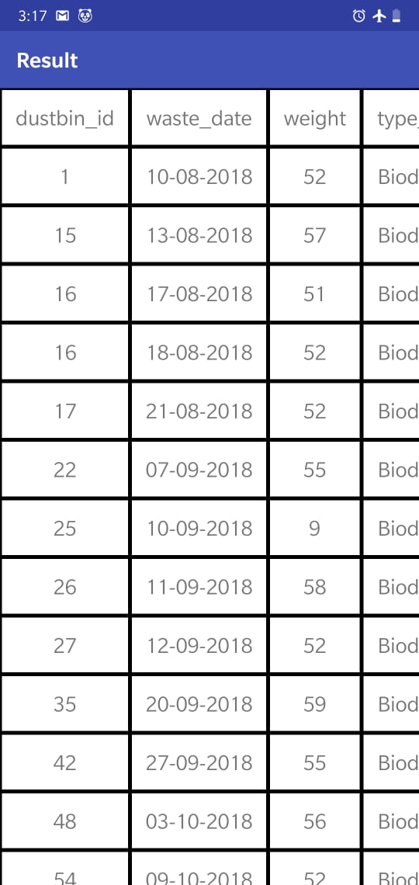

4.2. Results and Analysis

We have herewith attached two SQL queries along with their output which have been generated from a dummy database.
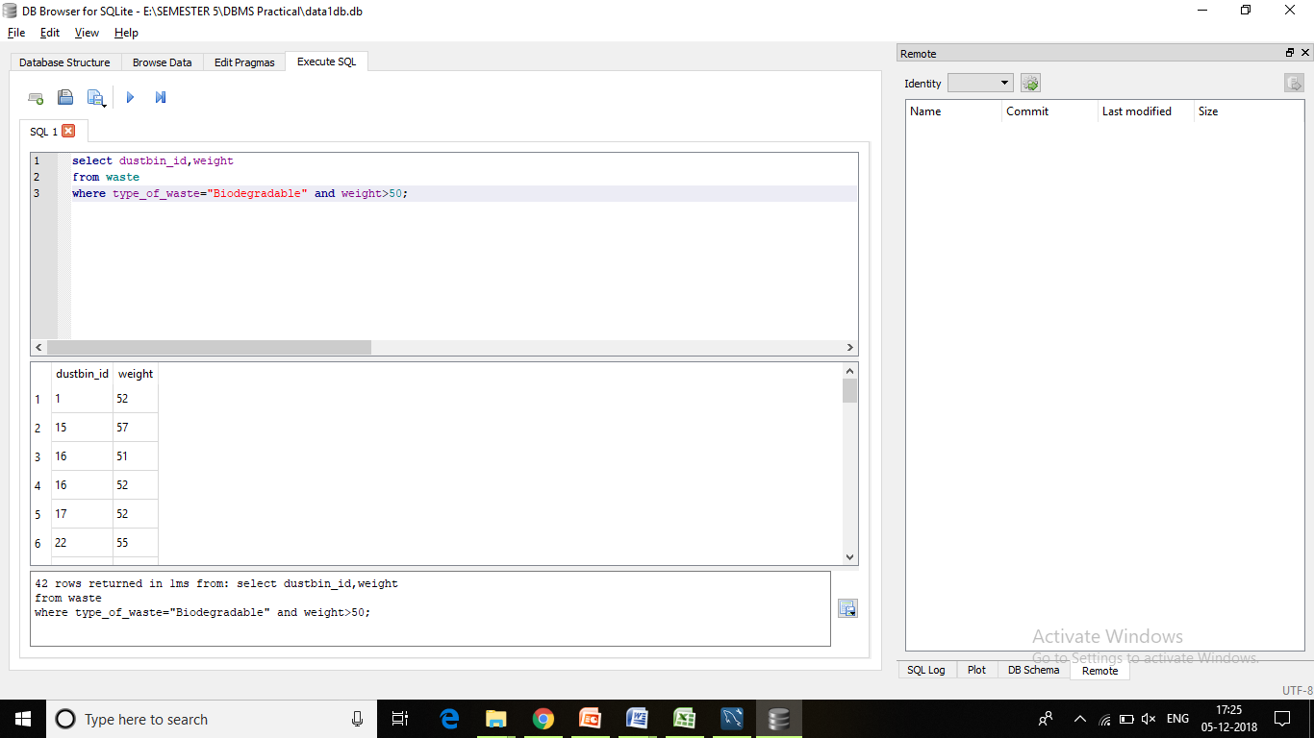
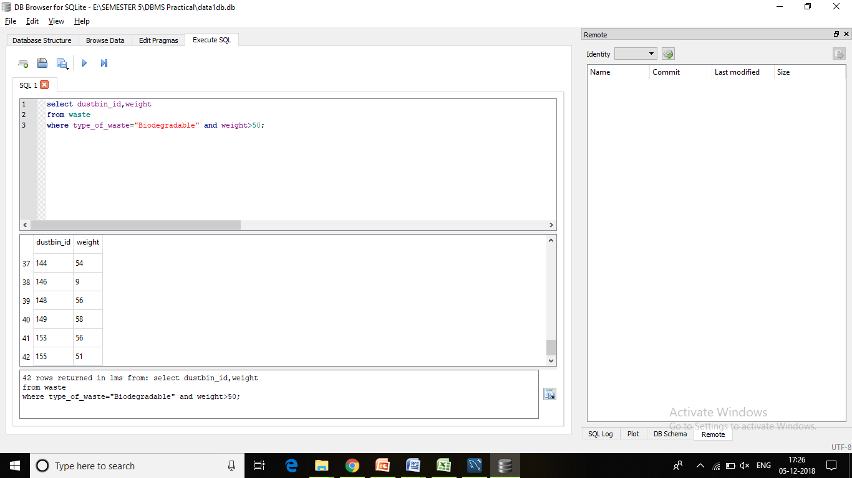

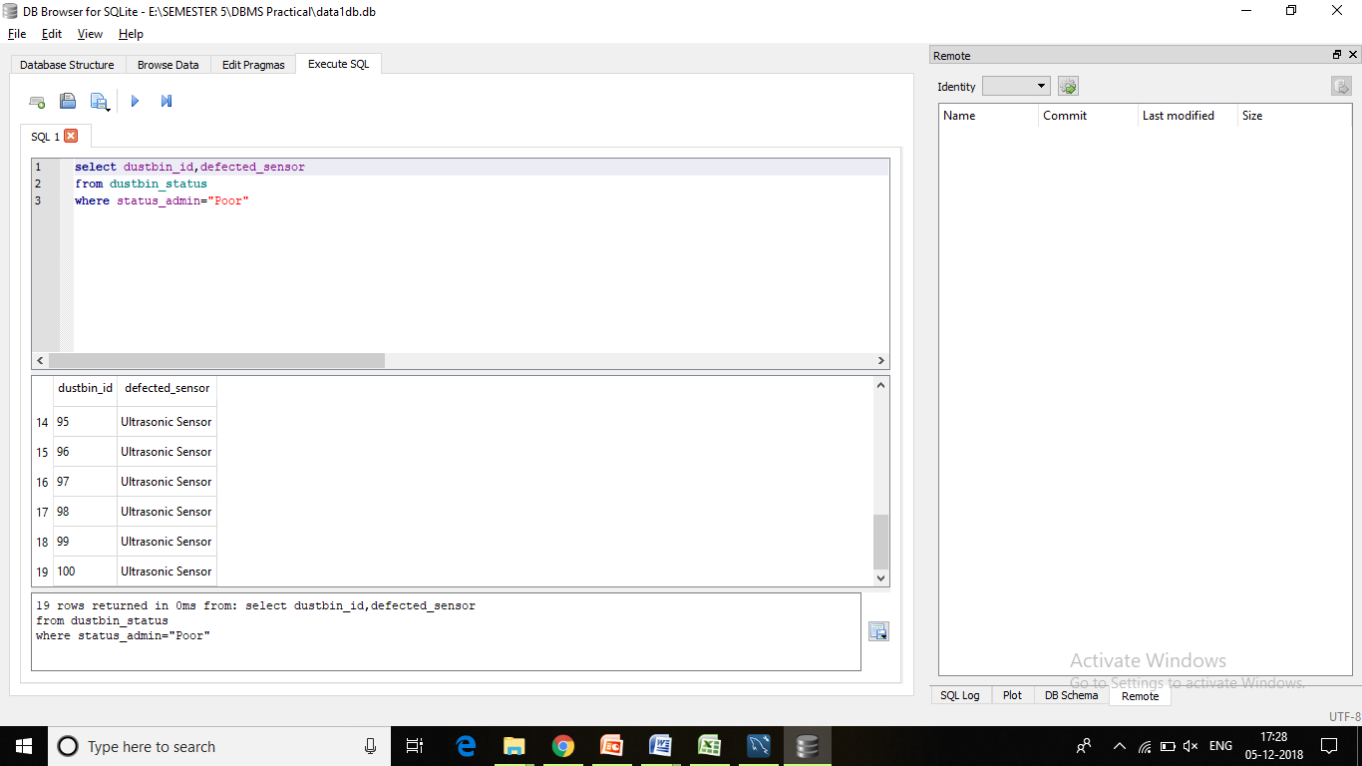

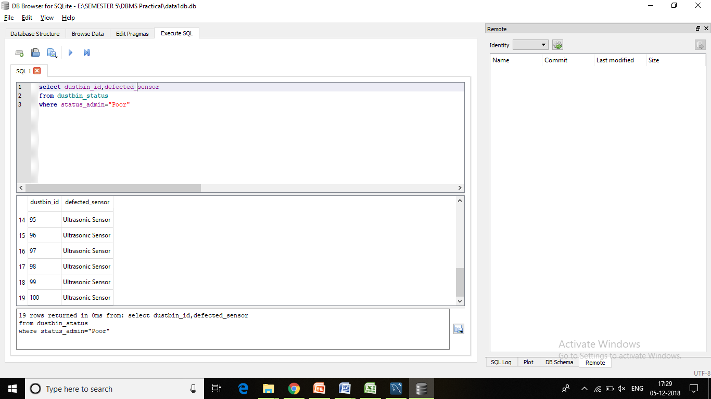

5. Conclusion and Future Work

Smart dustbin can segregate only three types of wastes. In future improvement can be done to segregate more number of wastes like plastic, glass, toxic waste, separation of different metals. This can be improved to segregate mix waste dumped at a time using different high accurate sensors and other technologies and segregation of mix waste can also be achieved by using a servo motor to give jerks to conveyor belt so that mix waste gets separated. Size of smart dustbin can be made compact using different technologies and different methodologies. Some additional feature can be added like generating power or biogas generation at root source itself.

6. References

http://www.arresearchpublication.com/images/shortpdf/1490730837_GS403ijeee.pdf
https://www.ijltemas.in/DigitalLibrary/Vol.7Issue4/171-173.pdf
http://www.kscst.iisc.ernet.in/spp/40_series/SPP40S/01_Seminar%20Projects/088_40S_BE_0621.pdf

