SQA Workflow — Design to Sign-off
Oct 10, 2026 · @Spriha
QA is involved from the moment a design is approved until the final sign-off note, so defects are prevented early rather than found late. This document describes the standard SQA workflow in an Agile SDLC, how each stage runs with and without AI, and how to handle exception cases.

Purpose, scope and roles
Scope: every feature from approved design and acceptance criteria (AC) to QA sign-off. Tool names in this document are examples only; any equivalent tool works.
Role | Responsibility
Project Manager (PM) | Tracks project timelines and sprint progress; creates tickets ahead of sprint planning
Product Owner (PO) | Owns the ticket description and AC; approves design; decides scope and priority
Designer | Owns the UI design; answers design questions
Business Analyst (BA) | Clarifies business rules and edge cases
Developer | Builds and deploys; shares the environment URL and test data; updates ticket status
QA Engineer | Reviews design and AC; writes and runs tests; logs bugs and retests; verifies deployments; writes the sign-off note
QA Lead | Reviews test coverage; approves the sign-off note
Typical tools (examples): a design tool (e.g. Figma), an issue tracker (e.g. JIRA), a test management tool (e.g. Zephyr), an API client (e.g. Postman), a CI/CD tool (e.g. Jenkins) and a wiki (e.g. Confluence).

Sprint cadence
The team works in Agile sprints: tickets are picked according to capacity, and code freezes one week before release so that week is spent on regression.
Event | When | QA's part
Ticket creation | Before sprint planning | PM creates tickets in advance so sprint time is not lost to setup
Backlog grooming | Before the sprint | Stages 1 and 2
Sprint planning | Start of sprint | Tickets picked by team capacity, including QA effort
Daily stand-up | Every day | Testing progress, blockers, open bugs
Mid-sprint check | Middle of sprint | Team and PM confirm all tickets can finish so the burndown chart stays on track; QA flags testing at risk
Code freeze and regression | Final week before release | Stage 7 on the release branch
Review and retrospective | End of sprint | Show tested work; raise process issues
Release | After sign-off | Stage 8 sign-off note required

Workflow at a glance
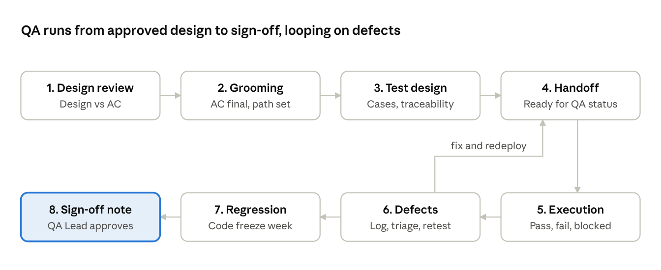
SQA workflow · 8 stages, 1 defect loop
Stages 1 to 3 happen before and during development; a failed retest loops back through handoff until the bug is fixed, and only then does the work move to regression and sign-off.

Workflow stages
Stage | What QA does | Done when
1. Design and AC review | Compares the approved design to the AC; lists missing states (empty, error, loading, permissions) and vague AC; prepares questions | Questions attached to the ticket
2. Backlog grooming | Raises questions; assesses risk and impact on existing flows; estimates QA effort; agrees the test environment (default QA environment, or Dev for high-risk changes) | AC final; estimate and environment agreed
3. Test design | Writes test cases (positive, negative, boundary, role-based) and API tests; links test cases to the ticket and maps them to AC; gets a peer review | Reviewed test cases linked to the ticket
4. Handoff | Developer deploys, comments the URL and test data, and sets the ticket to Ready for QA; QA verifies the correct branch is deployed (deploying it through CI/CD if not) and runs a smoke check | Build accepted by QA
5. Execution | Creates a test cycle; runs UI tests manually and API tests in the API client; checks audit trails and data accuracy; records Pass, Fail or Blocked with evidence | Every test case has a result; coverage is known
6. Bugs and retest | Logs each bug linked to its failed test case; sets severity; triages with Dev and PO; retests the fix and related cases | No open critical or high bugs; the rest deferred by the PO
7. Regression | During code freeze, runs a regression cycle on the release branch; only PO-approved fixes are merged; supports the PO's acceptance check | Regression passed; PO has accepted
8. Sign-off | Compiles results and writes the sign-off note | QA Lead approves; note linked to the ticket
Working rules
- A missing AC or new scope found during development or testing becomes a separate ticket, linked to the original and with its own test cases. Tickets in progress, in QA or Done are never changed.
- A missing AC found during testing is raised as a new ticket, not as a bug.
- Every test case is linked to its ticket, and every bug is linked to its failed test case.
- UI testing is manual; API testing is done in an API client.

QA sign-off note
QA issues the note once every exit criterion is met; the QA Lead approves it and the PO receives it as the record that the work is ready for release.
- ☐ All planned test cases executed, and every AC traced to at least one passed test case
- ☐ No open critical or high bugs; any others deferred by the PO and listed in the note
- ☐ Regression passed on the release branch
- ☐ PO acceptance received
Section | Contents
Feature and release | Ticket ID, feature name, sprint, release
Environment | Environment, build or branch, test dates
Scope | What was tested (modules, roles, browsers) and what was not, with reasons
Results | Test cases total, passed, failed, blocked; API test results
Bugs | Raised, closed and deferred, with IDs of deferred ones
Recommendation | Go, or Go with known issues (each listed with its risk)
Approvals | QA Engineer, QA Lead and PO, with dates

With and without AI
The stages, owners and exit criteria are the same in both processes; AI drafts and analyses, while QA makes every decision and every test verdict.
Stage | Without AI | With AI
1. Design and AC review | QA reads the ticket and design screen by screen | AI summarises the feature and flags AC with no matching screen or vague wording; QA confirms
2. Grooming | QA takes notes and estimates from experience | AI drafts meeting notes, revised AC and likely impacted areas; the team decides
3. Test design | QA writes every test case and API request by hand | AI drafts test cases, edge cases and API requests; QA reviews each one
4. Handoff | QA checks the handoff comment and deployment | Same; AI can flag a missing URL or test data
5. Execution | QA executes and records results | Execution stays manual; AI summarises progress and helps read failed API responses
6. Bugs and retest | QA writes bug reports and searches for duplicates | AI drafts bug reports and finds likely duplicates; QA checks every field
7. Regression | QA picks regression cases from experience | AI ranks regression cases by the areas changed; QA finalises the list
8. Sign-off | QA compiles the numbers and writes the note | AI drafts the note from tool data; QA verifies every number and owns the recommendation
Guardrails when using AI
- Never put real customer data, credentials or production data into an AI tool; use masked or synthetic data.
- Use only company-approved AI tools.
- QA reviews every AI draft before it is saved or shared.
- AI never marks a test as passed; only a human execution result counts.
- Audit trail and data-accuracy checks, and every number in the sign-off note, are verified by QA directly.

Exception scenarios
When the normal flow cannot be followed, the steps below apply instead; every scenario still ends with a sign-off note.
Scenario | How it is handled | QA's part
Urgent client requirement with no time for grooming | PO confirms the urgency; a short huddle (PO, Dev, QA) replaces full grooming; PM removes work of a similar size so the sprint stays balanced | Agree minimum AC in the huddle; write test cases while development runs; list untested areas as risks in the sign-off note
Issue reported by a client in production | A ticket is raised with severity; the fix goes on a hotfix branch and, if critical, is released outside the normal cycle | Reproduce the issue first; test the fix plus a targeted regression of the affected area; add a test case so future regression covers it; issue a short hotfix sign-off
Critical bug found during code freeze | PO decides whether to fix it now or defer it to the next release | If fixed: retest and rerun affected regression. If deferred: list it as a known issue
Ticket cannot finish within the sprint | Flagged at stand-up or the mid-sprint check; PM and PO split it or carry it over | Sign off only the tested part; untested scope moves with the carried-over ticket
Wrong branch deployed or environment down | QA redeploys the correct branch through CI/CD; an environment outage is escalated to Dev or DevOps | Mark affected test cases Blocked and flag them at stand-up
Incomplete handoff (no URL, test data or AC) | Ticket is returned to the developer or PO | Testing starts only once the gap is fixed
Release must go out with open bugs | PO accepts the risk in writing | Recommend Go with known issues, listing each open bug and any workaround

