Information for Rick

P2-16TA, AC Output Module, 16 Points. 0.5A per Output, 4.0 A per Common.

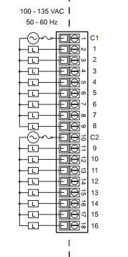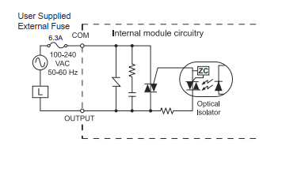

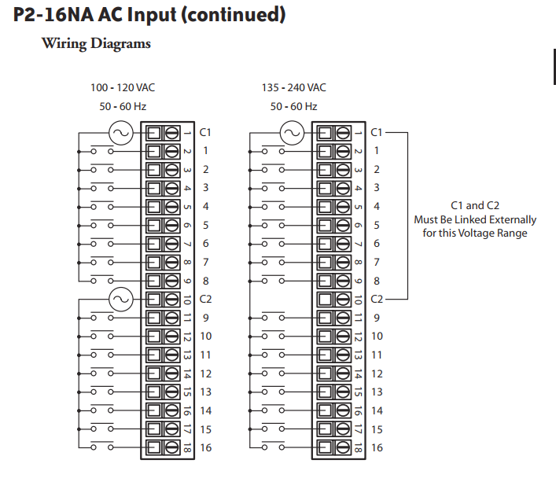

General Information:

Phase 1
Number of Motors: MCC1
VFD’s 27
Soft Starts 44
Total 71

VFD 1, 2, 4, 5 ,6, 8, 9, 10, 11, 12, 13, 14, 15, 16, 17, 18, 19, 20, 21, 22,
26, 27, 28, 29, 30, 31, 70 =27

Number of Motors: MCC2
VFD’s 6 Non Ethernet 83, 84, 85, 86, 87, 88
Soft Starts 11
Total 17

Phase 2
Number of Motors
VFD’s 9
Soft Starts 20
Total 29

Phase 3
Number of Motors
VFD’s 6
Soft Starts 12
Total 18

Modbus Addressing:

Coils
000001->000199 M01_Running -> M199_Running, VFD1->VFD200_Running
000201->000399 M01_TB -> M199_TB
000401->000599 M01_MOL > M199_MOL, VFD1->VFD200_FaultAlm
000601->000699 VFD01→VFD199_CommAlm
000801->000999 VFD01->VFD199_WarnAlm
001001->001099 Misc. Alarms
001101->001199 Misc. PB, LT & Inputs

Int
VFD01_SPEED to VFD199_SPEED 0→100% 400001- 400199

Motor & VFD Tags:

FVNR Starters & Soft Starts
Tag Modbus Address
MXX_Run (Run Motor)
MXX_Running (Motor is Running) 000001->000199
MXX_TB (Manual Mode Toggle Button) 000201->000399
MXX_MOL(Motor Overload Alarm) 000401->000599
MXX_Run_TOD (Run Motor On Delay Timer Done)

VFD’s
Tag Modbus Address
MXX_Faulted
MXX_Warning
MXX_RunningForward
MXX_RunningReverse
MXX_Ready
MXX_Running (Motor is Running + Off Delay) 000001->000199
MXX_TB (Manual Mode Toggle Button) 000201->000399
MXX_FaultAlm (VFD Fault Alarm) 000401->000599
MXX_ComAlm (VFD Communications Alarm) 000601->000799
MXX_WarnAlm (VFD Warning Alarm) 000801→000999
MXX_SPEED (Int, 0→100%) 400001- 400199
MXX_Run (Run Motor)
MXX_Run_TOD (Run Motor On Delay Timer Done)
MXX_VFDRunnng (Motor VFD Running )
MXX_Reset_TFD (Fault Reset Off Delay Timer Done)
MXX_Reset_FLSR (Fault Reset Flasher)
MXX_FltAlm_TOD (Fault Alarm On Delay Timer Done)

IP Addresses:
Device | IP Address | Device Type
Motor VFD | 192.168.110.(Motor # 1->199) | Eaton PowerXL DG1
Huller PLC #1 | 192.168.110.201 | Productivity 2000
Huller PLC #2 | 192.168.110.202 | Productivity 1000
Drier PLC #3 | 192.168.110.203 | Productivity 2000
Huller HMI #1 | 192.168.110.221 | Cmore EA9-T15CL
Huller Remote HMI #2 | 192.168.110.222 | Cmore EA9-T15CL
Drier HMI #3 | 192.168.110.223 | Cmore EA9-T15CL
Drier Remote HMI #4 | 192.168.110.224 | Cmore EA9-T15CL
Programming PC | 192.168.110.240 | IBM PC

Eaton PowerXL DG1 VFD

Ethernet/IP
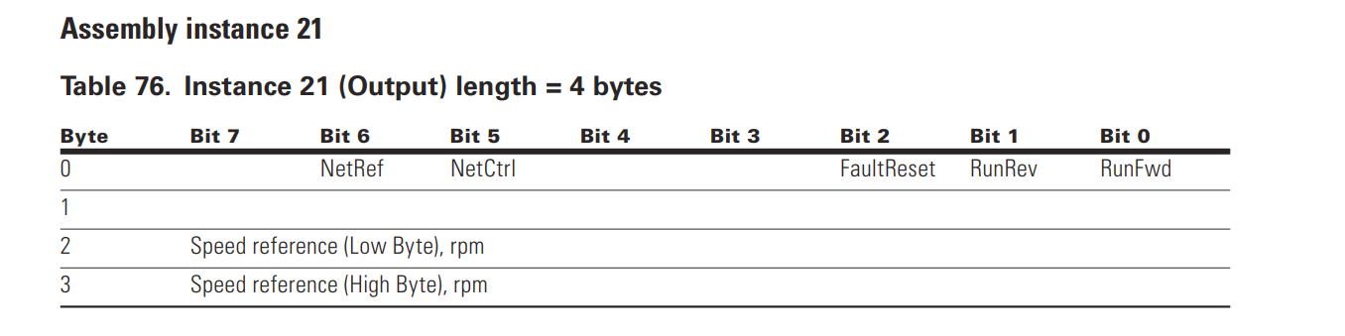

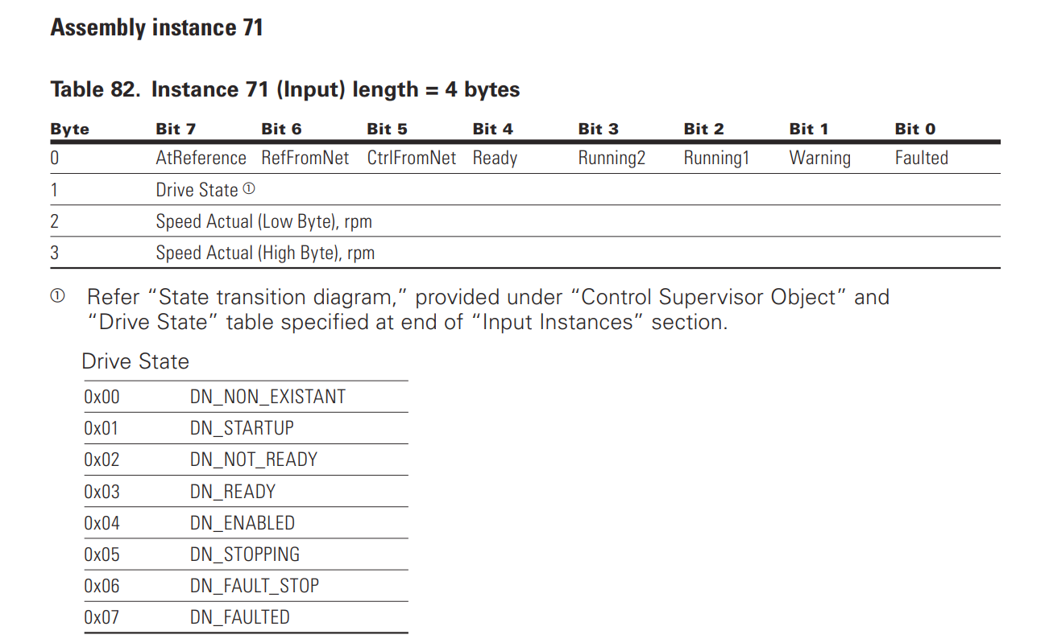

EDS File imported PowerXL DG1

