Main Screen. Utility Online & Not In Manual Mode.
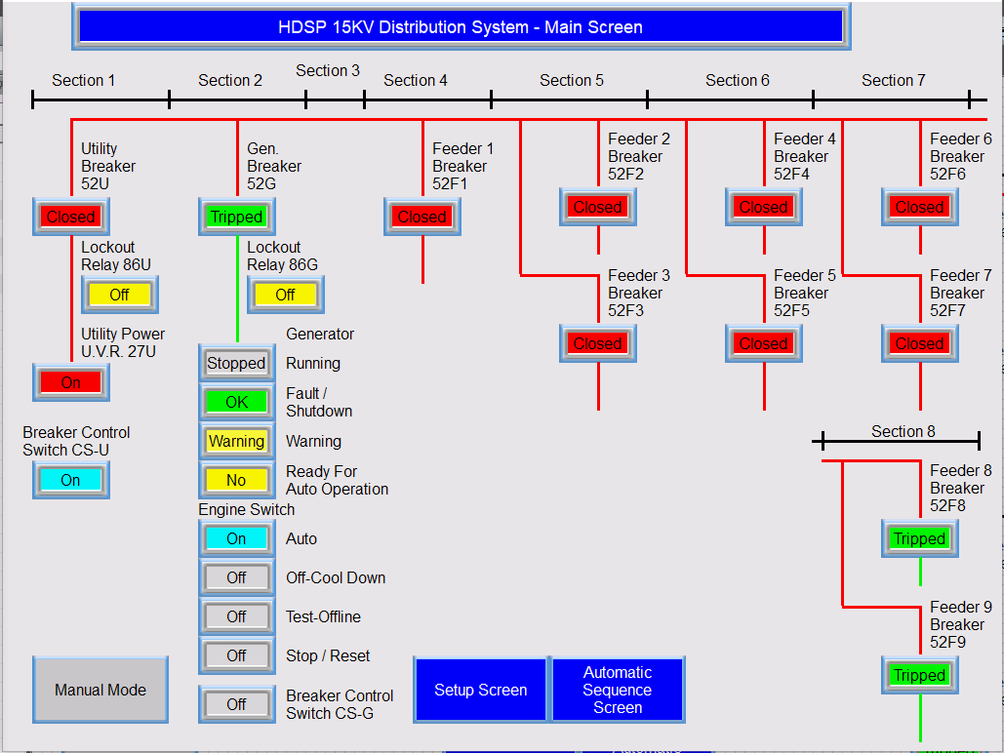

Colors Scheme:
Blue with white lettering is Navigation, which allows the displaying of other Screens, and indicates to the Operator which screen is currently showing. From the Main Screen, an operator can go to the Automatic Sequence Screen. When the Setup Screen button is pressed, a Keypad pops up where a Password must be entered before the Setup Screen will display.

Operator Controls (Human Entry) = Cyan. Engine Switch is Auto, so the Auto Light is on.
The Other options are Off, so they are Gray.
CS-U is also On, but CS-G is not, So it is Gray.

The Main & Feeder 1-7 Breakers are Closed = Red.
Feeder Breakers 8 & 9, and the Generator Breakes Are Tripped = Green
Hot Buses = Red, Non Powered buses are Green.

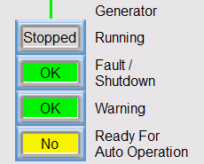Generator Status indicators are Off

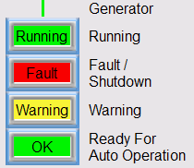Generator Status Indicators are On, which cannot happen really happen in normal operation

Main Screen In Manual Mode:

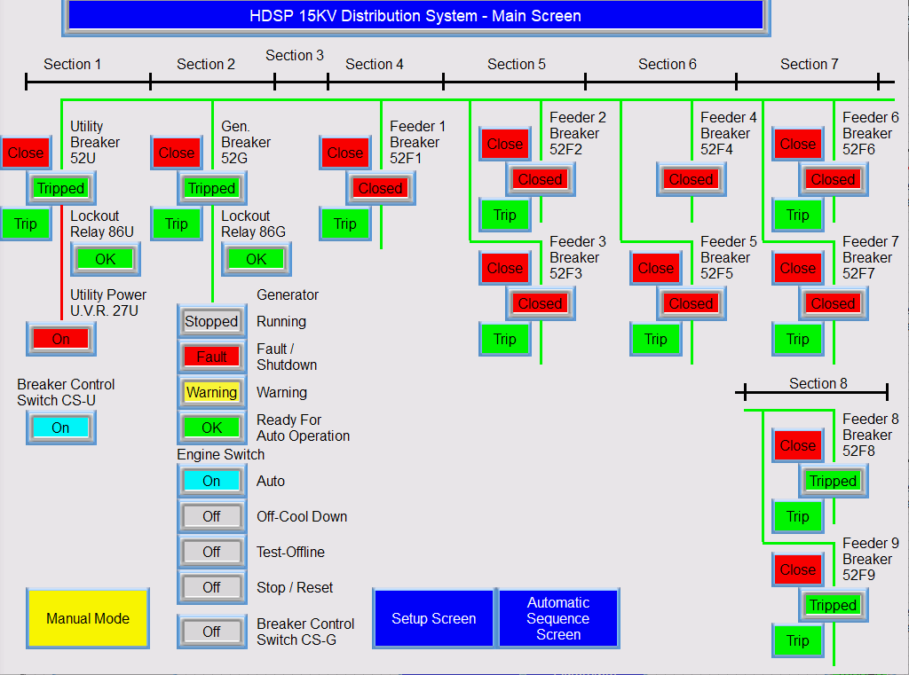

The Manual Buttons Show.
When a Red Close button is pressed, the Breaker closes and shows “Closed” Red.
When a Green Trip button is pressed, the Breaker trips and shows “Tripped” Green.
Manual Mode Can only be set via the Setup Screen. Only an Engineer with the Password can get to the Setup Screen.
Anyone and press the Manual button. When the System is not in Manual Mode, pressing the button does nothing. When the system is in Manual Mode, pressing the button will take the system out of Manual Mode.

Going to the Setup Screen:
The Operator press the Blue “Setup Screen” button:
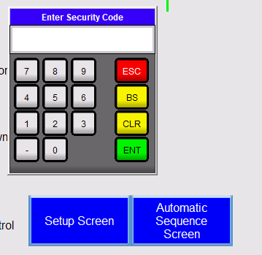The Password is 4885

Setup Screen:
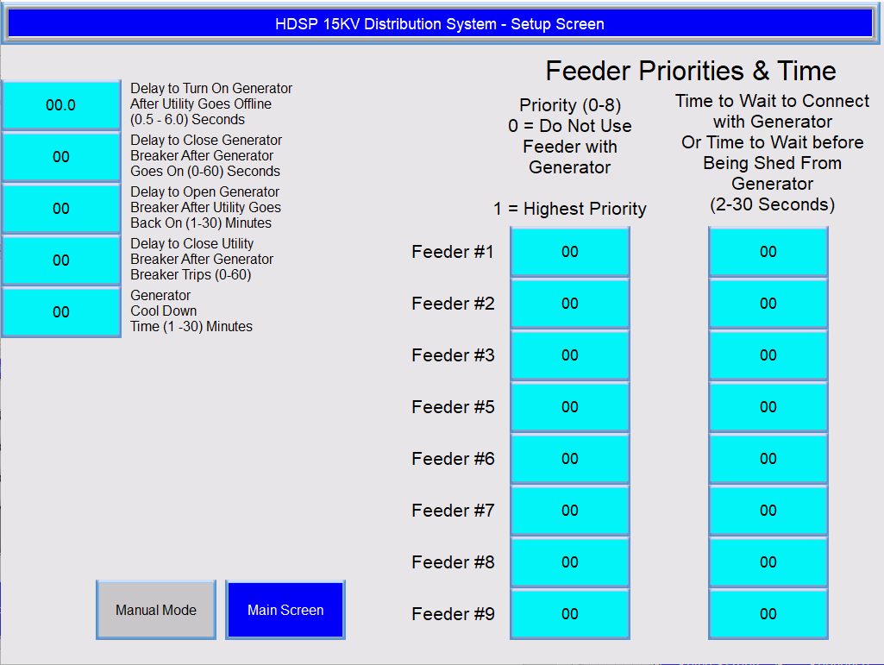

The Engineers enters values via Data Entry Buttons. Which are Cyan (Human Entry).
When a Data Entry is pressed, a popup keypad appears with Value Limits. The Engineer tries to enter 9 into Feeder #3 priority, which can only be between 0 – 8.

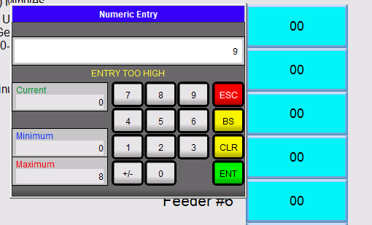

The Engineer changes the value to 3 and then the value shows in Feeder #3 Priority and presses the ENT key:

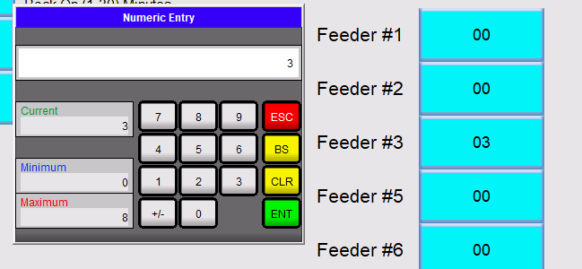
The Keypad disappears, and 03 now shows in the Feeder #3 Data Entry.

All of the Values are entered by the Engineer this way.

When the Manual button is pressed, the button turns yellow and the system is in manual Mode, providing the Generator not running with the STS switch or with the TEST/ONLINE switch. When the System goes into Manual Mode, nothing changes whether the Generator is online or when running normally from the Utility.

Revision History
Rev # | Date | Description | Initial
0 |  | Original | DDS
 |  |  | DDS

