Job # 19-6014
Link to Drop Box…..https://www.dropbox.com/sh/mpu4ylxdksx6mo6/AAA1Mx0fNkRBdPei_mjCeauya?dl=0

Contacts:
Slater and Son
Brandon Slater | LEED AP, DBIA Tim@slaterandson.com
Vice-President
Project Manager
Tim Duntsch Tim@slaterandson.com

3753 Morehead Ave.
Chico, CA. 95928
P (530) 893-3333
F (530) 893-1774
C (530) 519-7084

PASS.
Dan Pronsolino
(530) 801-1874

Kraemer & Co. Mfg., Inc.
Jerry Kraemer jkraemer@kcomfg.com
Gregory Hamberlin ghamberlin@kcomfg.com
530-624-4096
3778 Road 99 W
Orland, CA 95963
Office Phone 530-865-7982

Allen Bradley.
Bill Knapp
530 878-2849
William.Knapp@Rexelusa.com
MCC Data
https://literature.rockwellautomation.com/idc/groups/multi_media/documents/multimedia/files/virtualbrochure/ethernet-intellicenter/index.html

California Wonderware
Daniele Riboni 510.378.9562 Daniele.riboni@california.wonderware.com
Tony Vasco (707) 473-3102 - Direct Tony.Vasco@california.wonderware.com>

Justin Porter
Integrity First Technology Services, LLC
P.O. Box 26928 | Fresno, CA 93720
(559) 801-7363
justin@integrityfirsttechnology.com

TBD

Correspondence

Email to Dave Sims 26Feb2019
Hi Dave:
Great to hear about being awarded the job.
- I have crated a simple HMI Demo for future Huller / Sheller customers. I would like you to see it. We can use either Skype, “dsmithdhm”, or Teamviewer for you to see my screen. The demo shows typical operational screens, the manual warning screen and the Chico Electric Information screen. It is done with C-More, but can be implemented with any HMI.
- We have quoted a simple Wonderware HMI with only 4 Stand-alone Clients. The Clients are PC based and are fairly powerful. Wonderware has a more sophisticated arrangement where the 4 Clients can communicate with a server. The server can communicate with the PLC, Data Bases, either locally or on the Cloud, and can perform advance notifications, like email, voice or Text messages. I have a call into Wonderware, and they are going to get back to me for further details. The system as quoted, can be upgraded to the more sophisticated arrangement at a later time.
- With the Automation Direct, I was concerned about only gathering basic operational status & control for the Drives and VFD’s and keeping the advanced information for the IntelliCENTER software. Bill Knapp assured me that the AB controller can handle all basic control and advanced information. We can show the advance information with the HMI’s if the customer wants. We still can stick with our original plan, but we have more flexibility with the AB. The IntelliCENTER software as quoted, will do a good job.

Let me know when you want to do the conference call.

Meeting 11Jan2020 @ NSH:
- MCC Information from Allen Bradley with Arrangement, IP Address & Designations. Rick is Working On it.
- Updated Motor List & Mechanical Drawing Rick will get latest.
- Conversation with Mechanical to determine product flow. ( Cannot determine with Mechanical Drawings) The drawings do not show direction of travel and which units are above and below the others. Got Flow From Dan
- How the system is to be broken into Subsystems, if necessary, and how they are to start and stop. This is a good way to conserve energy. Per Dan. Huller ST/SP. Inshel or Meats. Preclean St/SP Line1 line2
- Do soft starts need FVNR contactor? No

- How Many PC’s. Does NSH want Development Software. Use RSNetworks for Ethernet/IP for Switches. Workstation #4
- NSH & Wonderware should determine type of PC & OS (Probably Server) Workstation
- Isolate Control LAN from System LAN. Prefer to use two NEC cards. Working With Justin Porter
- Email & Text Server supplied by NSH. Wonderware supports both both. Intellicenter has no notifications
- Non Motor Nodes and discrete IO. Use 120VAC. IO Needs ¼ the current and a 24VDC Power Supply is not needed. OK By Chico Electirc.

Meeting, Tuesday, 12 Feb 2020 Chico Electric:
Results

All the PLC items on Page 6, except for Ethernet Switch, are listed in:
“NorthStatePLC_QuoteFromRexel_S125593606-0001-1”. Dave Smith will get Quote from Bill Knapp for Pre-configured Switch & how the switch is to be connected to the 3 MCC’s

Are 48 AC inputs and 48 AC Output enough? No, 7 Input Module & 4 Output Modules

We need to add A-B Telephone Support for one year, which is about $1000.00 Jake to add to Quote

If we want to have remote support via Wonderware Workstation A, and have a copy of the PLC Development Software on a Chico PC, in addition, then we need to order another copy of the software: NO
AB 9324-RLD300ENE STUDIO 5000  STANDARD EDITION ESD S/W  Pn: 62430  UPC: 61259822934 | 3749.000/EA | 3749.00
We need to purchase and install the Wonderware Development, Wonderware Runtime, PLC Development, and Intellicenter Software on Workstation A and have it, and the 50” monitor, shipped to me, where I can perform the development. Yes. We will use off the shelf Monitors.

Rick & Darryl need help from Allen Bradley to:
Purchase the correct Ethernet Switch, shown on Page 6, how to configured it and connected to the Intellicenters MCC’s. There are several Switches in each Intellicenter MCC. Which switch to use, and what port of that switch will go the PLC’s and Wonderware Workstations A & B via the new switch is something we need help with. Copy of Disks to Dave Smith from Dave Sims.

I spoke with Phil McLachlan last week, where we discussed the diagram on page 7. He questioned my wanting to use two NEC cards for Workstations A & B. FYI Most people call them NIC cards. After I told him how the PLC’s communicated with the Intellicenters and how much real time traffic was on the network, he felt it was probably a good idea to isolate the Control LAN, and only let Workstations A & B connect to the Control LAN.
Phil Called me later and informed me that Justin Porter, justin@integrityfirsttechnology.com, was going to be in charge of the IT interface. I do not have his phone #. In an email from Phil, Justin got a copy of the page 7 diagram, and I asked him to call me. I have not heard from him. He may not feel the same way about isolating the Control LAN like I do. I am a controls guy, not an IT guy. Dave Smith is going to Contact Justin and discuss the possibility of having Integrity First Tech Supply the 4 PC’s ( Workstations: A, B, C & D). I will send Justin: Daniele Riboni, of California Wonderware, Contact Info. Justin may have them supply a Quote.

Dan at Pass gave us a flow diagram and suggested how to start & stop the system. For now, I feel this is fine. If NSH wants to break the system into smaller pieces, than can be discussed later. OK For Now. I will have time in the Quote for changes.

The biggest questions that I have are:
To avoid wasted time, how does NSH want the Wonderware to function.
I will need details and screen shots. Dave Smith will go to Dunnigan Hills for a Trip, and update the Quote. The trip expenses will be in the revised Quote.

We need to find out for sure if Mayo does want the Intellicenter Software. I was under the impression he wanted it at the meeting. He talked about trends for the motor control. Are these to be incorporated in Wonderware or Intellicenter? Intellicenter is a maintenance / monitoring tool and has no notification capability. Chico Electric could use it as a support tool in the future, for a charge, of coarse. One Copy of the Intellicenter Sofware will be supplied on Workstation A. Bill Knapp sent a quote.

We have two PLC’s. One PLC alone cannot communicate with all the devices. We have more than one MCC. After talking with Rick, I do not believe the MCC’s are arranged by system layout, but by device type, ie Horsepower, FVNR and VFD’s. We may just break up the PLC’s by the number of devices, and not necessarily by Huller or Preclean layout. YES, by # of Devices.

Additions Item: Why are we using Allen Bradley instead of Productivity.
- Allen Bradley PLC’s can communicate with 250 Motor Controllers, Productivity can only communicate with 32.
- Allen Bradley has A.D.C (Automatic Device Configuration). If a motor Controller is replaced, the Allen Bradley Switch’s assign the IP Address to the replaced Controller, & the PLC sends the configuration parameters to the replaced Controller; all automatically.

Email to Justin Porter 13Feb2020
Hi Justin:
Attached is: NorthStateHullingLans.pdf

Chico Electric received a Quotation from California Wonderware for the Software that is running on Workstations A & B. Workstations C & D will be Wonderware Remotes.

California Wonderware Contact:
Daniele Riboni 510.378.9562 Daniele.riboni@california.wonderware.com

Chico Electric plans on purchasing the Software, but not the PC’s.
The customer wants 50” monitors. Chico Electric is planning using consumer grade monitors, because the cost of industrial grade with enclosures is very expensive. It is just easier to replace a defective unit with consumer grade.

Daniele Riboni (AKA Danny) offered to Quote the 4 PC’s.

Chico Electric wants to know if Integrity First Technology Services is supplying hardware to NSH. If so, would it be best if you purchased the PC’s & monitors? If you need help with sizing, Danny can help or supply you a Quote. He also could install the software for you.

All of the components for the Controls Lan are all ready purchased. The Ethernet switches are Managed Industrial type and are configured & supplied by Allen Bradley. The Control Lan is using Ethernet/IP protocol, which uses TCP/IP for non real time communications and UDP/IP for real time communications. It is a very busy Lan, and that is why I have shown Workstations A & B with two NEC (NIC) cards for Isolation.

I am a controls engineer and not an IT guy. The use of the two NIC cards has been used by some of my customers, like General Mills and Lifescan, in the past. I am only showing them, because of past experience. All other workstations will be Remotes from Workstations A & B.

Give me a call at your convenience:

# Of Motors & VFD’s
Based on PDF Print Out: NSH HP List V3.pdf
From: Spreadsheet NSH HP List V3.xlsx

Page Motors VFD FVNR Soft Starts
1 8 0 6 2
2 43 3 40 0
3 21 8 13 0
4 24 6 18 0
5 22 19 3 0
6 18 9 9 0
7 20 15 5 0
8 20 16 4 0
9 20 12 8 0
10 16 0 16 0
11 18 4 14 0
12 21 0 21 0
13 23 0 23 0
14 22 0 19 3
15 19 0 19 0
16 3 0 3 0

Total 318 92 221 5

Page 17 3 - Syntrons 3 – 24VDC or 120VAC Relays

VFD Powerflex 525. FVNR E300 intelligent Overload Modules. SMC Flex Soft Starts

Questions:

What is a Lineup, and how I get one? Part of Data CD’s that come with Intellicenter Software
Will Rockwell provide files to Integrate MCC into PLC? Part of Intellicenter Intigrations assistant Software.

Do I merge the 3 Lineups on the Data Disks into the Database or use Individual Lineups?

RSLinx Classic Light:
To Configure the Ethernet Devices Driver for 320 devices, do I have to have 320/64 = 5 Drivers and then manually enter all 320 IP addresses?

Can the PLC perform ADC for a Stratix Switch. If not, will an SD card automatically upload to a replaced switch.

Main Switch connection to IntelliCENTERS What is the Smart Port setting?

PLC Arrangement
Power Supply
PLC #1
Control Logix 1756-L84E
Filler
Module
Filler
Module
PLC #2
Control
Logix 1756-L84E
4 Slot Rack

Industrial
20 Port
Ethernet
Switch
1783-BMS20CL
IntelliCENTER MCC1
12)Stratix 5700 Switches
111)E300 Electronic Overload Modules
2)Powerflex 525 VFD’s
IP Addresses 192.168.1.1-130
IntelliCENTER MCC2
10)Stratix 5700 Switches
99)E300 Electronic Overload Modules
7)Powerflex 525 VFD’s
IP Addresses 192.168.2.1-116
IntelliCENTER MCC3
10)Stratix 5700 Switches
80)E300 Electronic Overload Modules
22)Powerflex 525 VFD’s
IP Addresses 192.168.3.1-112
PC Workstation A
Wonderware HMI Development & Runtime
IntelliCENTER Software
Studio500 PLC Development Software
IP Address TBD
PC Workstation B
Wonderware HMI Runtime
IP Address TBD
Fan, Stand Alone
Powerflex 755 VFD
Fan, Stand Alone
Powerflex 755 VFD
Fan, Stand Alone
Powerflex 755 VFD
Fan, Stand Alone
Powerflex 755 VFD
Fan, Stand Alone
Powerflex 755 VFD
Fan, Stand Alone
Powerflex 755 VFD
Local Flex IO
Remote Flex IO

PLC’s

Intellicenter
MCC’s
Stratix
Ethernet
Switches
Wonderware
Workstation
A
With Intellicenter & PLC Development Software & Remote Support

Two NIC Cards
Wonderware
Workstation
B
Two NIC Cards
Control
Lan
(Isolated)
Wireless
Gateways
Plant
Lan
(Secure)
Wonderware
Remote
Workstation
D
Wonderware
Remote
Workstation
C
Wonderware
Remote
Device
Wireless
(Typical 4 Places)

Ethernet
Switches

Ethernet
Switches
Office
Lan
Secure
Bridge
Internet
Email
Server
SMS
Text
Server
Office
Wonderware
Remote, Remote
Device

Parts:
Qty | Allen Bradley Part # & Discription
 | ControlLogix
1 | 1756-A4 4 Slot Rack
1 | 1756-PA72 AC Ppwer Supply
2 | 1756-L84E 20MB Processor
2 | 1756-N2 Empty Slot Cover
 | Flex IO
2 | 1794-PS3 Power Supply
2 | 1794-ANETR 2 Port Ethernet/IP Adapter
?? | 1794-IA16 Flex IO 120 VAC 16 Point Input Module
?? | 1794-TBN Nema Screw Terminal Base
?? | 1794-OA16 Flex IO 120 VAC 16 Point Output Module
?? | 1794-TBNF Fused Nema Screw Terminal Base
 | Communications
1 | 1783-BMS20CL STRATIX ETHERNET SWITCH

IP Addresses:
Subnet Mask: 255.255.0.0
Default Gateway: 192.168.0.1
----------------------------------------------------------------------------------------------------
PLC#1: 192.168.0.11
PLC#2: 192.168.0.12
PLC Panel, Ethernet Switch: 192.168.0.21
Workstation A: 192.168.0.31
Workstation B: 192.168.0.32
MCC #1, Drives & Ethernet Switches: 192.168.1.1-130
MCC #2, Drives & Ethernet Switches: 192.168.2.1-116
MCC #3, Drives & Ethernet Switches: 192.168.3.1-120

Stratix 5700 Switches:
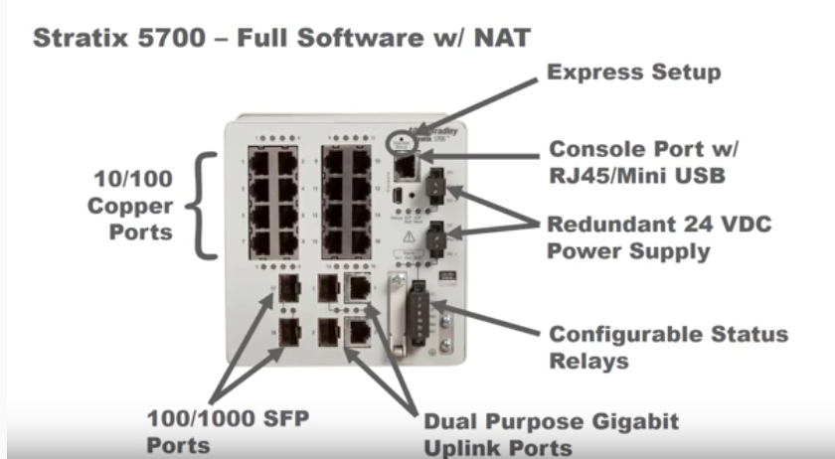

Initial Connections using Express setup
Set NIC on PC to DHCP
After bootup, the Express LED Flashes
Push with a paper clip the Express Setup recessed button until a Port Light blinks.
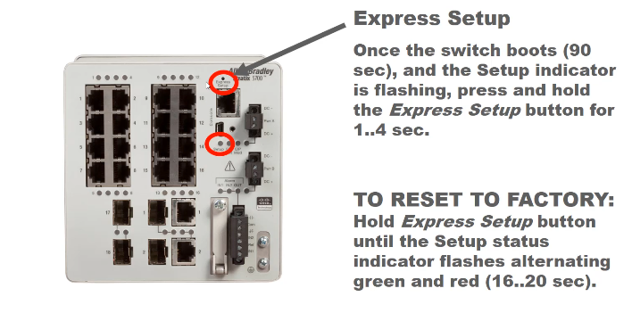
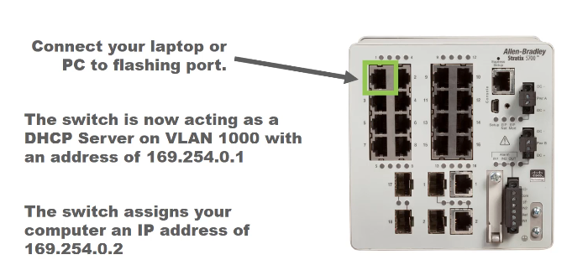

Set IP of Switch to Static.
Express Setup Page.
Keep Management Interface = VLAN 1
Keep user and password to admin & switch.
Leave Advance settings as is.
Reboot and then connect to the new fixed IP address.
Set PC NIC to static IP.
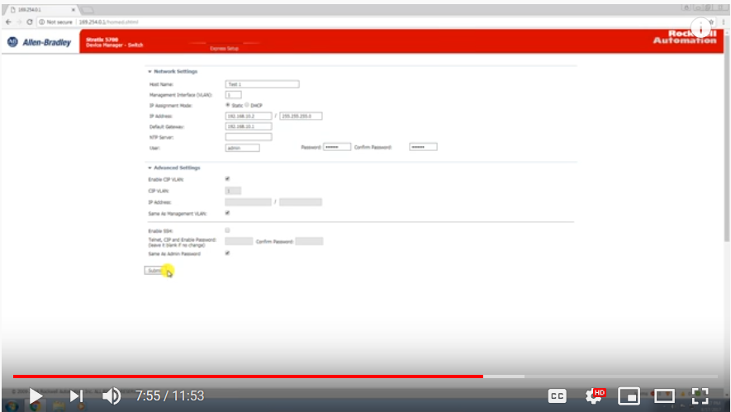

Go to Express Setup to Change IP of Switch.

Fire Fox
From any point on the network. Java Script enabled.
To make sure that Device Manager runs properly, disable any popup blockers or
proxy settings in your browser and any wireless clients on your computer.
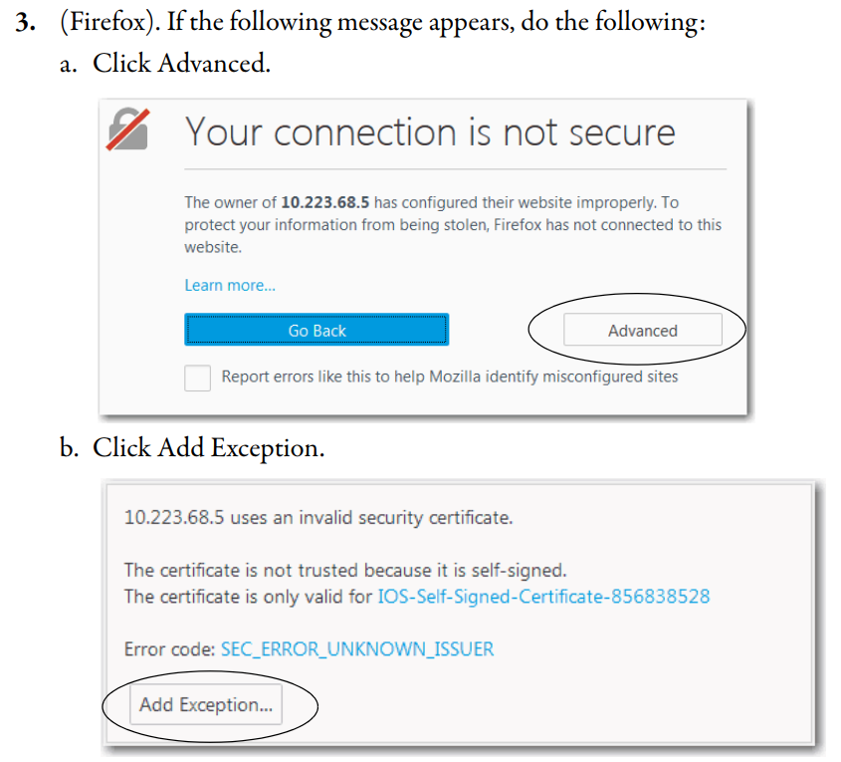

Do Not Permanently store exception
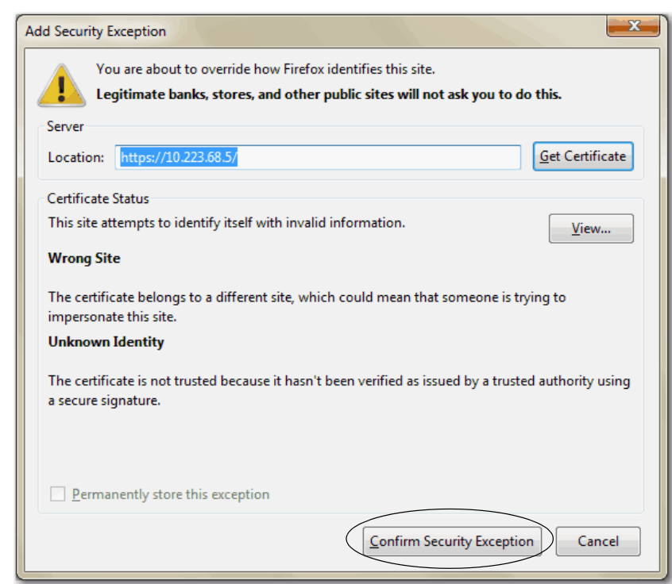
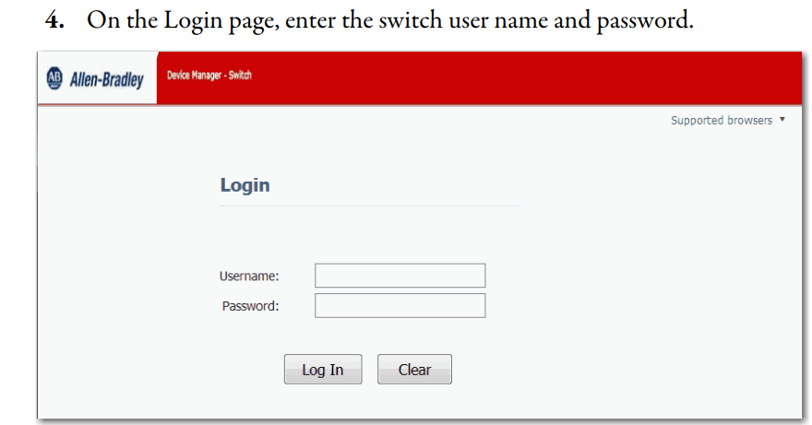
admin
switch

Smart Ports
Recommended roles for each Port.

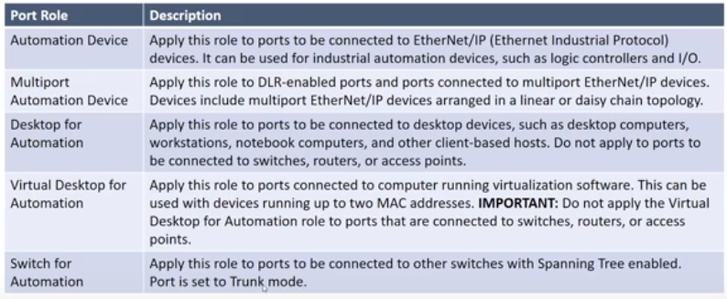
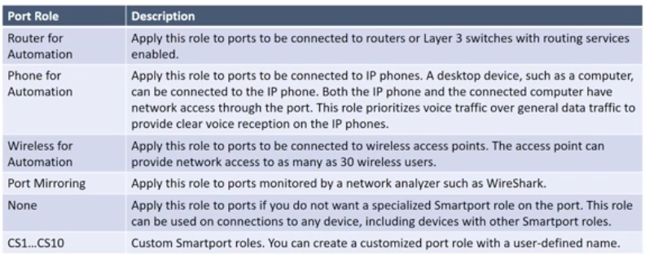
X
X

DHCP Persistence
DHCP server also serves addresses to BOOTP clients via, the DHCP Address Pool.

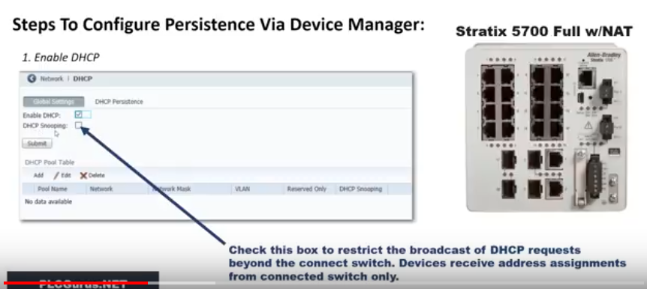

Need to Setup Pool Table first.

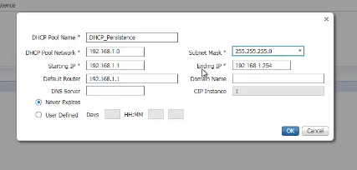Limit to Devices connected to Switch.

Assign address from Pool to each Port from Persistence Table, called DHCP_Persistance
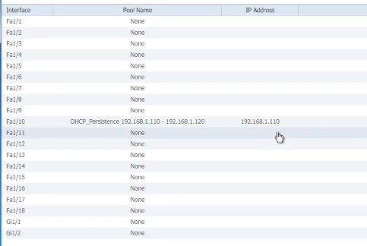

Click Radio button to edit
Port Numbering 10CL Fa1/1 ---Fa1/10
Port Numbering 20CL Fa1/1 ---Fa1/20
Fa = Fast Ethernet 100 Mb/s
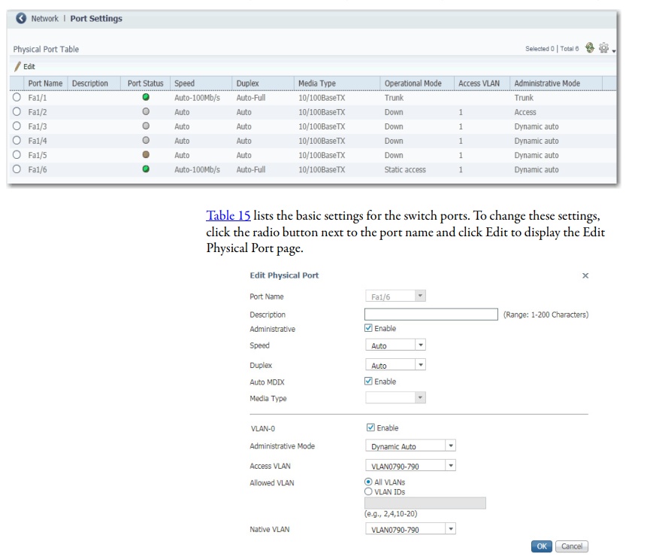

Lan Arrangement Wonderware Notes based on phone call with Daniele Daniele Riboni 26Feb2019
Developement Software AVEVA Edge $1300.00
Graphics
- Animation
- Active X controls
- list boxes
Recipe Manager
- Save, download
Trends
- Vertical & Horizontal
- Can Stop Trend, resume, no data is lost during trend stop
- Real Time & Historical
Alarms
- Active
- Historical with start, end acknowlege

Notification:
- Text
- Email

Screens have Multi-Touch animation

Each client can support one secondary client via built-in web server. Client can be Mobile device running a web browser.

Reports:
- HTML
- RTF
- Text
- PDF vai Word Processor

DB Connectivity for each Unit.
- Store & Forward for interrupted connection.

Event logging

Multi-language with translation table. Semi Automatic. User will have to fill in some text.

Windows type security with users and groups. User can be disabled, but activity trail maintained.

2 Year warranty with Wonderware Computers.
- Call wonderware
- Perform test with wonderware rep.
- New unit ships right away.
- Have 30 Days to return old unit.

Remote Access:
- Intouch Access Anywhere ITAA
- IOS / Android app using Windows RDS ( Remote Desktop Services) Standard Windows can only support one device at a time. Should use Windows Server. Recommend NSH to work with Wonderware Rep, Daniele Riboni to select computer and Windows Server. App is called Smart Glance of IOS & Android, by Invensys, which is free.
- Use Web Browser, no app needed.

2. Use a remote access software like TeamViewer, which runs on several platforms, including IOS. Give more control over PC.

ADC
ADC works for E300 & Power Flex 525 Drives Embedded Port.
Does Not work with Soft Starts
Use DHCP in Stratix 5700 Switch.
Switch Configured with RSNetworx for Ethernet/IP
Use Firmware Supervisor Also to upgrade Firmware
Helpful Link
https://training.kendallelectric.com/KCL-Materials/KCL-20181108ESAG-Leveraging-Automatic-Device-Configuration.pdf

Power Flex 525 Drives Notes
Use RA_PF5ClassAOP_Version_1.03 Add on Profile to RSlogix5000
From Power Flex 525 Manual: IO Messaging, Generic Module
Bucket Part #: 2163WB-6P0KB-4LG-14DFCC-14HBA3-38TGM

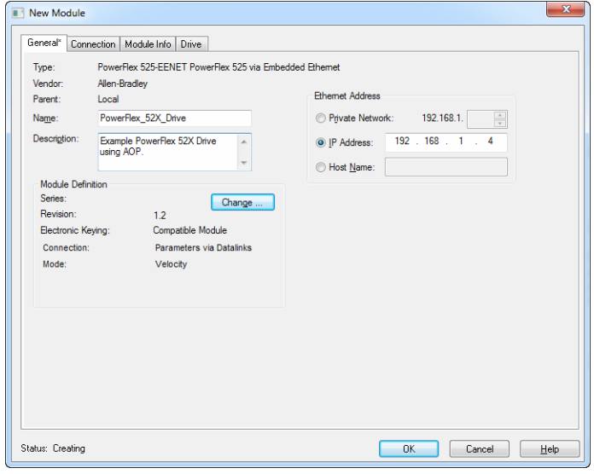
4
2
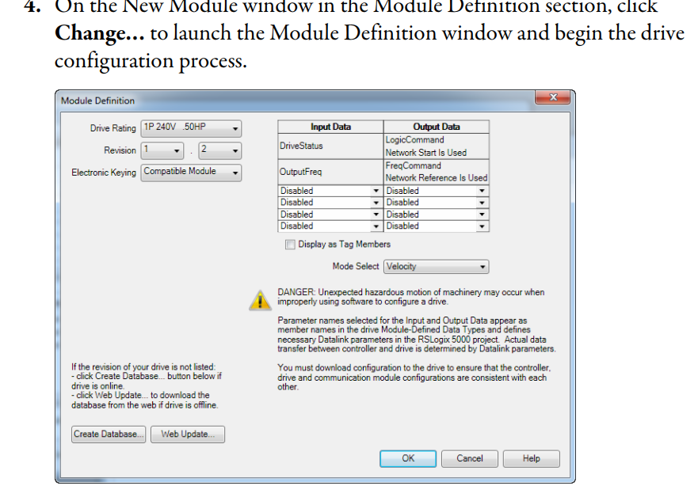
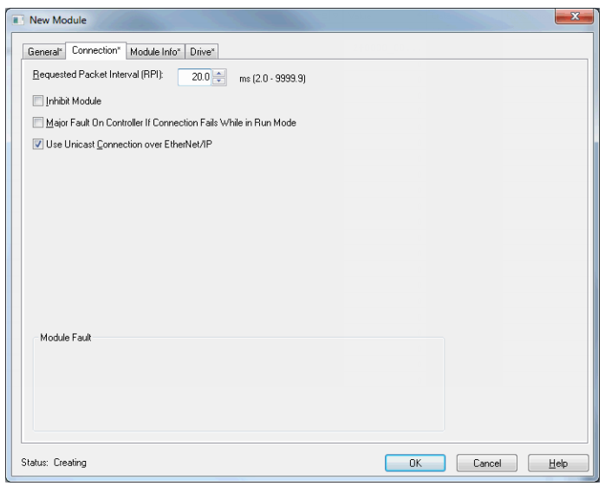

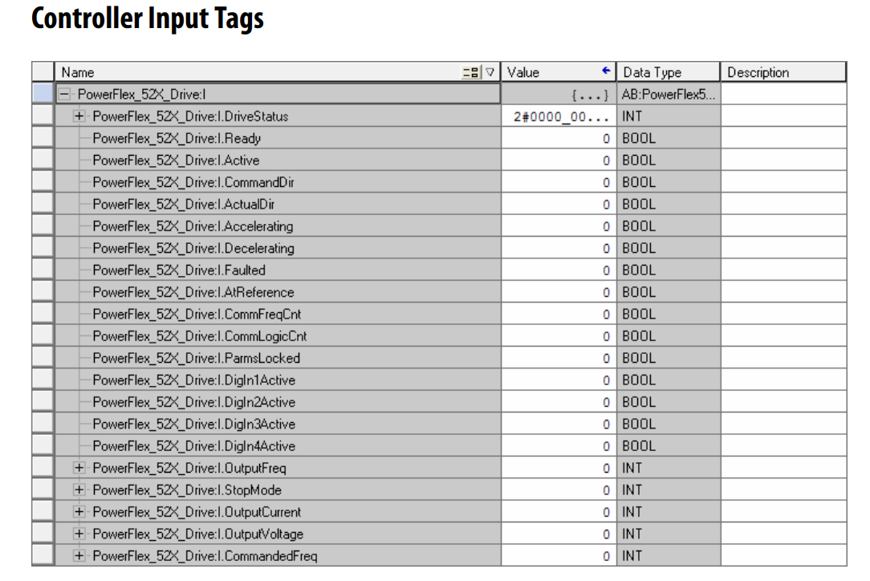

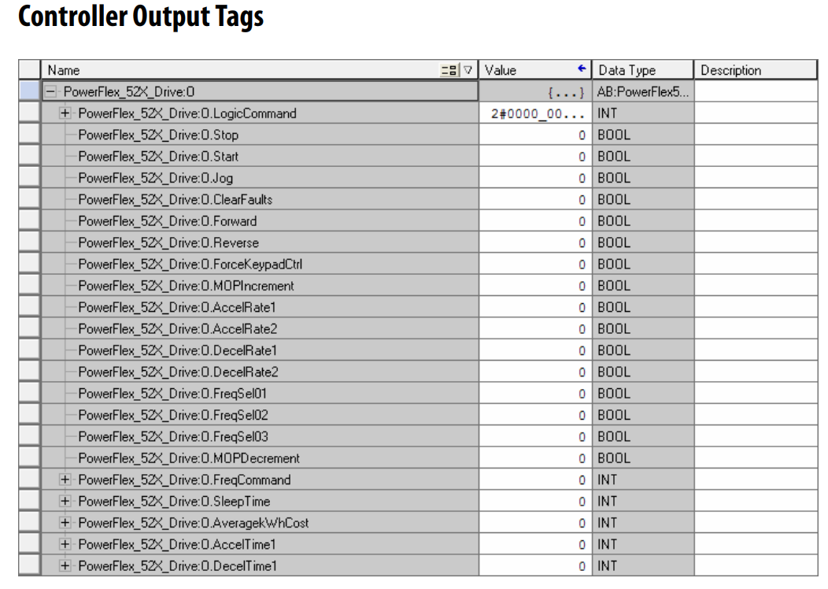

E300 Electronic Overload Module.
The E300 relay’s Operating Mode Reversing Starter (Network) (Parameter 195 = 5)

Wiring
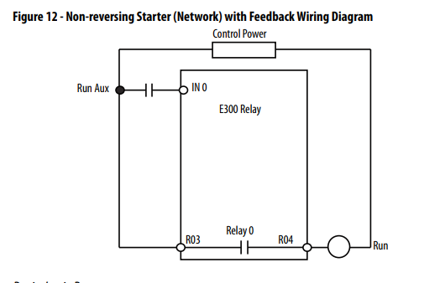
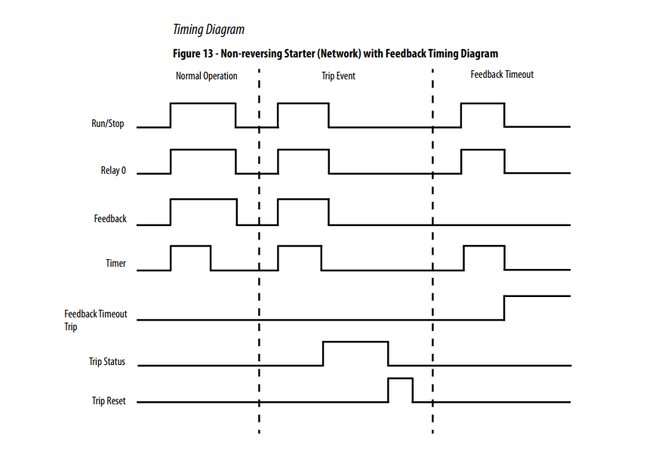

IntelliCENTER Notes

Problems:
Duplicate IP Addresses.
Leave MCC1 to 192.168.1.xxx Change Address of Switch 17L, from .69 - .125
Change MCC2 to 192.168.2.xxx.
Change MCC3 to 192.168.3.xxx

Change Fixed IP Address to DHCP and Configure 5700 Switches to DHCP Persistant.

Please see response from Allen Bradley IntelliCenter Support. Any correspondence with the factory please include case number 4008210793 and if you want the sales order number for the MCC’s is 6504547106. I sent in so far the PLC arrangement drawing and the two e-mails that you recently sent.

IntelliCENTER software Logix Designer Integration Assistant
Intellicenter Integration assistant problem with L83 Processors Fix.
https://rockwellautomation.custhelp.com/app/answers/detail/a_id/780083

Elevation view provides graphical representation of entire MCC lineup
- Status indicator displays condition of each motor controller
- Monitor view displays an overview of the monitored MCC and lets you change configuration parameters
- Documentation views customized for your MCC include manuals & wiring diagrams, spare parts list
- Event log records and stores events occurring with the MCC
- Integration Assistant seamlessly integrates IntelliCENTER® MCCs into the Studio 5000™ programming software and automatically generates tags and IP address configurations for devices in the MCC using a Lineup
- IntelliCENTER Energy provides automatic, pre-configured setup of FactoryTalk® EnergyMetrix™ for devices in the MCC and shows real-time energy consumption and historical trending for all intelligent devices directly from IntelliCENTER Software

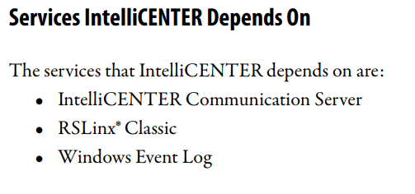

Default User Name: Administrator Password: password
Workspace files .wsp

Manual Notes:
Page 11 Features
- Elevation view provides graphical representation of your entire MCC
lineup.
- Monitor view displays an overview of a connected MCC intelligent
device and lets you change configuration parameters.
- Event log records and stores events that occur within the
IntelliCENTER MCC.
- Integration Assistant seamlessly integrates IntelliCENTER MCCs into
the Studio 5000® application and automatically generates tags and IP
address configurations for intelligent motor control devices in the
MCC
Recommended Additional Software
Use RSNetWorx™ for DeviceNet
RSLinx Classic

Intelicenter Master Password = NSH_Intellicenter1.
Default User Name = Administrator Default Password =password

Add Users, each with their own Name & Password.

Lineups are added to or removed from a Workspace.
Workspaces can be customized and saved as xx.wsp

Drawings:
Pages1-17 Table of Contents, MCC1 Elevations
Pages18-35 MCC1 & MCC2 Elevations
Pages36-44 MCC3 Elevations Missing Sections 1 - 9
Pages45-53 MCC3 Elevations, MCC1 One Lines.
Pages71-131 MCC1 Power Supplies & Ethernet Switches.
MCC2 One Lines, Power Supplies & Ethernet Switches.
MCC3 Title Page
Pages131-191 MCC3 One Lines, Power Supplies & Ethernet Switches.
MCC1 Firmware Table & Device Parameter Report
Pages192-251 MCC1 Parameter Report (continued)
MCC2 Firmware Table & Device Parameter Report
MCC3 Firmware Table & Device Parameter Report
MCC1 Schematics Page 1
Pages252-312 MCC1 Schematics Page 2-up
MCC2 Schematics (Page 21)
MCC3 Schematics (Page 42)

Up links to PLC Emailed to Rick, Dave & Darryl 25Feb2020
MCC1. Sheet 32 of 43. Unit 05L, Switch 1783-BMS10CL, Port 9.
MCC2. Sheet 30 of 39. Unit 05L, Switch 1783-BMS10CL, Port 9.
MCC3. Sheet 29 of 38. Unit 06L, Switch 1783-BMS10CL, Port 9.

Spare Ports to Stand Alone Drives, Emailed to Rick, Dave & Darryl 27Feb2020
MCC1. Sheet 43 of 43. Unit 22L, Switch 1783-BMS20CL, Ports 3-18.
MCC2. Sheet 39 of 39. Unit 20L, Switch 1783-BMS20CL, Ports 14-18
MCC3. Sheet 38 of 38. Unit 20L, Switch 1783-BMS20CL, Ports 6-18.

Email to Darryl, 7Mar2020.
The Stand alone drives will be wired to the Ethernet Switch in the PLC Panel.

