Automatic Sequence
AS_LowPressClose
AS_LowPressClose_T
AutoSeqStarted
AS_HighPressClose
AS_HPC_Close_Vx_T
AS_HPC_Open_V1_T
AS_FeedFilter
AS_FeedFilter_T <-- DE_FeedFilter
AS_FF_WeightOK
AS_LowFeedWeight
AS_LowFeedAck
AS_ResetFF
AS_FF_Repeat
AS_MembComp_Ena
AS_MembComp
AS_MembComp_T <-- DE_MembComp
AS_AirDry
AS_AirDry_T <-- DE_AirDry
AS_TopBlowAir1
AS_TopBlowAir1_T <--DE_TopBlow2Air1
AS_TopBlowWat
AS_TopBlowWat_T<-- DE_TopBlow2Water
AS_TopBlowAir2
AS_TopBlowAir2_T <--DE_TopBlow2Air2
AS_Drain
AS_Drain_T <-- DE_Drain
MAS_OpenHatch
MAS_OpenLowerHatch_T
MAS_HatchesOpen_T
MAS_OpenPress
AS_VibrateCloth
AS_VibrateCloth_T <-- DE_ClothVibrate
AS_EmptyWeightIsHigh
AS_HighEmptyWeight
AS_HighEmptyAck
MAS_CloseHatch
MAS_CloseUpperHatch_T
MAS_HatchesClosed_T
AS_ClothFlush
AS_ClothFlush_T <-- DE_ClothWash
AS_ClothVibWash
AS_ClothVibWash_T <-- DE_ClothVibWash
AS_Done
AS_Wait
AS_Wait_T <-- DE_DelayedStart

HMI Notes
Buttons cannot be made invisible.
Buttons connot be disabled
Goto Buttons Cannot show a disabled state, cannot use Goto Button, must set bit in PLC
Buttons: Raised, Solid, Rectangle
Border uses Back Color & Width = 2
Button Color Select Other and second from right at bottom
Arial 10

Main Screen Graphics & Pipes
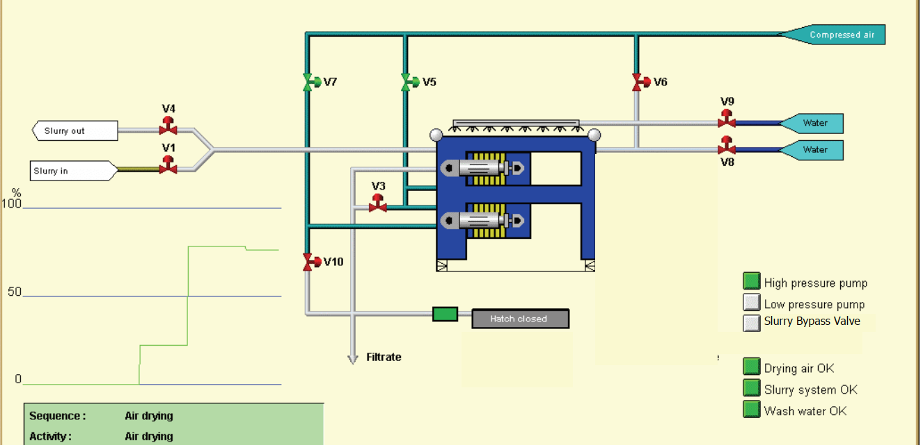
Pipe 1 Good Air, Aqua.
Pipe 1
Pipe 2
Pipe 3
Pipe 5
Pipe 4
Pipe 6
Pipe 7
Pipe 8
Pipe 9
Pipe 10
Water
Pipe # | Condition 1 | Condition 2 | Condition 3 | Condition 3
1 & Tag | Good Air = Aqua | Bad Air = Gray
2 | V 7 Open = Aqua | Else = Green
3 | V 5 Open = Aqua | Else = Green
4 | V 9 Open = Blue | Else = Gray
5 | V 6 Open = Aqua | V 8 Open = Blue | Else = Gray
6 | Air Drying = Gray | Else = Green
7 | V3 Open = Green | Else = Gray
8 | V1 Open & V4 Closed = Brown | V4, V7, V6 Open = Aqua | V4, V7, V8 Open = Blue | Else = Gray
9 & Tag | V1 & V4 Open = Brown, Brown | V4, V7, V6 Open = Aqua & Brown | V4, V7, V8 Open = Blue & Brown | Else = Gray & White
Water | Good Water = Blue | Else = Gray
10 Tag,  Pipe Always Lt Brown | V1 Open = Lt Brown | Else = White

Alarms Word 1
Alarm Discription | Alarm Address
Drying Air Not OK | ALM_W1.0
Slurry System Not OK | .1
Wash Water System Not OK | .2
High Pressure Pump Motor Overload | .3
Low Pressure Pump Motor Overload | .4
Slurry Valve, V1, Failed to Open | .5
Slurry Valve, V1, Failed to Close | .6
Spare Valve, V2, Failed to Open | .7
Spare Valve, V2, Failed to Close | .8
Filtrate Valve, V3, Failed to Open | .9
Filtrate Valve, V3, Failed to Close | .10
Slurry Return Valve, V4, Failed to Open | .11
Slurry Return Valve, V4, Failed to Close | .12
Drying Air Valve, V5, Failed to Open | .13
Drying Air Valve, V5, Failed to Close | .14
Top Blow Air Valve, V6, Failed to Open | .15
Top Blow Air Valve, V6, Failed to Close | .16
Membrane Air Valve, V7, Failed to Open | .17
Membrane Air Valve, V7, Failed to Close | .18
Top Blow Water Valve, V8, Failed to Open | .19
Top Blow Water Valve, V8, Failed to Close | .20
Wash Water Valve, V9, Failed to Open | .21
Wash Water Valve, V9, Failed to Close | .22
Membrane Drain Valve, V10, Failed to Open | .23
Membrane Drain Valve, V10, Failed to Close | .24
Upper Hatch Failed to Raise | .25
Upper Hatch Failed to Lower | .26
Lower Hatch Failed to Raise | .27
Lower Hatch Failed to Lower | .28
Press Failed to Go to Neutral Position | .29
Press Failed to Go to Park Position | .30
Press Failed to Go to Press Position | .31

Alarms Word 2
Alarm Discription | Alarm Address
Press Weight Sensor Out Of Range | ALM_W2.0
Press Pressure Sensor Out Of Range | .1
Cloth Damaged | .2
 | .3
 | .4
 | .5
 | .6
 | .7
 | .8
 | .9
 | .10
 | .11
 | .12
 | .13
 | .14
 | .15
 | .16
 | .17
 | .18
 | .19
 | .20
 | .21
 | .22
 | .23
 | .24
 | .25
 | .26
 | .27
 | .28
 | .29
 | .30
 | .31

