Proposed Changes:

Addition of Bin Full Indicators:
Currently, the Bins are Red for diverter at Bin, Green for diverter not at Bin, and Flashing Yellow when diverter is in-between. A Pop up “Bin Full” Text Box will appear when the Bin Full. The Text Box will flash when the diverter is directing nuts to the Bin. The Text Box will stop Flashing with the diverter is not diverting to the Bin. The Text Box will disappear when the Bin is not Full.

Proposed changes in Motor Pop Up Windows:
- The three position HAND-OFF-AUTO selector switch is replaced by two Radio HAND and AUTO Buttons:. See Below
- The New warning Indicator is Green, for OK, Yellow for Warning.
- For VFD Motors Only: Speed is a Data Display, Green on Black.
- Amps is a Data Display, Green on Black, showing the Actual Amps.
- The Fault or Warning Description is a Data Display, Green on Black, showing the Actual Description of the Warning or Fault.
- Information is always shown with the location of the MCC Bucket in the MCC Map View. The MCC and INFORMATION buttons are removed. The 3 MCC’s are broken into Columns., 1-22. The Column # & Bucket Number are show near a Red Dot.

Popup Screen as is
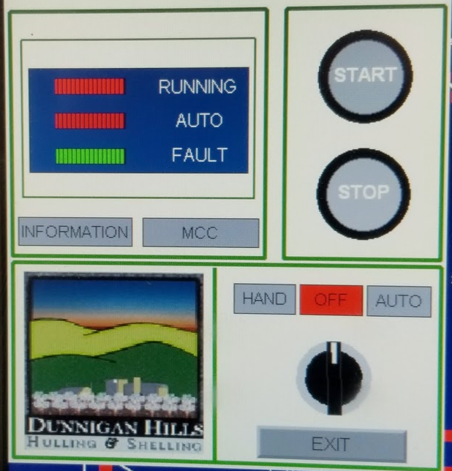

Popup Screen in Auto
In Auto Mode, the Motor runs when the next downstream motor in the sequence runs, plus a start up delay. If this motor trips an overload, it and the necessary upstream motors stop. When the motor overload is reset, this motor and all the necessary upstream motors re-start in timed start sequence. If this motor and upstream motors are not to all re-start upon overload reset, the HAND button is pressed, see below.

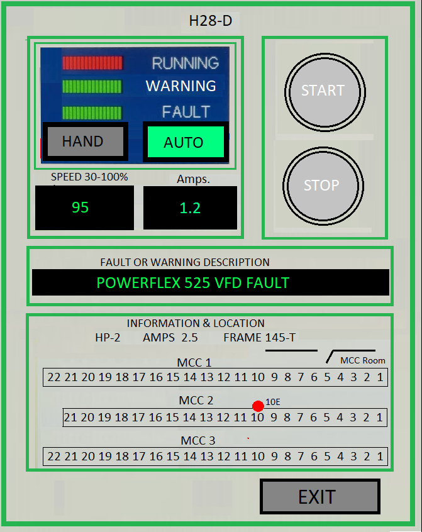

Popup Screen in Hand
If this motor needs to be run without running the upstream motors, the operator pushes the START button, and the motor runs until the operator presses the STOP button. The upstream motors remain stopped. When it is OK to run the motor in Auto, the AUTO button is pressed, see above, and this motor and upstream motors re-start in timed sequence.

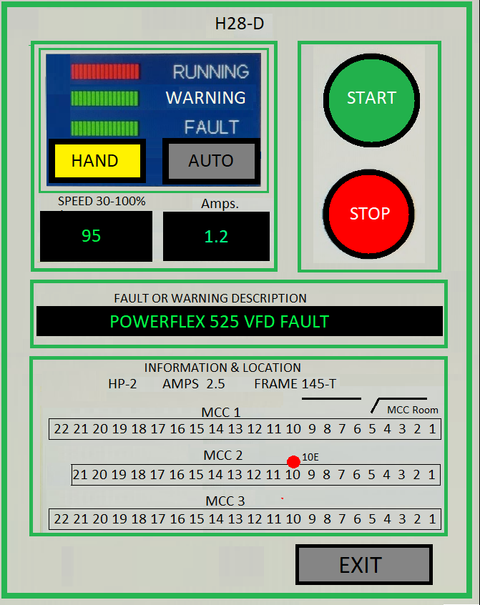

Proposed Speeds Screen:
- A Master Speed Data Entry, Black on Cyan, will be provided to offset the speeds of all Non-Quality motors by a factor of 75 – 125 % (.75 – 1.25). Non-Quality are Elevators & Bottom Bins. Quality Motors are Shear Rolls & Vibratory Decks.
- Each Non-Quality Motor with a VFD, will have a Data Entry, Black on Cyan and a Data Display, Green on Black. The Data Entry is use to set the Nominal Speed of the motor when the Master Data Entry = 100 % (1.0). The Data Displays show the actual speed the motor runs: (Nominal Speed x Master Speed).
- Quality Motors will have only a Data Entry, Black on Cyan. The Speeds will not be affected by the Master Speed.
- When a Data Entry is pressed, a numeric keypad pop-up window shows, where the operator can enter a value. All entered values are ranged checked.
- No motor will go more than 100% nor less than 30%.
- Baghouse Motors speeds will be on a different Speed Screen, which will contain Data Entries, Black on Cyan. The Speeds will not be affected by the Master Speed. The Screen will be accessed from this screen via the BAGHOUSE SPEEDS button. A password will be required to get to the Baghouse Speeds Screen.

