Main Screen.

Utility Online & Not In Manual Mode.
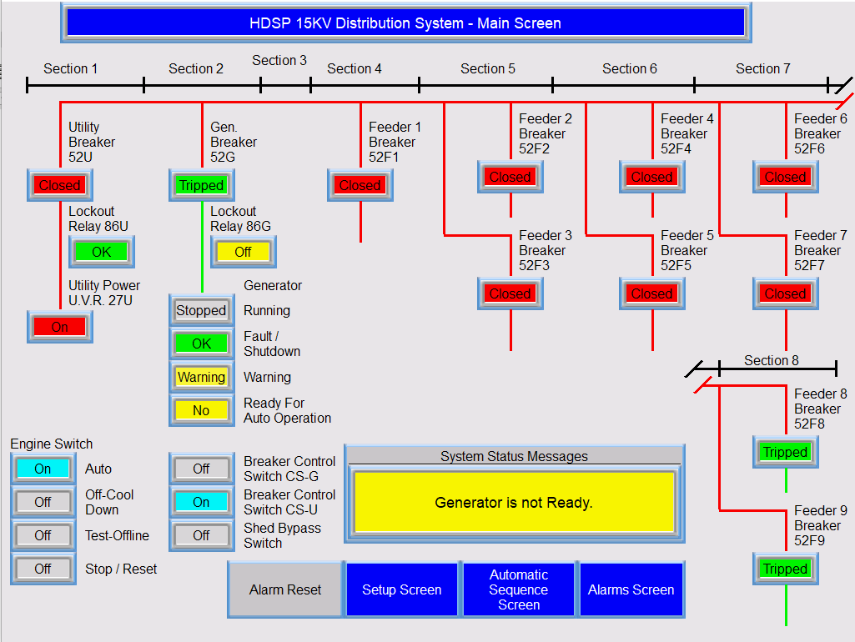

Colors Scheme:
Blue with white lettering is Navigation, which allows the displaying of other Screens, and indicates to the Operator which screen is currently showing. From the Main Screen, an operator can go to the Automatic Sequence Screen. When the Setup Screen button is pressed, a Keypad pops up where a Password must be entered before the Setup Screen will display. Pressing the Alarms Screen displays the Alarms Summary Screen

Operator Controls (Human Entry) = Cyan. Engine Switch is Auto, so the Auto Light is on.
The Other options are Off, so they are Gray.
CS-U is also On, but CS-G is not, So it is Gray.

The Main & Feeder 1-7 Breakers are Closed = Red.
Feeder Breakers 8 & 9, and the Generator Breakers Are Tripped = Green
Hot Buses = Red, Non Powered buses are Green.

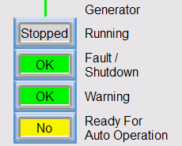Generator Status indicators are Off

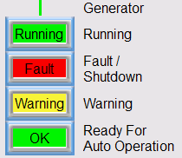Generator Status Indicators are On, which cannot happen really happen in normal operation

System Status Message Display.
The following messages are displayed, one at a time on the display. When multiple conditions exist at the same time, the message higher on the list has priority.
- Emergency Stop Pushed
- Utility Lockout Relay 86U.Tripped. Reset Manually.
- Generator Lockout Relay 86G. Tripped. Reset Manually & Momentarily Place the Engine Switch to STOP/RESET.
- Alarm, see Alarm Banner or Alarm List.
- Generator is not In Auto.
- Generator is not Ready.
- Generator in Test Mode.
- Generator is Ready For Auto.
- Utility Power off, and Generator is going Online.
- Utility Power off, and Generator is Online.

Main Screen In Manual Mode:

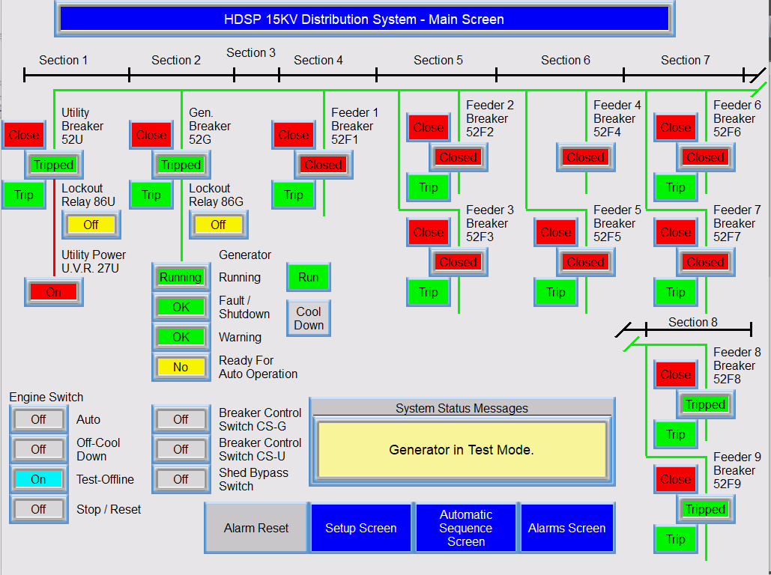

The Manual Buttons Show.
When a Red Close button is pressed, the Breaker closes and shows “Closed” Red.
When a Green Trip button is pressed, the Breaker trips and shows “Tripped” Green.
When The Generator Run & Cool Down buttons ar pressed, they go from Gray to Green.
Manual Mode Can only be set via the Setup Screen. Only an Engineer with the Password can get to the Setup Screen.
Anyone can press a Manual button. When the System is not in Manual Mode, pressing the button does nothing. No one except the Engineer should press a Manual button while the System is in Manual.
The Engineer Goes back to the Setup Screen and presses the Manual button. The button goes from yellow to gray, and the System exits Manual Mode.

Going to the Setup Screen:
The Operator press the Blue “Setup Screen” button:
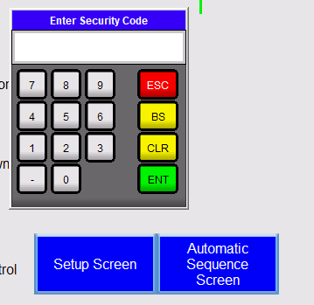The Password is 4885

Setup Screen:
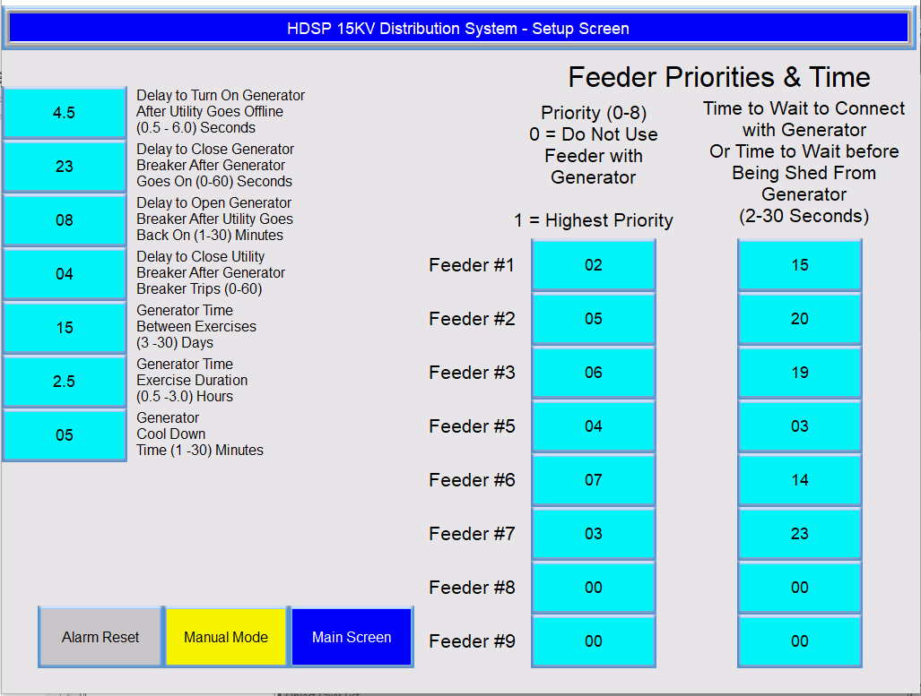

The Engineers enters values via Data Entry Buttons. Which are Cyan (Human Entry).
When a Data Entry is pressed, a popup keypad appears with Value Limits. The Engineer tries to enter 9 into Feeder #3 priority, which can only be between 0 – 8.

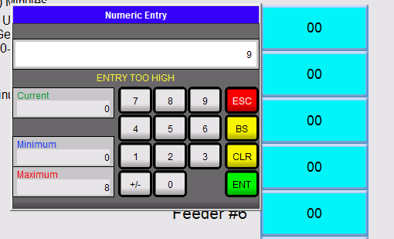

The Engineer changes the value to 3 and then the value shows in Feeder #3 Priority and presses the ENT key:

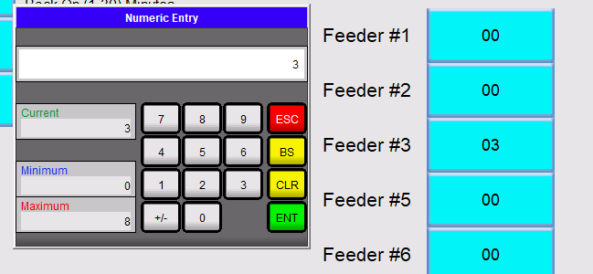
The Keypad disappears, and 03 now shows in the Feeder #3 Data Entry.

All of the Values are entered by the Engineer this way.

When the Manual button is pressed, the button turns yellow and the system is in manual Mode. When the System goes into Manual Mode, nothing changes whether the Generator is online or when running normally from the Utility. The Engineer Returns to the Main Screen and uses the manual push buttons.

Auto Sequence Screen:
A List of each step in the sequence is shown. When the Step is running or complete, a Green indicator to the left illuminates.

On the right side are the Indicators showing the Tripped or Closed state of the Breakers. The Priorities of the Feeders, which were entered via the Setup Screen are show with Data Displays. The Setup Screen contains Data Entries, which are Cyan. The Data Displays, which display data only, are green text on a black background,

The Generator must be Ready for Auto for the Sequence:
The Generator Sequence runs for 4 Reasons:
Utility Off….STS Switch On…..Engine Switch on Test Offline …...Exercise Timer has Timed Out
Currently the Generator is running because The Utility is Off.
Currently the Sequences is Tripping the Feeders one-at-time, and Feeder #5 is being Tripped.

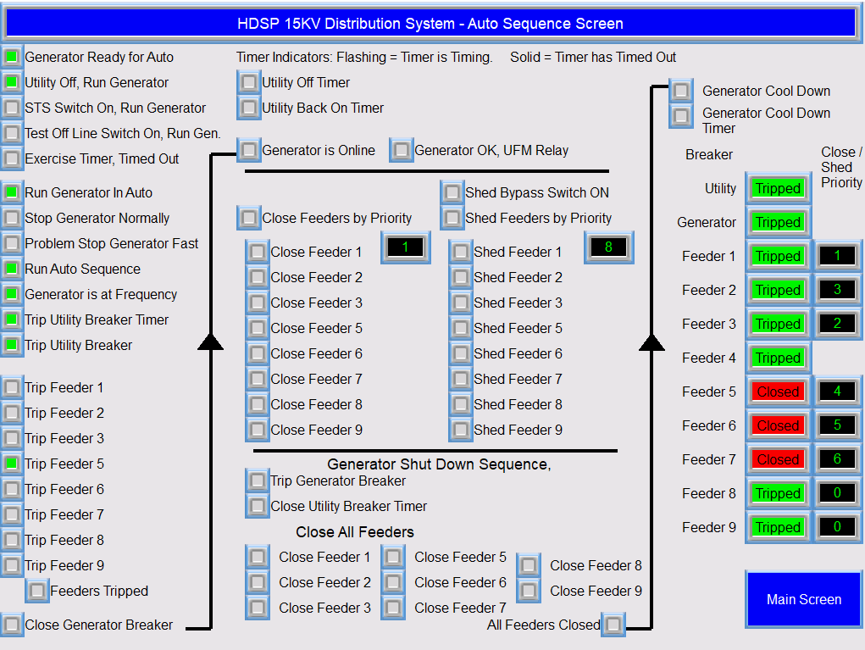

Many of the Sequence Indicators Remain on during the Sequence, but all the Indicators that Trip Feeders, Close Feeders and Shed Feeders are only on Momentarily. The Indicator are on until the Breakers Changes to the desired state, and then the Indicators go Off.
The Trip Feeder 5 indicator is on, and Feeder 5 is closed. When Feeder 5 Trips, the Trip Feeder 5 will go off, and the Feeder 5 Indicator will go green and indicate Tripped..
After all the Feeders Trip, the Feeders Tripped Indicator will go on, and remain On.

After the Generator is on line, the Feeders Close per priority, Priority 1 first to Priority 8. If the Generator cannot maintain the load, the Generator OK, UFM Relay Indicator will go off, and no more Feeders will be Closed. If the Shed Bypass Switch is Off, and the UFM Relay remains off for a time, the Feeders are shed, with Priority 8 First to Priority 1 last. When the UFM Relay comes back on, the Shed Feeders operation will stop.
Data Displays show which Feeder is next to be closed and which feeder is next to be shed. When the Close Feeders Sequence Starts, the Close Data Display is set to 1. When the Shed Feeders Sequence Starts, the Shed Data Display is set to 8.

When the Utility comes back on, the Generator Shut Down Sequence will Start. The Generator Breaker is Tripped, the Utility Breaker is Closed, and Feeders are Closed, one-at-a-time. When all Feeders are closed, and the Generator is performing Cool Down, all of the Sequence Indicators go Off, until the next condition requires operation of the Automatic operation of the Generator.

Alarms:
When an Alarm Occurs, the Alarm Reset button flashes and the alarm text appears at the bottom of all screens via a banner. Alarms from the Generator Controller are reset at the Controller.

There are Alarms in Addition to the ones that come from the Generator Control.
When a Breaker takes too long to Close or Trip, an Alarm occurs. These alarms are reset via the pressing of the Alarm Reset button.

If more than one Alarm is active at the same time, the banner shows the text of each alarm for a short period of time, and then goes on to the next alarm.
Alarms are Red, and Pre-Alarms are yellow.

When the Alarms Screen button at the Main Screen is pushed, the Alarms Summary shows:
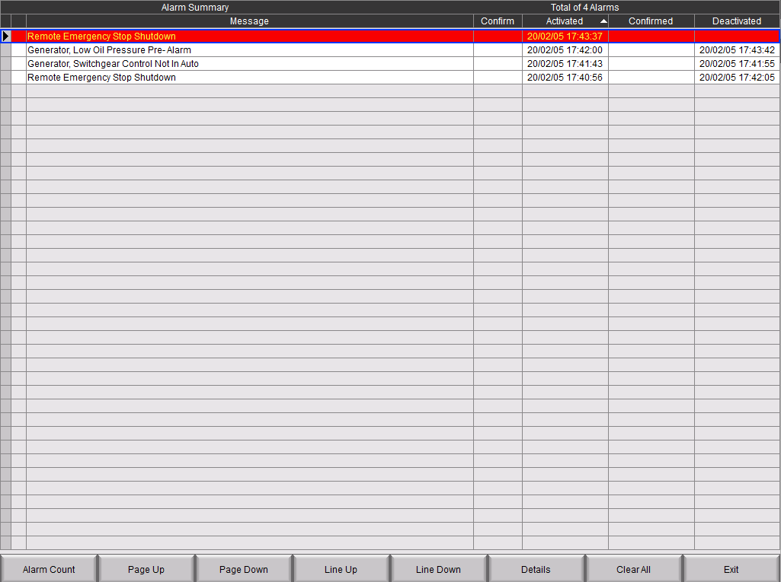

The Top Alarm is still active. The others are History.
Revision History
Rev # | Date | Description | Initial
0 | 06Feb2020 | Original | DDS
 |  |  | DDS

