  - Classification of common terpenoids based on Aromaticity and Molecular Size
  - Diego Soeldi, 2025-12-03

Introduction
In previous works it was stated that aromaticity and molecular size are good indicators to differentiate between the different types of metabolites in a metabolome [1]. This was concluded from multiple different descriptors being combined in a principal component analysis (PCA), based on Aromaticity, Size and Lipophilicity. This work showed that in the class of terpenoids, the heterogeneity in aromaticity and size is substantial, which the following analysis tries to take use to train a Machine Learning model to differentiate between the 5 most common terpenoids found within the metabolome of tropical plants. These terpenoids were chosen because they were the 5 biggest groups in the given data [2].

Methods
The initial data was a part of the work mentioned above and described different molecules found in tropical plants [1,2]. After initial data exploration, multiple descriptors, chosen for their relation to aromaticity and molecule size and calculated with the rdkit library for python, were chosen for the training and analysis process. A Random Forest (RF) model was trained using randomized search CV to optimize the hyperparameters. The precision score, calculated from predicted terpenoid lables, using separate test data, is shown in the left bar plot in figure 1. Additionally, a permutation importance method was used to find the importance of each feature based on its impact when it gets left out. This was also plotted as a bar plot; visible on the right in Figure 1. The Scripts for this analysis can be found on Github [3].

Results
Precision values of 0.75 to 0.96 were produced in all categories. The permutation analysis shows that the molecular weight was the most important feature used in the classification, but all features added to the analysis, and nothing could be left out without impacting the final accuracy.
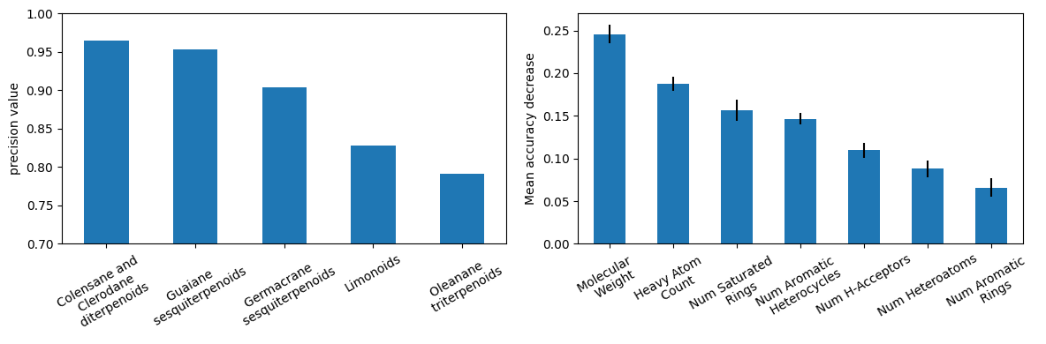

Discussion
The importance of each descriptor shows that descriptors that relate to aromaticity and size of the molecule both impact the classification of terpenoids. This is in line with the findings of Walker et al. as the PCA showed similar findings where different classes of metabolites could be differentiated from each other [1]. This subset of Features describes Colensane and Clerodane diterpenoids best; the reason for this is hard to make out, as interpreting RF classifiers can get complicated, due to its large number of decision trees and the presence of multiple predictors in the data set [4]. In the end it can be said that molecular size and aromaticity can be used to differentiate the most common terpenoid types in the given data. This can be expanded upon to differentiate metabolites from each other.

References
[1] T. W. N. Walker et al., “Leaf metabolic traits reveal hidden dimensions of plant form and function,” SCIENCE ADVANCES, doi: 10.1126/sciadv.adi4029.
[2] T. Walker, „Data from: Leaf metabolic traits reveal hidden dimensions of plant form and function“. Zenodo, Juli 31, 2023. doi: 10.5281/zenodo.8160741.
[3] Diego Söldi, DSA_103_projects_dsoeldi, 2025, https://github.com/DSoeldi/DSA_103_projects_dsoeldi
[4] M. Aria, C. Cuccurullo, and A. Gnasso, “A comparison among interpretative proposals for Random Forests,” Machine Learning with Applications, vol. 6, p. 100094, Dec. 2021, doi: 10.1016/j.mlwa.2021.100094.

