**Project Chat**

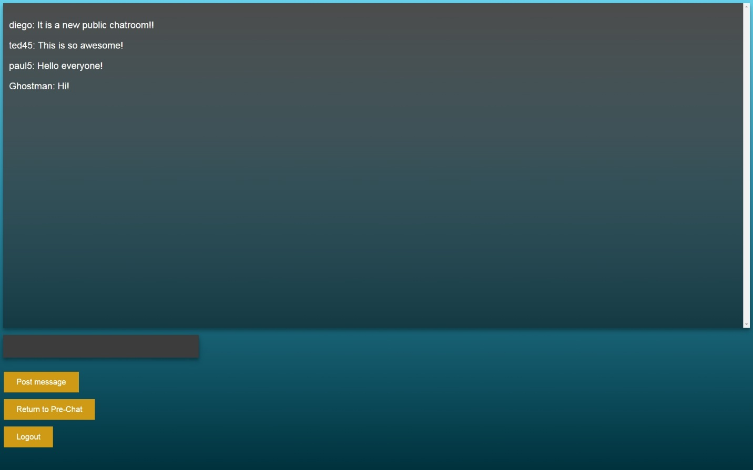

**A great way to meet and talk with friends**

**Development Team:**

Michael Bechtel

Diego Soliz

Connor Welch

Dustin Wendt

Table of Contents

1. The product

1.1 Description……………………………………………………………….1

1.2 Features……………………………………………………………………1

2. Tutorial

2.1 Login Page

2.1.1 Signing up………………………………………………………1

2.1.2 Logging in………………………………………………………1

2.2 Pre-Chat Room

2.2.1 Users…………..…………………………………………………..1

2.2.2 Friends………..…………………………………………………..1

2.2.2 Notifications..…………………………………………………..1

2.3 Chat Rooms

2.3.1 Private Chats….………………………………………………..1

2.3.2 Public Chats……………………………………………………..1

**Section 1**

**The Product**

* 1. Product Description

Welcome to Project Chat, a web based chat program that allows the user to communicate with people from around the world, meet new people, and talk with friends.

* 1. Features

Project Chat is a chat program that implements features that makes communicating and meeting new people a simple task. Some of these features include:

Public Chat-

The public chat room allows all users of Project Chat to come together and communicate with each other in one convenient place.

Private Chat-

Private chat rooms are a great place for friends to hold private conversations with a friend that is not visible to other users.

Friends-

Project Chat allows users to compile lists of friends by adding other users as friends. Being a friend with someone allows you to hold private conversations with that user.

**Section 2**

**Tutorial**

* 1. Login Page

Now let’s get familiar with how to use Project Chat. First go to (insert link here) and let’s get started!

* + 1. Signing Up With Project Chat

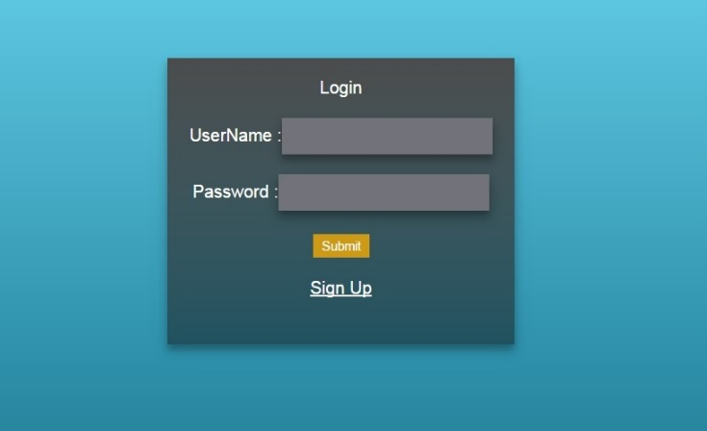The first thing screen you will see when going to the website should be this login screen.

Obviously, we need to create an account first so click the “Sign Up” button at the bottom of the gray box. The gray box will turn into a sign up field that looks similar to the above screen. In the text boxes provided enter a custom username and password then hit the “Submit Registration” button at the bottom of the gray box. A pop up saying you have been successfully registered should appear. That’s it! You are now registered to Project Chat.

*Note: Don’t forget to write down your password! Project Chat does not have a password recovery feature.*

* + 1. Logging In

To log in after signing up click the “Sign In Here” button at the bottom of the registration page to go back to the login page. Enter your username and password into the login field and click “submit”

* 1. Pre-Chat

Now that you are registered and logged in let’s get familiar with some of the features of Project Chat.

* + 1. Users

With Project Chat you can find anyone who has signed up to use it. To find users, locate the magnifying glass icon towards the top center of the screen that says “Search Users” next to it. 

Click the magnifying glass to reveal a text field. In the text field type the name of the user you want to find. As you start typing it will filter users with the input in the text field. You should notice that each user underneath the search bar has an “Add Friend” button next to their name. Users who are already friends with you will only have their username appear. To add a user as a friend click the “Add Friend” Button

* + 1. Friends

Project Chat allows you to add other users as friends. Now that you know how to search for users add some friends! Users will have to accept your request before they will appear as your friend.

Once you have added some friends you should see something like the picture below in the top left of your screen. This is your friends list.

Using the search icon you can search your friends list. Next to each user there will be a “Chat” button and an “Unfriend” button. The “Chat” button takes you a private conversation between you and that user. The unfriend button allows you to remove a user as a friend.

* + 1. Notifications

Up in the top right corner of the screen you will see some text that says “Notifications”. Any friend requests you receive will appear here along with a confirmation when you send friend requests from other users.

From here you can accept or decline any friend requests you may have from other users.

* 1. Chat Rooms

Project Chat has two different types of chat rooms, a public chat room, and private chat rooms.

* + 1. Private Chat Rooms

Project Chat allows you to communicate privately with any user you have added as a friend. To enter a private chat room click the “CHAT” button next to a user’s name under your friends list. 

When you click the button, a blank chat room similar to the one below should appear on you screen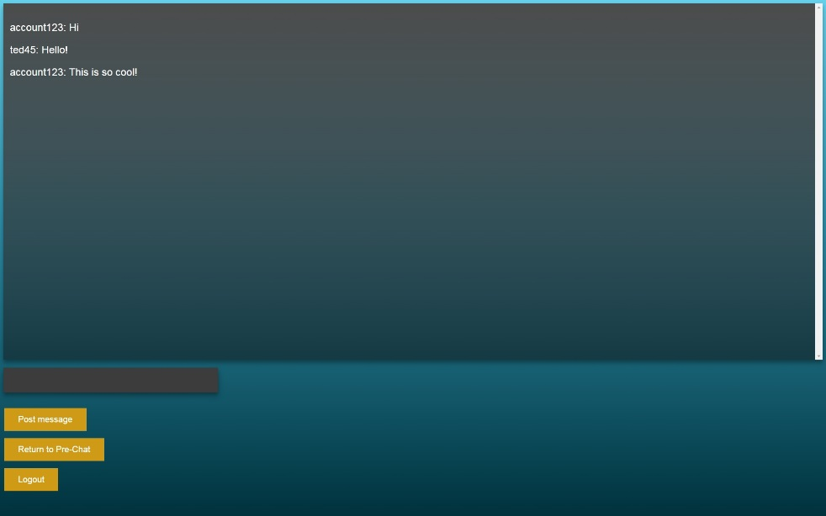

From here you can send messages to each other using the text box and “Post Message” button, return to the Pre-Chat screen using the button in the middle or logout of your account using the “Logout” button.

* + 1. Public Chat Room

Project Chat has a chat room that is available to all users to post messages. To enter the public chat room find the “ENTER PUBLIC CHAT” located towards the center of the screen.



After clicking the button you will be brought into the public chat room as shown below.

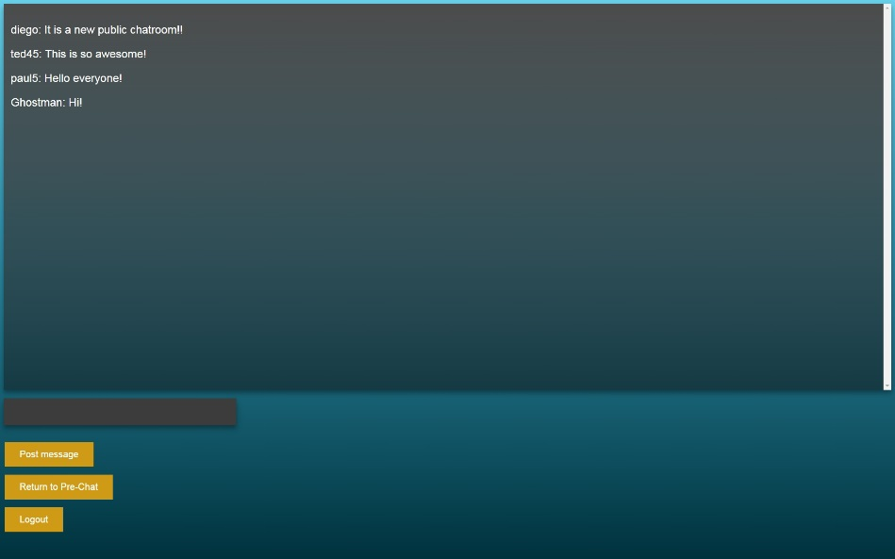Here any user can join to chat with any other user registered with Project Chat. In this screen you can post messages to the chat using the “Post Message” button, go back to the Pre-Chat screen using the middle button or use the “Logout” button to logout of Project Chat.