User Manual

Judgement Management System

Dheeraj Kaushik



Judgment Management System

High Court of Uttarakhand, Nainital

User Manual

Version 1.1

Author

Dheeraj Kaushik

Table of Contents

1. Backup DSpace 4

2. Restore DSPace 4

# Backup DSpace

In order to backup DSpace, we have provided cron jobs(scheduled tasks) which periodically take backup of the DSpace metadata and assetstore separately. In this crob job following two commands are executed at the date/time specified in the crob job.

*$cp -dR /dspace/assetstore /home/backup/.*

*$/opt/PostgreSQL/9.2/bin/pg_dump -U dspace /home/backup/dspace.metadata.sql*

**For further information on how to add cron-jobs in linux; please refer to the user-manual for ‘gnome-schedule’ utility.**

In order to manually take a backup of the PostgreSQL ‘dspace’ database;

Use the pgadmin3 utility at the following location:

*$/opt/PostgreSQL/9.2/pgAdmin3/bin/pgadmin3*

This will open up the following GUI application, as shown in figure 1

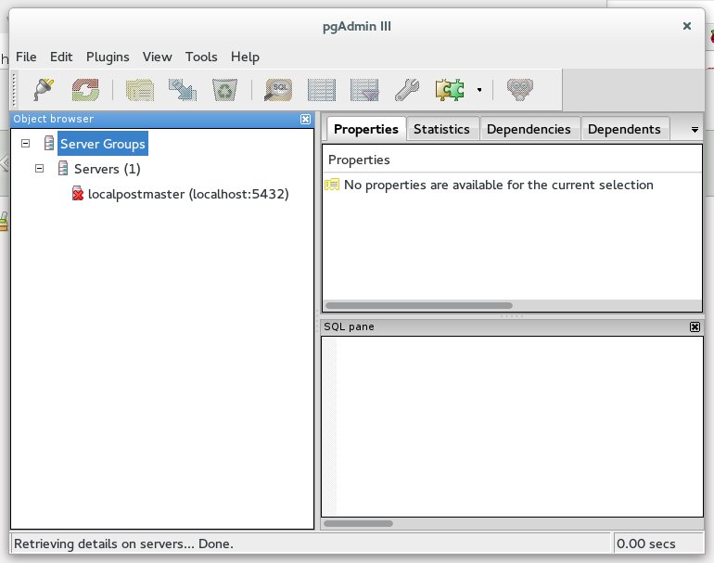

Next try and connect to the PostgreSQL database server, as shown in the

following step in figure 2

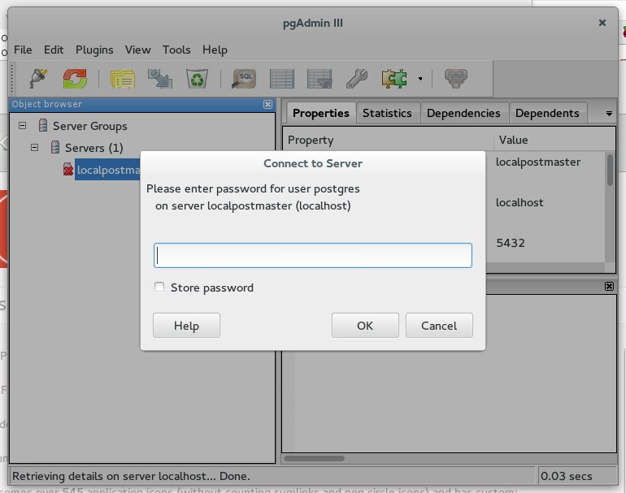

Enter the password for PostgreSQL database server which ‘postgres’ only.

Following screen with all the active databases will open up, as shown in

figure 3.

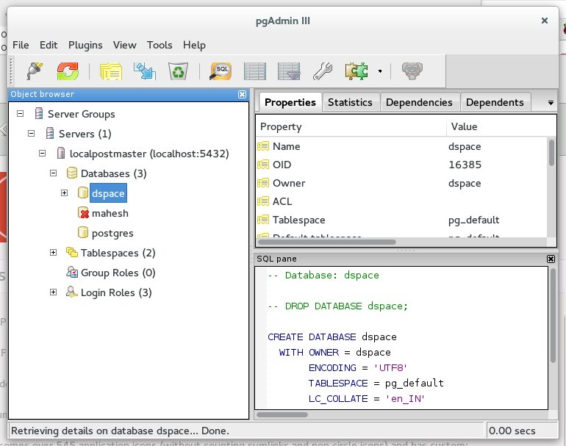

Now, right-click on the database ‘dspace’ to be backed-up and click on

backup menu item. Following screen will pop-up in front of you. Refer to

figure 4

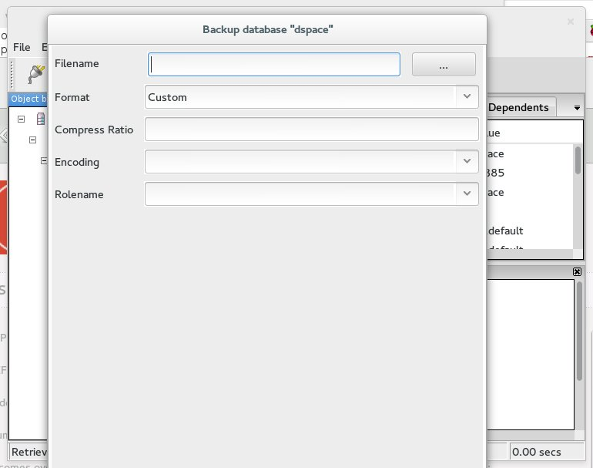

Please fill in the fields as mentioned below in figure 5 and click the backup buttom on the bottom on this window.

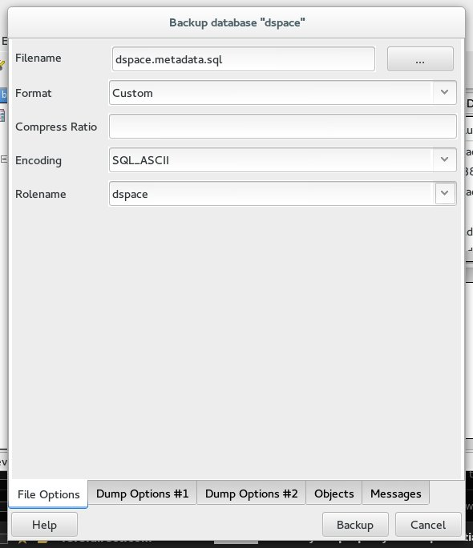

# Restore DSPace

While the backup is pretty straight forward; On the contrary restoration of DSpace is a bit involved process. It requires familiarity with skills like Linux Administration and Database Server Administration. The steps involved in DSpace restoration are as follows:

1. Install DSpace on the new/recovery machine.
2. Ensure that dspace database doesn’t exist of the PostgreSQL Database at this machine
3. On command-line run the following command:

*$psql dspace < dspace.metadata.sql*

here dspace.metadata.sql is the backup file created as specified in the Section 1 with which you want to restore the PostgreSQL database.

1. Next copy the assetstore folder backed at ‘/home/backup/assetstore’

to ‘/dspace/assetstore’ .

1. Re-launch the apache web-server and verify properly that all the

collections/items have been restored properly.

**NOTE: A word of caution, however simple these steps may appear but all these steps have a potential to crash the server; Therefore, we shall warn the user to backup all the critical data in a secondary drive for data-protection.**